|  |  |  |
| --- | --- | --- |
| **LAB221 Assignment** | **Type:** | **Short Assignment** |
| **Code:** | **J2.S.P0018** |
| **LOC:** | **50** |
| **Slot(s):** | **1** |

**Title**

Student Management - RMI

**Background Context**

When you withdraw some money from ATM, the information of your account will be sent from ATM machine to the bank, that included the account’s information like account number, balance, transaction type,…if we can pack all of them into an object, we need to send transaction object to the bank, valid the account before doing any transaction. This assignment will guide you how to work with objects in network application.

**Program Specifications**

Create an application using java swing to create a frame look like (1) for client side.

**1. Main.java - for client side**

Make a frame look like description below.

**2. Main.java – for server side**

Program for the server side so that when users click on sign up button from client side, server will save a student object to sv.dat file

***Function details:***

1. Display the GUI like figure (1)
2. When users enter information of student and click on sign up, connect to server and save entered student to sv.data file

***Expectation of User interface:***

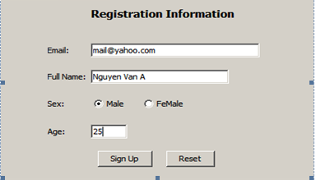

**Guidelines**