|  |  |  |
| --- | --- | --- |
| **LAB221 Assignment** | **Type:** | **Short Assignment** |
| **Code:** | **J2.S.P0020** |
| **LOC:** | **50** |
| **Slot(s):** | **1** |

**Title**

File listing

**Background Context**

We often work with windows explorer where we can easily working with files and directories. By using java swing, we can make our own sample window explorer. We will learn how to work with file and directories.

**Program Specifications**

Create an application by using java swing, the interface of application look like figure below.

***Function details:***

1. When user clicks on *“List file”* button, the program will load all files on local machine with the path is entered in the text-field and display them on the list-box.
2. When user selects a file in the list-box, this program also will show the file name and file size on the labels as sample. And, if selected file:
   1. is a text file (with .txt extension), its content will be showed on the text-area. So user can edit the content of file.
   2. is not a text file, this program will show the dialog with message *“Selected file is not a text file, content cannot be shown”*.
3. When user clicks *“Update”* button, the edited content on the text-area will be updated to local file and save to correct file that he/her has selected.
   1. When user clicks *“Delete”* button, the selected file will be deleted on local machine.

***Expectation of User interface:***

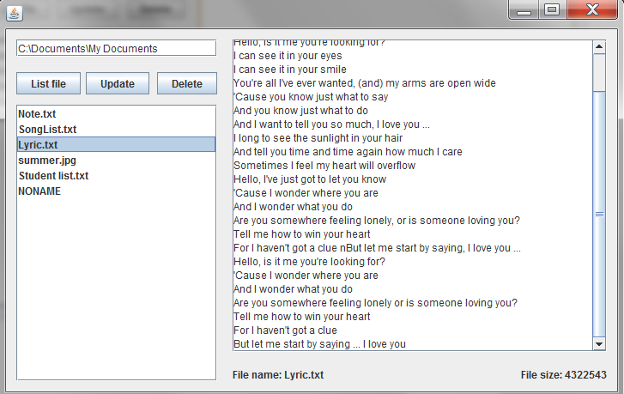

**Guidelines**