|  |  |  |
| --- | --- | --- |
| **LAB221 Assignment** | **Type:** | **Short Assignment** |
| **Code:** | **J2.S.P0101** |
| **LOC:** | **60** |
| **Slot(s):** | **1** |

**Title**

Create a program display data in a tree form.

**Background Context**

NA

**Program Specifications**

* Use swing library to create tree example, do not use drag and drop, must write code to generate all controls.

Main functions described as below:

***Function details:***

1. Add new node: allow user add new node at run time
2. Remove an existing node: allow user remove an existing node at run time

***Expectation of User interface:***

The screen should be as:

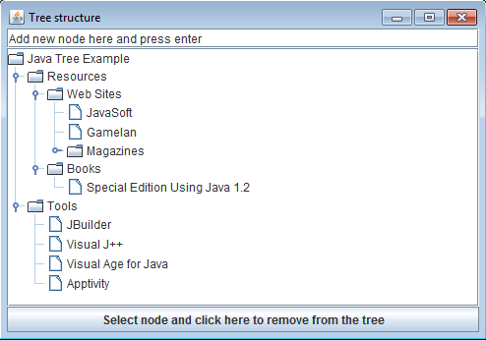

**Guidelines**

* Use JFrame, JTextFiled, JTree in swing library
* Create controls at run time and define listener for them, for example: create text filed

JTextField text;

text= new JTextField("Add new node here and press enter");

text.addActionListener(new ActionListener(){

public void actionPerformed(ActionEvent ae){

addTextFieldValue();

}

});

add(text,"North");