|  |  |  |
| --- | --- | --- |
| **LAB221 Assignment** | **Type:** | **Short Assignment** |
| **Code:** | **J2.S.P0103** |
| **LOC:** | **15** |
| **Slot(s):** | **1** |

**Title**

Adjust scrollbar position to change font size

**Background Context**

NA

**Program Specifications**

Create a program to adjust scrollbar position to change font size, scrollbar move up then font size is decrease, scrollbar move down then font size is increase.

***Function details:***

NA

***Expectation of User interface:***

The screen when the program startup should be as:

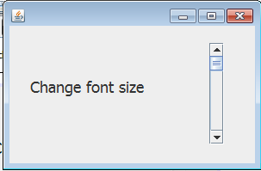

Font size is increase when move down scrollbar

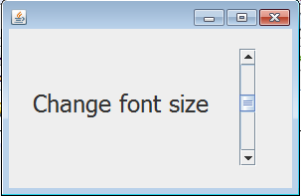

**Guidelines**