|  |  |  |
| --- | --- | --- |
| **LAB221 Assignment** | **Type:** | **Short Assignment** |
| **Code:** | **J2.S.P0105** |
| **LOC:** | **30** |
| **Slot(s):** | **1** |

**Title**

Use JFormatTextField in a program

**Background Context**

Formatted text fields provide a way for developers to specify the valid set of characters that can be typed in a text field. Specifically, the [JFormattedTextField](https://docs.oracle.com/javase/8/docs/api/javax/swing/JFormattedTextField.html" \t "_blank) class adds a formatter and an object value to the features inherited from the JTextField class. The formatter translates the field's value into the text it displays, and the text into the field's value.

Using the formatters that Swing provides, you can set up formatted text fields to type dates and numbers in localized formats. Another kind of formatter enables you to use a character mask to specify the set of characters that can be typed at each position in the field. For example, you can specify a mask for typing phone numbers in a particular format, such as (XX) X-XX-XX-XX-XX.

**Program Specifications**

Create a program to use JFormatTextField in java swing.

***Function details:***

Enter data in specific formats:

* Number format: #,###.00
* Date format: MM/dd/yyyy
* Currency format: ¤#,##0.00
* Time format: h:mm:ss a
* Percent format: #,##0%

***Expectation of User interface:***

The screen when the program startup should be as:

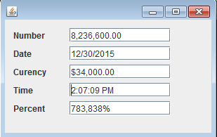

**Guidelines**