BDA400 – Data Science Tools and Techniques
Assignment 2
Technical Analysis using R, Preliminary Stage
Submitted by
Tasveer Kanwal
GitHub repository
https://github.com/tasveerKanwal/TechnicalAnalysis

1. Introduction
This report documents the first stage of a three-part technical analysis project in R. The goal of this stage was to prepare the working environment and build the foundation that the later assignments depend on. I set up a GitHub repository to store all course work, installed R and RStudio, installed the packages needed for technical analysis, and created a portfolio file listing the stocks I chose to follow. I then wrote functions to import historical price data, calculate descriptive statistics, and display both the data and the results in tables and charts.
Every step below includes a short explanation of what I did and why, followed by a screenshot taken at that point in the process.
The deliverables for this assignment are listed in the table below, together with the file names used in the repository.
Deliverable | File or location
GitHub repository | TechnicalAnalysis
Portfolio file | Assignment_2/portfolio.txt
R script (functions and display code) | Assignment_2/TasveerKanwal_BDA400_A02.R
Report | Assignment_2/TasveerKanwal_BDA400_A02_Report.docx
Cover page | TasveerKanwal_BDA400_A02_CoverPage.docx

2. GitHub Account and Repository Setup

2.1 Installing Git
Git is the version control tool that sends my local files to GitHub. I followed the GitHub installation guide and downloaded the installer for my operating system, then accepted the default options during setup.
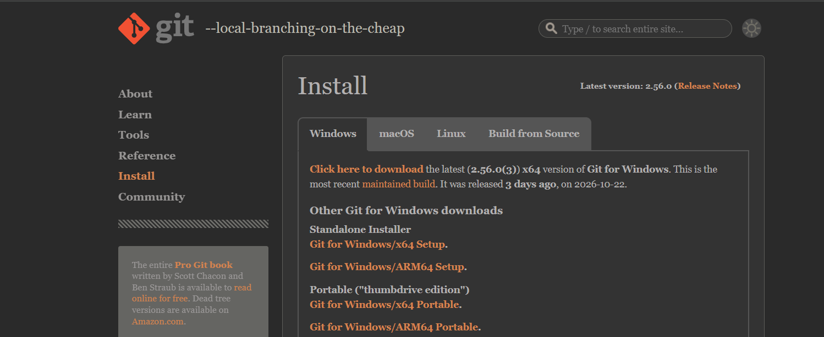
Figure 1: Git installer download page
To confirm that the installation worked, I opened a terminal and checked the version number.
git --version

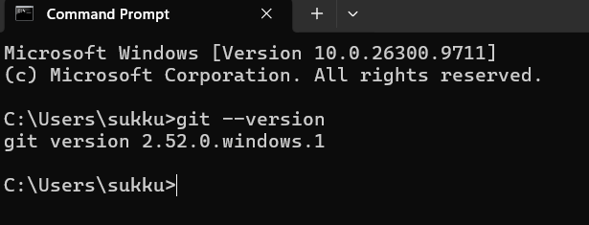
Figure 2: Terminal showing the installed Git version

2.2 Creating the GitHub account
I signed up for a GitHub account at github.com using my email address, chose the username tasveerKanwal, and verified my email.
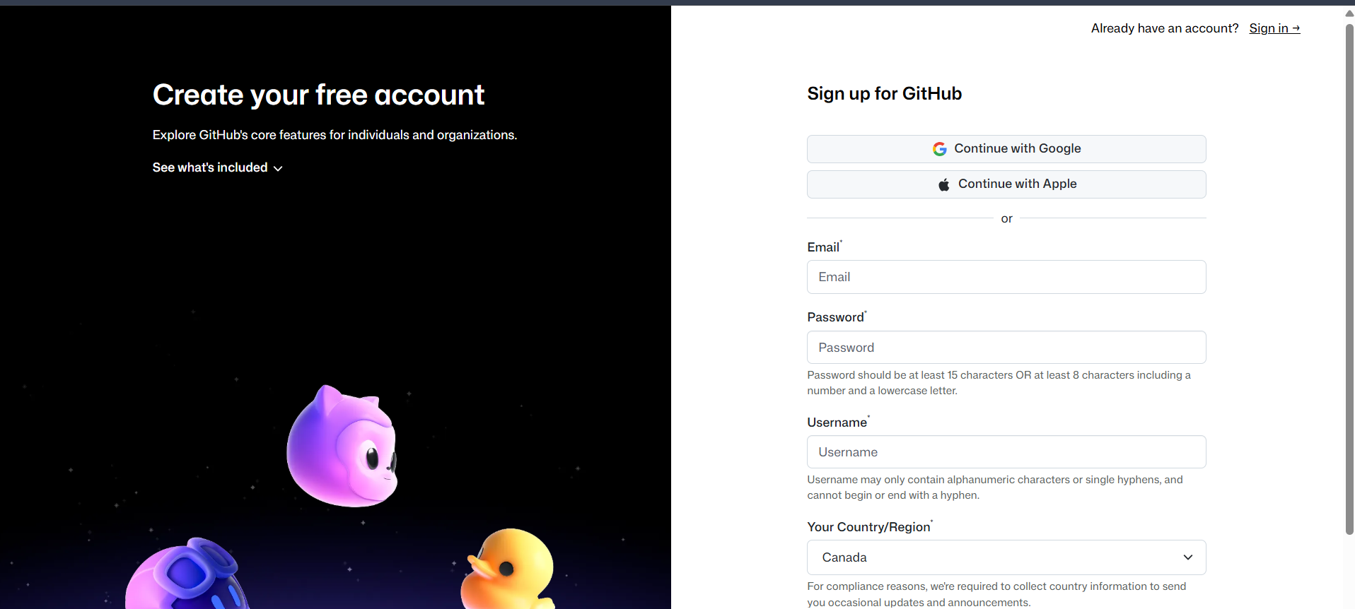
Figure 3: GitHub sign-up page
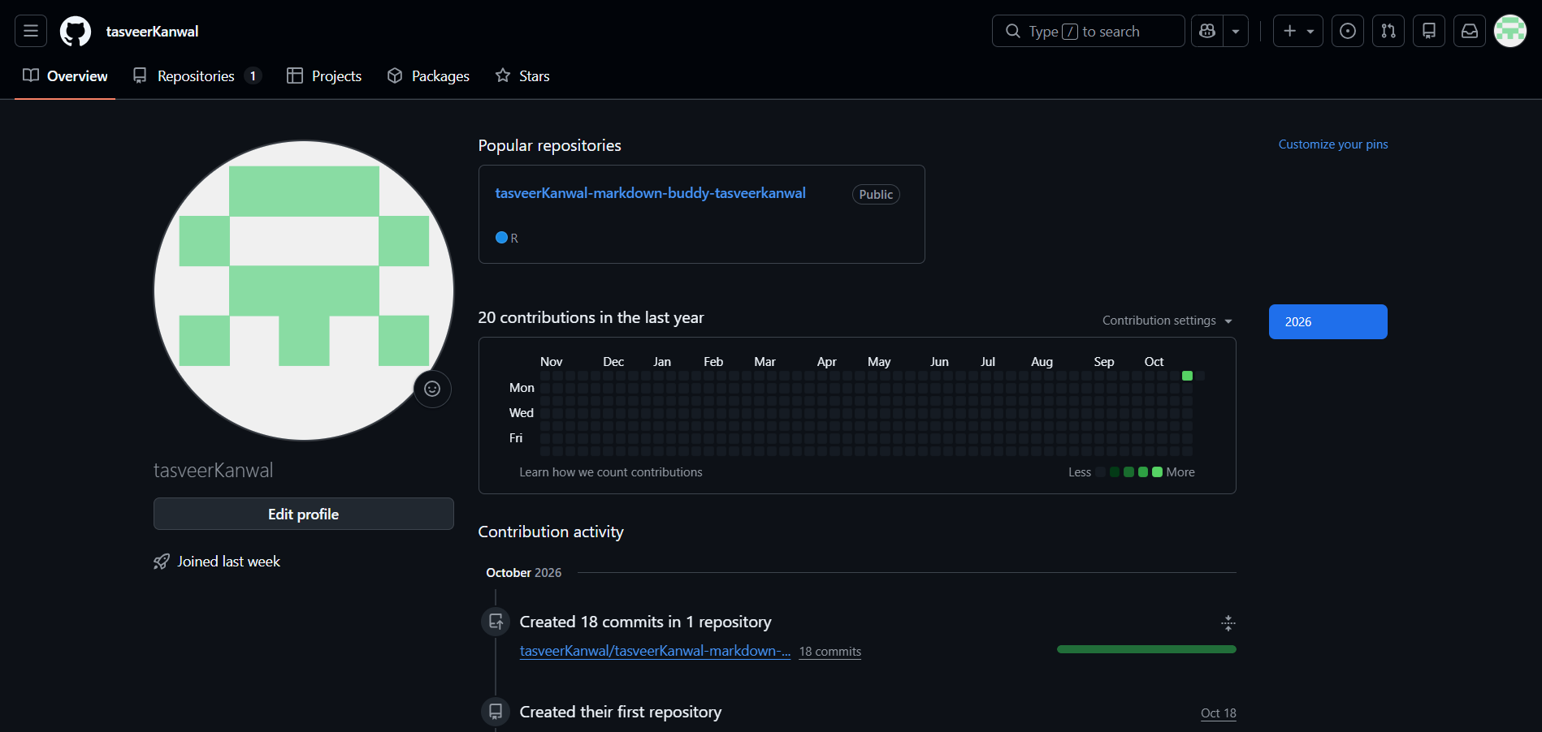
Figure 4: GitHub profile page after account creation

2.3 Configuring Git
Following the GitHub setup guide, I told Git who I am so that each commit carries my name and email.
git config --global user.name "Tasveer Kanwal"
git config --global user.email "tasveerkanwal@gmail.com"

2.4 Creating the TechnicalAnalysis repository
On GitHub I created a new repository named TechnicalAnalysis, set it to public so that my instructor can review the work, and added a README file.
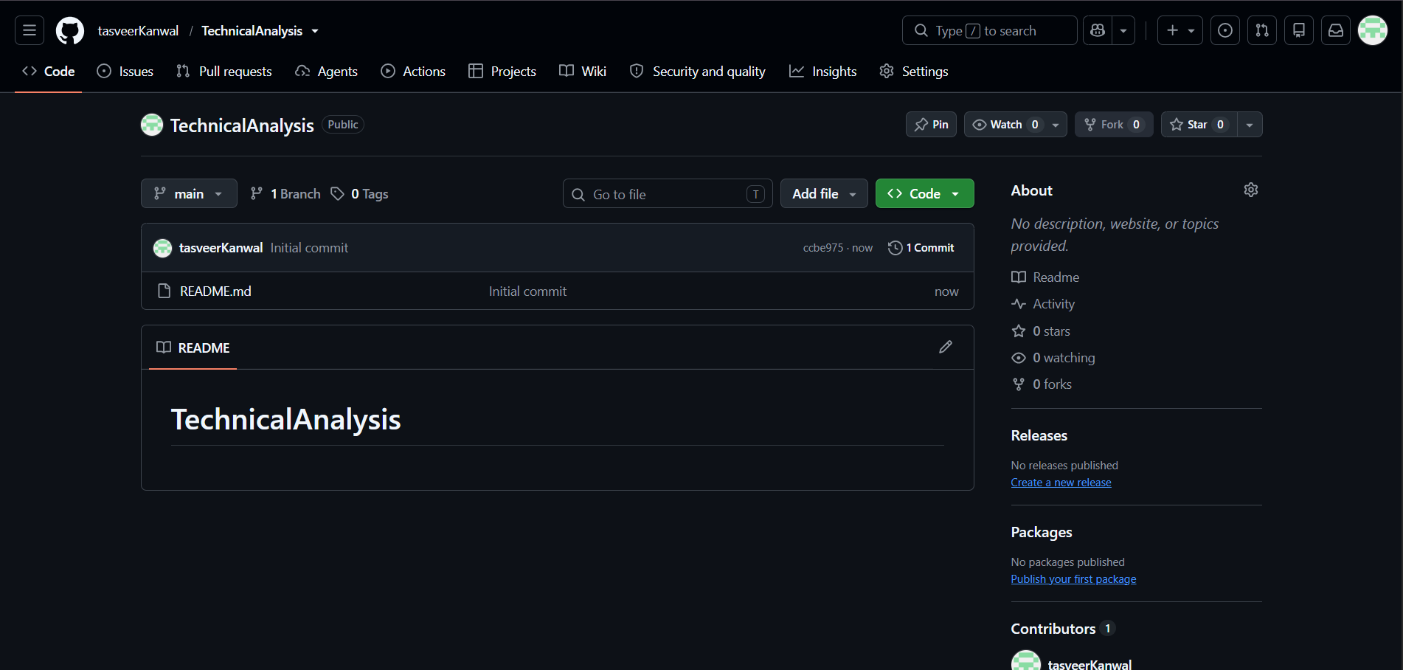
Figure 5: New repository form with the name TechnicalAnalysis

3. Installing and Configuring R and RStudio

3.1 Installing R
R is the programming language and RStudio is the editor I use to write and run it, so R has to be installed first. I downloaded the latest R release for my operating system from CRAN and ran the installer with the default settings.
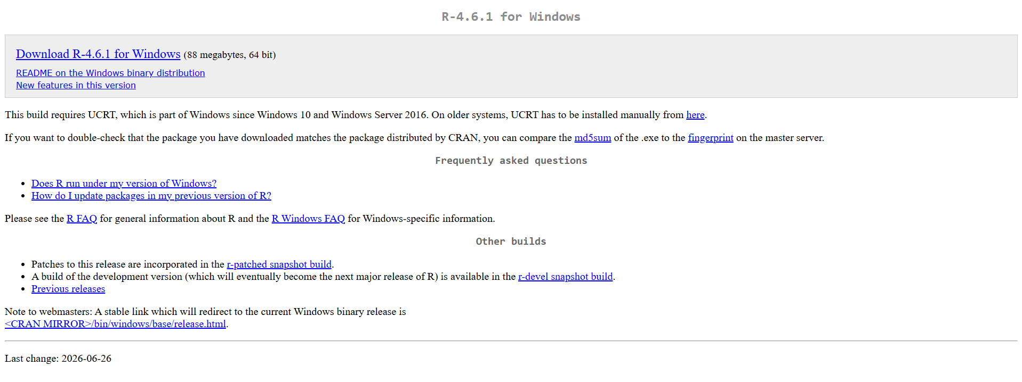
Figure 6: CRAN download page for R
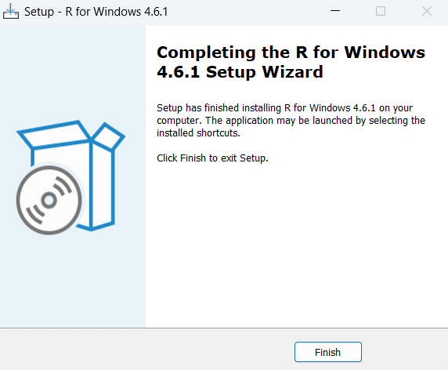
Figure 7: R installer running

3.2 Installing RStudio
I then downloaded RStudio Desktop from the Posit website and installed it. RStudio detects the existing R installation automatically.
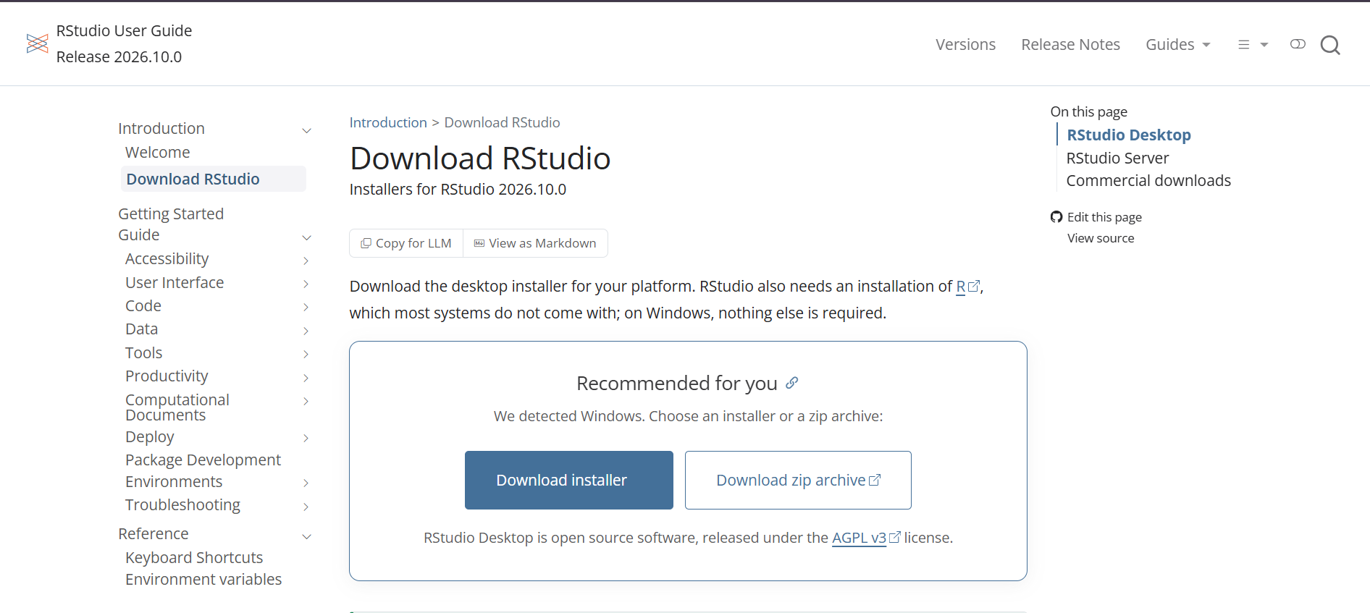
Figure 8: RStudio download page
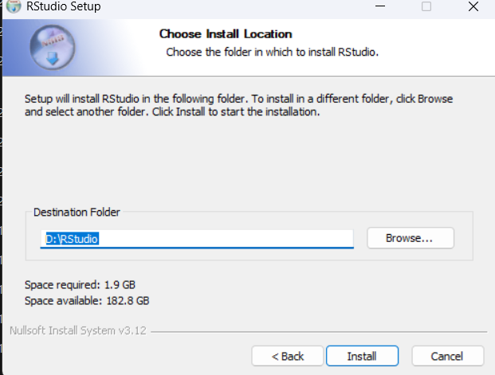
Figure 9: RStudio installer running

3.3 Verifying the installation
I opened RStudio and ran a short command in the console to check the R version and confirm that everything was working.
R.version.string

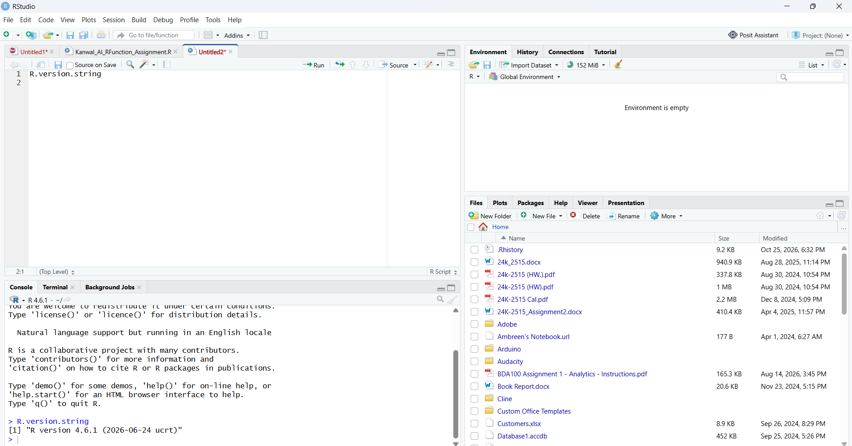
Figure 10: RStudio window with the R version printed in the console

4. Installing R Packages for Technical Analysis
The analysis relies on three packages. quantmod downloads historical market data from sources such as Yahoo Finance. TTR (Technical Trading Rules) provides indicators such as the simple moving average. ggplot2 is used to build the charts. I installed them with install.packages() and then loaded them with library().
install.packages("quantmod")
install.packages("TTR")
install.packages("ggplot2")

library(quantmod)
library(TTR)
library(ggplot2)

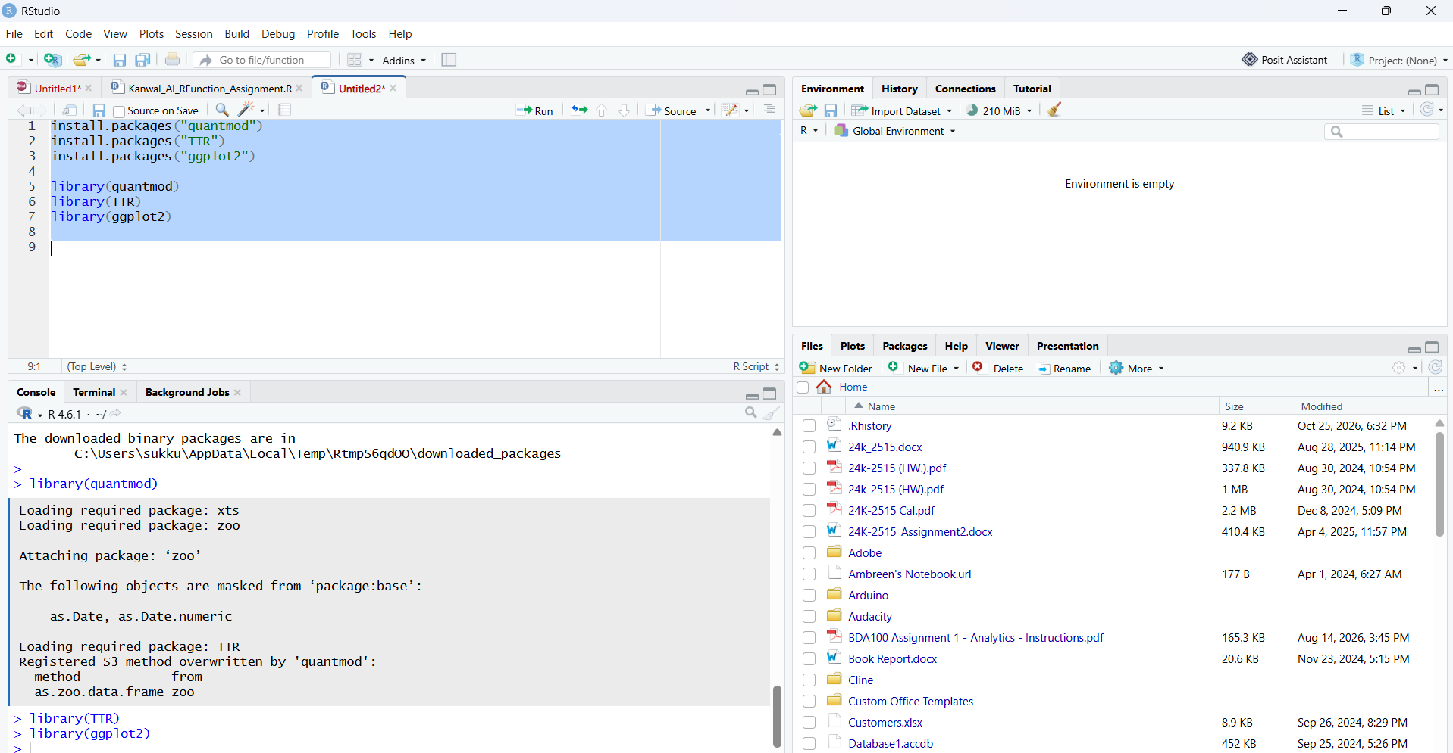
Figure 11: Running install.packages() for quantmod and TTR

5. Project Configuration and Initialization
The project reads its list of stocks from a plain text file named portfolio.txt. I created the file in RStudio and listed one ticker symbol per line. My portfolio contains five large technology companies:
Symbol | Company
AAPL | Apple Inc.
MSFT | Microsoft Corporation
GOOGL | Alphabet Inc.
AMZN | Amazon.com, Inc.
NVDA | NVIDIA Corporation

Keeping the symbols in a separate file means that the portfolio can be changed without touching any code.
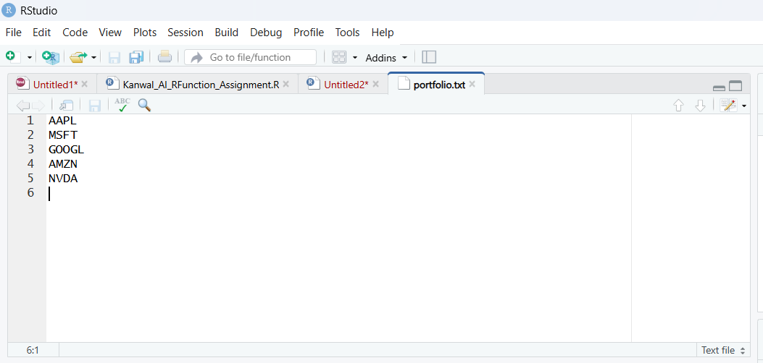
Figure 12: portfolio.txt open in RStudio

6. Function to Import and Load Stock Data
The function load_stock_data() reads portfolio.txt and downloads the historical prices for every symbol with quantmod. For each stock it builds a data frame with the columns Date, Open, High, Low, Close, Volume and Adjusted, and it removes rows with missing values. The data frames are stored in a named list and are also copied into the global environment, so each stock is available as its own object (for example AAPL or MSFT).
A helper function, read_portfolio(), trims the lines of the file, converts the symbols to upper case and ignores blank lines. If a symbol cannot be downloaded, the function issues a warning and continues with the remaining stocks instead of stopping.
load_stock_data <- function(path = "portfolio.txt", from = "2023-01-01", to = "2023-07-01") {
stocks <- list()
for (symbol in read_portfolio(path)) {
df <- tryCatch({ ... }, error = function(e) NULL)
if (!is.null(df) && nrow(df) > 0) stocks[[symbol]] <- df
}
stocks
}

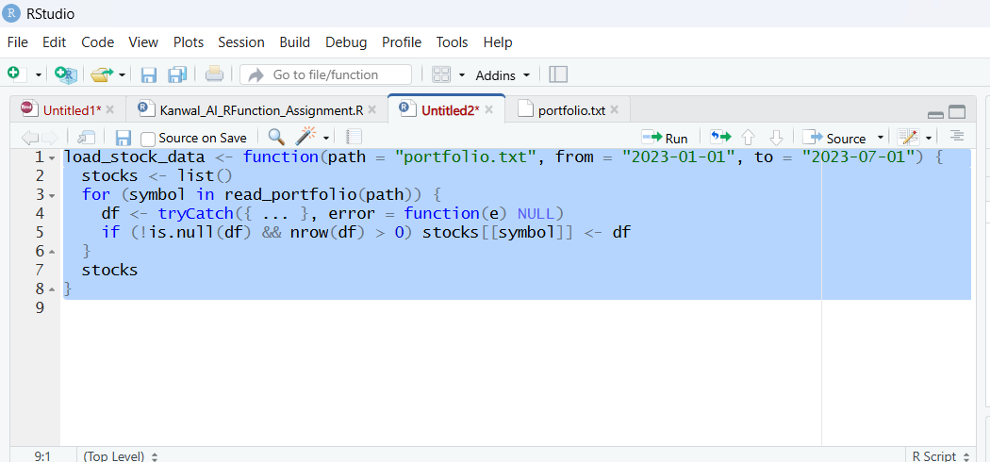
Figure 13: load_stock_data() defined in the RStudio script
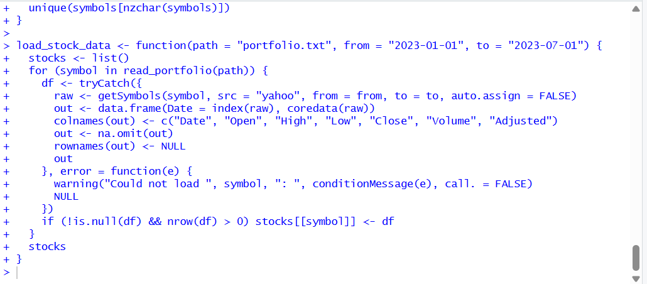
Figure 14: Console output after loading the portfolio, showing one data frame per stock
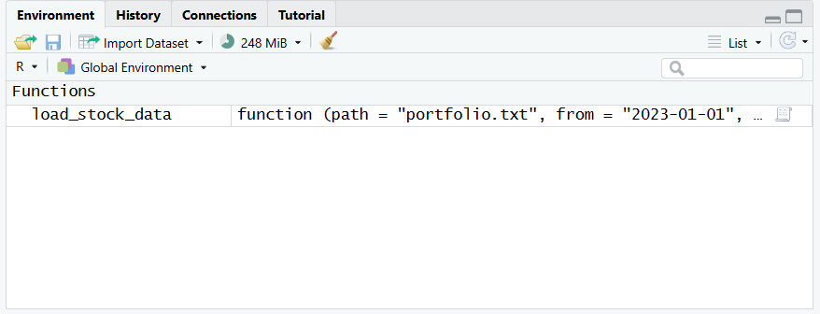
Figure 15: Environment pane listing the data frames for each symbol

7. Functions to Compute Basic Statistics
The function calculate_statistics() takes one stock data frame and returns a single-row data frame of statistics based on the closing price. calculate_all_statistics() applies it to every stock and combines the results into one table.
Statistic | How it is calculated
Mean | mean() of the closing prices
Median | median() of the closing prices
Mode | Most frequent closing price after rounding to the nearest dollar (calculate_mode())
Standard deviation | sd() of the closing prices
Moving average | 20-day simple moving average from TTR::SMA(); the latest value is reported
Minimum and maximum | min() and max() of the closing prices

Closing prices are continuous values, so exact repeats are rare. I therefore rounded the prices to whole dollars before finding the mode, which gives a more meaningful most-common price level.
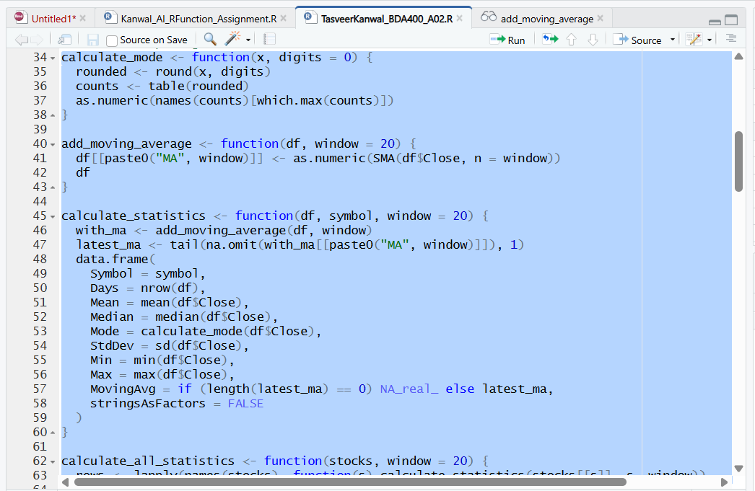
Figure 16: calculate_statistics() and calculate_mode() in the script
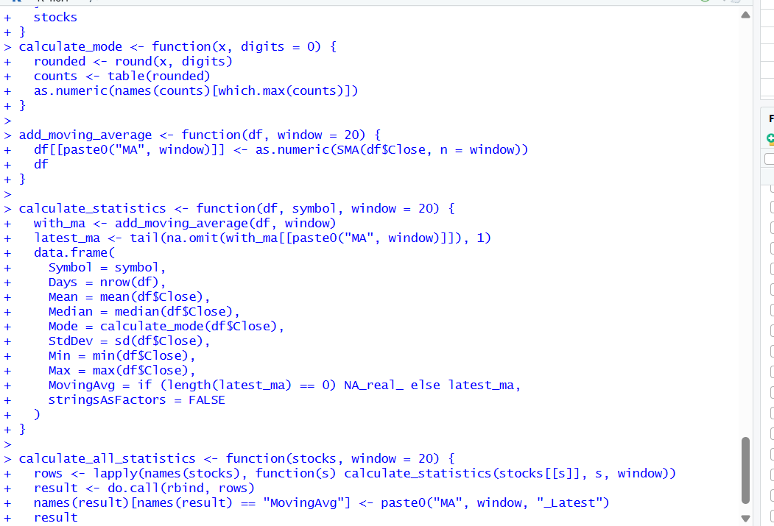
Figure 17: Statistics table printed for all five stocks

8. Utilities to Display Output
I wrote several display functions to show the data in different ways, similar to how Yahoo Finance presents market data.
- display_stock_table() prints the date range, the first rows and the last rows of each stock.
- display_summary() prints the base R summary of the price and volume columns.
- display_statistics() prints the combined statistics table.
- display_candlestick() draws a candlestick chart with volume and a moving average using quantmod.

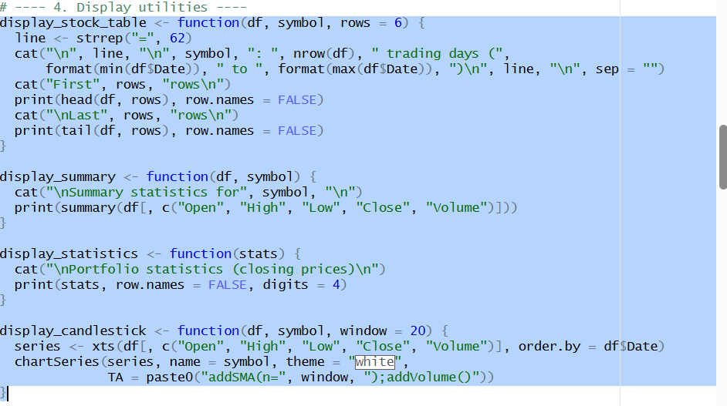
Figure 18: Output of display_stock_table() for one stock
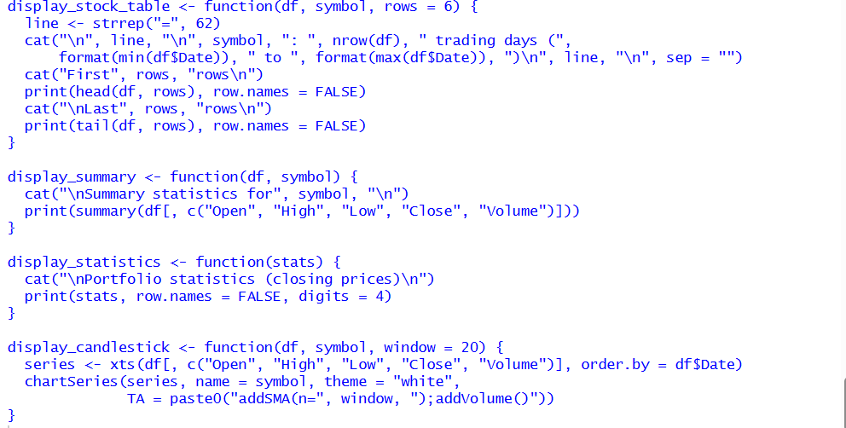
Figure 19: Output of display_summary() for one stock

8.1 Visualizations
For each stock the script produces a closing price chart with the 20-day moving average, a volume chart, and a histogram of closing prices with the mean and median marked. Two portfolio-level charts compare all the stocks: a rebased price chart where every stock starts at 100, and a bar chart of mean, median and standard deviation. All charts are saved as PNG files in the plots folder.
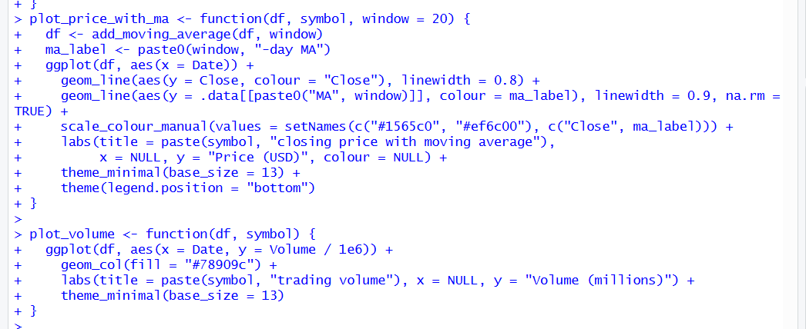
Figure 20:
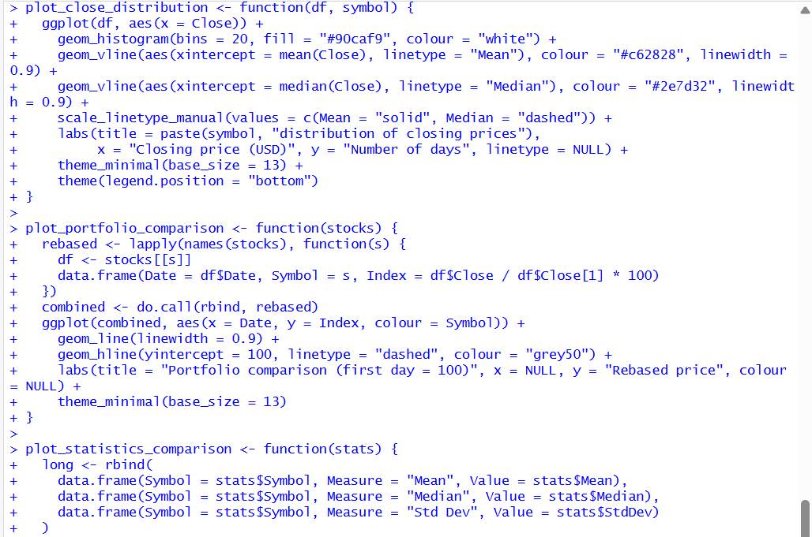
Figure 21:
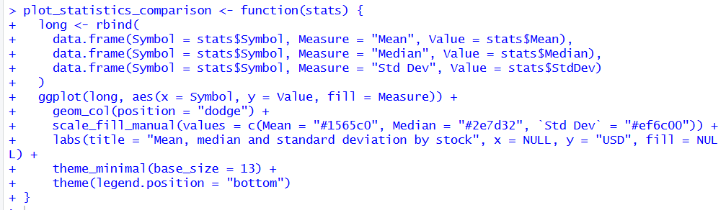
Figure 22:

