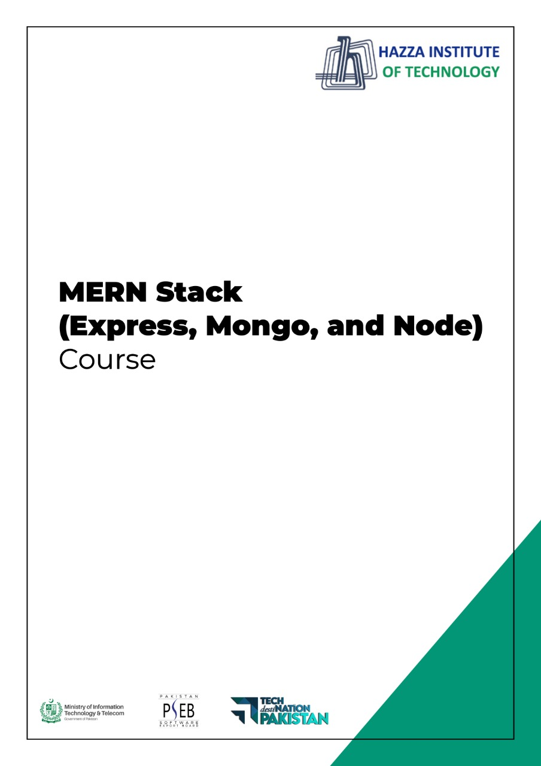

**Total Time:**

**3 hours**

**Pre-Lab Activities:**

* No Pre-Lab Activity

**Learning Outcomes:**

* Perform the execution, debugging, testing, and profiling of web apps in modern IDEs.

**Lab Tasks:**

* + Understanding ES6

**Student Activities:**

Explore the followings:

* + Classes
  + Arrow Functions
  + Variables (let, const, var)
  + Array Methods like .map()
  + Destructuring
  + Modules
  + Ternary Operator
  + Spread Operator

**Tasks: Do the following tasks to complete this Lab.**

1. Install Node.js and VS code

(Write and run the code from the lecture and explore the following)

* 1. Classes
  2. Arrow Functions
  3. Variables (let, const, var)
  4. Array Methods like .map()
  5. Destructuring
  6. Modules
  7. Ternary Operator
  8. Spread Operator

1. Create React app with two methods