**Project: SQL Database Testing**

**Description**

Performed extensive SQL queries on a sample database to simulate real-world scenarios, focusing on CRUD operations (Create, Read, Update, Delete) and data validation. The project involved testing data retrieval, updates, and deletion using SQL Server. The goal was to validate data integrity and optimize query performance.

## ****Technologies Used****

* **SQL**
* **Database Management System**: MySQL
* **Development Environment**: Visual Studio Code with relevant SQL extensions

**Key Achievements**

* Created tables, inserted data, and performed complex data queries.
* Validated data integrity using JOIN, GROUP BY, and ORDER BY clauses.
* Wrote scripts to identify data anomalies and optimize database performance.

#### ****Project Scope****

**Set Up Database**

Create simple database schema (e.g., users, orders, products tables).

**CRUD Operations**

**Create**: Insert new records into the database.

**Read**: Query the database to retrieve records.

**Update**: Modify existing records in the database.

**Delete**: Remove records from the database.

**Data Validation**

Write SQL queries to check data consistency and correctness.

**Join Operations**

Use JOIN operations to combine data from multiple tables.

### ****Validation and Testing****

* Verified the data retrieval accuracy using SELECT statements.
* Ensured proper error handling for cases where data did not exist.
* Confirmed the successful execution of updates and deletions with subsequent SELECT queries.

**Example Screenshots**

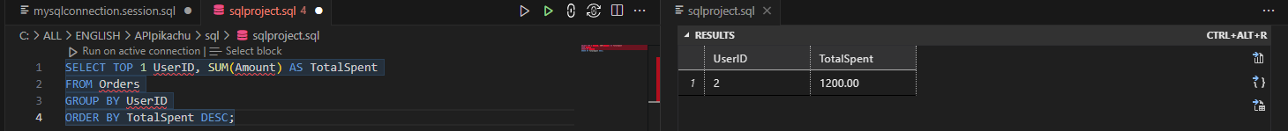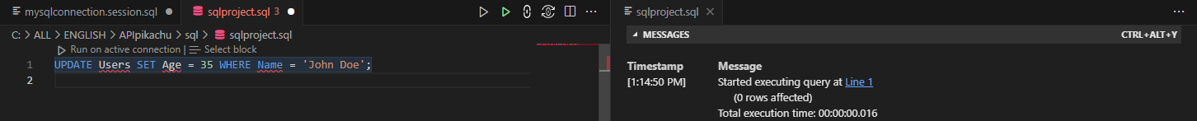

**Example Code Snippets**

Find the most expensive product bought

SELECT Product, MAX(Amount) AS MaxAmount FROM Orders;

Get the number of orders per user

SELECT UserID, COUNT(OrderID) AS NumberOfOrders FROM Orders GROUP BY UserID;

Find the user with the highest total spending

SELECT UserID, SUM(Amount) AS TotalSpent FROM Orders GROUP BY UserID ORDER BY TotalSpent DESC LIMIT 1;