4. Role 2: Packet Capture dengan Wireshark

4.1 Tujuan Role 2
Role 2 bertugas membuktikan bahwa request GET dan POST dari Postman benar-benar berjalan melalui protocol HTTP menggunakan Wireshark.

4.2 Tools dan Filter
Packet capture dilakukan menggunakan Wireshark pada Npcap Loopback Adapter karena server berjalan secara lokal di 127.0.0.1:8088.
Filter yang digunakan:
tcp.port == 8088
atau:
http

4.3 Packet yang Dianalisis
No | Packet | Makna
1 | GET /api/uts/orders HTTP/1.1 | Client meminta data orders
2 | HTTP/1.0 200 OK | Server berhasil mengirim data
3 | POST /api/uts/evidence HTTP/1.1 | Client mengirim payload JSON
4 | HTTP/1.0 201 Created | Server berhasil membuat data
5 | GET /api/webhook/inbox HTTP/1.1 | Client membaca evidence
6 | HTTP/1.0 200 OK | Server berhasil mengirim data evidence

4.4 Analisis Packet GET Orders
Packet GET /api/uts/orders menunjukkan bahwa client meminta data orders dari server lokal. Response 200 OK menunjukkan bahwa server berhasil mengirim data dalam format JSON.

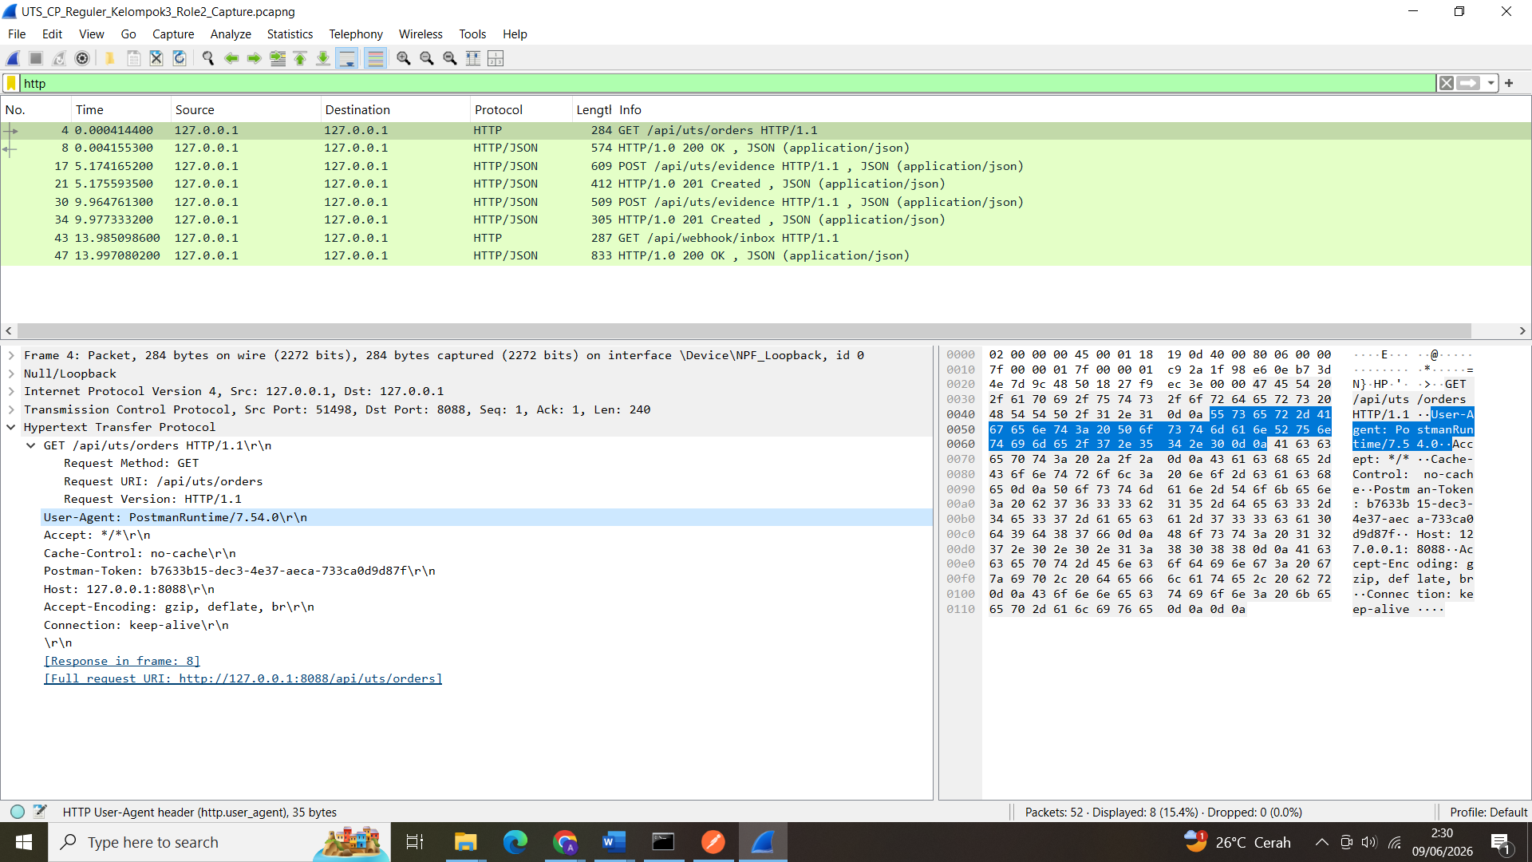
screenshot: Wireshark GET /api/uts/orders request

Request Method: GET
Request URI: /api/uts/orders
Request Version: HTTP/1.1
Host: 127.0.0.1:8088
User-Agent: PostmanRuntime
Full request URI: http://127.0.0.1:8088/api/uts/orders

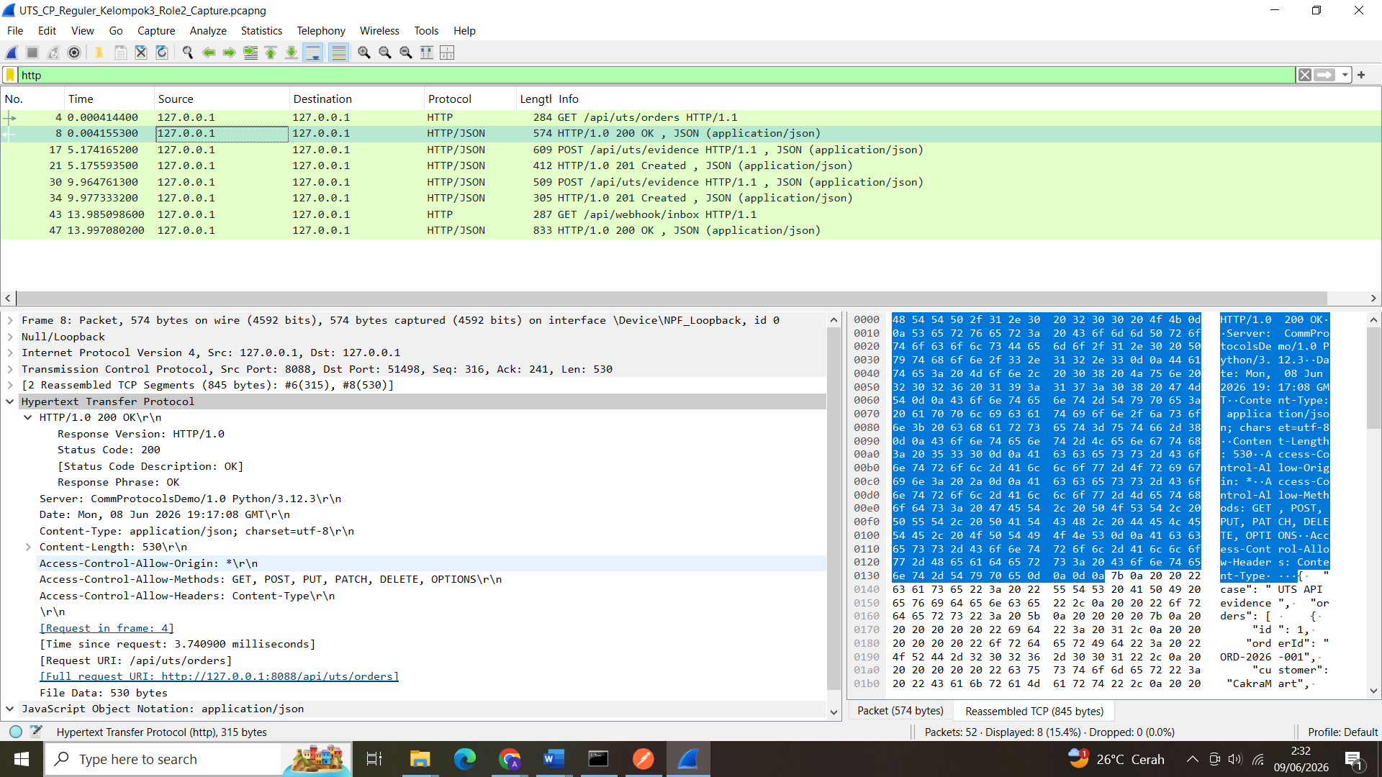
screenshot: Wireshark response 200 OK

Status Code: 200
Status Code Description: OK
Response Phrase: OK
Content-Type: application/json
Request URI: /api/uts/orders
Full request URI: http://127.0.0.1:8088/api/uts/orders

4.5 Analisis Packet POST Evidence
Packet POST /api/uts/evidence menunjukkan bahwa Postman mengirim payload JSON ke server. Header Content-Type: application/json membuktikan bahwa data dikirim dalam format JSON. Response 201 Created menunjukkan bahwa server berhasil membuat data evidence baru.
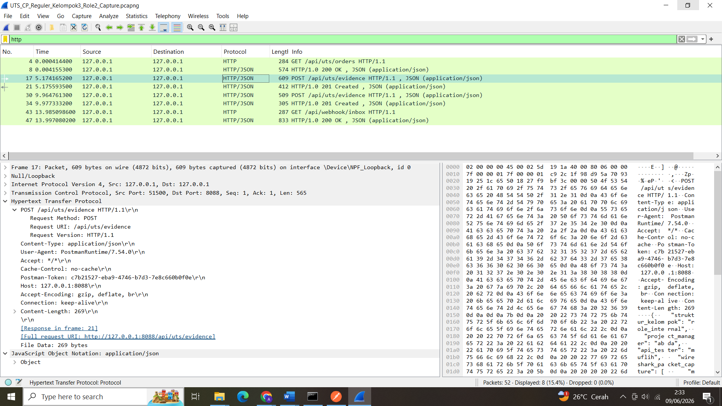
screenshot: Wireshark POST1 /api/uts/evidence request
Request Method: POST
Request URI: /api/uts/evidence
Request Version: HTTP/1.1
Content-Type: application/json
Host: 127.0.0.1:8088
Content-Length
Full request URI: http://127.0.0.1:8088/api/uts/evidence

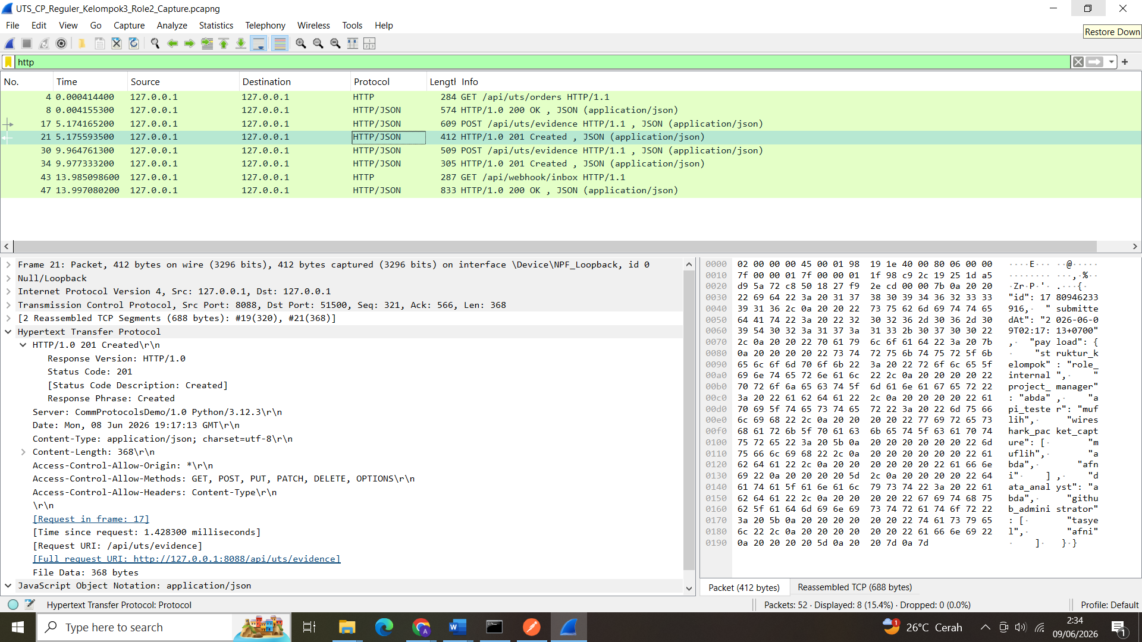
screenshot: Wireshark response 201 Created
Status Code: 201
Status Code Description: Created
Response Phrase: Created
Content-Type: application/json
Request URI: /api/uts/evidence
Full request URI: http://127.0.0.1:8088/api/uts/evidence

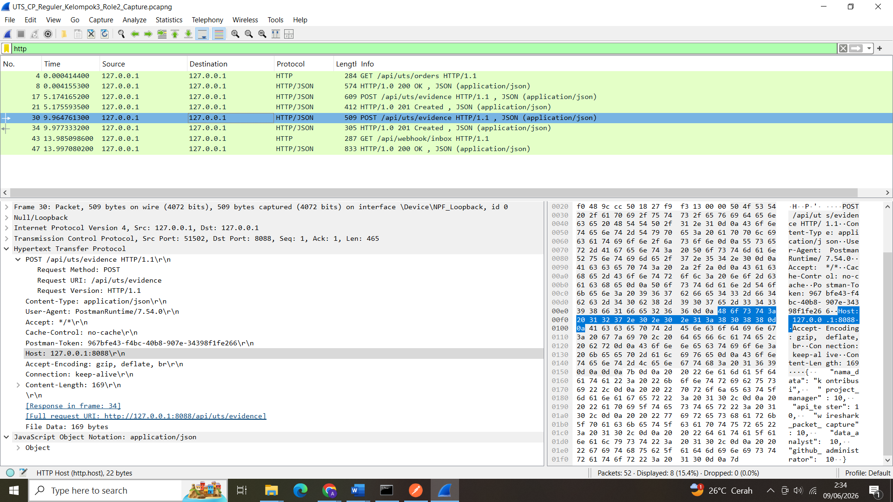
screenshot: Wireshark POST2 /api/uts/evidence request

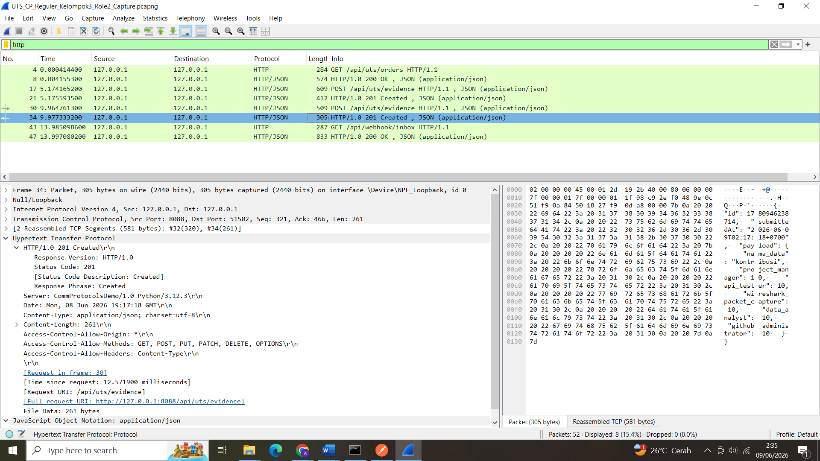
screenshot: Wireshark response 201 Created

4.6 Analisis Packet GET Webhook Inbox
Packet GET /api/webhook/inbox menunjukkan bahwa client membaca kembali data evidence yang sudah dikirim melalui POST. Response 200 OK menunjukkan bahwa server berhasil mengirim data evidence dalam format JSON.

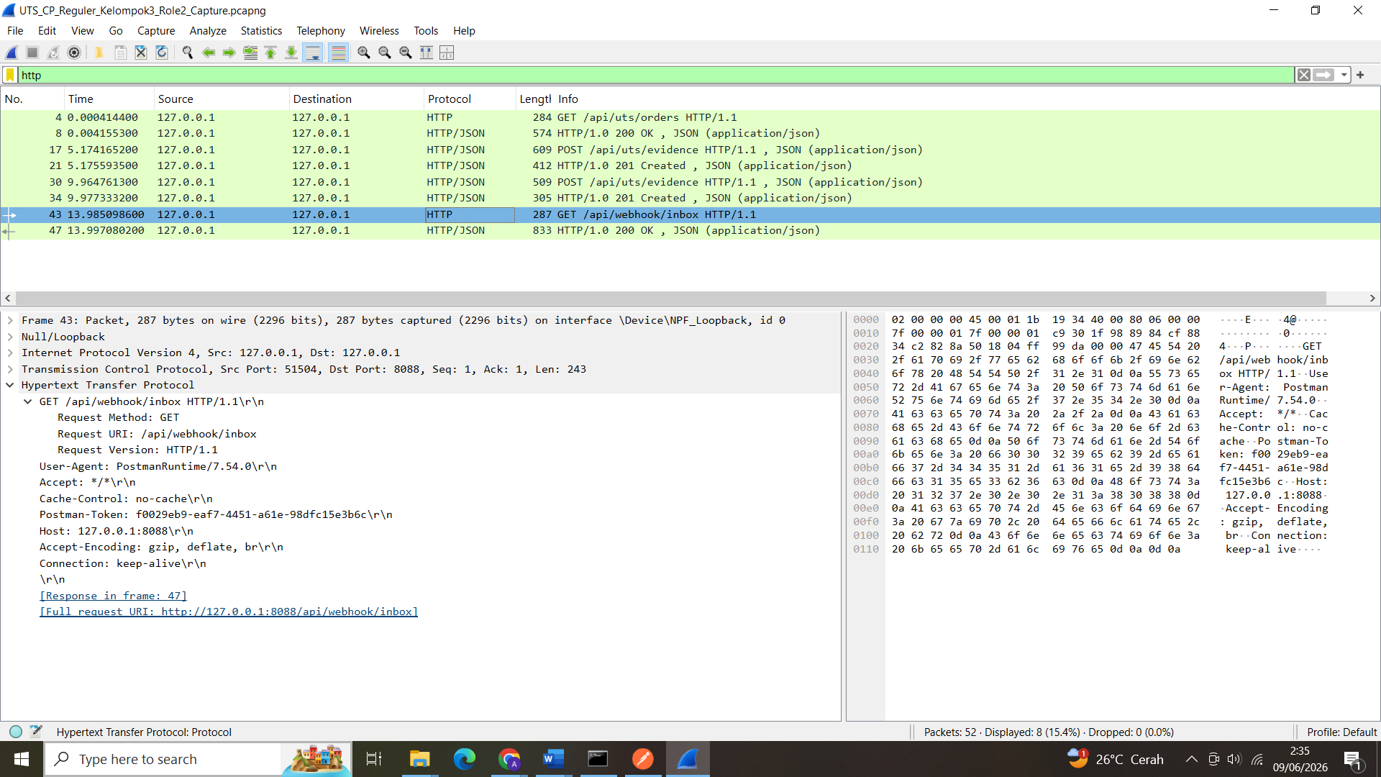
screenshot: Wireshark GET /api/webhook/inbox request
Request Method: GET
Request URI: /api/webhook/inbox
Request Version: HTTP/1.1
Host: 127.0.0.1:8088
User-Agent: PostmanRuntime
Full request URI: http://127.0.0.1:8088/api/webhook/inbox

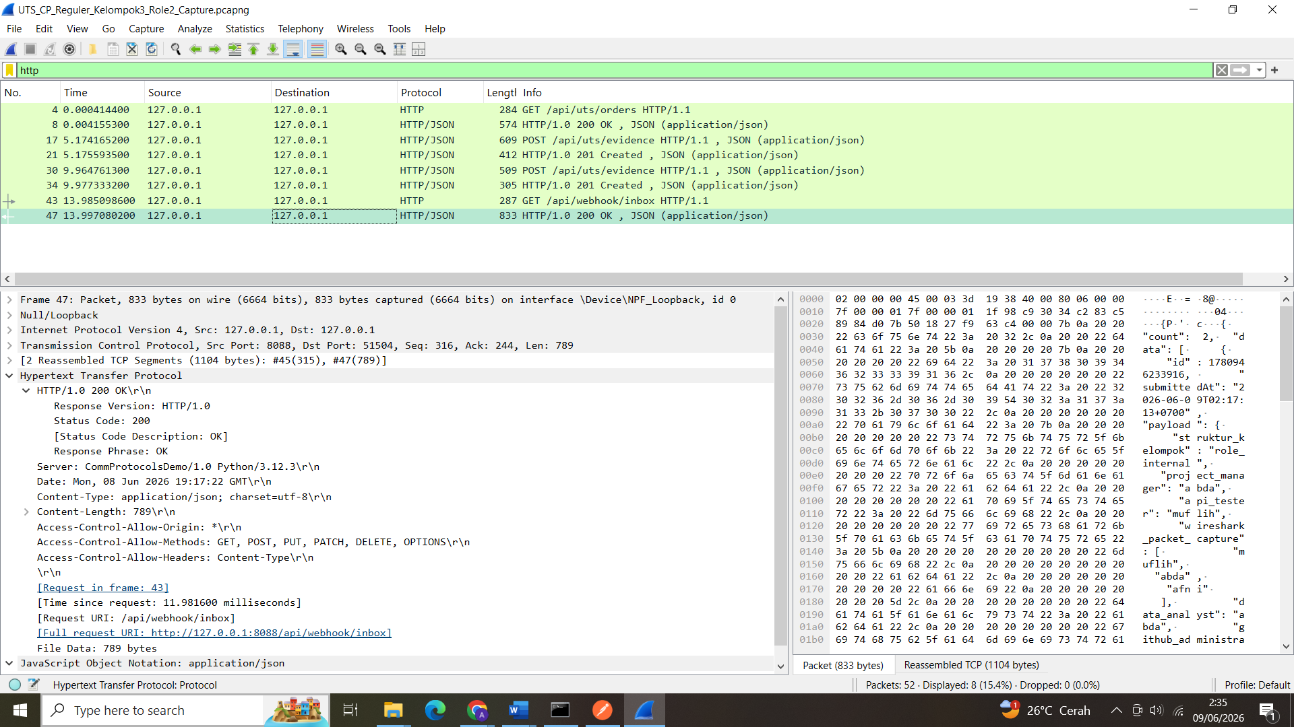
screenshot: Wireshark response 200 OK
Status Code: 200
Status Code Description: OK
Response Phrase: OK
Content-Type: application/json
Request URI: /api/webhook/inbox
Full request URI: http://127.0.0.1:8088/api/webhook/inbox

4.7 Troubleshooting Note
Selama pengujian, request utama berhasil diproses. Response POST menghasilkan 201 Created dan response GET menghasilkan 200 OK. Jika data pada /api/webhook/inbox muncul lebih dari satu, hal tersebut bukan error karena POST pernah dikirim beberapa kali saat pengujian atau packet capture. Setiap POST dianggap sebagai data baru oleh server.
Source dan destination pada Wireshark sama-sama 127.0.0.1 karena Postman dan server berjalan pada laptop yang sama. Port 8088 menunjukkan bahwa request diarahkan ke server Communication Protocols Demo App.

4.8 Kesimpulan Role 2
Packet capture menggunakan Wireshark berhasil membuktikan bahwa request dari Postman berjalan melalui protocol HTTP. Packet GET, POST, response 200 OK, dan response 201 Created berhasil tertangkap. Dengan demikian, evidence Role 2 menunjukkan bahwa komunikasi client-server berjalan dengan benar.
Evidence Role 2:
- File capture .pcapng
- Screenshot packet GET request
- Screenshot packet response 200 OK
- Screenshot packet POST request
- Screenshot packet response 201 Created
- Troubleshooting note

