CASE STUDY PROBLEM STATEMENT

Group No.: Group 10

Student Names: Chenxuan He and Zejin Kong

I. Background Information
People can guess where you come from based on the person's appearance or way of speaking, but how do we identify the breed of a cat. When you see a cat on the road or a photo of a cat on social media, you may want to know what kind of cat it is. In this way, if we can know its breed through just a photo, it will be very pleasing to those who are crazy for cats.

II. Data Collection

Our dataset is form https://archive.org/details/CAT_DATASET, this dataset includes over 10,000 cat images. There are annotations of the head of cat with nine points, two for eyes, one for mouth, and six for ears. Each of the image is annotated as below figure shown :
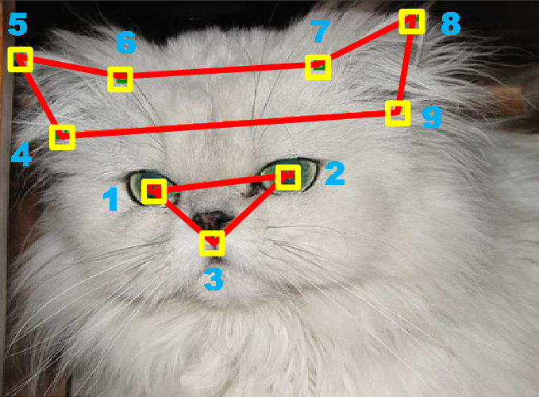

III. The problem
Our goal is to classify the cat breed using supervised machine learning. We would transform the image data to annotation data could be processed.

IV. Possible solution
We randomly divide the data into three sets: 6,000 images for training, 2,000 images for validation and 2000 images for testing. We could use PCA to catch the main annotations of cats.

