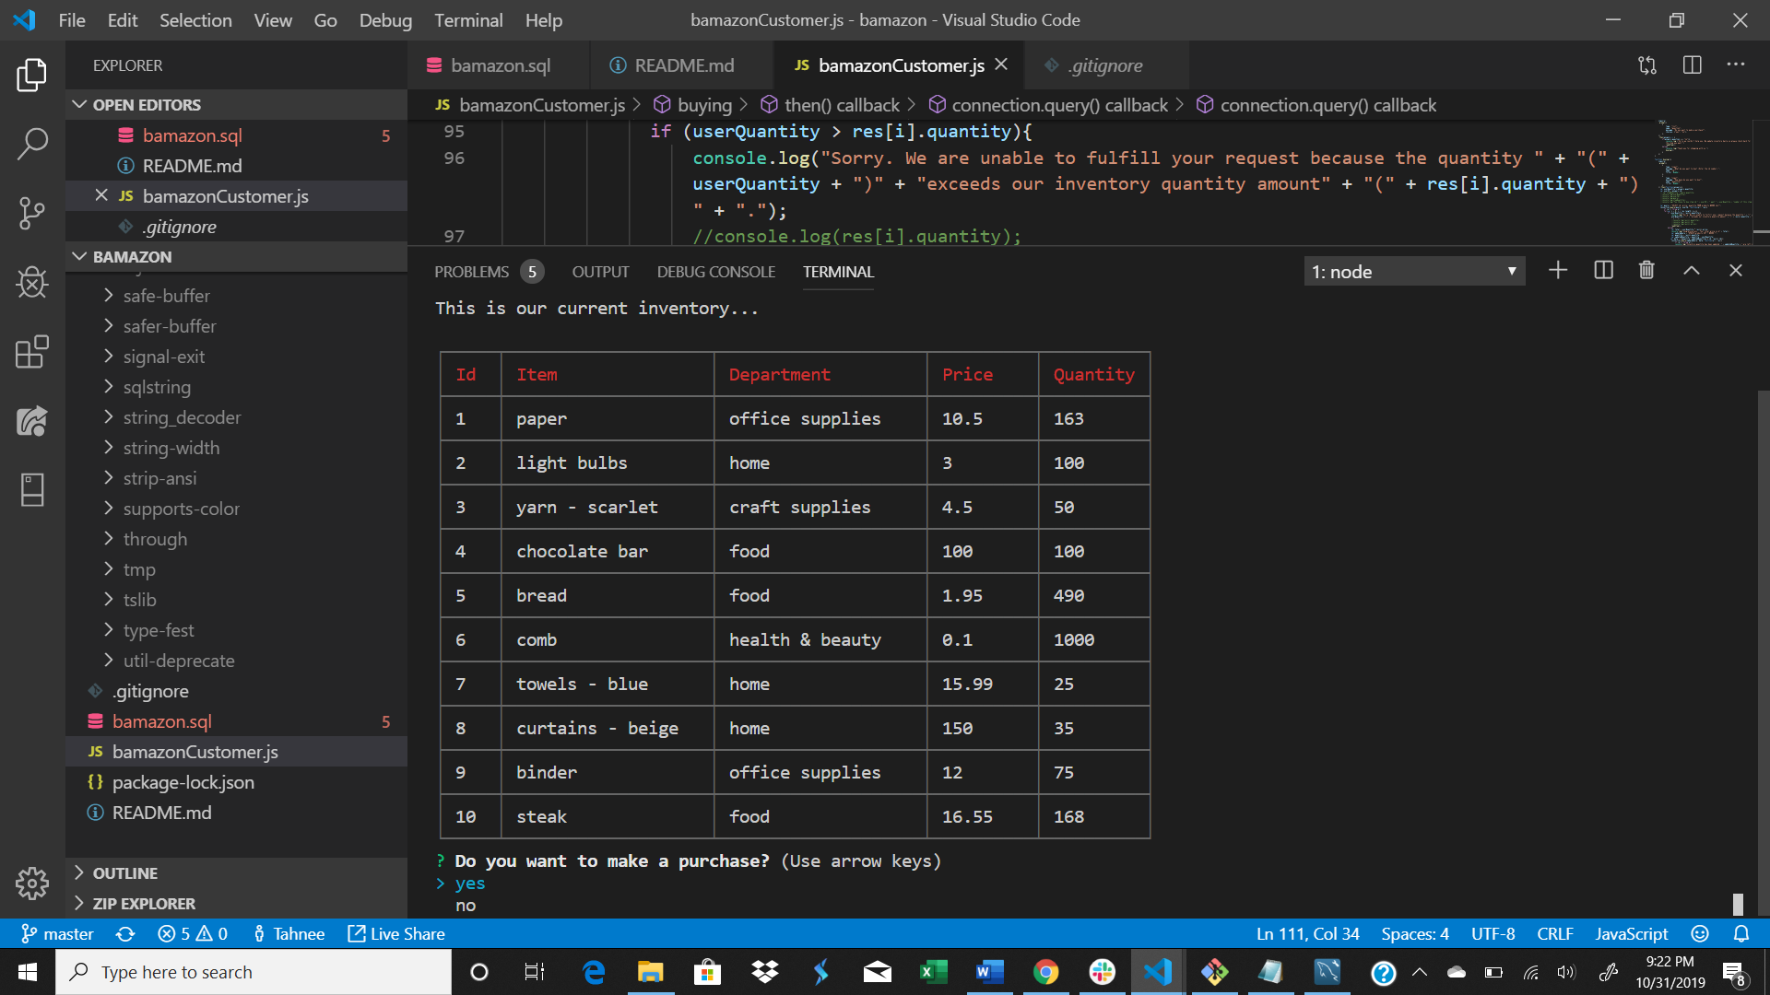

Enter “Yes”

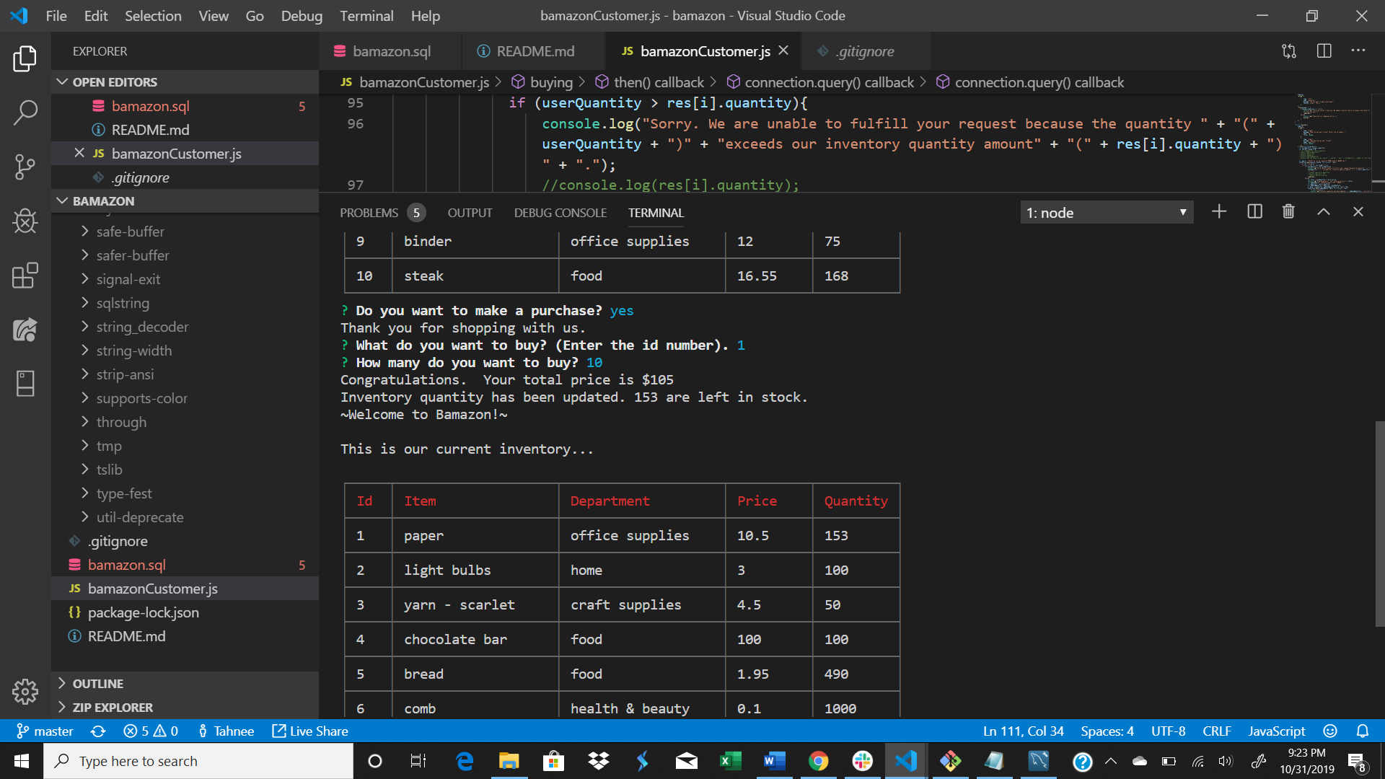

Enter id #

Enter quantity

Total price is displayed and the database is updated.

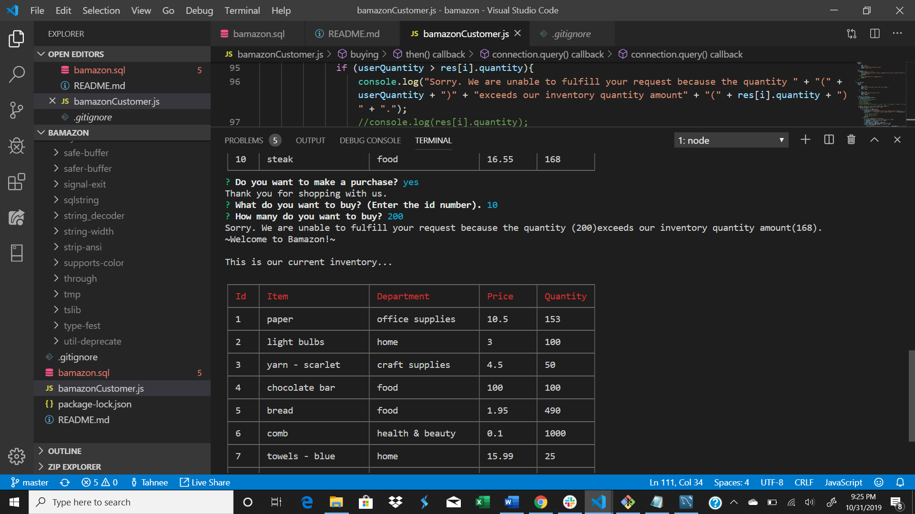

Enter “yes”.

Enter id number.

Enter quantity amount.

Requested quantity is greater than quantity in inventory. Complete inventory is re-displayed.

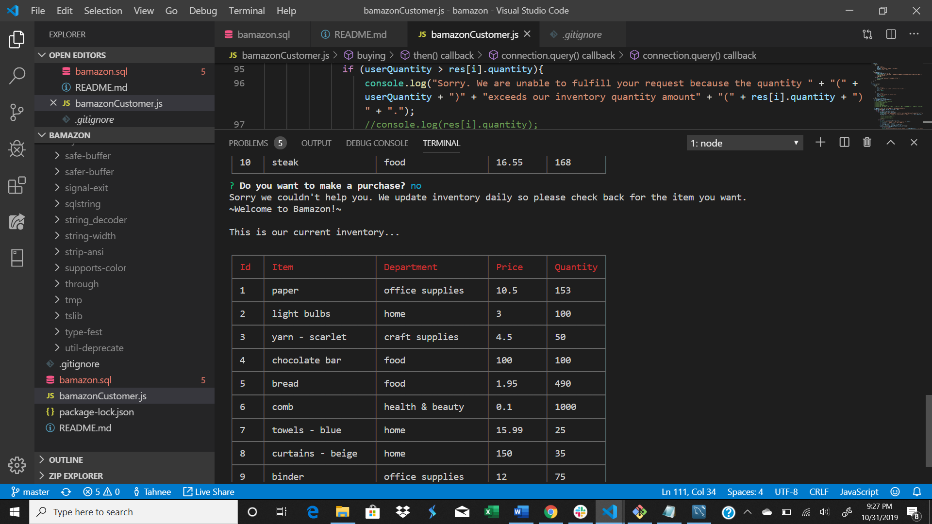

Enter “no”.

Inventory re-displays.