* Change the below property in JMETER.PROPERTIES file
  + jmeter.save.saveservice.assertion_results=all

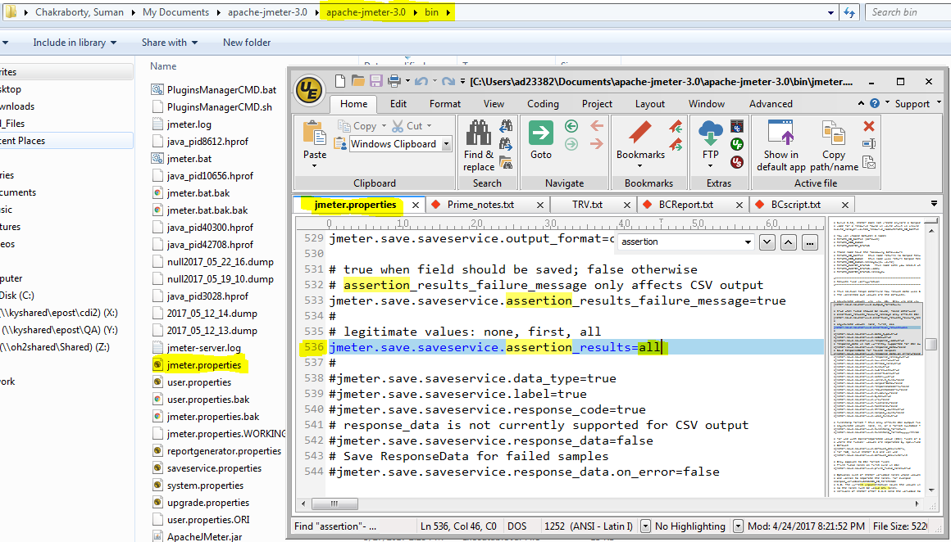

* Click View Results Tree in your Test Suite JMX and select ALL check-boxes and then click Done

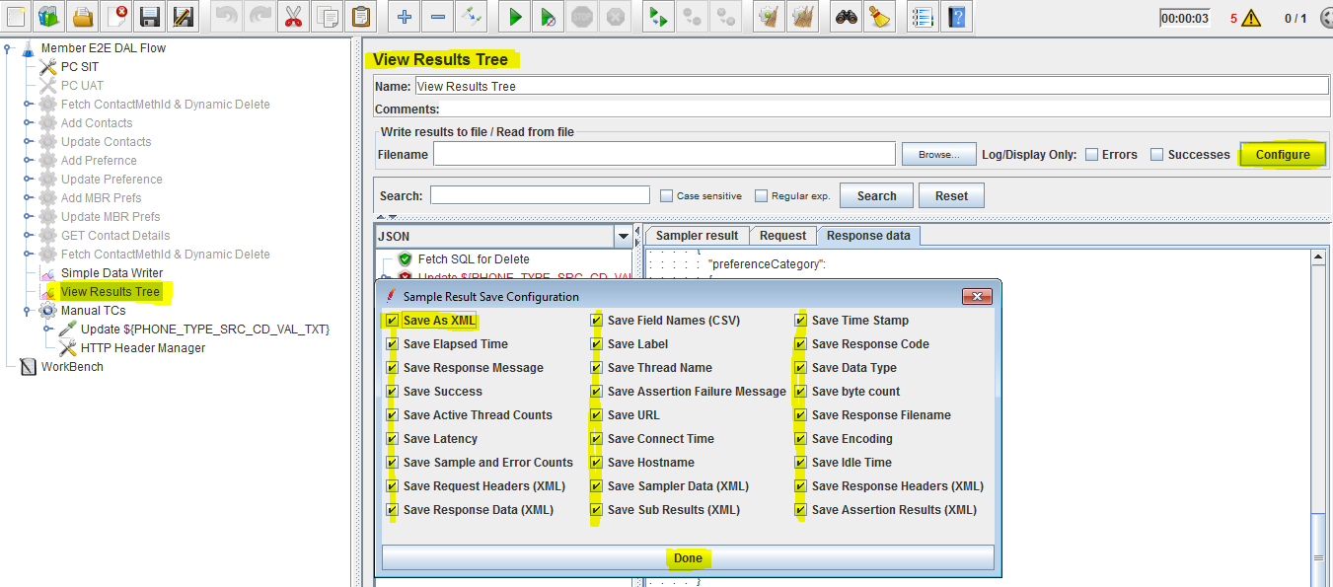

* Place Reporting related files in config\report_files under your automation BASE_DIR
  + 3 Logos
  + 2 XSLTs
  + SAXON.JAR (to be moved to <JMETER>\lib. Steps later)

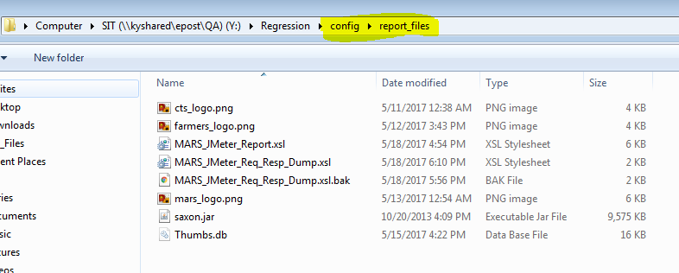

* Move or Copy saxon.jar to JMeter\lib directory: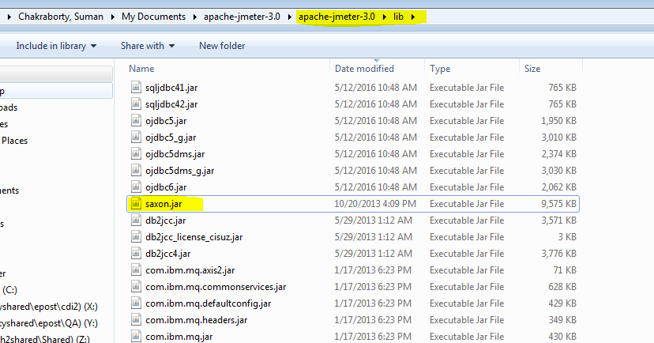
* Edit the MARS_JMeter_Report.xsl:
  + Change the client logo with correct absolute path of the image.  
    Do not forget to change the **Client_Logo** **image** itself  
    (we already placed under config\report_files)
  + Just change the absolute path of CTS logo
  + Just change the absolute path of MARS logo

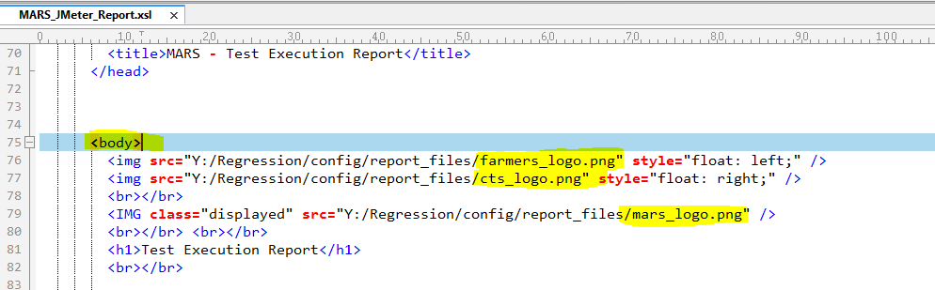

* Open the Report_Generator.JMX in JMeter
* Change the paths of the 6 User Defined variables:
  + v_xml = Path of JMeter xml log generated by actual JMX suite
  + v_report_xslt = XSLT to generate HTML report
  + v_dump_xslt = XSLT to generate request & response dump files for ALM/JIRA upload
  + v_html = Target HTML Report
  + v_dump_file = An empty Dump file path which’ll be generated by Dump generator XSLT
  + base_dir = Base Directory for the Dump Generator sampler to place files

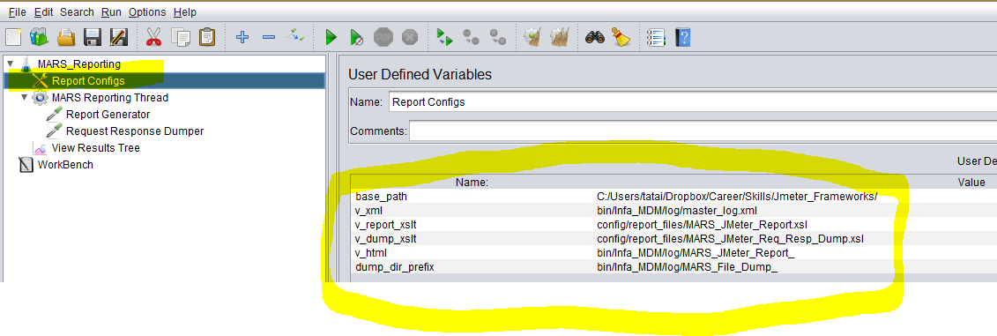

Setup Complete, you should get results like below after Report Generator JMX execution

* HTML Report in Chrome:

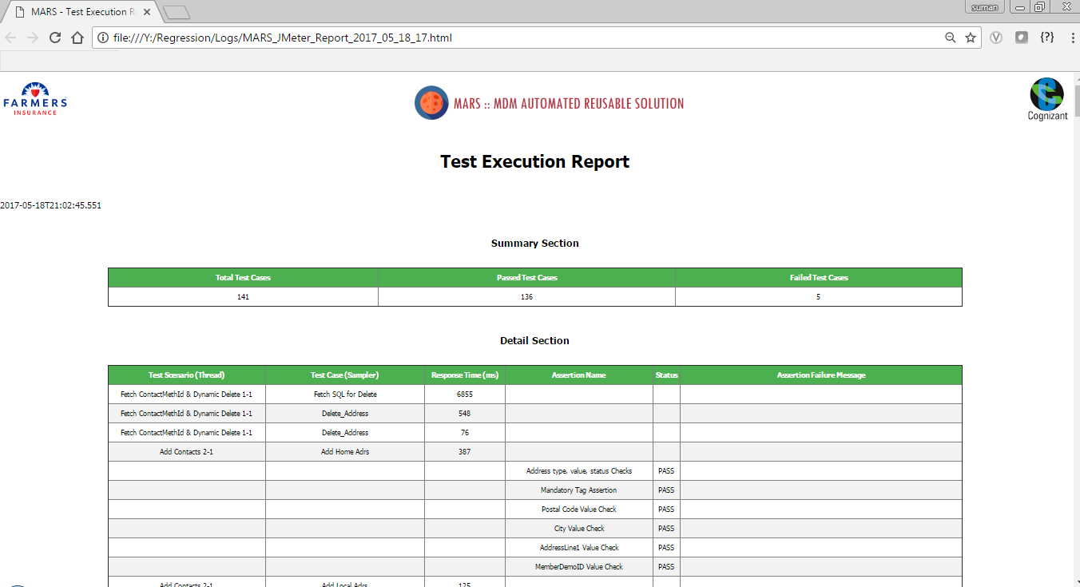

* Request & Response Dumps in BASE_DIR path:

