

Report on the Project

TimeWise24

Nuren Nafisa   
Lecturer ,dept of CSE

IIUC

Submitted to

Created by

NUSRAT JAHAN (C233464)

TAHASINA TASNIM AFRA(C233456)

TANISHA CHOWDHURY(C233462)

• To create a versatile and user-friendly time management system that caters to different user roles (Student, Employee, Entrepreneur, Athlete, Homemaker, Retiree, Miscellaneous).

• To provide an efficient way to manage schedules, set reminders, and record health conditions.

• To improve productivity and well-being by offering tailored functionalities for each user role.

• To transition from traditional planning methods to a digitalized, automated system.

• To minimize the risk of losing important schedules and health records.

• To make it easier to monitor and follow daily routines and reminders.

• To provide tools for goal setting and tracking progress over time.

• To enable users to balance their personal and professional lives effectively.

Project objective

Application

Application

Anyone can use it to utilize their timetable

Welcome page

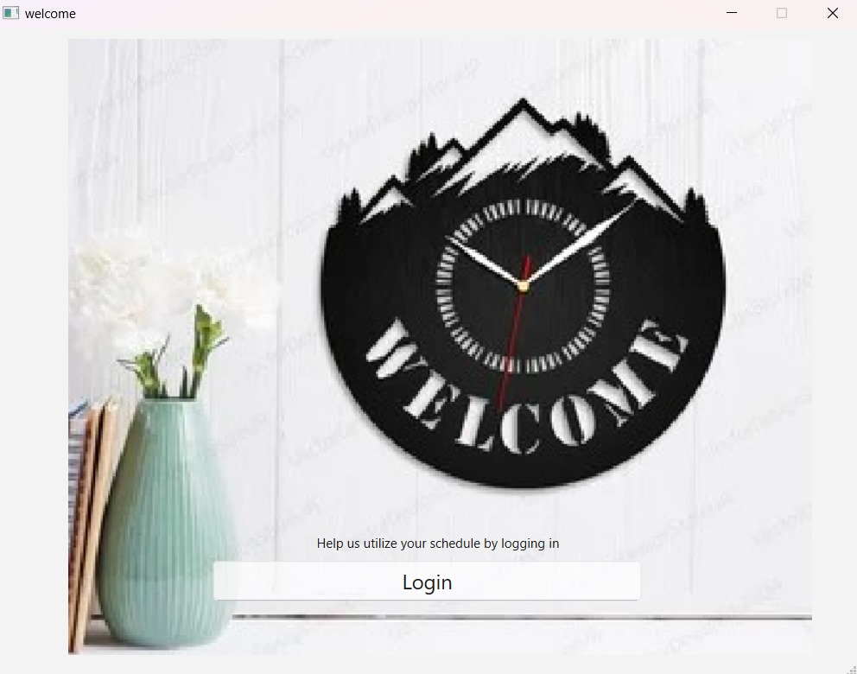

A user can utilize their schedule by login

Login page

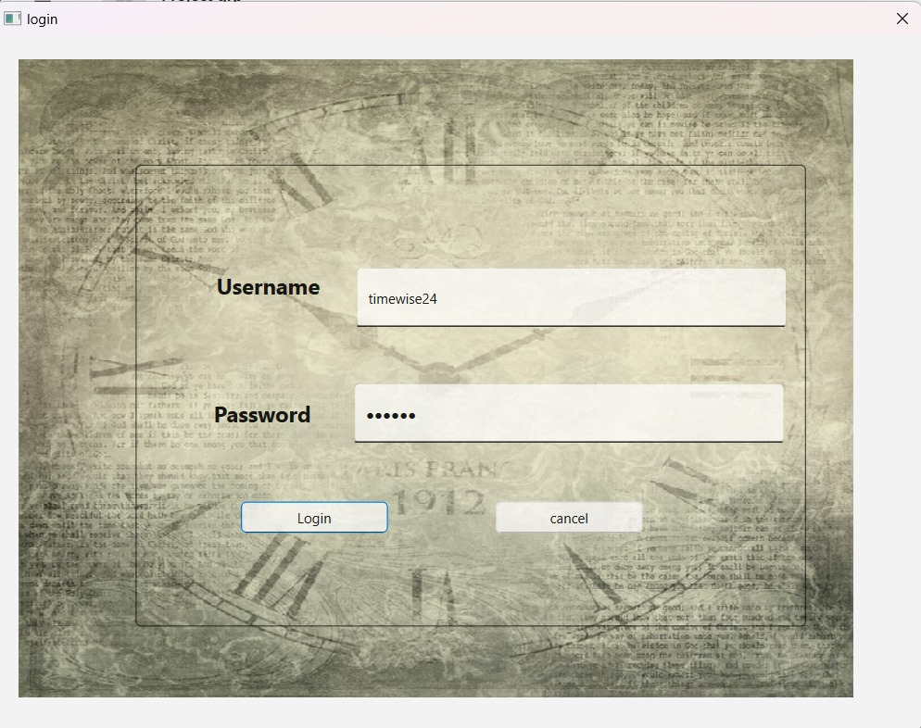

User can login By username and password

User role panel

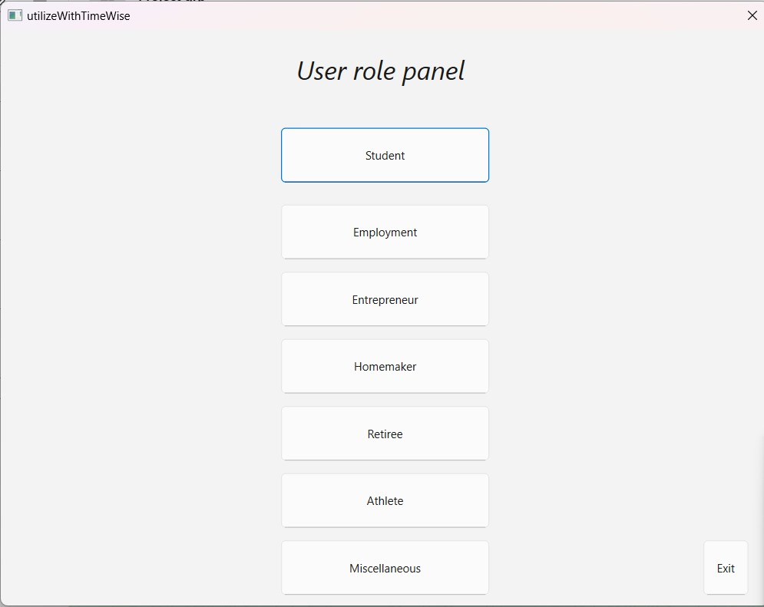

User can choose their role here ….

Activity panel

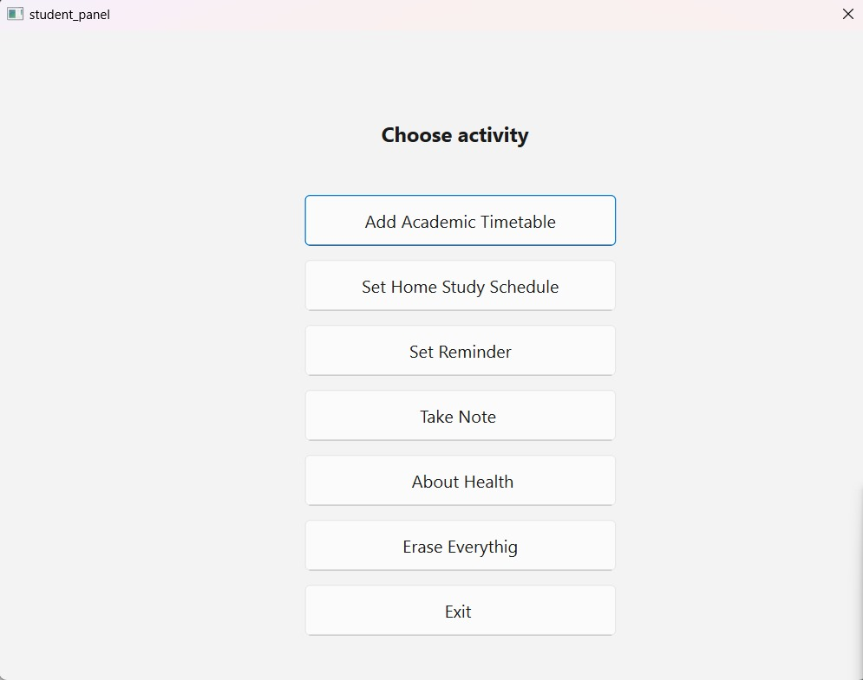

After selecting role as a student they choose their activity here

Academic timetable

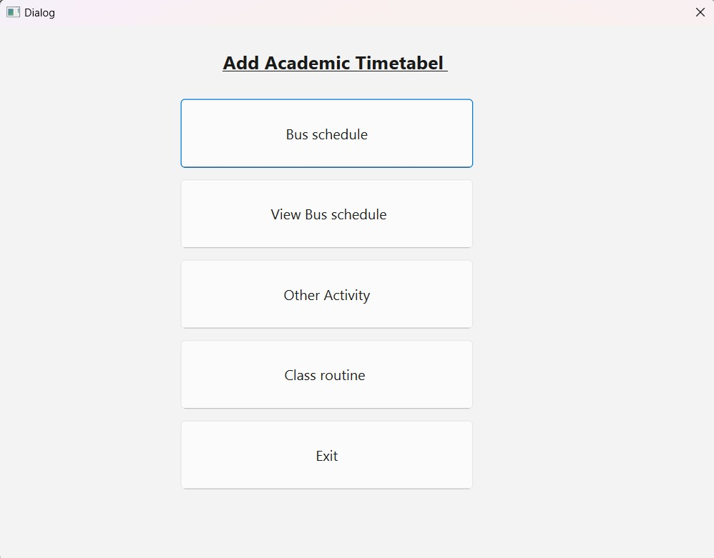

User can choose their Academic timetable here

Bus Schedule

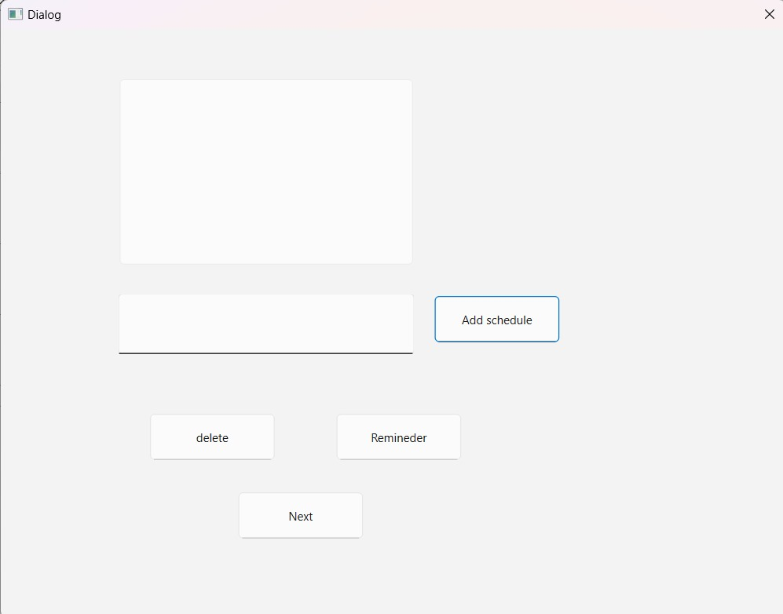

After selecting their Activity As Bus schedule they can add,delete ,and set a remineder for it

Our Qt base project End here…..

Console base project

Welcome page

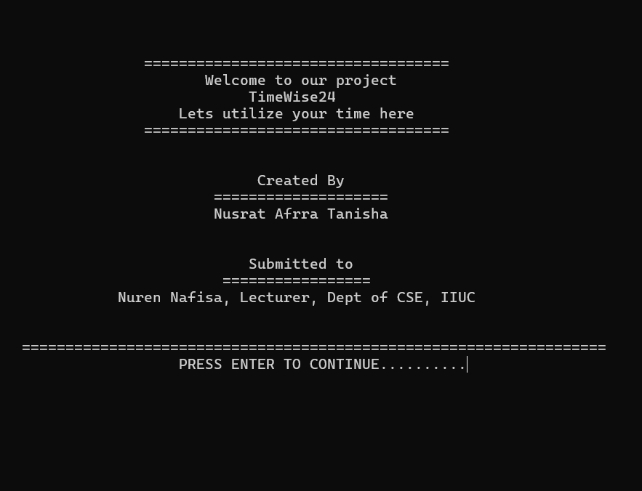

Login page

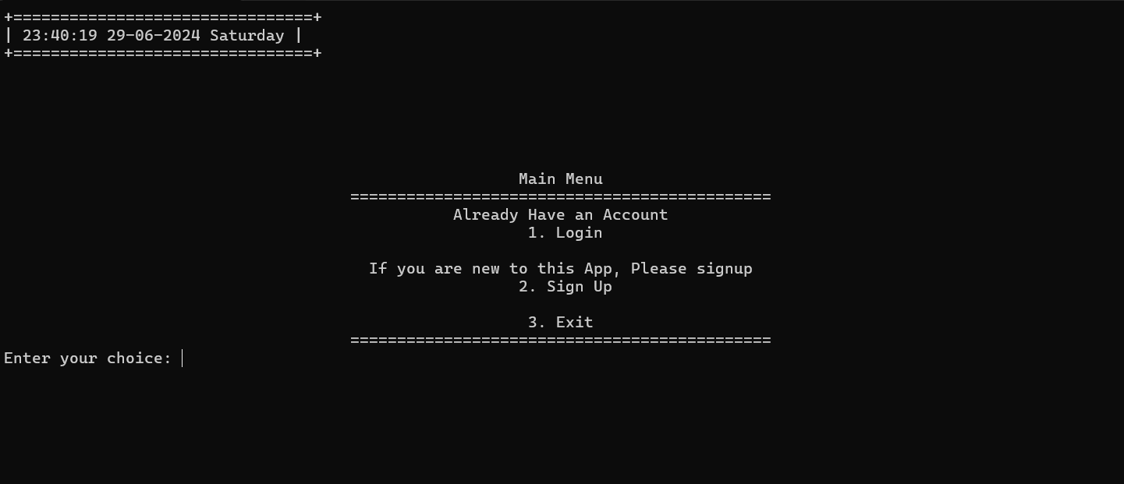

If user wants to login they need to sign up first

Login page

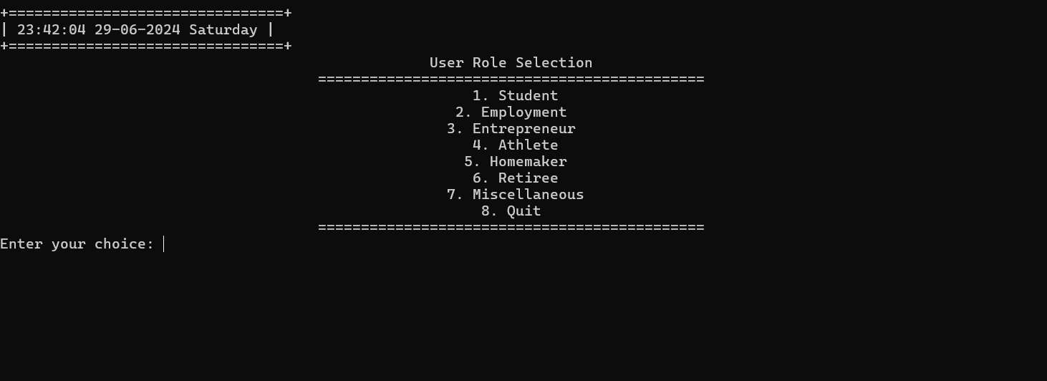

Here user can chose their role

Student panel

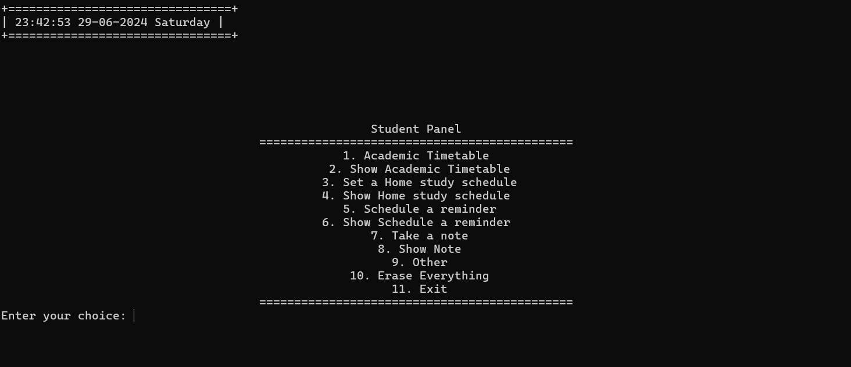

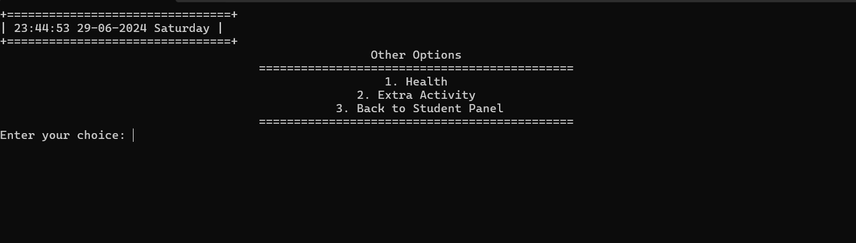

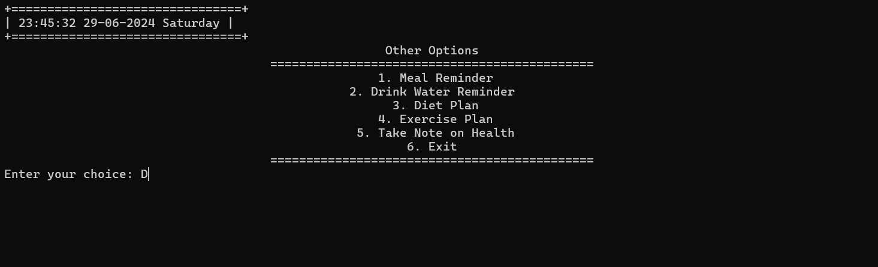

If user choose Health

Note :Rest of everything has its funtionality

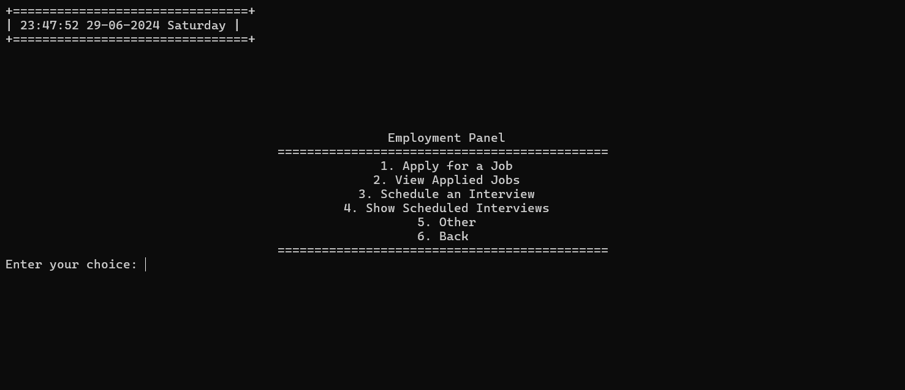

Employment panel

Entrepreneur Menu

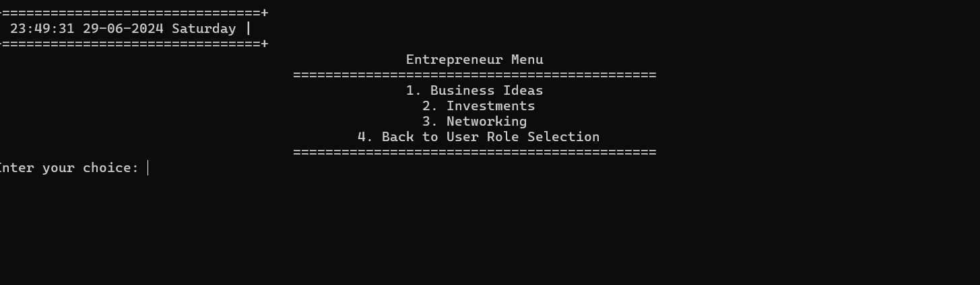

Athlete Menu

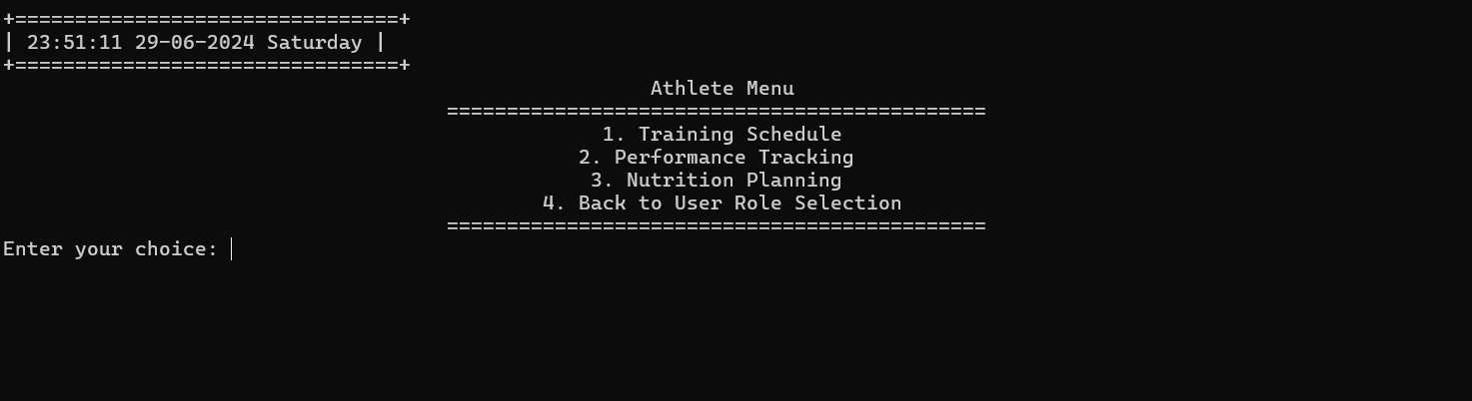

Home maker

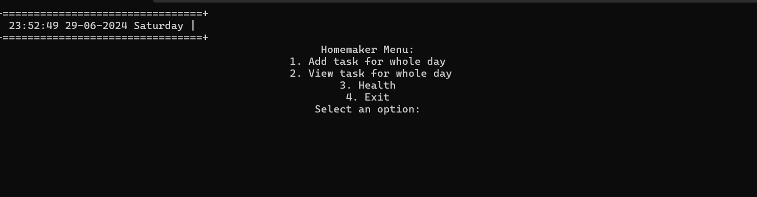

Retiree menu

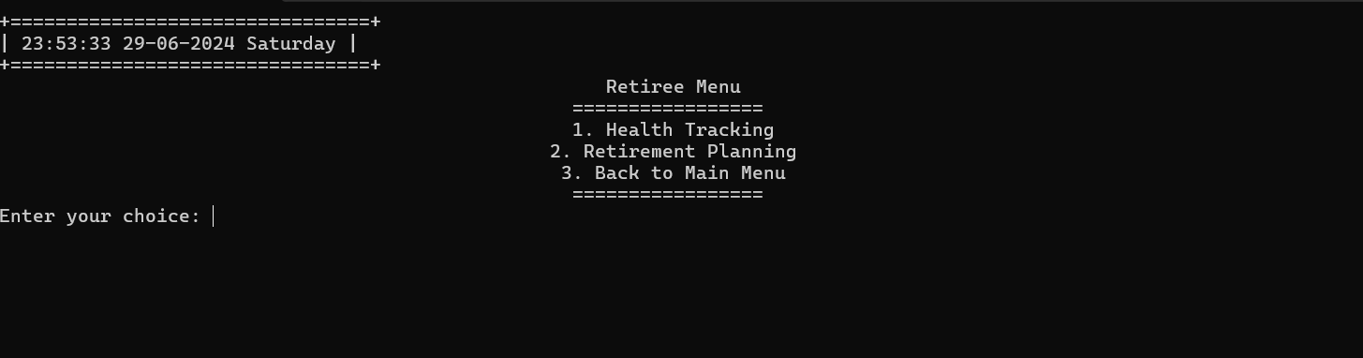

Miscellaneous

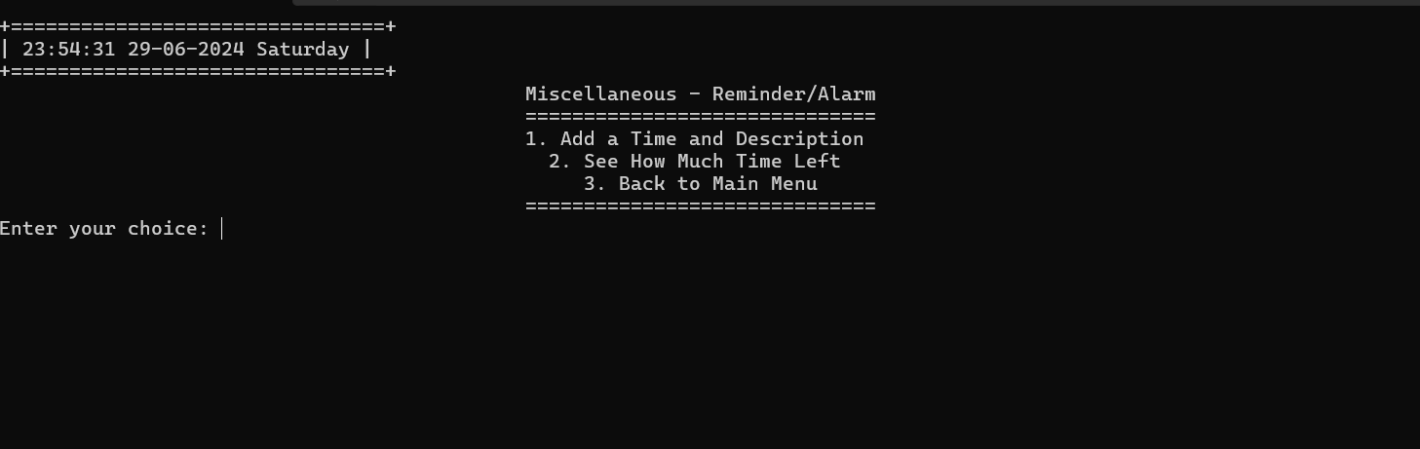

Note : Every Funtion has its funtinality

***Our console base project end here…..***

***Thank you ..***

o