Project 1
1-Tic Tac Toe
2-Find the ball
CIS-17A 42636
Name: Erik Nurja
Date: 4/16/2017

Introduction
Project 1:
This project will have two games so that the minimum requirements for the projects can be met. The menu system can be navigated by the user.
For the first game “Find the ball” it will show the player 5 identical cups and he will be asked to guess where the ball is. To pick a cup you must input a number from 1-5 to show in which cup you think the ball is.
The second game being Tic Tac Toe is a simple game that most people know. The user will be tasked with the challenge of beating a computer and to do so he has to get a full row of his own X.
Summary
Project size: about 400 lines The number of variables: about 21 variables The number of method: 13 functions.
The project includes all the concepts required for the project which we learned from the book and from the power point. It took getting use to using the structures with arrays inside of it. The most difficult part of coding this project is the de-allocation of memory from different types of arrays, such as array of structures and pointers in structures. I believe I have done the de- allocating correctly but I can’t seem to find any way of checking if any memory is leaking.
Building the game was not that difficult and the game was perfect for using a set of arrays in different types of ways.
Description
The creation of the game was to implement the concepts learned in class. The game utilizes structures with arrays to be used as a storage area to leave information and take information to functions to help process in an organized way.

Input / Output
The entire program is navigated from a menu type system
For example to pick the game such as Tic Tac Toe from the figure above you would simply press the number 2 to head into that game from the menu.
The second game “Tic Tac Toe” is a popular game which is also used in a similar set of inputs. The game starts with the computer choosing first and asks you to enter a choice between 1 and 9.
The number is coordinated such that [1][2][3] [4][5][6] [7][8][9]. These choices are lined up in this order. Simply play the game of Tic Tac Toe in which getting 3 “X’s” in a row will award you with a win.

PseudoCode
Initialize
Do While loop until game =0 Display Menu If input equals 1 then go to first game Do while unti game is finished Create the cups Display the cups Put a ball into one of the cups randomly Asks to choose a cup to find the ball Input the answer Win or Lose Ask to play again Input If input equals 2 then go to second game
Do while game is over Create a tic tac toe display Randomly choose one of the arrays for computer Ask user to input in a box Input Win or Lose Ask if want to play again input If input equals 3 then go exit

Flowchart
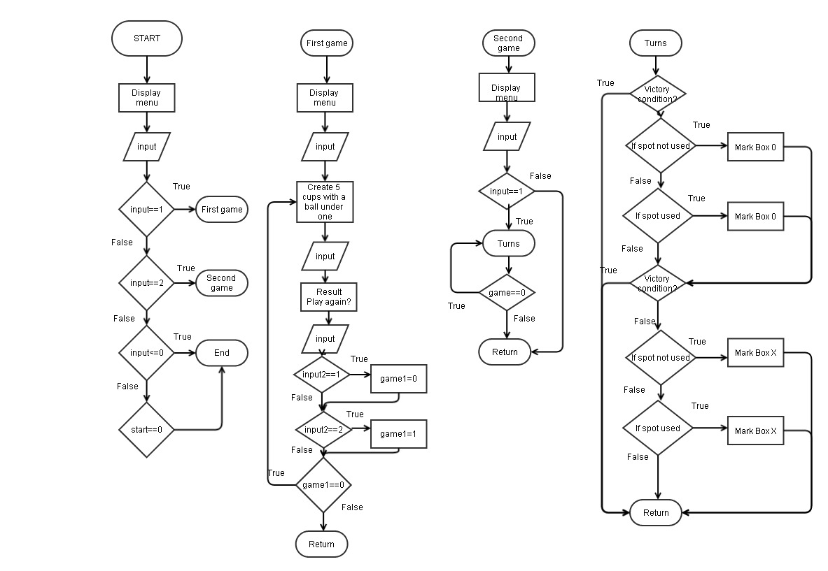
Major Variables
Type Variable Name Description Location integer input used as input main() integer start used as an off switch main() integer size used as a memory number game1() integer game1 off switch game1() integer input1 as input game1() integer input2 as input game1() integer count to count wins game1() integer cup array to fill fillAry() integer random random variable random() integer choose input used to choose a cup result() integer SIZE used to fill in array memory game2() integer input used to input game2() integer game leave game game2() integer check array to check if box filled game2() character point used to store in X or O game2() integer input2 used as input turns() integer a1 used as random variable turns() integer a2 used as random variable turns() integer count used to count how many are filled tie()
Concepts
Concept Variable Name Description Location Pointers with arrays check uses pointers in arrays within a structure game2() Arrays of structures point used to fill in X or O game2() Pointers with arrays * used all arrays as pointers fillAry() game2() Memory allocation SIZE used to dynamically allocate SIZE In every array
Reference
1. Textbook 2. Power point 3. Past classwork code

Program
/*
* File: main.cpp * Author: Erik Nurja * Created on April 13, 2017, 12 PM * CSC-17A - Project 1 */
/System Libraries
#include <iostream>
#include <cstdlib>
#include <ctime>
using namespace std;

//User defined libraries
#include "Array.h"

//No Global Constants

//Structures
//Game 2
struct checkga{
int *box;
};
//Function Prototypes
//Game 1
void game1(int &);
void fillAry(Array *,int);
void prntAry(Array *);
void dstry(Array *);
void effecta();
void effectb(Array *);
void random(Array *);
void result(Array *,int &);
//Game 2
void game2(int &);
void display(Array2 *);
void turns(checkga &,Array2 *,int &);
void win(Array2 *,int &);
void tie(Array2 *,int &);
//Execution Begins Here
int main(int argc, char** argv) {
//Declare variables
int input,start=0;
//Continue the loop until player exits
do{
//Menu
cout<<"Pick a game from the list below."<<endl;
cout<<"1. Find the ball from 5 cups"<<endl;
cout<<"2. Tic Tac Toe"<<endl;
cout<<"Press any other key to end program."<<endl;
cout<<endl;
cin>>input;
if(input==1)game1(start);
if(input==2)game2(start);
if(input<=0||input>2)start=1;
}while(start==0);
return 0;
}

void tie(Array2 *a,int &game){
int count =0;
for(int i=0;i<9;i++){
if(a[i].store==88||a[i].store==79){
count++;
}
}
if(count==9)game=1;
cout<<"Tied"<<endl;
}

void win(Array2 *a,int &game){
//Person
//Straight Line Horizontal
if(a[0].store==88&&a[1].store==88&&a[2].store==88){
cout<<"You Win"<<endl;
game=1;
}
if(a[3].store==88&&a[4].store==88&&a[5].store==88){
cout<<"You Win"<<endl;
game=1;
}
if(a[6].store==88&&a[7].store==88&&a[8].store==88){
cout<<"You Win"<<endl;
game=1;
}
//Straight Line Vertical
if(a[0].store==88&&a[3].store==88&&a[6].store==88){
cout<<"You Win"<<endl;
game=1;
}
if(a[1].store==88&&a[4].store==88&&a[7].store==88){
cout<<"You Win"<<endl;
game=1;
}
if(a[2].store==88&&a[5].store==88&&a[8].store==88){
cout<<"You Win"<<endl;
game=1;
}
//Cross
if(a[0].store==88&&a[4].store==88&&a[8].store==88){
cout<<"You Win"<<endl;
game=1;
}
if(a[2].store==88&&a[4].store==88&&a[6].store==88){
cout<<"You Win"<<endl;
game=1;
}
//Computer
//Straight Line Horizontal
if(a[0].store==79&&a[1].store==79&&a[2].store==79){
cout<<"You Lose"<<endl;
game=1;
}
if(a[3].store==79&&a[4].store==79&&a[5].store==79){
cout<<"You Lose"<<endl;
game=1;
}
if(a[6].store==79&&a[7].store==79&&a[8].store==79){
cout<<"You Lose"<<endl;
game=1;
}
//Straight Line Vertical
if(a[0].store==79&&a[3].store==79&&a[6].store==79){
cout<<"You Lose"<<endl;
game=1;
}
if(a[1].store==79&&a[4].store==79&&a[7].store==79){
cout<<"You Lose"<<endl;
game=1;
}
if(a[2].store==79&&a[5].store==79&&a[8].store==79){
cout<<"You Lose"<<endl;
game=1;
}
//Cross
if(a[0].store==79&&a[4].store==79&&a[8].store==79){
cout<<"You Lose"<<endl;
game=1;
}
if(a[2].store==79&&a[4].store==79&&a[6].store==79){
cout<<"You Lose"<<endl;
game=1;
}
}

void display(Array2 *a){
cout<<"~~~~~~~~~~~~"<<endl;
cout<<"["<<a[0].store<<" ]["<<a[1].store<<" ]["<<a[2].store<<" ]"<<endl;
cout<<"["<<a[3].store<<" ]["<<a[4].store<<" ]["<<a[5].store<<" ]"<<endl;
cout<<"["<<a[6].store<<" ]["<<a[7].store<<" ]["<<a[8].store<<" ]"<<endl;
cout<<"~~~~~~~~~~~~"<<endl;
}

void turns(checkga &chec,Array2 *b,int &game){
//Declare variables
int input2,a1,a2;
if(game==0){
//Computer
cout<<"Computer's Turn"<<endl;
a1=rand()%9+1;
if(chec.box[a1-1]==0){
b[a1-1].store=79;
chec.box[a1-1]=1;
}
else if(chec.box[a1-1]==1){
do{
a2=rand()%9+1;
}while(chec.box[a2-1]==1);
b[a2-1].store=79;
chec.box[a2-1]=1;
}
win(b,game);
tie(b,game);
}
display(b);
if(game==0){
//Person
cout<<"Person's Turn"<<endl;
cout<<"Enter Choice 1~9"<<endl;
cin>>input2;
if(chec.box[input2-1]==0){
b[input2-1].store=88;
chec.box[input2-1]=1;
}
else if(chec.box[input2-1]==1){
do{
cout<<" Re-Enter Choice 1~9"<<endl;
cin>>input2;
}while(chec.box[input2-1]==1);
b[input2-1].store=88;
chec.box[input2-1]=1;
}
win(b,game);
tie(b,game);
}
}

void game2(int &start){
//Set timer seed
srand(static_cast<unsigned int>(time(0)));
//Declare variables
const int SIZE=9;
int input,game=0;
//Check if box is filled
checkga check;
check.box=new int [SIZE];
//Array of structures to use to fill X or O
Array2 *point=new Array2[SIZE];
for(int i=0;i<SIZE;i++){
check.box[i]=0;
}
for(int i=0;i<SIZE;i++){
point[i].store=0;
}
cout<<"~~~~~~~~~~~~"<<endl;
cout<<"Tic Tac Toe"<<endl;
cout<<"~~~~~~~~~~~~"<<endl;
cout<<"1. Start Game."<<endl;
cout<<"2. Exit."<<endl;
cin>>input;
if(input==1){
cout<<"Computer goes first"<<endl;
do{
turns(check,point,game);
}while(game==0);
};
//Un-allocated
delete []point;
delete []check.box;

}

void result(Array *a,int &count){
//Declare variable
int choose;
cout<<"Which cup has the ball?"<<endl;
cout<<"Input the number between 1 to 5"<<endl;
cout<<"1. First Cup"<<endl;
cout<<"2. Second Cup"<<endl;
cout<<"3. Third Cup"<<endl;
cout<<"4. Forth Cup"<<endl;
cout<<"5. Fifth Cup"<<endl;
cin>>choose;

cout<<"Your choice was "<<choose<<endl;
if(choose==1){
if(a->cup[0]==1){
cout<<"You were right!"<<endl;
count++;
}
else{
cout<<"Wrong!"<<endl;
}
}
if(choose==2){
if(a->cup[1]==1){
cout<<"You were right!"<<endl;
count++;
}
else{
cout<<"Wrong!"<<endl;
}
}
if(choose==3){
if(a->cup[2]==1){
cout<<"You were right!"<<endl;
count++;
}
else{
cout<<"Wrong!"<<endl;
}
}
if(choose==4){
if(a->cup[3]==1){
cout<<"You were right!"<<endl;
count++;
}
else{
cout<<"Wrong!"<<endl;
}
}
if(choose==5){
if(a->cup[4]==1){
cout<<"You were right!"<<endl;
count++;
}
else{
cout<<"Wrong!"<<endl;
}
}
}

void random(Array *a){
//Set timer seed
srand(static_cast<unsigned int>(time(0)));
//Declare variables
int random;
random=rand()%5+1;
if(random==1)a->cup[0]=1;
if(random==2)a->cup[1]=1;
if(random==3)a->cup[2]=1;
if(random==4)a->cup[3]=1;
if(random==5)a->cup[4]=1;
}

void effectb(Array *a){
if(a->cup[0]==1){
cout<<" .-~~-."<<" .-~~-."<<" .-~~-."<<" .-~~-."<<" .-~~-."<<endl;
cout<<",|`-__-'|"<<" ,|`-__-'|"<<" ,|`-__-'|"<<" ,|`-__-'|"<<" ,|`-__-'|"<<endl;
cout<<"|| BALL |"<<" || ? |"<<" || ? |"<<" || ? |"<<" || ? |"<<endl;;
cout<<"`| |"<<" `| |"<<" `| |"<<" `| |"<<" `| |"<<endl;
cout<<" `-__-'"<<" `-__-'"<<" `-__-'"<<" `-__-'"<<" `-__-'"<<endl;
}
if(a->cup[1]==1){
cout<<" .-~~-."<<" .-~~-."<<" .-~~-."<<" .-~~-."<<" .-~~-."<<endl;
cout<<",|`-__-'|"<<" ,|`-__-'|"<<" ,|`-__-'|"<<" ,|`-__-'|"<<" ,|`-__-'|"<<endl;
cout<<"|| ? |"<<" || BALL |"<<" || ? |"<<" || ? |"<<" || ? |"<<endl;;
cout<<"`| |"<<" `| |"<<" `| |"<<" `| |"<<" `| |"<<endl;
cout<<" `-__-'"<<" `-__-'"<<" `-__-'"<<" `-__-'"<<" `-__-'"<<endl;
}
if(a->cup[2]==1){
cout<<" .-~~-."<<" .-~~-."<<" .-~~-."<<" .-~~-."<<" .-~~-."<<endl;
cout<<",|`-__-'|"<<" ,|`-__-'|"<<" ,|`-__-'|"<<" ,|`-__-'|"<<" ,|`-__-'|"<<endl;
cout<<"|| ? |"<<" || ? |"<<" || BALL |"<<" || ? |"<<" || ? |"<<endl;;
cout<<"`| |"<<" `| |"<<" `| |"<<" `| |"<<" `| |"<<endl;
cout<<" `-__-'"<<" `-__-'"<<" `-__-'"<<" `-__-'"<<" `-__-'"<<endl;
}
if(a->cup[3]==1){
cout<<" .-~~-."<<" .-~~-."<<" .-~~-."<<" .-~~-."<<" .-~~-."<<endl;
cout<<",|`-__-'|"<<" ,|`-__-'|"<<" ,|`-__-'|"<<" ,|`-__-'|"<<" ,|`-__-'|"<<endl;
cout<<"|| ? |"<<" || ? |"<<" || ? |"<<" || BALL |"<<" || ? |"<<endl;;
cout<<"`| |"<<" `| |"<<" `| |"<<" `| |"<<" `| |"<<endl;
cout<<" `-__-'"<<" `-__-'"<<" `-__-'"<<" `-__-'"<<" `-__-'"<<endl;
}
if(a->cup[4]==1){
cout<<" .-~~-."<<" .-~~-."<<" .-~~-."<<" .-~~-."<<" .-~~-."<<endl;
cout<<",|`-__-'|"<<" ,|`-__-'|"<<" ,|`-__-'|"<<" ,|`-__-'|"<<" ,|`-__-'|"<<endl;
cout<<"|| ? |"<<" || ? |"<<" || ? |"<<" || ? |"<<" || BALL |"<<endl;;
cout<<"`| |"<<" `| |"<<" `| |"<<" `| |"<<" `| |"<<endl;
cout<<" `-__-'"<<" `-__-'"<<" `-__-'"<<" `-__-'"<<" `-__-'"<<endl;
}
}

void effecta(){
//Cup with effects
cout<<" .-~~-."<<" .-~~-."<<" .-~~-."<<" .-~~-."<<" .-~~-."<<endl;
cout<<",|`-__-'|"<<" ,|`-__-'|"<<" ,|`-__-'|"<<" ,|`-__-'|"<<" ,|`-__-'|"<<endl;
cout<<"|| ? |"<<" || ? |"<<" || ? |"<<" || ? |"<<" || ? |"<<endl;;
cout<<"`| |"<<" `| |"<<" `| |"<<" `| |"<<" `| |"<<endl;
cout<<" `-__-'"<<" `-__-'"<<" `-__-'"<<" `-__-'"<<" `-__-'"<<endl;
}

void dstry(Array *a){
delete []a->cup;
}

void prntAry(Array *a){
//Print the cup and its contents
for(int i=0;i<a->size;i++){
cout<<a->cup[i]<<" ";
}
cout<<endl;
}

void fillAry(Array *a,int n){
//Declare size in array structure
a->size=n;
//Allocate memory
a->cup=new int [a->size];
//Fill the array with 0's
for(int i=0;i<a->size;i++){
a->cup[i]=0;
}
}

void game1(int &start){
//Declare variables
int size=5,game1=0,input1,input2,count=0;
//Display Game 1 Menu
cout<<"~~~~~~~~~~~~~~~~~~~~~~~~~~~~~~~~~~~~"<<endl;
cout<<"Try to find which cup holds the ball"<<endl;
cout<<"~~~~~~~~~~~~~~~~~~~~~~~~~~~~~~~~~~~~"<<endl;
cout<<"1. Start Game."<<endl;
cout<<"2. Exit."<<endl;
cin>>input1;
if(input1==1){
do{
Array cup;
//Fill the cup
fillAry(&cup,size);
//Display the cups
effecta();
//Put a ball in one of the cups
random(&cup);
//prntAry(&cup);//To check
result(&cup,count);
effectb(&cup);
//De-allocate
dstry(&cup);
//Give options to keep playing
cout<<"~Current Record~"<<endl;
cout<<"You currently have "<<count<<" wins."<<endl;
cout<<endl;
cout<<"Do you want to try again?"<<endl;
cout<<"1. Yes."<<endl;
cout<<"2. Exit."<<endl;
cin>>input2;
if(input2==1)game1=0;
if(input2==2)game1=1;
}while(game1==0);
};
}

