6. PART STRUCTURE SEARCH

6.6 MSJFF25: UNIT INFORMATION INQ/UPD
SCREEN OBJECTIVE
- To set unit code used to identify unit in production.
- To automatically assign unit code by following unit assignment range.
- To calculate BOOK/YEAR from assembly part no of UNIT, and get the product country group information from total book year table.

HOW TO USE IN BUSINESS
- To set unit code used to identify unit in production.
- To automatically assign unit code by following unit assignment range.
- To calculate BOOK/YEAR from assembly part no of UNIT, and get the product country group information from total book year table.

HOW TO START
- Menu screen→ execute the [CV_MAIN] [PART STRUCTURE SEARCH]-[ UNIT INFORMATION INQ/UPD]

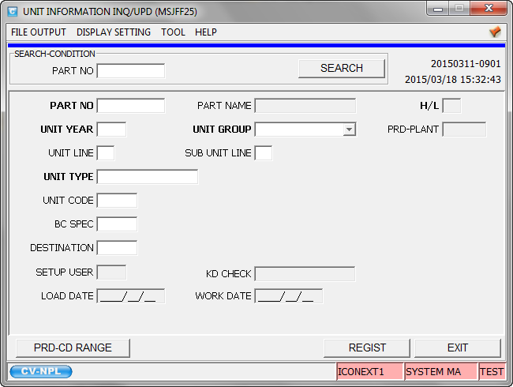
Figure UNIT INFORMATION INQ/UPD (MSJFF25)

SCREEN’S FUNCTION
- SEARCH Button
This function is used to inquiry or update unit information.
- User can filter scope of request in 1 search criteria as below
- PART NO
- PRD-CD RANGE Button
- Transit to Screen PRODUCT MODEL CODE RANGE ASSIGNMENT TABLE (MSJCF85)
- REGIST Button
- Save all change data to database.
- EXIT Button
- Terminate UNIT INFORMATION INQ/UPD screen.

SCREEN DETAIL

①
②
③
④
⑤

No. | Field | Type | Digit | Must be input | Description
 | PART NO | Char | 10 | X | To search unit information with specified part number.
 | SEARCH | Button | - | X | To search unit information with input condition.
 | PART NO | Char | 10 | √ | To display or update part number.
 | PART NAME | Char | 16 | - | To display part name.
 | H/L | Char | 1 | - | To display heavy or light code.

⑥
⑦
⑧
⑨
⑩

No. | Field | Type | Digit | Must be input | Description
 | UNIT YEAR | Char | 3 | √ | To display or update unit year.
 | UNIT GROUP | Combo Box | 1 | √ | To display or update unit group.
 | PRD PLANT | Char | 4 | - | To display production plant.
 | UNIT LINE | Char | 1 | X | To display or update unit line.
 | SUB UNIT LINE | Char | 1 | X | To display or update sub unit line.

⑪
⑫
⑬
⑭
⑮

No. | Field | Type | Digit | Must be input | Description
 | UNIT TYPE | Char | 16 | √ | To display or update unit type.
 | UNIT CODE | Char | 5 | X | To display or update unit code.
 | BC SPEC | Char | 5 | X | To display or update BC SPEC e.g. Function/Trailer used in manufacturing.
 | DESTINATION | Char | 5 | X | To display or update destination.
 | SETUP USER | Char | 3 | - | To display setup user.

⑯
⑰
⑱

No. | Field | Type | Digit | Must be input | Description
 | KD CHECK | Char | 16 | - | To display kd check e.g.  G:OUT SOURCE K:PARTS SUPPLY N:ASSEMBLY NULL:(SPACE)
 | LOAD DATE | Date | 8 | - | To display release date from center. (YYYY/MM/DD)
 | WORK DATE | Date | 8 | - | To display last updates date. (YYYY/MM/DD)

⑲
⑳
㉑

No. | Field | Type | Digit | Must be input | Description
 | PRD-CD RANGE | Button | - | X | Transit to Screen PRODUCT MODEL CODE RANGE ASSIGNMENT TABLE (MSJCF85)
 | REGIST | Button | - | X | Save all change data to database.
 | EXIT | Button | - | X | Screen terminates.

