Assignment #7. jQuery (Selectors, Effects, Animations)
Student: Ilnur Saipiyev
Group: SE-2439
Git hub : https://tatarpower69.github.io/asik7web/
Objective:
The goal of this assignment is to introduce jQuery, a powerful JavaScript library that simplifies DOM manipulation, event handling, and animations. By the end of this assignment, students will be able to:
- Select and manipulate elements using jQuery selectors
- Apply effects (show, hide, toggle, fade, slide)
- Create basic animations with jQuery methods
Part 1 — Getting Started with jQuery
Task 0: Setup
I included jQuery from a CDN and used $(document).ready() to confirm jQuery was loaded.
Printed "jQuery is ready!" in the console.

Task 1: Selectors & CSS
Used jQuery selectors to access elements by ID, class, and tag.
Modified their content and CSS dynamically:
$("#task1 p").text("Text changed!").css("color", "blue");

Part 2 — jQuery Effects
Task 2: Visibility Methods
Created a paragraph and buttons (Show, Hide, Toggle) that use .show(), .hide(), and .toggle().
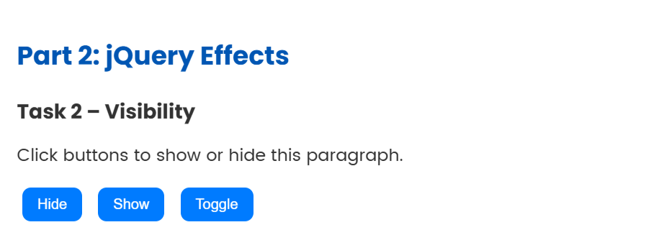

Task 3: Fade Methods
Added an image and controlled its visibility using .fadeIn(), .fadeOut(), and .fadeToggle().
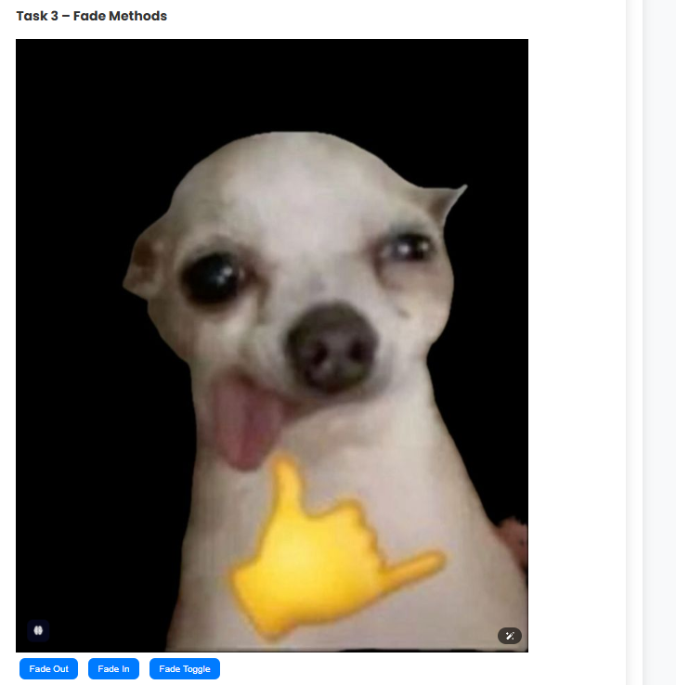

Task 4: Slide Methods
Created a collapsible panel using .slideUp(), .slideDown(), and .slideToggle().
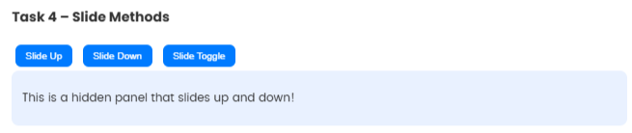


Part 3 — DOM Manipulation
Task 5: Add & Remove Elements
Made a list with buttons to add or remove items using .append() and .remove().
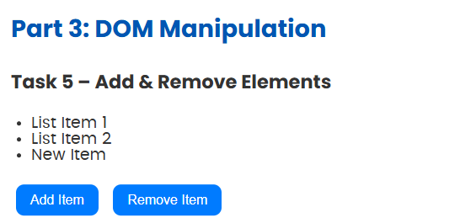

Task 6: Modifying Attributes
Used .attr() to change an image’s src and a link’s href dynamically when buttons are clicked.
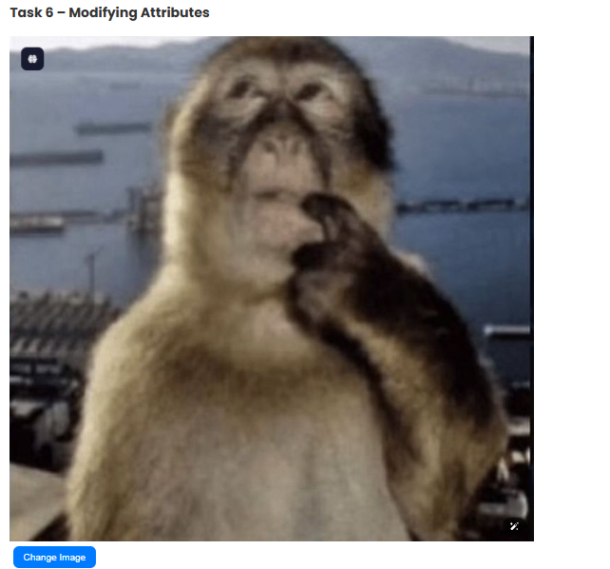
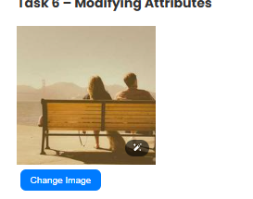
Task 7: Form Interaction
Created a small form with Name and Email inputs.
Used .val() and .text() to show live typing feedback below the form.
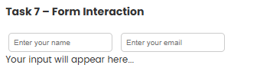
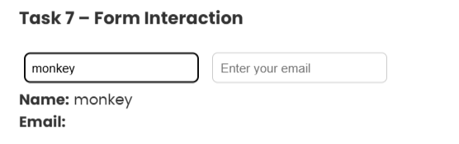

Part 4 — Animations
Task 8: Basic Animation
Animated a square <div> by increasing its size and moving it with .animate().
Task 9: Sequential Animations
Performed a step-by-step animation: move right → move down → shrink → return to start.
Task 10: Combined Animation
Created a complex animation combining movement, resizing, and opacity changes in one .animate() call.
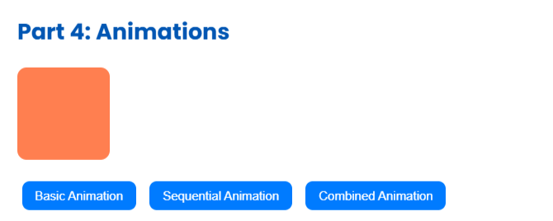

🖼️ Part 5 — Mini Project: Image Gallery
I created an interactive image gallery using jQuery effects and animations:
- Thumbnails fade in and enlarge when clicked.
- All images have equal size and rounded corners.
- Smooth transitions and hover effects for better UI.
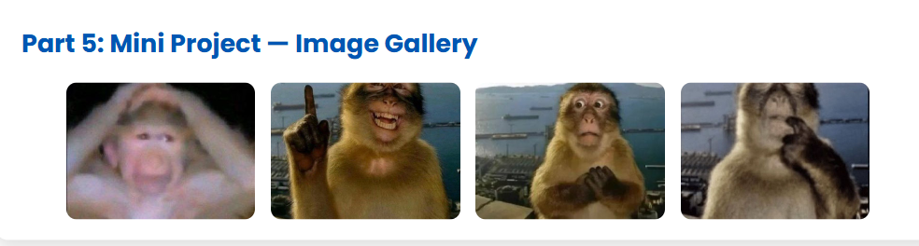

Summary
In this project, I learned how to use jQuery to manipulate HTML elements, handle user actions, and create animations easily.
I practiced:
- Using jQuery selectors (#id, .class, tag)
- Applying effects like fade, slide, show/hide
- Modifying attributes and dynamically updating content
- Writing animations with .animate()
- Building a small interactive mini project
This assignment helped me understand how jQuery simplifies JavaScript tasks, making it easier to add interactivity and animation to web pages.

