Tate Prodigalidad
CMSC 430
Project2 Documentation

- Approach
To implement the required changes for Project 2, I followed a phased approach and verified each phase with the provided test data. For every test, I rebuilt the project and executed a consistent run procedure:
make
cp "<TESTDIR>/testN.txt" input.txt
./compile
cat listing.txt
I started by confirming the baseline pipeline and driver. After ensuring make produced the compile binary and that listing.txt was generated from input.txt, I validated the initial program shape with test1.txt (arithmetic expression in a minimal function). This confirmed scanner/parser wiring, token handoff, and listing output.
Next, I extended the grammar to cover simple statements beyond expressions. I added the WHEN statement and validated with test2.txt. I then introduced SWITCH/CASE/OTHERS with a single expression body, verified by test3.txt. With control-flow in place, I added list declarations and indexing, and ran test4.txt.
With structure working, I expanded literal and type coverage. I added real literals and character literals, and validated with test5.txt. These changes also required updating the scanner’s numeric/char rules and corresponding tokens.
I then implemented the IF / ELSIF* / ELSE** family. Because Bison does not support EBNF braces directly, I replaced “zero or more” ELSIFs with a recursive elsif_tail production and validated the full statement with test6.txt.
Next, I implemented the FOLD statement and its two subordinate productions: direction (left/right) and operator (add/mul). I accepted either an identifier or a list literal as the fold target and verified with test7.txt.
I broadened declaration forms to permit 0 or more variable declarations (replacing the skeleton’s 0 or 1 behavior with a recursive list) and validated using test8.txt. After that, I enabled 0 or more function parameters in the header using a comma-separated list and confirmed both the single-parameter case with test9.txt and the two-parameter case with test10.txt.
I finished the arithmetic operator set by adding remainder (%), exponentiation (^) (right-associative), and unary minus (~) with the correct precedence layering. I verified all operator interactions with test11.txt. Then I added the remaining logical operators | (lowest precedence) and ! (highest), and validated the combined relational/logical precedence with test12.txt.
With the full language in place, I confirmed that nested constructs parse correctly by running test13.txt (nested if) and test14.txt (nested switch). These tests ensured that statement lists, control-flow scoping, and designator recursion behaved as expected under composition.
Finally, I implemented targeted error recovery so that the compiler reports meaningful diagnostics and continues parsing where appropriate. I added a recovery in the function header (missing colon in a parameter), validated with syntax2.txt; a recovery in variable declarations, validated with syntax3.txt; a guarded case-body rule plus a switch-tail that reports a missing OTHERS, validated with syntax4.txt; and combined all recoveries in syntax5.txt, confirming that the compiler reports the expected five errors. Throughout, I kept a generic recovery at the statement-list level (not at the individual statement when it would swallow switch-tail errors) and normalized messages via yyerror so listing output remained concise.
Operationally, I worked in WSL with inputs stored under /mnt/c/.... I quoted paths containing spaces and normalized CRLF endings in scripts and tests as needed. For bulk validation, I used a simple loop over tests 1–14 and syntax1–5 that rebuilt once, copied each case to input.txt, ran ./compile, and aggregated all listing.txt outputs for quick review.

- Test Plan
Each test was used to validate a specific portion of the lexical analyzer / parser pipeline. The tables below summarize the objectives and results.
Test Case | Description | Expected Result | Screenshot (paste here)
test1.txt | Arithmetic expression (baseline) | Compile successfully | 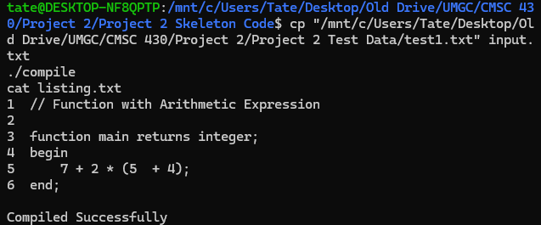
test2.txt | WHEN statement | Compile successfully | 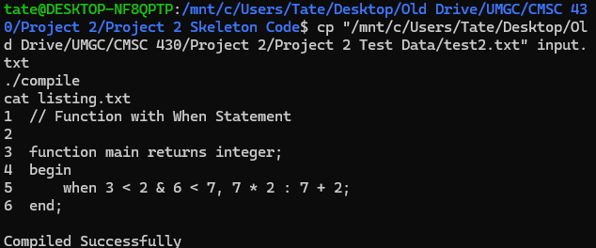
test3.txt | SWITCH/CASE with OTHERS | Compile successfully | 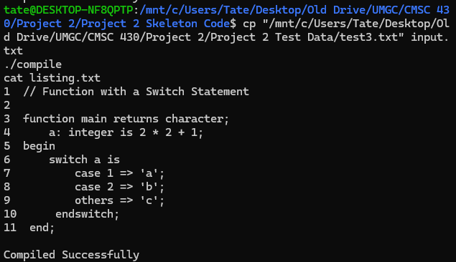
test4.txt | List variable declaration + indexing | Compile successfully | 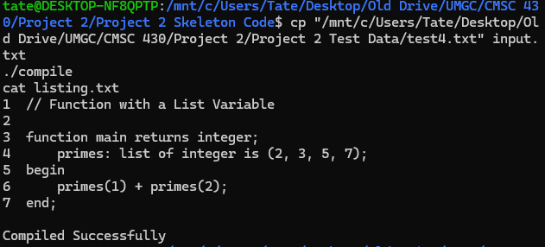
test5.txt | Real & character literals/variables | Compile successfully | 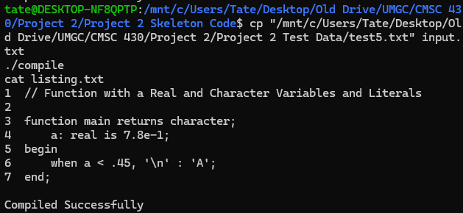
test6.txt | IF with multiple ELSIF + ELSE | Compile successfully | 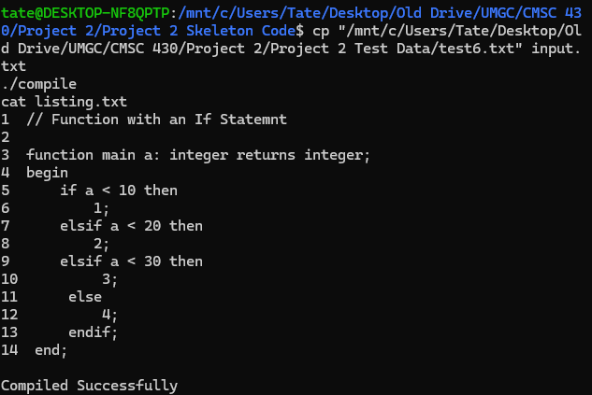
test7.txt | FOLD left/right + operator | Compile successfully | 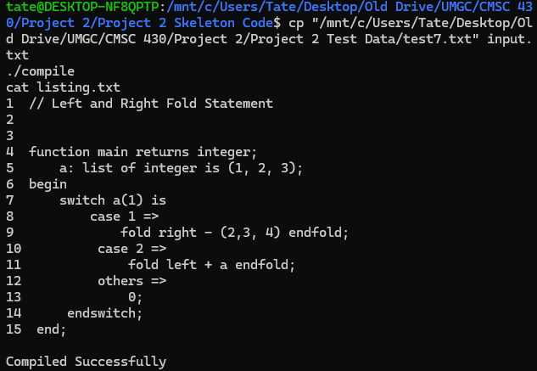
test8.txt | Multiple variable declarations (0+) | Compile successfully | 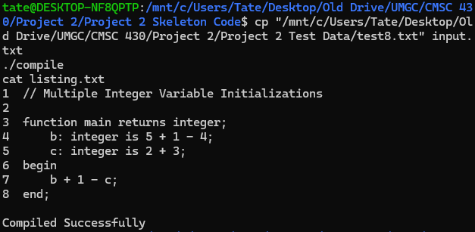
test9.txt | Single parameter declaration | Compile successfully | 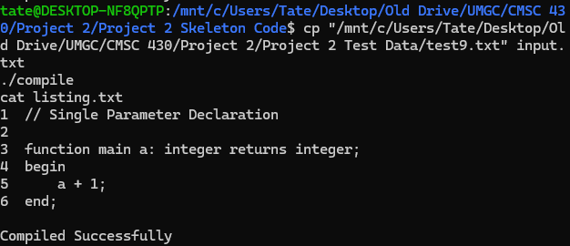
test10.txt | Two parameter declarations | Compile successfully | 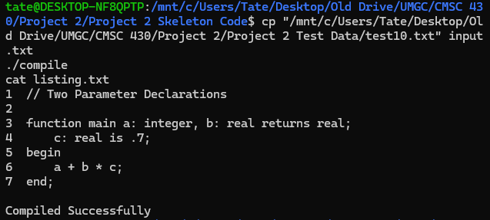
test11.txt | All arithmetic operators | Compile successfully | 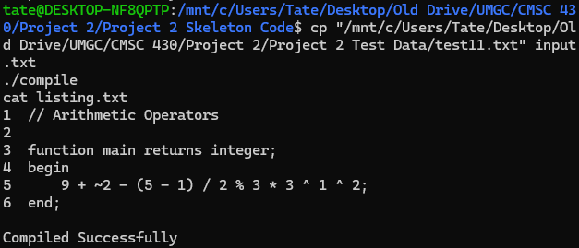
test12.txt | Relational and logical operators | Compile successfully | 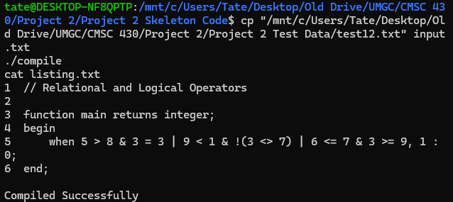
test13.txt | Nested IF (comprehensive) | Compile successfully | 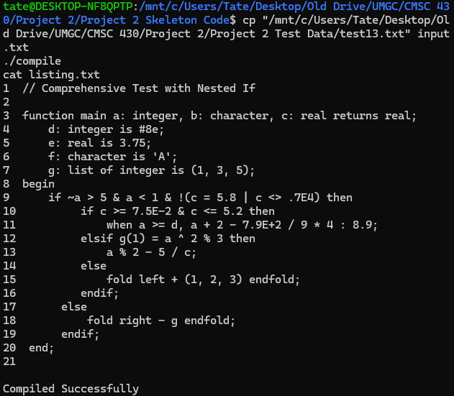
test14.txt | Nested SWITCH (comprehensive) | Compile successfully | 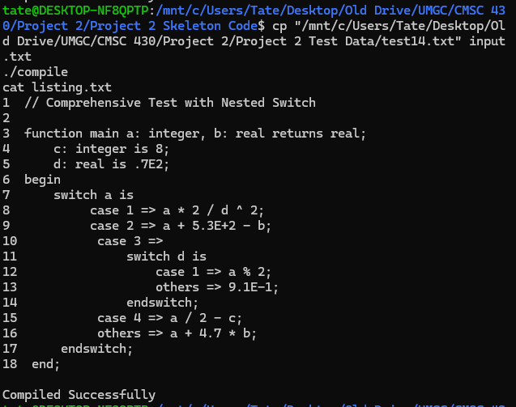

Test Case | What it tests | Expected Result | Screenshot (paste here)
syntax1.txt | Expression error (missing operator) | 1 syntax error; recovered at ';' | 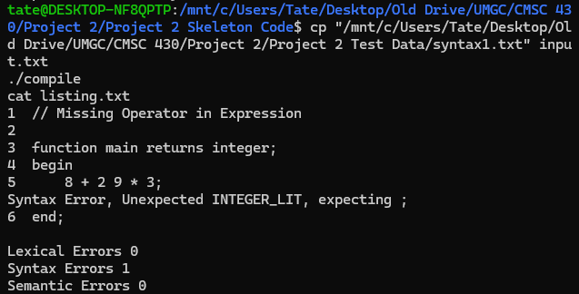
syntax2.txt | Function header param colon recovery | 1 syntax error; rest parses | 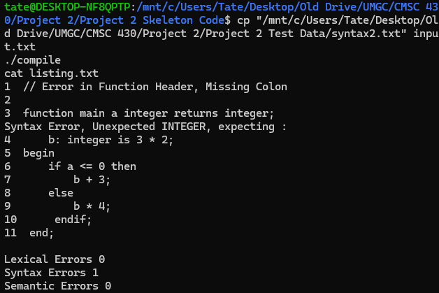
syntax3.txt | Variable declaration error recovery | 1 syntax error; no cascade | 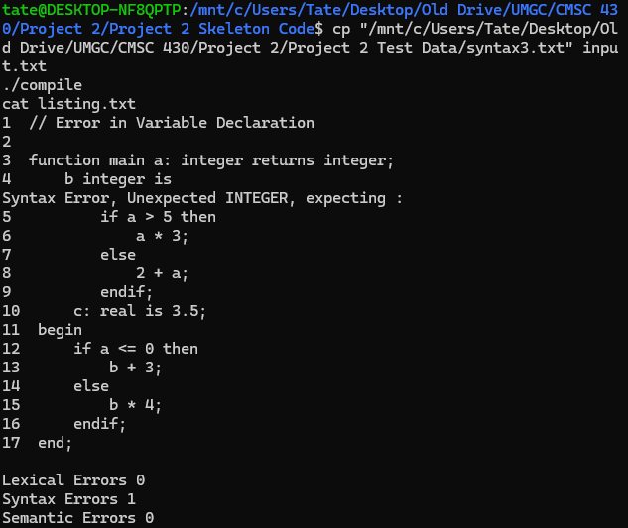
syntax4.txt | Bad CASE body + missing OTHERS | 2 syntax errors | 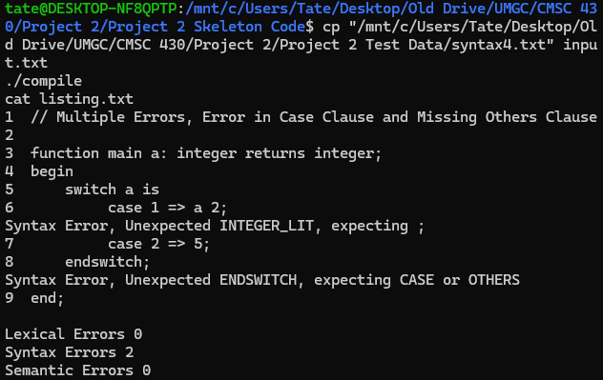
syntax5.txt | Multiple errors incl. missing OTHERS | 5 syntax errors | 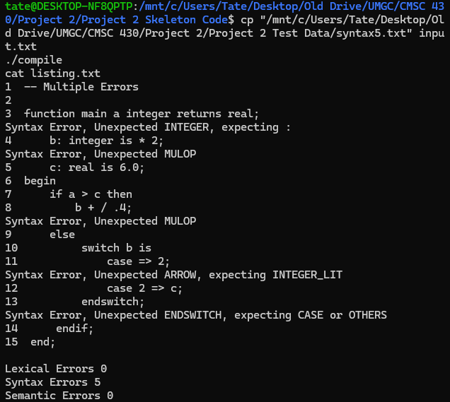

- Lessons Learned
This project clarified how to turn a language spec into a working Bison grammar. I replaced the spec’s EBNF zero-or-more notation with explicit recursive lists for parameters, variables, and ELSIF chains, which made the grammar easier to maintain and gave me clear places to add recovery. I also layered expressions so precedence and associativity were unambiguous; making exponentiation right-recursive and keeping unary above the binary tiers removed several early conflicts.
Conflict debugging was mostly about running Bison with -v and reading the .output file. The counterexample hints helped me tighten the designator rule and separate expression tiers more cleanly. I also avoided tool collisions by renaming tokens that overlap with Flex macros (e.g., using BEGIN_ instead of BEGIN).
Error recovery needed careful placement. A broad statement: error ';' rule is convenient, but it can hide switch-tail errors, including the “missing OTHERS” case. Moving the generic recovery to the statement list and adding targeted rules (CASE INT_LITERAL ARROW error ';' and switch alternatives that accept malformed bodies) produced the expected messages without duplication. I also removed extra appendError(...) calls where the error token already reports an issue.
On the tooling side, I normalized CRLF endings and quoted /mnt/c/... paths in WSL to avoid noisy failures unrelated to the grammar. I kept a simple shell loop to rebuild once and run the whole suite (tests 1–14 and syntax1–5) after each change. That made it straightforward to confirm the specific expectations: two errors on syntax4 and five on syntax5.

