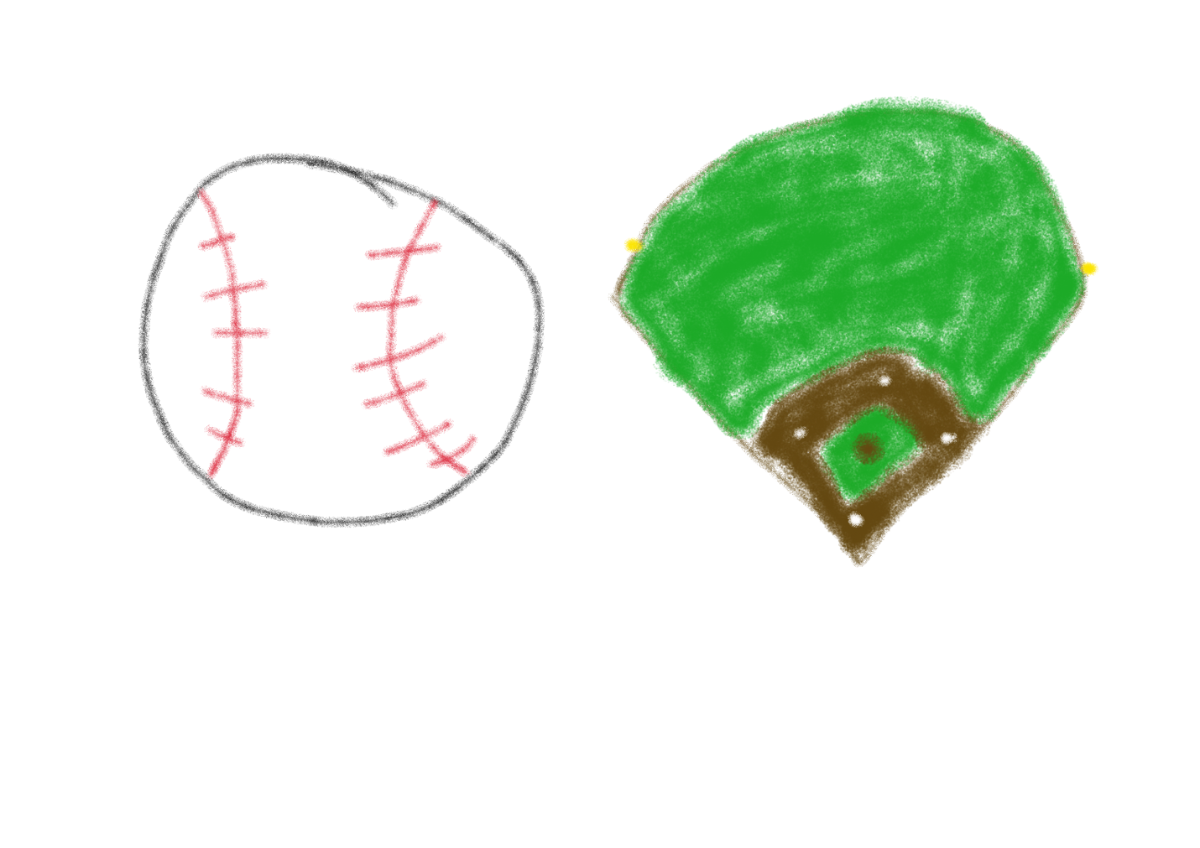

I drew a baseball and a baseball field for a few reasons. The main reason is because I am a baseball player at NJIT. I began playing baseball when I was 3 years old and have played my entire life. Many of my friends have come from playing the game and some of my family members have played too. Baseball led me to NJIT, which is my 2nd different university, allowing me to experience different things and meet many new people.

