**Bughound**

*Documentation Delieverables*

|  |  |
| --- | --- |
| Instructor: Hoffman Michael, PhD | |
| Student: | ID: |
| Eduardo Aceituno | 012485198 |
| Tate McGeary | 008581051 |
| Zachary Obeid | 017433310 |



California State University Long Beach | Course 1104 - 11042 |

Computer Engineering and Computer Science 544 (*Section 01)* Spring 2019

Contents

**Use Cases** 3

**3.1** **Use Cases** 3

**Employee Use Cases** 3

Login 3

Adding an Employee 5

Edit Employee 7

Delete Employee 8

**Bug Report Use Cases** 9

Add a bug for a program 9

View Bug Report 10

Edit/Update Bug Report 11

Search/List Bug Report 12

Export Bug Report 13

**Program Use Cases** 14

Add a program 14

Edit/Update Program 15

Delete a Program 16

Search/List Program 17

**Attachment Use Cases** 18

Add an Attachment 18

Delete an Attachment 19

**3.2** **Relational Schema** 20

**3.3** **Entity Relationship Diagram** 21

**3.4** **Deployment Diagram** 22

# **Use Cases**

# **Use Cases**

## **Employee Use Cases**

|  |  |  |
| --- | --- | --- |
| **USE CASE 1** | Login | |
| **Description** | User logs in using the login page, expects to be redirected to their respective dashboard after successful authentication | |
| **Used By** | Staff | |
| **Preconditions** | User knows his/her username and password | |
| **Success End Condition** | User logins successfully and is redirected to dashboard | |
| **Failed End Condition** | User cannot login or is not redirected to their respective dashboard | |
| **Actors** | User and Bughound | |
| **Trigger** | User submits username and password | |
| **DESCRIPTION** | **Step** | **Action** |
|  | 1 | User navigates to the Bughound Login form |
|  | 2 | Bughound System displays the login page |
|  | 3 | User enters username and password and submits form |
|  | 4 | Bughound System verifies submitted data and authenticates user |
|  | 5 | Bughound System re-directs user to respective dashboard on successful validation |
|  | 6 | User sees their dashboard |
| **EXTENSIONS** | **Step** | **Branching Action** |
|  | 3a | Bughound System is unsuccessful at validating client  3a1. Redirect to login form if less than 3 unsuccessful attempts  3a2. Display error message after 3 unsuccessful attempt and do not allow login for 15 minutes |
|  | 5a | Bughound has not set or configure his dashboard  5a1. Have a default dashboard set for each type of client |
| **VARIATIONS** |  | **Branching Action** |
|  | 1 | Bughound may use:  Desktop |
| **Exceptions** | 1 | Bughound System is unavailable  1a1. End of use case, fail |
|  | 3 | Bughound does not provide correct credentials  3a3. End of use case, fail |
| **Other Information** | 5-10 seconds to login and redirect user | |
| **Due Date** | March 2, 2019 | |

|  |  |  |
| --- | --- | --- |
| **USE CASE 2** | Adding an Employee | |
| **Description** | Site Administrator adds an employee to Bughound. | |
| **Used By** | Site Administrator | |
| **Preconditions** | Site Administrator must be logged into the system. | |
| **Success End Condition** | Employee is added correctly within the system. | |
| **Failed End Condition** | Employee is not registered. | |
| **Actors** | Site Administrator, Bughound | |
| **Trigger** | New employee joins the organization. | |
| **DESCRIPTION** | **Step** | **Action** |
|  | 1 | Site Administrator goes to the add player page. |
|  | 2 | System displays add employee page. |
|  | 3 | Site Administrator enters minimum required fields to register an employee. |
|  | 4 | System will display validation issue if they are present.  Missing fields, wrong character input, etc. |
|  | 5 | Site Administrator saves and registers employee. |
|  | 6 | Site Administrator is then prompted with a success message and completed record after submission. |
| **EXTENSIONS** | **Step** | **Branching Action** |
|  | 6a | Error occurs in submission   1. No internet connection 2. Database is unavailable 3. Session invalidated    1. Redirect to login 4. Employee already registered    1. Display message and option to modify (Use Case 4). |
| **VARIATIONS** |  | **Branching Action** |
|  |  | Site Administrator may use:  Desktop |
| **Exceptions** | 2a | Site Administrator does not provide required field. End of use case. |
| **Other Information** | 5 minutes to register an employee. | |
| **Due Date** | March 2, 2019 | |

|  |  |  |
| --- | --- | --- |
| **USE CASE 3** | Edit Employee | |
| **Description** | Site Administrator logs in (use case 3) and proceeds to search for employee and after successfully finding employee, they click on edit button of desired employee. | |
| **Used By** | Site Administrator | |
| **Preconditions** | Employee has new information.  Site Administrator must be logged into the system. | |
| **Success End Condition** | Employee is either edited or updated successfully. | |
| **Failed End Condition** | Employee failed to either be edited or updated successfully. | |
| **Actors** | Site Administrator and Bughound | |
| **Trigger** | Change in Employee, permission level/password change. | |
| **DESCRIPTION** | **Step** | **Action** |
|  | 1 | Site Administrator search for employee in database |
|  | 2 | System Displays Employee information |
|  | 3 | Site Administrator select on Edit Employee |
|  | 4 | Based on user role system directs to appropriate page. System also displays appropriate information regarding edits, new updates, and appropriate permissions for actors based on their role. |
|  | 5 | Site Administrator saves all changes to Employee. |
|  | 6 | Site Administrator is then prompted with a success message and shown completed recorded after submission. |
| **EXTENSIONS** | **Step** | **Branching Action** |
|  | 1a | Employee cannot be located in database for Site Administrator  3a1. Redirect Site Administrator to register Employee. (Use Case 2). |
|  | 6a | Error occurs in submission   1. No internet connection 2. Database is unavailable 3. Session invalidated    1. Redirect to login 4. Employee already registered    1. Display message and option to modify (Use Case 4). |
| **VARIATIONS** |  | **Branching Action** |
|  | 1 | Client may use:  Desktop |
| **Due Date** | March 2, 2019 | |

|  |  |  |
| --- | --- | --- |
| **USE CASE 4** | Delete Employee | |
| **Description** | Site Administrator logs in (use case 1) and proceeds to search for employee and after successfully finding employee, they click on delete of desired employee. | |
| **Used By** | Site Administrator | |
| **Preconditions** | Employee is no longer at the company or uses Bughound.  Site Administrator must be logged into the system. | |
| **Success End Condition** | Employee is deleted successfully. | |
| **Failed End Condition** | Employee failed to be removed or deleted successfully. | |
| **Actors** | Site Administrator and Bughound | |
| **Trigger** | Change in Employee status. | |
| **DESCRIPTION** | **Step** | **Action** |
|  | 1 | Site Administrator search for employee in database |
|  | 2 | System Displays Employee information |
|  | 3 | Site Administrator selects on delete Employee |
|  | 4 | Site Administrator is then prompted with a success message and shown completed transaction |
| **EXTENSIONS** | **Step** | **Branching Action** |
|  | 3a | Error occurs in submission   1. No internet connection 2. Database is unavailable 3. Session invalidated    1. Redirect to login |
|  | 3b | Site administrator is prompted with a confirmation message confirming deletion. |
| **VARIATIONS** |  | **Branching Action** |
|  | 1 | Client may use:  Desktop |
| **Due Date** | March 2, 2019 | |

## **Bug Report Use Cases**

|  |  |  |
| --- | --- | --- |
| **USE CASE 5** | Add a bug for a program | |
| **Description** | User adds a bug to the system for a program. | |
| **Used By** | Staff | |
| **Preconditions** | User must be registered in the system.  User must be signed on. | |
| **Success End Condition** | User reports symptom. | |
| **Failed End Condition** | User does not report symptom. | |
| **Actors** | User, Database, GUI | |
| **Trigger** | User fills out form to report symptoms | |
| **DESCRIPTION** | **Step** | **Action** |
|  | 1 | Navigate to Create a Bug Report page |
|  | 2 | Fill out the form with appropriate information |
|  | 3 | Submit information |
|  | 4 | User is prompted with success message |
| **EXTENSIONS** | **Step** | **Branching Action** |
|  | 3a | System does not submit data |
|  | 3a1 | Prompts user that there was an error or incorrectly filled field. |
|  | 3a2 | Prompts user to fix errors and resubmit. |
|  | 3a3 | User fixes errors and resubmits. |
| **VARIATIONS** |  | **Branching Action** |
|  | 1 | User may use  - website |
| **Other Information** | System is unavailable  - End of use case, fail | |
| **Due Date** | March 2, 2019 | |

|  |  |  |
| --- | --- | --- |
| **USE CASE 6** | View Bug Report | |
| **Description** | User can view bug information | |
| **Used By** | Staff | |
| **Preconditions** | User already logged in  User has permissions to view bug report. | |
| **Success End Condition** | User views selected bug report. | |
| **Failed End Condition** | User cannot view bug report. | |
| **Actors** | User, Bughound | |
| **Trigger** | User Selects Bug Report Dashboard | |
| **DESCRIPTION** | **Step** | **Action** |
|  | 1 | User navigates to the Bug Report Dashboard |
|  | 2 | Bughound System displays Bug Report Dashboard |
|  | 3 | User searches or list bugs. (Use Case 8) |
|  | 4 | User selects Bug Report. |
|  | 5 | Bughound re-directs User to view Bug Report. |
|  | 6 | User sees selected bug Report |
| **EXTENSIONS** | **Step** | **Branching Action** |
|  | 6a | Client is unable to view Bug Report  6a1. Display message to user if Bug Report is unavailable  6a2. Display error message to user does not have the necessary permissions. |
| **VARIATIONS** |  | **Branching Action** |
|  | 1 | User may use:  Desktop |
| **Exceptions** | 1 | Bughound unavailable  1a1. End of use case, fail |
|  | 6 | User does not have permissions to view Bug Report  6a3. End of use case, fail |
| **Other Information** | 5-10 seconds to login and redirect client | |
| **Due Date** | March 2, 2019 | |

|  |  |  |
| --- | --- | --- |
| **USE CASE 7** | Edit/Update Bug Report | |
| **Description** | User can edit/update bug information | |
| **Used By** | Staff | |
| **Preconditions** | User already logged in  User has permissions to edit/update bug report. | |
| **Success End Condition** | User edited/updated selected bug report. | |
| **Failed End Condition** | User cannot edited/updated bug report. | |
| **Actors** | User, Bughound | |
| **Trigger** | User Selects Bug Report Dashboard | |
| **DESCRIPTION** | **Step** | **Action** |
|  | 1 | User navigates to the Bug Report Dashboard |
|  | 2 | Bughound System displays Bug Report Dashboard |
|  | 3 | User searches or list bugs. (Use Case 8) |
|  | 4 | User selects Bug Report. |
|  | 5 | Bughound re-directs User to edit/update Bug Report. |
|  | 6 | User edits/updates bug report. |
|  | 7 | User clicks update button. |
| **EXTENSIONS** | **Step** | **Branching Action** |
|  | 6a | User is unable to view Bug Report  6a1. Display message to user if Bug Report is unavailable  6a2. Display error message to user does not have the necessary permissions. |
|  | 7a | Edit/Update fails  7a1. Display error message to user that action  failed. |
| **VARIATIONS** |  | **Branching Action** |
|  | 1 | User may use:  Desktop |
| **Exceptions** | 1 | Bughound unavailable  1a1. End of use case, fail |
|  | 6 | User does not have permissions to edit/update Bug Report  6a3. End of use case, fail |
| **Other Information** | 5-10 seconds to login and redirect client | |
| **Due Date** | March 2, 2019 | |

|  |  |  |
| --- | --- | --- |
| **USE CASE 8** | Search/List Bug Report | |
| **Description** | User can Search/List bug report. | |
| **Used By** | Staff | |
| **Preconditions** | User already logged in  User has permissions to search/list bug report. | |
| **Success End Condition** | User searched/listed a bug report or bug reports. | |
| **Failed End Condition** | User cannot search/list bug reports. | |
| **Actors** | User, Bughound | |
| **Trigger** | User Selects Bug Report Dashboard | |
| **DESCRIPTION** | **Step** | **Action** |
|  | 1 | User navigates to the Bug Report Dashboard |
|  | 2 | Bughound System displays Bug Report Dashboard |
|  | 3 | User selects Search/list Bug Report. |
|  | 4 | System displays all bugs in DB and a search bar. |
|  | 5 | User selects desired bug report. |
|  | 6 | System displays Bug Report. |
| **EXTENSIONS** | **Step** | **Branching Action** |
|  | 4a | User clicks on Bug Report from the list provided of all bug reports. |
|  | 4b | User types in necessary information to search for bug report.  4a1. User types in bug report number. |
|  | 6a | User is unable to view Bug Report  6a1. Display message to user if Bug Report is unavailable  6a2. Display error message to user does not have the necessary permissions. |
| **VARIATIONS** |  | **Branching Action** |
|  | 1 | User may use:  Desktop |
| **Exceptions** | 1 | Bughound unavailable  1a1. End of use case, fail |
| **Other Information** | 5-10 seconds to login and redirect client | |
| **Due Date** | March 2, 2019 | |

|  |  |  |
| --- | --- | --- |
| **USE CASE 9** | Export Bug Report | |
| **Description** | User can export Bug Report | |
| **Used By** | Staff | |
| **Preconditions** | User already logged in  User has already selected/created bug report.  User has already selected bug report. | |
| **Success End Condition** | User has exported bug report to supported file format. | |
| **Failed End Condition** | User cannot export bug report. | |
| **Actors** | User, Bughound | |
| **Trigger** | User Selects Program Dashboard | |
| **DESCRIPTION** | **Step** | **Action** |
|  | 1 | User selects EXPORT BUG REPORT. |
|  | 2 | System prompts user with message with a list of support file types for export. (XML, PDF, ASCII) |
|  | 3 | User selects desired file type. |
|  | 5 | System export file type to the user. |
|  | 6 | System displays success message. |
| **EXTENSIONS** | **Step** | **Branching Action** |
|  | 5a | User is unable to export file.  6a1. Display message to user if it cannot export bug report.  6a2. Display error message to user does not have the necessary permissions. |
| **VARIATIONS** |  | **Branching Action** |
|  | 1 | User may use:  Desktop |
| **Exceptions** | 1 | Bughound unavailable  1a1. End of use case, fail |
| **Other Information** | 5-10 seconds to login and redirect client | |
| **Due Date** | March 2, 2019 | |

## **Program Use Cases**

|  |  |  |
| --- | --- | --- |
| **USE CASE 10** | Add a program | |
| **Description** | User adds a program to the system. | |
| **Used By** | Staff | |
| **Preconditions** | User must be registered in the system.  User must be signed on. | |
| **Success End Condition** | User adds a program. | |
| **Failed End Condition** | User does not add a program. | |
| **Actors** | User, Database, GUI | |
| **Trigger** | User fills out form to add a program. | |
| **DESCRIPTION** | **Step** | **Action** |
|  | 1 | Navigate to Add a program page |
|  | 2 | Fill out the form with appropriate information |
|  | 3 | Submit information |
|  | 4 | User is prompted with success message |
| **EXTENSIONS** | **Step** | **Branching Action** |
|  | 3a | System does not submit data |
|  | 3a1 | Prompts user that there was an error or incorrectly filled field. |
|  | 3a2 | Prompts user to fix errors and resubmit. |
|  | 3a3 | User fixes errors and resubmits. |
| **VARIATIONS** |  | **Branching Action** |
|  | 1 | User may use  - website |
| **Other Information** | System is unavailable  - End of use case, fail | |
| **Due Date** | March 2, 2019 | |

|  |  |  |
| --- | --- | --- |
| **USE CASE 11** | Edit/Update Program | |
| **Description** | User can edit/update program information | |
| **Used By** | Staff | |
| **Preconditions** | User already logged in  User has permissions to edit/update program | |
| **Success End Condition** | User edited/updated selected program. | |
| **Failed End Condition** | User cannot edit/update program. | |
| **Actors** | User, Bughound | |
| **Trigger** | User Selects Program Dashboard. | |
| **DESCRIPTION** | **Step** | **Action** |
|  | 1 | User navigates to the Program Dashboard |
|  | 2 | Bughound System displays Program Dashboard |
|  | 3 | User searches or list programs. (Use Case 13) |
|  | 4 | User selects program. |
|  | 5 | Bughound re-directs User to edit/update program. |
|  | 6 | User edits/updates program. |
|  | 7 | User clicks update button. |
| **EXTENSIONS** | **Step** | **Branching Action** |
|  | 6a | User is unable to view Program information  6a1. Display message to user if program information is unavailable  6a2. Display error message to user does not have the necessary permissions. |
|  | 7a | Edit/Update fails  7a1. Display error message to user that action  failed. |
| **VARIATIONS** |  | **Branching Action** |
|  | 1 | User may use:  Desktop |
| **Exceptions** | 1 | Bughound unavailable  1a1. End of use case, fail |
|  | 6 | User does not have permissions to edit/update Bug Report  6a3. End of use case, fail |
| **Other Information** | 5-10 seconds to login and redirect client | |
| **Due Date** | March 2, 2019 | |

|  |  |  |
| --- | --- | --- |
| **USE CASE 12** | Delete a Program | |
| **Description** | User goes to view/list a program page | |
| **Used By** | Staff | |
| **Preconditions** | Program has been deprecated and all associated information is to be removed.  User is on view program page. User has necessary permission levels to delete a program. | |
| **Success End Condition** | Program has been deleted from the database. | |
| **Failed End Condition** | Program has failed to be deleted from the database. | |
| **Actors** | Staff and Bughound | |
| **Trigger** | Deprecation of program. | |
| **DESCRIPTION** | **Step** | **Action** |
|  | 1 | User searches for program. |
|  | 2 | System Displays program information |
|  | 3 | User selects delete program. |
|  | 4 | User is then prompted with a success message and shown completed transaction |
| **EXTENSIONS** | **Step** | **Branching Action** |
|  | 3a | Error occurs in submission   1. No internet connection 2. Database is unavailable 3. Session invalidated    1. Redirect to login |
|  | 3b | User is prompted with a confirmation message confirming deletion. |
| **VARIATIONS** |  | **Branching Action** |
|  | 1 | Client may use:  Desktop |
| **Due Date** | March 2, 2019 | |

|  |  |  |
| --- | --- | --- |
| **USE CASE 13** | Search/List Program | |
| **Description** | User can Search/List Program. | |
| **Used By** | Staff | |
| **Preconditions** | User already logged in  User has permissions to search/list program. | |
| **Success End Condition** | User searched/listed a program or programs. | |
| **Failed End Condition** | User cannot search/list program | |
| **Actors** | User, Bughound | |
| **Trigger** | User Selects Program Dashboard | |
| **DESCRIPTION** | **Step** | **Action** |
|  | 1 | User navigates to the Program Dashboard |
|  | 2 | Bughound System displays Program Dashboard |
|  | 3 | User selects Search/list programs. |
|  | 4 | System displays all programs in DB and a search bar. |
|  | 5 | User selects desired programs. |
|  | 6 | System displays program. |
| **EXTENSIONS** | **Step** | **Branching Action** |
|  | 4a | User clicks on a program from the list provided of all programs. |
|  | 4b | User types in necessary information to search for programs  4a1. User types in program name. |
|  | 6a | User is unable to view program.  6a1. Display message to user if program information is unavailable  6a2. Display error message to user does not have the necessary permissions. |
| **VARIATIONS** |  | **Branching Action** |
|  | 1 | User may use:  Desktop |
| **Exceptions** | 1 | Bughound unavailable  1a1. End of use case, fail |
| **Other Information** | 5-10 seconds to login and redirect client | |
| **Due Date** | March 2, 2019 | |

## **Attachment Use Cases**

|  |  |  |
| --- | --- | --- |
| **USE CASE 14** | Add an Attachment | |
| **Description** | User can add an attachment | |
| **Used By** | Staff | |
| **Preconditions** | User already logged in  User has permissions to create/modify bug reports.  User has already selected/created bug report. | |
| **Success End Condition** | User added an attachment. | |
| **Failed End Condition** | User cannot add an attachment | |
| **Actors** | User, Bughound | |
| **Trigger** | User Selects Program Dashboard | |
| **DESCRIPTION** | **Step** | **Action** |
|  | 1 | User selects Insert attachment option. |
|  | 2 | System prompts user with an explorer to select attachment from their system. |
|  | 3 | User selects desired attachment. |
|  | 4 | User presses Save. |
|  | 5 | System saves attachment into file system |
|  | 6 | System displays success message. |
| **EXTENSIONS** | **Step** | **Branching Action** |
|  | 5a | User is unable to save attachment  6a1. Display message to user if it cannot load attachment.  6a2. Display error message to user does not have the necessary permissions. |
| **VARIATIONS** |  | **Branching Action** |
|  | 1 | User may use:  Desktop |
| **Exceptions** | 1 | Bughound unavailable  1a1. End of use case, fail |
| **Other Information** | 5-10 seconds to login and redirect client | |
| **Due Date** | March 2, 2019 | |

|  |  |  |
| --- | --- | --- |
| **USE CASE 15** | Delete an Attachment | |
| **Description** | User can delete an attachment | |
| **Used By** | Staff | |
| **Preconditions** | User already logged in  User has permissions to create/modify bug reports.  User has already selected/created bug report.  Attachment is associated with selected bug report. | |
| **Success End Condition** | User deleted an attachment. | |
| **Failed End Condition** | User cannot deleted an attachment | |
| **Actors** | User, Bughound | |
| **Trigger** | User Selects Program Dashboard | |
| **DESCRIPTION** | **Step** | **Action** |
|  | 1 | User selects red X next to attachment. |
|  | 2 | System prompts user with confirmation message to delete attachment. |
|  | 3 | User selects YES. |
|  | 5 | System deletes attachment from filesystem. |
|  | 6 | System displays success message. |
| **EXTENSIONS** | **Step** | **Branching Action** |
|  | 5a | User is unable to delete attachment  6a1. Display message to user if it cannot delete attachment.  6a2. Display error message to user does not have the necessary permissions.  6a3. User does not have the necessary permission level to perform the action.  6a3.1. System displays message that user lacks  permission level |
| **VARIATIONS** |  | **Branching Action** |
|  | 1 | User may use:  Desktop |
| **Exceptions** | 1 | Bughound unavailable  1a1. End of use case, fail |
| **Other Information** | 5-10 seconds to login and redirect client | |
| **Due Date** | March 2, 2019 | |

# **Relational Schema**

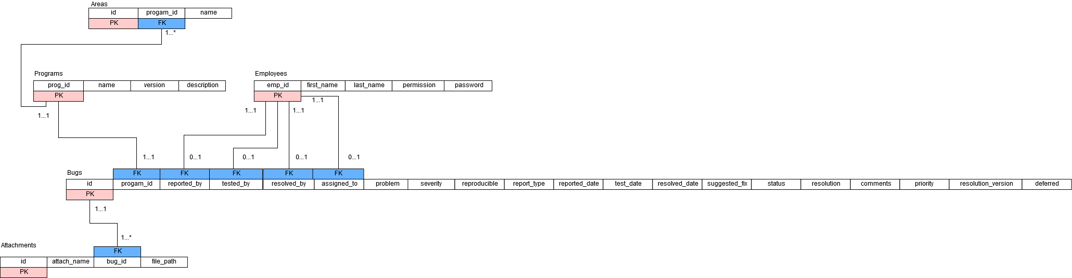

# **Entity Relationship Diagram**

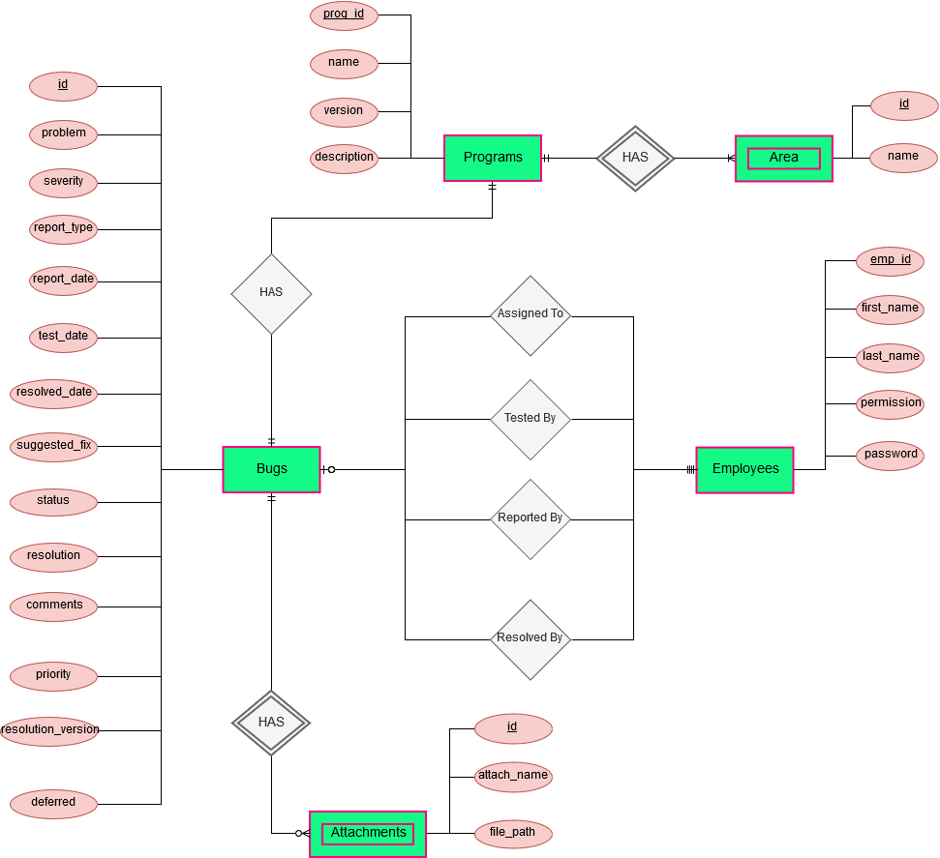

# **Deployment Diagram**

