ANALYSTLAB AFRICA

FinTrust Digital Bank
Week 1: Understand & Plan
Track: Data Analytics
Field | Detail
Intern Name | Tatenda Shoko
Project | FinTrust Financial Intelligence & Digital Banking Support Solution
Track | Data Analytics
Submission Date | Sunday, 20 September, 2026

1. General Requirements for Week 1

1.1 Business Understanding
1. What problem is FinTrust trying to solve?
FinTrust needs a reliable way to understand what is happening across its customer base and transaction environment. At present, the bank has customer and transaction data which only provides partial information about the customers and transactions which the bank is involved in. There is no integrated way to turn this data into business intelligence, risk visibility, predictive insight, or reliable digital customer support. The organisation can see the data but cannot use it for informed decisions on risk management, channel strategy and customer support. These business operations are being made without a structured analytical foundation based on customer or transactions data.
2. Why is the problem important?
The dataset already shows why this matters in numbers: 19.6% of all transactions carry a risk-review flag, international transactions are flagged at roughly double the domestic rate (36.9% vs 18.9%), and 7.1% of customer accounts are dormant. Left unmonitored, these patterns represent unmanaged risk exposure and silent customer attrition (churn); which can negatively impact the bank as FinTrust's customer base grows. Analysing transactions and customer characteristics can help management to understand:
- Transaction success, failure, reversals and pending patterns;
- Transaction volumes and monetary values
- Differences in behavior across customer segments;
- Patterns associated with the synthetic risk-review label.
3. How can the Data Analytics track contribute?
The Data Analytics track will contribute by:
- Profiling and validating the supplied datasets, establishing relevant data quality checks;
- Developing business questions that can be answered using the two datasets provided;
- Establishing the relationship between customer and transaction records and analysing customer and transaction behaviour;
- Define measurable KPIs;
- Developing an interactive dashboard and communicating the findings in a way that supports business decision-making.
By converting the two raw tables into a validated data profile, a set of decision-linked analytical questions, and a KPI framework, data analytics can provide quality data which can be used across other teams such as the Data Science track.
4. What type of output could this track provide?
The data analytics track will provide data profiling report, an analytical question set, a KPI definition table, and a dashboard wireframe and these are provided in Section 2.

1.2 Resource Review
Resource | What It Contains | How it will be used / Limitations
FinTrust_Customer_Data.csv | 1,500 customers × 12 fields: demographics (Age, Gender, City), segment, account type, tenure, digital engagement score, income band, preferred channel, account status. | Primary source for customer segmentation and behavioural KPIs.  Limitation: Monthly_Income_Band is bucketed, not continuous which limits precision on income-linked analysis.
FinTrust_Transaction_Data.csv | 12,000 transactions × 11 fields: date/time, type, amount (NGN), channel, device, location, international flag, status, risk-review flag. | Primary source for transaction and risk analysis, joined to customers via Customer_ID.  Limitation: 96 rows (0.8%) missing Device_Type and Location which is confirmed by the project notes as an intentional data-quality exercise.
FinTrust_Data_Dictionary – Project Notes.csv | A short 5-line reference confirming currency (NGN), the join key (Customer_ID), and that Risk_Review_Flag is a synthetic educational label. | Used to validate my own profiling rather than as a full field-by-field dictionary
FinTrust Project Brief | Business scenario, objectives, in/out of scope, team structure, and success criteria for the full 4-week project. | Used to ground this document's business-understanding section and confirm Data Analytics' role (KPIs, dashboards, business analysis) within the wider team.
FinTrust 4-Week Master Roadmap | Week-by-week phase description across all four weeks. | Used to build the Week 2–4 plan in Section 1.5 so it lines up with what the rest of the cohort is doing at each stage.

1.3 Data Analytics Track Objectives
- To profile the FinTrust customer and transaction datasets and establish an accurate baseline of structure, quality and relationships between the two datasets.
- To provide analytical questions that connect customer behaviour, transaction activity and risk indicators to decisions FinTrust management can actually act on.
- To define e a KPI framework where every metric can be obtained from the supplied data.
- To design a dashboard wireframe that shows the highest-impact KPIs and gives Week 2's Power BI build a clear starting brief.
- To flag any data-quality and structural issues (missingness, target imbalance) in the given datasets.

1.4 Success Criteria
The project will be considered successful if the following are addressed:
- Every analytical question and KPI traces to a specific column (or column combination) in the supplied data.
- The data profile should provide a true reflection of the data provided, that is: 0 missing values in customer data, 96 missing Device_Type and Location rows in transaction data, 0 duplicate IDs in either table.
- The dashboard wireframe is buildable in Power BI directly from the two source tables, with no additional undocumented data required.

1.5 Initial Plan for Weeks 2 - 4
Week | Focus
Week 2: Data Cleaning & Preparation | Investigate and document the handling of the missing Device_Type & Location rows, standardise Transaction_DateTime, perform EDA, calculate baseline figures for the defined KPIs, and begin building the interactive dashboard in Power BI.
Week 3: Dashboard development & Integration | Build the interactive dashboard (drill-downs, filters), validate every KPI card against the source data manually, refine the business narrative around what the numbers show, and integrate any relevant Data Science / ML Engineering output (e.g. a risk-model score).
Week 4: Test, Refine & Present | User-test the dashboard for clarity, refine visuals and layout, finalise documentation, and prepare a recorded presentation covering contribution, results, limitations and lessons learned.

2. Data Analytics Track: FinTrust Business & Data Intelligence Assessment

Part A: Business Understanding
1. What business questions should FinTrust's management be able to answer?
- Which customer segments generate the highest transaction volumes and transaction values?
- Where in the transaction lifecycle is risk actually concentrated; by channel, by transaction type, or by international status?
- Is synthetic risk-review flag rate higher for international transactions than domestic transactions, and does the difference still remain after accounting for channel and transacton characteristics?
- Which channels are under- or over-used relative to customer income band, and does that inform where to invest?
2. What decisions could data analysis support?
- Resourcing the risk-review team: with 19.6% of all 12,000 transactions flagged, and Web/ATM channels flagging above that average (~21%), staffing could be weighted toward those channels rather than spread evenly.
- Channel investment: Mobile App carries 42.5% of transaction volume — is FinTrust's digital roadmap matching where usage already concentrates?
- Retention targeting: 107 of 1,500 accounts (7.1%) are Dormant — a candidate segment for a re-engagement campaign, sized and defined by data rather than guesswork.
3. What stakeholders could benefit from the analytical outputs?
Stakeholder | Decision supported
Risk & Compliance Team | Identify channels/transaction types requiring further review
Executive Management | Monitor overall customer and transaction performance
Product / Channel Strategy Team | Understand channel utilization and customer adoption
Customer Experience / Retention Team | Identify dormant or low-engagement customer segments

Part B: Understanding Given Data
Customer Data — FinTrust_Customer_Data.csv
The customers data consists of 1,500 records with 12 columns.
Field | Data Type | Notes
Customer_ID | Text (key) | Unique, 1,500 values, 0 duplicates join key to transactions.
Customer_Name | Text | Not unique (name pool reused) — not usable as an identifier.
Age | Numerical (int) | Range 18–65, mean 41.6.
Gender | Categorical | Male / Female / Prefer not to say.
City | Categorical | 8 Nigerian cities (Lagos, Kano, Abuja, etc.).
Customer_Segment | Categorical | Everyday (711), Premium (295), Student (278), SME (216).
Account_Type | Categorical | Savings / Current / Premium.
Tenure_Months | Numerical (int) | Range 1–96 months.
Digital_Engagement_Score | Numerical (float) | Range 16.7–100.
Monthly_Income_Band | Categorical (ordinal) | 5 bands, Below 100k to 1m+.
Preferred_Channel | Categorical | Mobile App / USSD / Web.
Account_Status | Categorical | Active (1,367), Dormant (107), Restricted (26).

Transaction Data — FinTrust_Transaction_Data.csv
The dataset has 12,000 records and 11 columns and it does not have duplicates.
Field | Data Type | Notes
Transaction_ID | Text (key) | Unique, 12,000 values, 0 duplicates.
Customer_ID | Text (foreign key) | Every value exists in the customer table — clean join, 0 orphans.
Transaction_DateTime | Date/time (as text, e.g. 1/1/2026 0:00) | Needs parsing to a real datetime type before analysis. Range: 1 Jan – 31 Mar 2026 (Q1 only).
Transaction_Type | Categorical | 6 types: Card Purchase, Cash Withdrawal, Transfer, Deposit, Airtime/Data, Bill Payment.
Amount_NGN | Numerical (float) | Mean ₦46,706, median ₦10,306; strongly right-skewed; use median alongside mean.
Channel | Categorical | Mobile App (5,102 / 42.5%), POS (2,393 / 19.9%), Web (1,869 / 15.6%), ATM (1,747 / 14.6%), USSD (889 / 7.4%).
Device_Type | Categorical | 96 missing (0.8%); confirmed intentional in the project notes.
Location | Categorical | 96 missing (0.8%); same rows as Device_Type in most cases; same note applies.
International_Transaction | Categorical (binary) | Yes / No.
Transaction_Status | Categorical | Successful 90.5%, Failed 5.3%, Reversed 2.7%, Pending 1.6%.
Risk_Review_Flag | Categorical (binary — target candidate) | Yes 19.6% / No 80.4%; imbalanced, synthetic label only (per data dictionary).

Relationship between the datasets:
There is possibility of one-to-many relationship where each Customer_ID in the customer table links to roughly 8 transactions on average. Every Customer_ID in the transaction table has a matching record in the customer table; the join is clean.
Obvious data-quality observations:
- Device_Type has 96 missing values (0.8%) and Location also has 96 missing values. These two fields should be assessed separately because the missing records are not identical.
- Amount_NGN is right-skewed (mean nearly 4.5× the median). This implies that transaction values are strongly right-skewed, therefore the average is higher than the median and therefore may not represent the typical transaction, Both mean and median should be reported where appropriate.
- Risk_Review_Flag is imbalanced (80/20) which will be addressed before model development.
- Monthly_Income_Band is banded, not a raw figure which is suitable for data segmentation, but it caps how precisely income can be tied to behaviour.

Part C: Possible Analytical Questions
The following questions should be addressed:
- Customer behaviour: Which customer segments generate the highest transaction volumes and transaction volumes?
- Transaction activity: How does transaction activity vary across levels of customer digital engagement?
- Transaction value: What is the average and median Amount_NGN by Customer_Segment and Transaction_Type, and which segment/type combination drives the most total value?
- Transaction channels: How does channel mix (Mobile App 42.5%, POS 19.9%, Web 15.6%, ATM 14.6%, USSD 7.4%) vary by City or Monthly_Income_Band?
- Transaction status: Do Failed (5.3%) and Reversed (2.7%) rates vary meaningfully by Channel or Device_Type, pointing at an operational weak point?
- Risk-related patterns: Is the risk-review flag rate materially higher for International_Transaction = Yes (36.9%) than No (18.9%), and does that gap hold once Channel is controlled for?
- Risk-related patterns: Do higher value transactions have a higher synethetic risk-review flag rate?
- Time pattern: Does transaction volume or the risk-flag rate shift across the Jan–Mar 2026 window (e.g. by week or day-of-week)?

Part D: KPI Planning

The following KPIs are proposed for dashboard development
KPI | Definition | Why It Matters | Required Data
Average Transaction Value | Mean (and median) of Amount_NGN, overall and by segment | Baseline spend intensity per customer group; median needed because the distribution is skewed | Amount_NGN, Customer_Segment
Risk Review Rate | % of transactions with Risk_Review_Flag = Yes | Core risk-exposure indicator; currently ~19.6% overall | Risk_Review_Flag
Failed Transaction Rate | % of transactions with Transaction_Status = Failed | Signals operational/UX friction; currently ~5.3%, worth breaking out by channel | Transaction_Status, Channel
International Risk Uplift | Risk Review Rate for International = Yes vs No | Quantifies the added risk of cross-border transactions (36.9% vs 18.9%) | Risk_Review_Flag, International_Transaction
Channel Mix Share | % of transaction volume per Channel | Guides channel investment or deprecation decisions | Channel
Dormant Account Rate | % of customers with Account_Status = Dormant | Retention/re-engagement indicator; currently 7.1% | Account_Status
Digital Engagement by Segment | Mean Digital_Engagement_Score per Customer_Segment | Tests whether the stated engagement score actually tracks segment behaviour | Digital_Engagement_Score, Customer_Segment

Part E: Dashboard Wireframe
The dashboard layout will be as follows

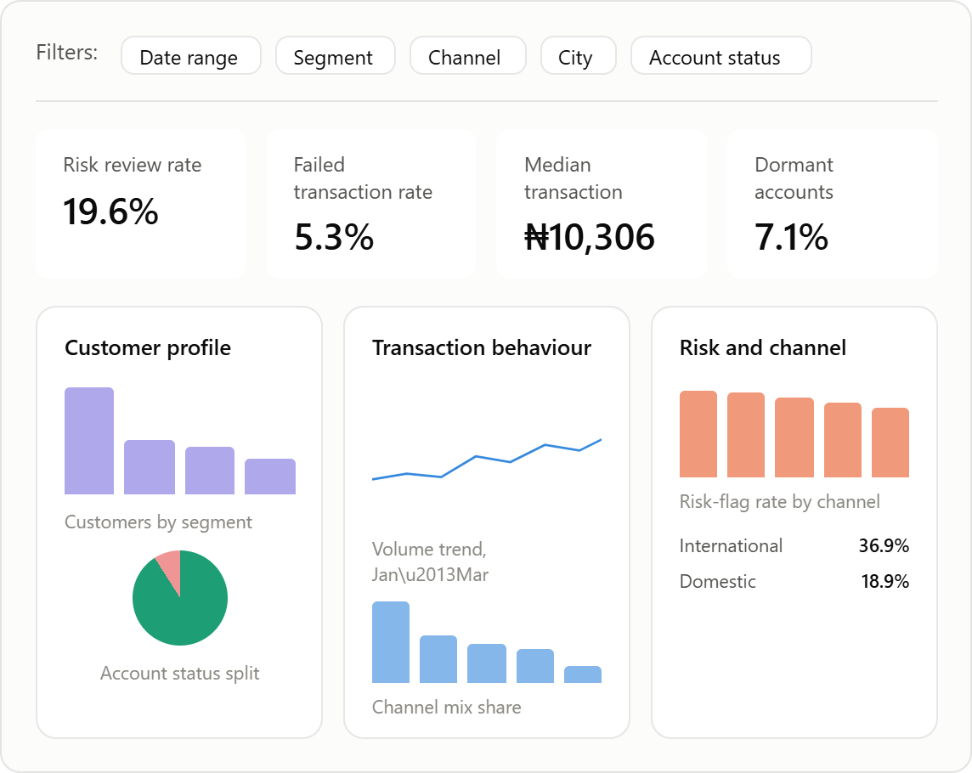

Section | Contents
1. KPI Strip (top row of cards) | Risk Review Rate, Failed Transaction Rate, Average Transaction Value (median), Dormant Account Rate — the four numbers management should see first.
2. Customer Profile (left panel) | Bar chart: customer count by Customer_Segment. Bar chart: Digital_Engagement_Score by Segment. Donut: Account_Status split.
3. Transaction Behaviour (centre panel) | Line chart: transaction volume and value trend across Jan–Mar 2026. Bar chart: Channel Mix Share. Bar chart: Transaction_Type breakdown.
4. Risk & Channel (right panel) | Bar chart: Risk Review Rate by Channel. Bar chart: Risk Review Rate — International vs Domestic. Table: Failed/Reversed rate by Channel.

Proposeed filters include: Date range · Customer_Segment · Channel · City · Account_Status.
Insights the dashboard should communicate:
- International transactions carry roughly double the domestic risk-flag rate.
- Mobile App dominates channel volume, but Web and ATM carry the highest risk-flag rates; volume and risk concentration don't line up on the same channel.
- A visible, sizeable Dormant segment (7.1%) exists and is identifiable by the same fields used elsewhere in the dashboard no extra data required to act on it.

3. Relevant Risks & Future Dependencies
- Risk: Treating Risk_Review_Flag as ground-truth fraud rather than a synthetic label could mislead any risk KPI. Mitigation: label every risk-related output as "review flag rate," never "fraud rate."
- Risk: The undocumented rule for handling the 96 missing Device_Type/Location rows could quietly bias channel-level KPIs if dropped versus flagged inconsistently. Mitigation: decide and document the rule in Week 2 before any KPI is calculated.
- Risk: Amount_NGN's skew could produce a misleading "average transaction value" if only the mean is reported. Mitigation: always pair mean with median in KPI reporting.

