Installation

Run you CMD as admin

Past this line

python –m pip install --upgrade google-api-python-client google-auth-httplib2 google-auth-oauthlib

Go to this like <https://developers.google.com/calendar/quickstart/python>  
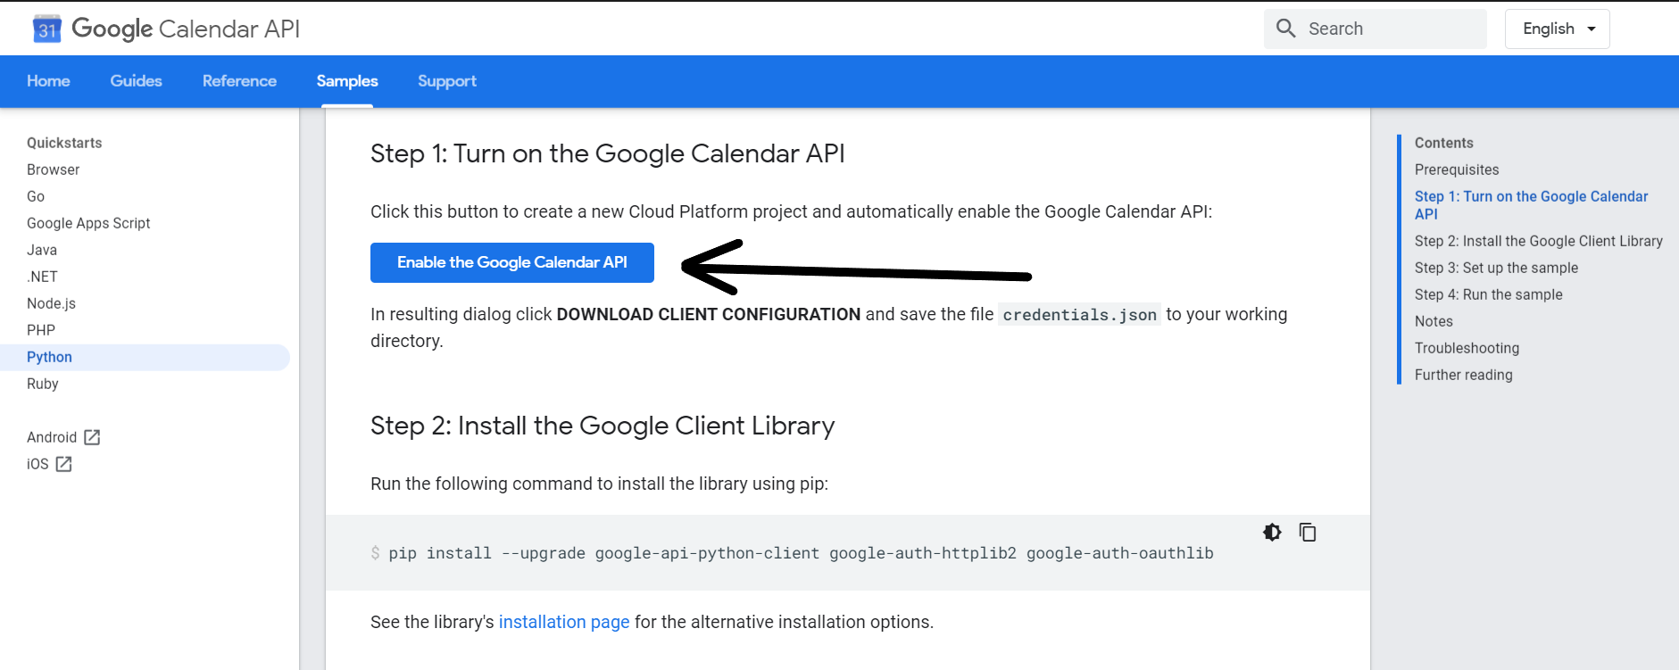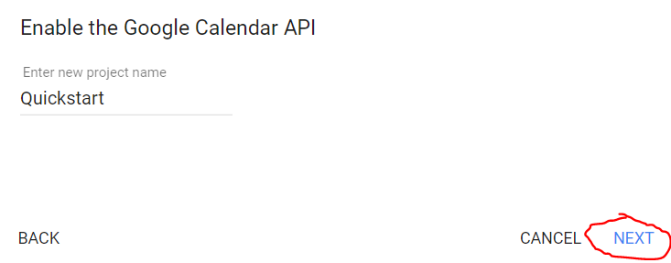

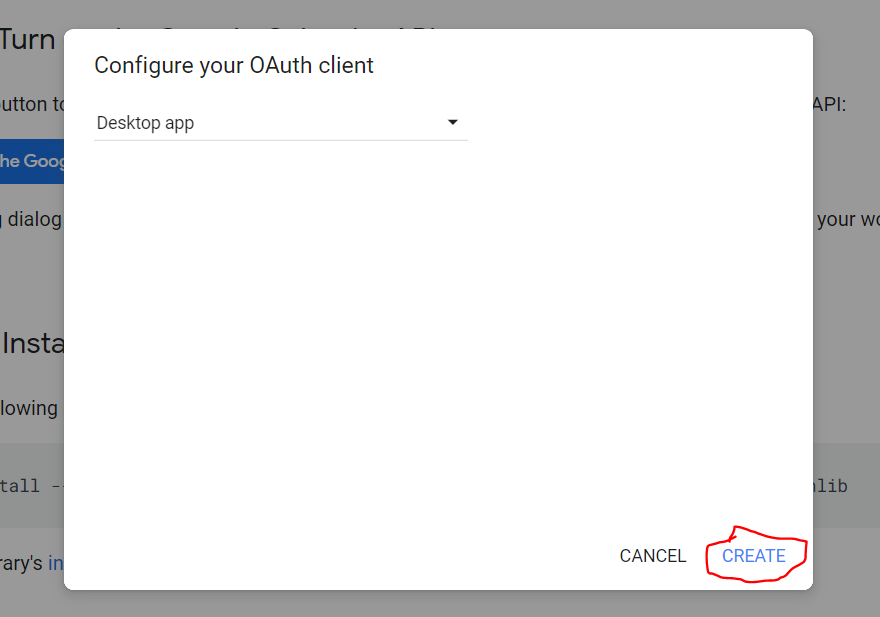

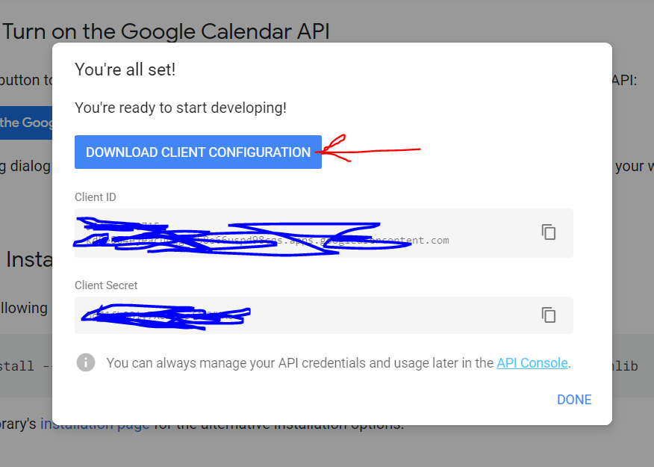

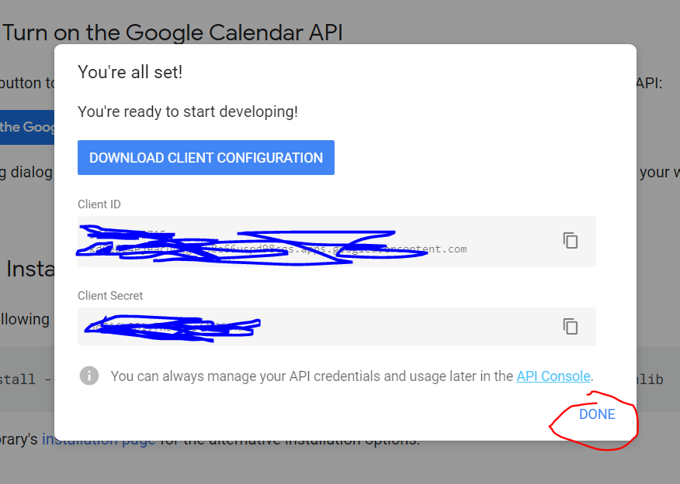

open gcalendar.py  
change this line

calendar = GoogleCalendar('yourgmail@gmail.com')

run script