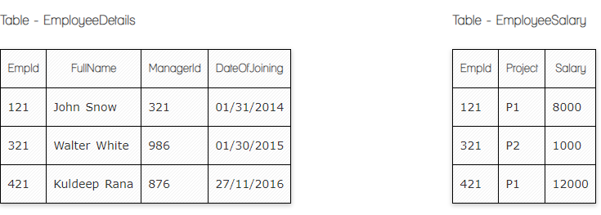

**Ques.1. Write a SQL query to fetch the count of employees working in project 'P1'.**

**Your Answer:**

**select count(*), ed.FullName, es.Project**

**from EmployeeDetails as ed, EmployeeSalary as es**

**where es.Project = ‘P1’**

**Ques.2. Write a SQL query to fetch employee names having salary greater than or equal to 5000 and less than or equal 10000.**

**Your Answer:**

**select ed.FullName, es.Salary**

**from EmployeeDetails as ed, EmployeeSalary as es**

**where es.Salary >= 5000 <=10000**

**Ques.3. Write a query to fetch employee names and salary records. Return employee details even if the salary record is not present for the employee.**

**Your Answer:**

**select ed.FullName, es.Salary**

**from EmployeeDetails as ed, EmployeeSalary as es**

**left join EmployeeDetails on ed.EmpId=es.EmpId**

**order by ed.FullName**

**Ques.4. Write a SQL query to fetch all the Employees details from EmployeeDetails table who joined in Year 2016.**

**Your Answer:**

**select * from EmployeeDetails**

**where DateofJoining like ‘%2016’**

**Ques.5. Write a SQL query to insert new record to the EmployeeDetails table with any data.**

**Your Answer:**

**Insert into EmployeeDetails (FullName, ManagerID, DateOfJoining)**

**values (‘Tatevik Gyurjyan’, ‘999’, ‘01.11.2017’)**

**Ques.6. Write a SQL query to update EmployeeSalery table with setting Salary to 2000 for Project P2.**

**Your Answer:**

**Update EmployeeSalary as es**

**set es.Salary = ‘2000’**

**where es.Project = ‘P2’ and es.EmpId = 321**



**Ques.7. Write a SQL query to right join both tables and draw the results.**

**Your Answer:**

**select * from EmployeeDetails right join EmployeeSalary**

**on EmployeeDetails.EmpId = EmployeeSalary.EmpId**

**select * from EmployeeSalary right join EmployeeDetails**

**on EmployeeDetails.EmpId = EmployeeSalary.EmpId**

**Now take these two tables:**

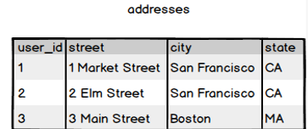

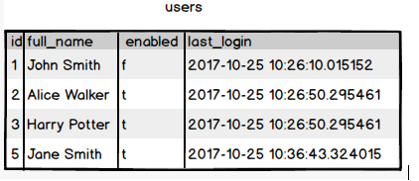

**Ques.8. Write a SQL query to fetch all users full_name from San Francisco.**

**Your Answer:**

**select u.full_name, a.city**

**from users as u, addresses as a**

**where a.city = ‘San Francisco’**

**order by u.full_name**

**or**

**select users.full_name, addresses.city**

**from users**

**inner join addresses on users.id = addresses.user_id**

**order by full_name**

**Ques.9. Write a SQL query to fetch all users full_name, last_login who are enabled**

**Your Answer:**

**select full_name, last_login from users**

**where enabled = ‘t’**

**Ques.10. Write a SQL query to fetch all users full_name who are not from 3 Main street**

**Your Answer:**

**select users.full_name, addresses.street**

**from users, addresses**

**where addresses.street != ‘3 Main Street’**

**group by users.full_name**

**Ques.11. Write a SQL query to fetch all users full_name who are from 3 Main street or San Francisco**

**Your Answer:**

**select users.full_name, addreesses.street, addresses.city**

**from users, addresses**

**where addresses.street = ‘3 Main Street’ or ‘’**

**or city = ‘San Francisco’**

**Ques.12. Write a SQL query to fetch user full_name who is equal to user_id from Boston (find user_id value in sub_query)**

**Your Answer:**

**select users.full_name, addresses.city**

**from users, addresses**

**where users.id = (select user_id from addresses**

**where city = ‘Boston’)**