**VCOMP :-**

**(Version Comparator/Difference Tool)**

*A Thesis*

*Submitted in partial fulfillment of the*

*requirements for the award of the Degree of*

**MASTER OF COMPUTER APPLICATIONS**

BY

**TATHAGAT KUMAR**

**(MCA/10023/2020)**



**DEPARTMENT OF COMPUTER SCIENCE AND ENGINEERING**

**BIRLA INSTITUTE OF TECHNOLOGY**

**MESRA-835215, RANCHI**

**2022**

**DECLARATION**

**I certify that**

a. The work contained in the thesis is original and has been done by

myself under the general supervision of my supervisor(s).

b. The work has not been submitted to any other Institute for any degree or diploma.

c. I have followed the guidelines provided by the Institute in writing the thesis.

d. I have conformed to the norms and guidelines given in the Ethical Code of Conduct of the Institute.

e. Whenever I have used materials (data, theoretical analysis, and text) from other sources, I have given due credit to them by citing them in the text of the thesis and giving their details in the references.

Signature of the Student

Name : Tathagat Kumar

Roll No : MCA/10023/2020

2

**APPROVAL OF THE GUIDE(S)**

Recommended that the thesis entitled **“VCOMP :- Version Comparator”** prepared By Mr. Tathagat Kumar under my/oursupervision and guidance be accepted as fulfilling this part of the requirements for the degree of Master of Computer Applications. To the best of my/our knowledge, the contents of this Project did not form a basis for the award of any previous degree to anyone else.

Date:

|  |  |
| --- | --- |
| Jyoti Mehta | B.K.Chanda |
| Software Engineering Manager | Assistant Professor, |
| Amdocs Development Centre India | Department of CSE, |
| Pune. | BIT-Mesra, Ranchi |

3



**THESIS APPROVAL CERTIFICATE**

This is to certify that the work embodied in this thesis

entitled “**“VCOMP :- Version Comparator”** " is carried out by

Mr. Tathagat Kumar (Roll No. MCA/10023/2020) is approved for the degree of Master of Computer Applications of Birla Institute of Technology, Mesra, Ranchi.

Date:

Place:

Internal Examiner(s)

Name & Signature

External Examiner(s)

Name & Signature

Head

Dept of Computer Science and Engineering

Birla Institute of technology, Mesra

4

**ACKNOWLEDGEMENT**

We take this opportunity to express our profound gratitude and deep regards to our mentor **Jyoti Mehta**, Software Engineering Manager, Amdocs Development Centre, Pune, India, for their exemplary guidance, monitoring and constant encouragement throughout the course of this project work. The blessing, help and guidance given by them time to time shall carry us a long way in the journey of life on which we are about to embark.

We are obliged to all the faculty members of MCA, Computer Science Department, Birla Institute of Technology Mesra, for the valuable information provided by them in their respective fields. We are grateful for their cooperation during the period of our assignment. I would like to take this opportunity to acknowledge and express my gratitude to all the people directly or indirectly involved with me in making this project a success.

**Tathagat Kumar**

**Roll no. – MCA/10023/2020**

5

**ABSTRACT**

‘ VCOMP : Version Comparator ’ is a tool or resource that generates a

Report showing the changes in two different versions of same product, which will help the developers or user to know exactly what are the changes made in new file that will result in faster debugging of Code, Error detection and its rectification.

User will have to provide two library files using CMD, which will be Input to the tool and will generate a Text File (.txt/.rtf) or a HTML File(.htm /.html) containing detailed report of all the changes.

6

**TABLE OF CONTENTS**

|  |  |  |  |  |  |  |
| --- | --- | --- | --- | --- | --- | --- |
|  | TOPIC | |  | PAGE NO. | |  |
|  |  |  |  |  |  |  |
|  | Declaration |  |  | 2 |  |  |
|  |  |  |  |  |  |
|  | Approval Of The Guide(S) | | 3 | |  |  |
|  |  |  |  |  |
|  |  | |  |  |  |  |
|  | Thesis Approval Certificate |  |  | 4 |  |  |
|  |  |  |  |  |  |
|  | Acknowledgement | | 5 | |  |  |
|  |  |  |  |  |
|  |  | |  |  |  |  |
|  | Abstract |  |  | 6 |  |  |
|  |  |  |  |  |  |
|  | About The Company | | 8 | |  |  |
|  |  |  |  |  |
|  |  | |  |  |  |  |
|  | **CHAPTER 1- INTRODUCTION** |  |  | 10 |  |  |
|  | 1.1.1 PROJECT OVERVIEW |  |  |  |  |
|  |  |  | 11 |  |  |
|  | 1.1.2 TECHNICAL TERMINOLOGY |  |  |  |  |
|  |  |  |  |  |  |  |
|  | **CHAPTER 2- REQUIREMENT ANALYSIS** | | 16 | |  |  |
|  | 2.1.1 EXISTING SYSTEMS AND SOLUTION | |  |  |
|  |  |  |  |  |
|  |  | |  |  |  |  |
|  | **CHAPTER 3- METHODOLOGY ADOPTED** |  |  | 17 |  |  |
|  | 3.1.1 WORK BREAKDOWN STRUCTURE |  |  |  |  |
|  |  |  | 19 |  |  |
|  | 3.1.2 TOOLS AND TECHNOLOGIES USED |  |  |  |  |
|  | 3.1.3 PROPOSED SOLUTION |  |  | 20 |  |  |
|  |  |  |  |  |  |
|  | **CHAPTER 4- DESIGN SPECIFICATIONS** | | 24 | |  |  |
|  | 4.1.1 FLOWCHART OF APPLICATION | |  |  |
|  | 25 | |  |  |
|  | 4.1.2 SYSTEM SCREENSHOTS | |  |  |
|  |  | |  |  |  |  |
|  | **CHAPTER 5- CONCLUSION AND FUTURE** |  |  | 28 |  |  |
|  | **SCOPE** |  |  |  |  |
|  |  |  |  |  |  |
|  |  |  |  |  |  |  |
|  | **APPENDIX : REFERENCES** | | 29 | |  |  |
|  |  |  |  |  |
|  |  |  |  |  |  |  |

7

|  |  |  |  |  |  |  |  |  |
| --- | --- | --- | --- | --- | --- | --- | --- | --- |
|  |  | **LIST OF FIGURES** | | |  |  |  |  |
|  | FIGURE | | | | | PAGE NO. | |  |
|  |  | |  |  | |  |  |  |
|  | Flowchart Showing Overview Of | |  |  | | 10 |  |  |
|  | Project | |  |  |  |  |  |
|  |  |  |  |  |  |  |
|  | Creating Library Files | | |  | | 12 |  |  |
|  |  |  |  |  |  |  |  |
|  |  | | |  | |  |  |  |
|  | Using Online Decompilers | |  |  | | 15 |  |  |
|  |  |  |  |  |  |  |  |
|  | Using Online Comparator | | |  | | 16 |  |  |
|  |  |  |  |  |  |  |  |
|  |  | | |  | |  |  |  |
|  | Work Breakdown Structure | |  |  | | 17 |  |  |
|  |  |  |  |  |  |  |  |
|  | Hash Function | | |  | | 21 |  |  |
|  |  |  |  |  |  |  |  |
|  |  | | |  | |  |  |  |
|  | Storing Key-Value Records | |  |  | | 24 |  |  |
|  |  |  |  |  |  |  |  |
|  | System Screenshots | | |  | | 25 |  |  |
|  |  |  |  |  |  |  |  |
|  |  |  |  |  |  |  |  |  |

8

**Chapter-1**

**COMPANY PROFILE**

Amdocs, founded in 1982, is a leading software and services provider to communications and media companies of all sizes, accelerating the industry’s dynamic and continuous digital transformation. With a rich set of innovative solutions, long-term business relationships with 350 communications and media providers, and technology and distribution ties to 600 content creators.

Amdocs delivers business improvements to drive growth. Amdocs and its 25,000 employees serve customers in over 85 countries.

Amdocs’ market offerings address five business imperatives:

* Consumer experience and monetization
* Media and digital services
* Enterprise and connected society
* Service-driven networks
* Services and agile operations

**Global presence**:

* Workforce of around 25,000 serving customers across six continents
* Support and development Centers located worldwide, including Brazil, Canada, Cyprus, India, Ireland, Israel, Mexico, the Philippines, the United Kingdom and the USA.

**Market Position**:

Amdocs ONE provides service providers with the broadest set of products and services to grow revenue and build loyalty. Uniquely designed to meet the challenge of our customers’ hybrid environment, Amdocs ONE is available on an open, modular architecture, built on cloud-native microservice technologies for high-velocity time to market. Deployed using DevOps in small iterations to control costs, Amdocs ONE brings optimal scope and drives agility.

9

**PROJECT OVERVIEW**



Library Files



**Decompilation**



Original Code



**File Handling / Comparison**



Report

10

**TECHNICAL TERMINOLOGY :-**

**Library**

The files that tell the compiler how to call some functionality (without knowing how the functionality actually works) are called header files. They contain the function prototypes. They also contain Data types and constants used with the libraries.

**Whereas,** Library is the place where the actual functionality is implemented i.e. they contain function body.

Library files are non-human-readable. Since they are in the form of machine code. Library files in our program are included in last stage by special software called as *linker*.

Libraries have mainly two categories :

1. Static
2. Shared or Dynamic

**Static:** Static libraries contains object code linked with an end user application and then they become the part of the executable. These libraries are specifically used at ***compile time*** which means the library should be present in correct location when user wants to compile his/her C or C++ program. In windows they end with **.lib** extension and with **.a** for MacOS.

**Shared or Dynamic:** These libraries are only required at ***run-time*** i.e, user can compile his/her code without using these libraries. For example, when we open our game folders we can find many **.dll** (dynamic link libraries) files. As these libraries can be shared by multiple programs, they are also called as shared libraries. These files end with **.dll** or **.lib** extensions. In windows they end with .dll extension.

11

**1.Creation of Header File and .lib file:-**

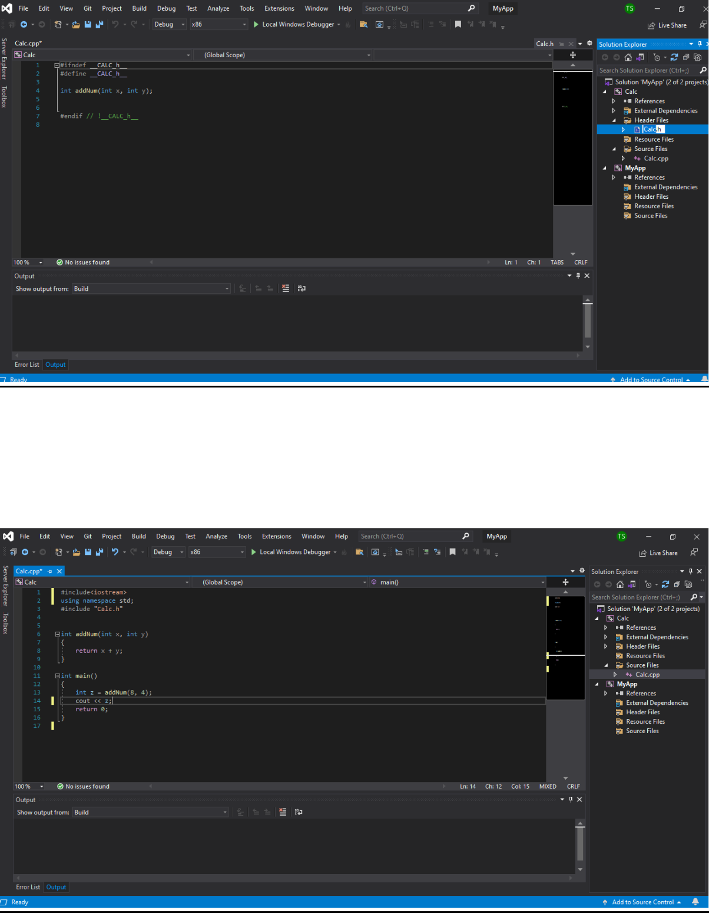

12

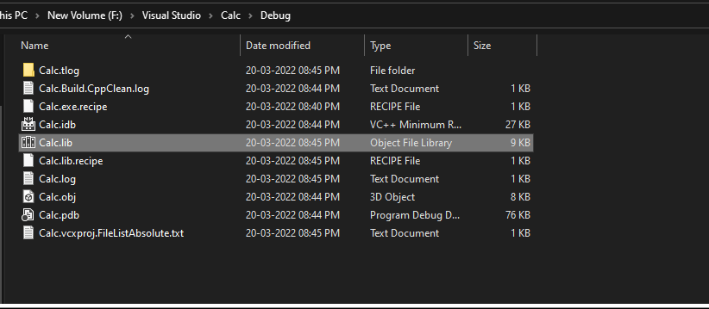

**2.Using Online Decompiler (**[**https://onlinedisassembler.com/):-**](https://onlinedisassembler.com/):-)

**Uploading .lib files-**

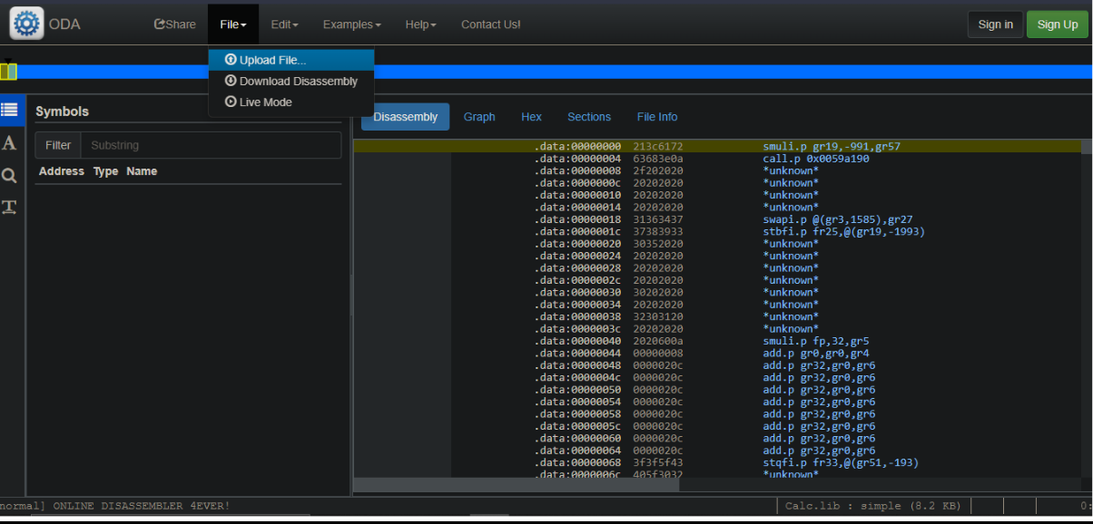

13

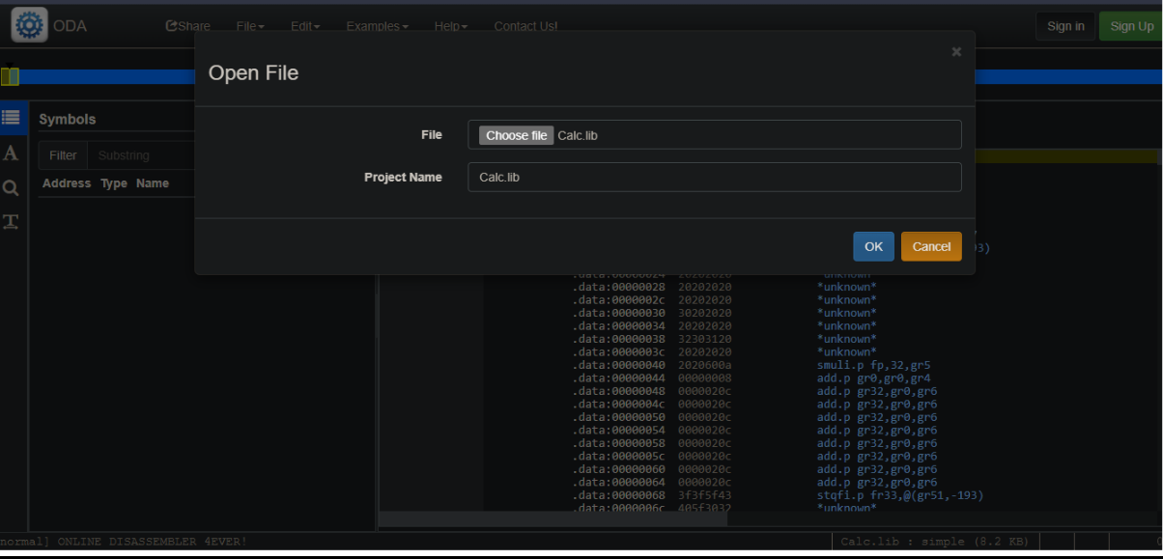

**3.Output:**

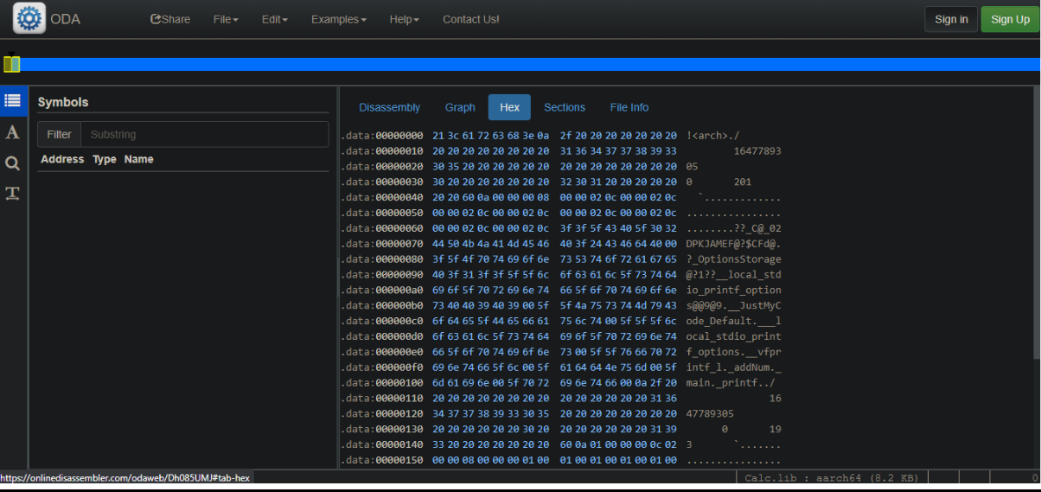

14

**4.Output using another application (Snowman)**

[**https://derevenets.com/**](https://derevenets.com/)

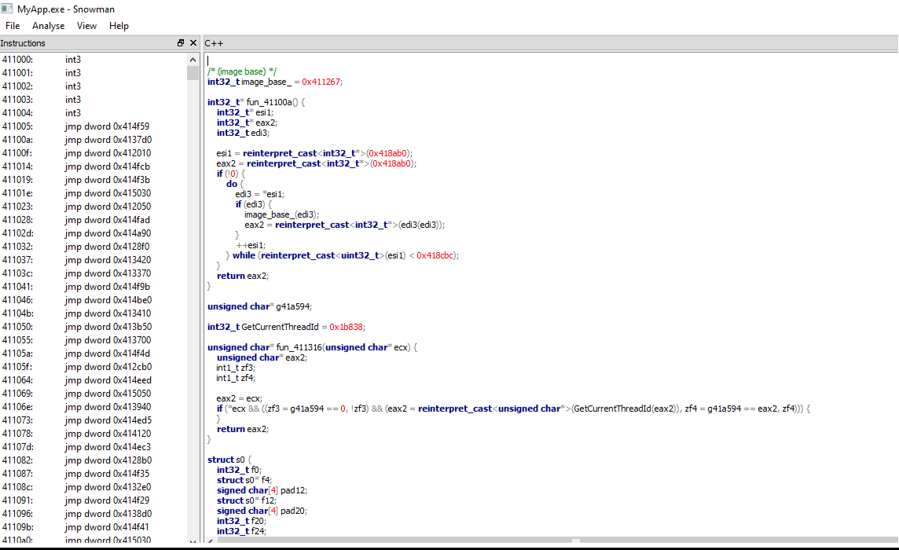

**5.Output using IDA Freeware:**

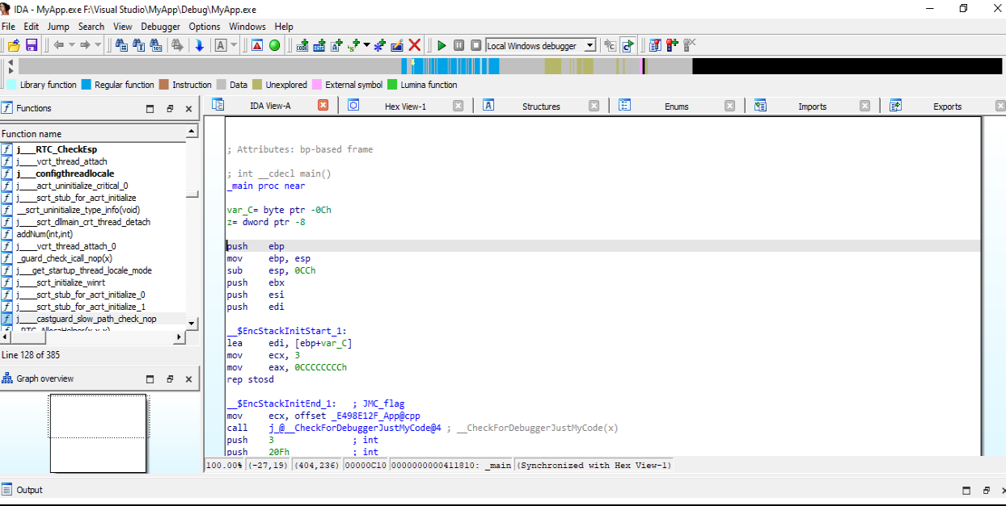

15

**Chapter 2- Requirement Analysis EXISTING SYSTEMS AND SOLUTIONS**

**Source Code Comparison using Online Comparator:-**

(<https://www.diffnow.com/compare-clips>)

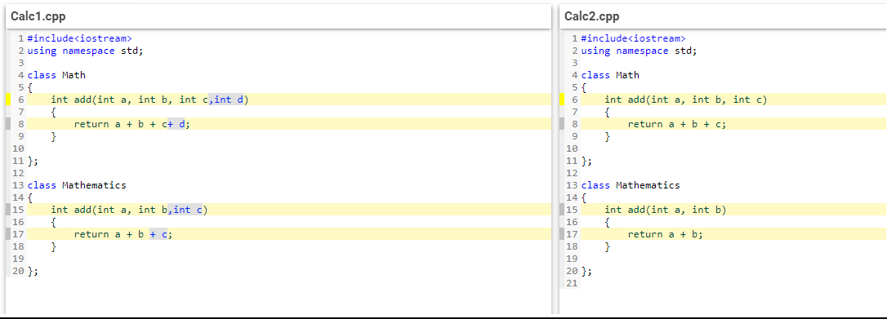

**Limitation:-**

* Performing Text-based comparison only
* Cannot display specific changes
* Not able to generate any kind of report

16

**CHAPTER 3 – METHODOLOGY ADOPTED**

**WORK BREAKDOWN STRUCTURE:-**

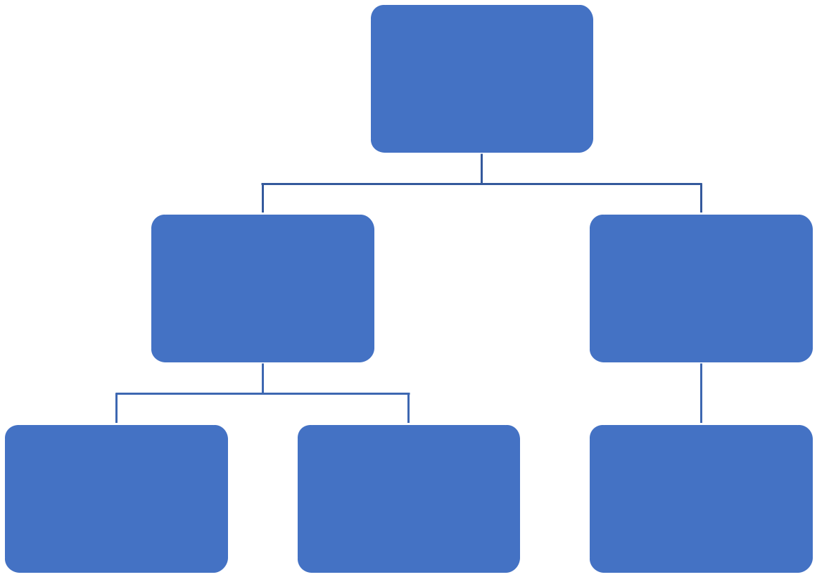

VComp

Phase-1 Phase-2

Deploy it to

File Handling Comparison Maven Repository

17

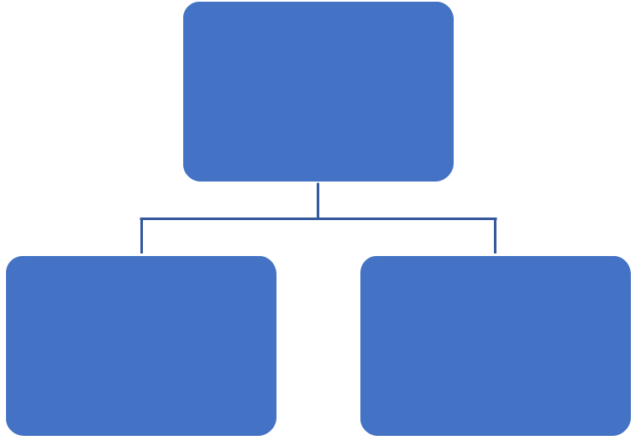

File Handling

Read data from/

Opening/Closing Write data to files

files

18

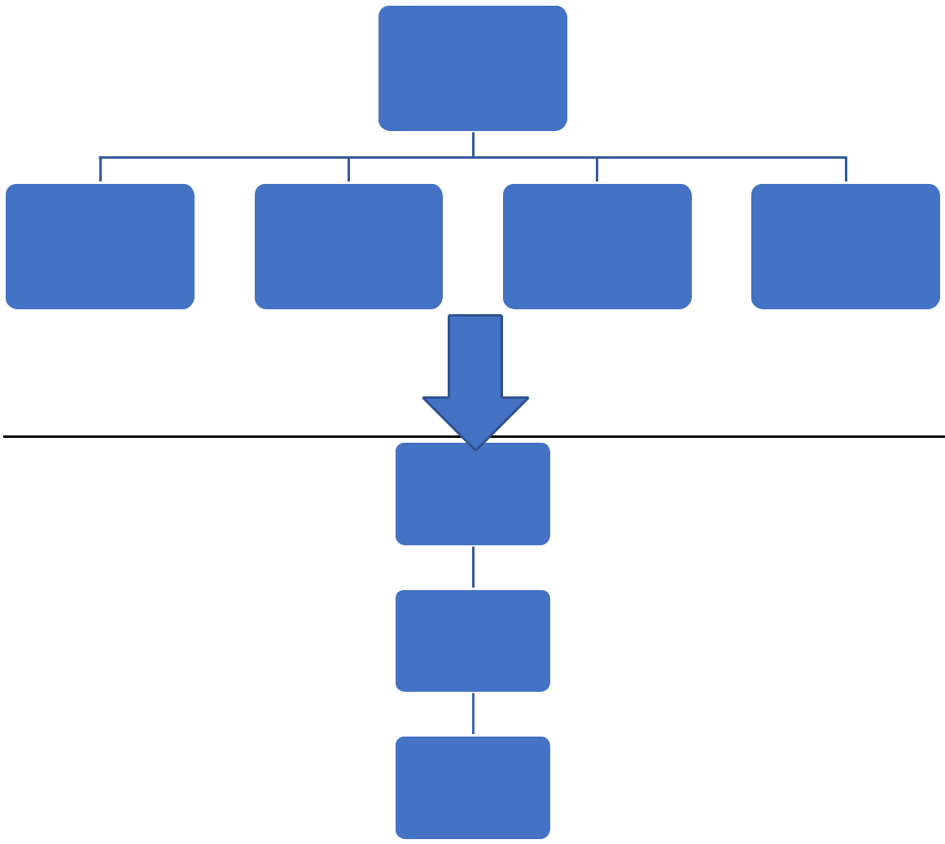

Comparison

|  |  |  |  |  |
| --- | --- | --- | --- | --- |
| Detecting | Detecting | Detecting | Detecting |  |
| Data |  |
| Class | Function | Constructor |  |
| Member |  |
|  |  |  |  |

Store

Compare

Generate

Report

**Tools and Technologies Used:-**

* **C++**

19

**PROPOSED SOLUTION:-**

For Comparison, We can use Hashing Concept.

**DIGEST OR HASH FUNCTION**

A digest or hash function is a process which transforms any random dataset in a fixed length character series, regardless of the size of input data. The output is called hash value or code, digest, image or hash. Often, the term “hash” is used both in reference to the hash function as to the hash value, which is the output of playing this function on a particular message. The data that are to be run through the hash function are called the message or preimage. The set formed by all possible messages or preimages is the message domain or message space.

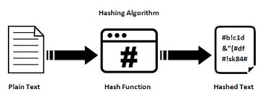

Terminology:-

* Hash table:

A data structure where the data is stored based upon its hashed key which is obtained using a hashing function.

* Hash function:

A function which for a given data, outputs a value mapped to a fixed range. A hash table leverages the hash function to efficiently map data

20

such that it can be retrieved and updated quickly. Simply put, assume S = {s1, s2, s3, ...., sn} to be a set of objects that we wish to store into a map

of size N, so we use a hash function H, such that for all s belonging to S; H(s) -> x, where x is guaranteed to lie in the range [1,N]

* Perfect Hash function:

A hash function that maps each item into a unique slot (no collisions).

**PROPERTIES IN A HASH FUNCTION**

* Any given input may produce a fixed size numerical output
* This output is deterministic, that is; the same input message or dataset always yields the same output
* A minimum variation in the original message (one bit) must yield a completely different hash (diffusion).
* The hash algorithm must cover the entire hash space uniformly, which means that any output of a hash function has, in principle, the same probability of occurrence as any other. Therefore, all values in the hash space may be an output of the hash function.

21

**DESCRIPTION OF A HASH FUNCTION**

**In general, hash functions work as follows**:

* The input message is divided into blocks.
  + Then the hash for the first block, a value with a fixed size, is calculated for the first block.
* Then, the hash for the second block is obtained and added to the previous output.
* This process is repeated until all blocks are calculated.

**Why Hashing?**

**HASH AS AN UNIQUE IDENTIFIER:-**

Hashing provides *constant time search, insert and delete operations* on average. This is why hashing is one of the most useddata structure, example problems are, [distinct elements](https://www.geeksforgeeks.org/print-distinct-elements-given-integer-array/), counting frequencies of items, finding duplicates, etc.

There are many other applications of hashing, including modern day cryptography hash functions.

Various programming languages have hash table based Data Structures. The basic idea is to create a key-value pair where key is supposed to be a unique value, whereas value can be same for different keys. This implementation is seen in unordered_set & unordered_map in C++, HashSet & HashMap in java, dict in python etc.

22

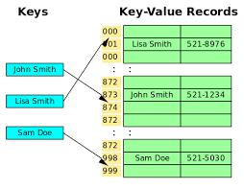

* unordered_map is used as a container that stores elements formed by the combination of key-value and a mapped value. The key value is used to uniquely identify the element and the mapped value is the content associated with the key. Both key and value can be of any type predefined or user-defined**.**
* Methods on unordered_map

A lot of functions are available which work on unordered_map. Most useful of them are – operator =, operator [], empty and size for capacity, begin and end for the iterator, find and count for lookup, insert and erase for modification.The STL library also provides functions to see internally used bucket count, bucket size, and also used hash function and various hash policies but they are less useful in real applications.We can iterate over all elements of unordered_map using Iterator.

23

**Chapter 4 - DESIGN SPECIFICATIONS**

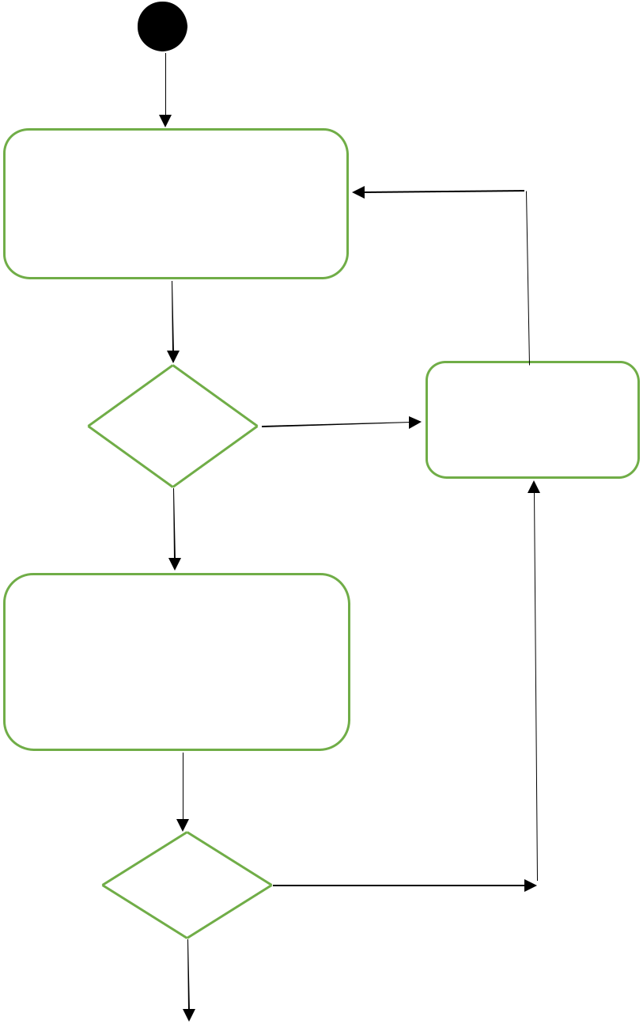

Input two file names

(with extension),which

is to be compared

Valid

Yes

Enter Choice:

1.For Brief Report

2.For Detailed Report

Valid

Yes

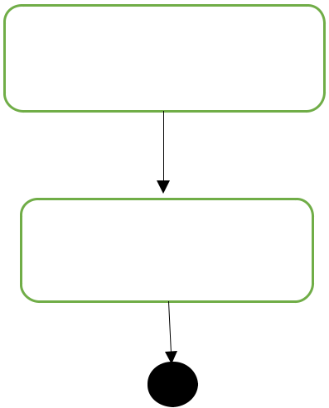

No

Error Message

No

Enter a Valid Output File

Name to generate Report

Generate Report

24

**System Screenshots:-**

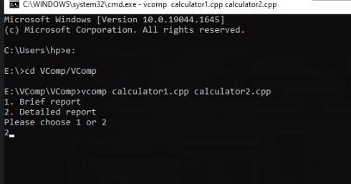

**Ouput:- Report in Text Format-**

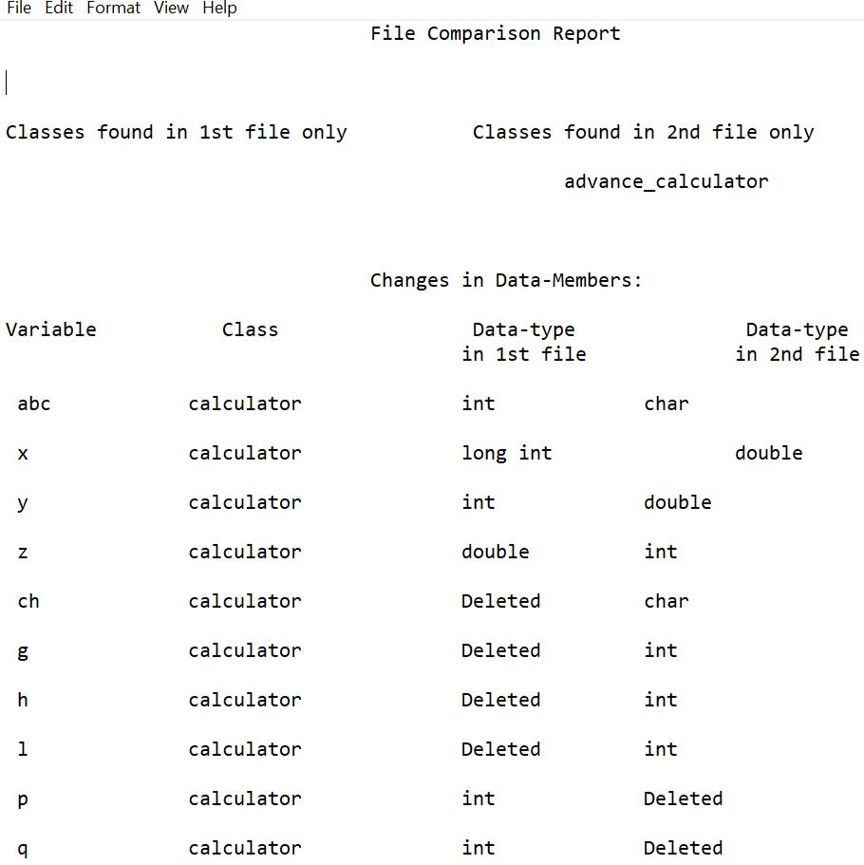

25

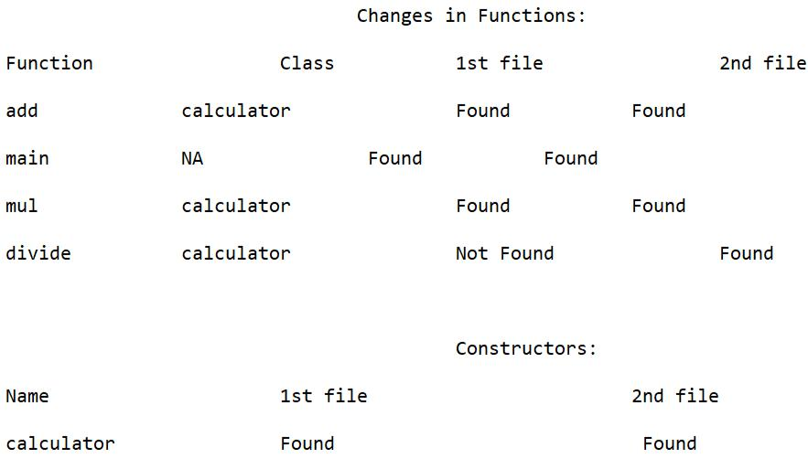

**Ouput:- Report in HTML Format-**

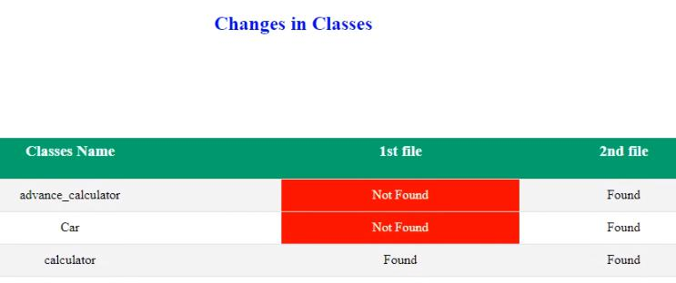

26

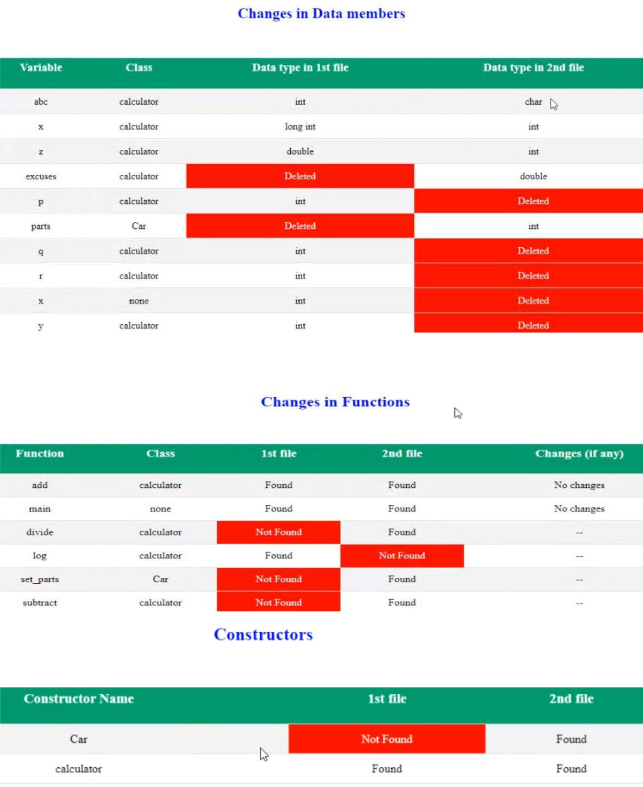

27

**Chapter 5 - CONCLUSION AND FUTURE SCOPE**

This Project provides a platform for developers or users to generate a brief or detailed report about changes made in two files in text or html format.

The project was successfully made and implemented in the company, still there is lot of improvement and features which we can further expand.

Some of them are :-

* Deployment in Maven Repository
* Make it Unix Compatible
* Adding some more features like comparing multiples files at a time
* Handling multiple reports

28

**REFERENCES**

* <https://www.tutorialspoint.com/>
* <https://stackoverflow.com/>
* <https://www.geeksforgeeks.org/>
* <https://www.giac.org/paper/gsec/3294/study-hash-functions-cryptography/105433>
* <https://www.educative.io/>

29