AN EMPIRICAL REPORT
on
From Click to Delivery: Streamlining E-commerce Operations Using Advanced Analytics
Type of Project: Case Study
Submitted to Great Lakes Institute of Management, Tamil Nadu -603102

By
Nithesh Krishna V K | DM251054
Nivashini E | DM251055
Tathagata Chakraborty | DM251081

Under the Guidance of
Faculty Guide | Dr. Narassima M S
Designation | Assistant Professor

EXECUTIVE SUMMARY
Our study aims at optimizing the entire supply chain of a retail business across borders (2-stage supply chain) using Data Analytics & Simulation. We conducted a thorough Exploratory Data Analysis (EDA) to fully understand the dataset. This analysis gave us a complete insight into the current supply chain process, covering every detail from the moment an item is ordered to its final delivery. We examined important aspects like the ordered item, city, time, and quantity. Additionally, we analysed transaction records, shipping performance, delivery timelines, and customer details, including their order region. Then we ran a GFA that captured supply chain concepts like warehouse optimization, logistics setup, and inventory policy modification. Our study aimed to improve the supply chain Responsiveness (Service Level) by ensuring better inventory control by better demand forecast, optimizing delivery routes, and implementing the right transportation strategies thereby improving the delivery performance while keeping an eye on Sustainability.
Our objective was to establish a bootstrap project from choosing the warehouses to optimizing so that the customer knows accurately when the product will be delivered instead of giving false hope. It involved forecasting the demand in the regions with maximum sales.
Our recommendations were based on the outputs that we obtained from time series forecasting for demand, warehouse locations, inventory policies and transportation techniques from AnyLogistix and some marketing-centered ML algorithms like Apriori.

TABLE OF CONTENTS

EXECUTIVE SUMMARY 2
ABSTRACT 5
CHAPTER 1 INTRODUCTION 5
CHAPTER 2 LITERATURE REVIEW 6
CHAPTER 3 DATA COLLECTION 8
SOURCE 8
PROBLEMS IDENTIFIED 9
CHAPTER 4 METHOD AND ANALYSIS 10
SETTING UP KEY PERFORMANCE INDICATORS 10
PICKING THE CITIES TO FIX WAREHOUSES 11
SETTING UP WAREHOUSE 11
WAREHOUSE DETAILS 13
WAREHOUSE WISE CHOOSING PRODUCTS FOR INVENTORY MANAGEMENT 14
MARKET BASKET ANALYSIS USING APRIORI ALGORITHM 17
RECENCY-FREQUENCY-MONETARY ANALYSIS 19
GREEN SUPPLY CHAIN 20
CHAPTER 5: DISCUSSION & INFERENCES 22
CHAPTER 6: CONCLUSION & RECOMMENDATIONS 23
REFERENCES 24
APPENDICES 25

ABSTRACT
By performing an extensive EDA, a thorough knowledge of the company's supply chain was gained. It examined key factors like customer demographics, shipping, delivery type, product prices, etc. Leveraging these data points, warehouse management, and other logistics setup was possible with AnyLogistix. Our end objective was to provide an efficient supply chain by having warehouses located at proper places to improve service levels.

CHAPTER 1 INTRODUCTION
In today’s competitive business landscape, traditional supply chain and inventory management might not be relevant. Traditional supply chains rely on manual data keeping. They frequently face issues like delay in deliveries, mismanagement of inventory and lack of optimized warehouses. And all these lead to longer lead times, higher operational costs, and reduced customer satisfaction. On top of all this right now, quick commerce has revolutionized the supply chain operations by adopting hyperlocal warehousing and last-mile delivery optimization. And quick commerce is growing to cater to various product segments proving that even traditionally non-urgent items can be delivered within minutes or hours. Initially focussed on B2C segments, now the scope is expanded to B2B quick commerce and is gaining traction as companies seek faster procurement cycles, reduced inventory holding costs, and real-time stock replenishment. The most important aspect in the E-commerce industry be it B2B or B2C is delivering products on time. Customers will never be satisfied if the products are delivered late. Smart Warehousing and IoT-driven automation is booming as they help businesses achieve real-time inventory visibility, minimize stock discrepancies, and enhance order fulfillment accuracy. RFID tags, IOT sensors and robotics are used to streamline warehouse operations and parallely collects data which can be used for future analysis. At the same time, there is a growing emphasis on sustainability and Green Supply Chain Practices which makes companies rethink their logistics strategies. Companies are focusing on route optimization to lower carbon footprints, sustainable packaging options such that their supply chain models are environmentally responsible. This is also because there is an increasing awareness and preference for sustainable operations from the perspective of investors and customers.
There are several case studies of companies adapting to the dynamic world. For e.g., Hewlett Packard (HP) adopted local production, increased vendor-managed inventory and also adopted late product configuration strategies. Supply chain volatility indexes can be created to track the level of instability that exists in the business. For e.g., oil prices, raw material costs, exchange rates, etc. Adaptability can be built into the supply chain structure to tackle major disruptions like global crises. Managing the supply chain with the help of data driven decisions is a crucial part for every organization.

CHAPTER 2 LITERATURE REVIEW
A lot of logistics companies contribute to environmental degradation through a lot of factors. It includes emissions from transports, waste generation, and resource consumption, making the adoption of green practices crucial. Green Supply Chain Management (GSCM) aims to minimize the above factors across supply chain activities (product design, procurement, manufacturing, distribution, and end-of-life product management). As concerns arise globally about environmental pollution, organisations should move from purely economic performance measures towards a sustainability focused business [1].
The paper 'A Strategic Approach to Develop Green Supply Chains' speaks about the importance of selecting the green supply chain initiatives. Since all the green practices cannot be implemented, only certain initiatives can be prioritized and implemented. There is a presence of both external and internal drivers of GSCM. There are frameworks like Analytical Network Process (ANP) and Structural Equation Modelling (SEM) to aid the managers in making strategic choices regarding green initiatives. The study proposes a combined ANP and SEM approach to strategically prioritize green supply chain initiatives. The model also includes an importance-performance matrix analysis (IPMA) to assess the effectiveness of green initiatives [2]
Big Data Analytics plays a very important role in overcoming many of the uncertainties that exist in the supply chain. It helps to reduce the bullwhip effect by better forecasting, and reduces excess inventory. The research highlights that companies integrating big data-driven demand forecasting into their supply chain strategies will improve the sustainability performance. It is done by reducing energy consumption, reducing waste and optimizing production scheduling. There is a lack of integration between GSCM and Big Data models. The predictive analytics models are not completely leveraged to enhance sustainability strategies [3]
The Center of Gravity (CoG) Method is one among many approaches that is used to find an optimal warehouse location by minimizing transportation costs. Its goal is to find a central point that balances inbound supply and outbound distribution. It is based on demand and distance. The Network optimisation model uses computation techniques to estimate the best warehouse locations, by considering a lot of objectives and the constraints present. The models use Mixed Integer Programming, Linear Programming, and Geographic Information systems [4]
AnyLogistix helps to design super-efficient supply chain networks, which reduces operational costs and transport emissions. Real world logistic scenarios can be modelled to understand sustainability impacts like CO2 emissions. Greenhouse gases can be tracked and reduced by optimising transport routes. It also supports facility location modelling, which includes renewable energy integration, and energy efficiency [5]
In the paper titled, ‘E-commerce Supply Chain analysis using the AnyLogistix computational tool’, it is explained how the software helps businesses to allow modelling of disruptions, delays, and all other uncertainties present in logistics. Scenario planning and sensitivity analysis features are present, which helps mitigate risks like bottlenecks in transportation and supplier failures [6]

CHAPTER 3 DATA COLLECTION

SOURCE
The dataset is from DataCoGlobal. It is an information and data management company. It provides services to help clients make informed decisions be it technical, non-technical, commercial or safety decisions.

ABOUT THE DATASET
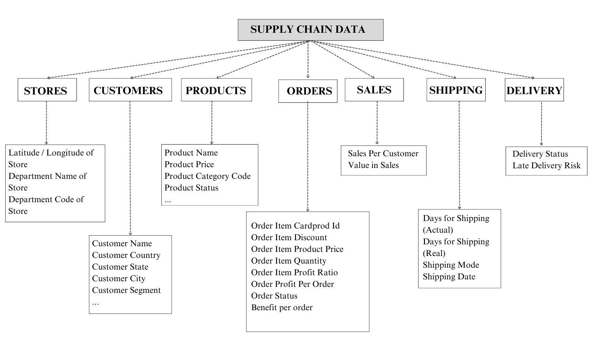
The dataset has around 1,80,000 rows with 52 columns. There are few columns which do not add much value to the analysis. Customer Email, and Password are masked. The Product Description column was completely blank with no values. The Product Status has values 0. Product Image has links but is not accessible. There are 118 unique product names, which are delivered to different customer segments. Customer segmentation included Consumer, Home Office, and Corporate. The products are purchased under four types of transactions. They are Debit, Cash, Payment and Transfer. The orders placed are for 164 unique countries, 1,089 unique states, and 359 unique cities. They are shipped to various markets, including Africa, Europe, LATAM, Pacific Asia, and USCA. Days for shipping ranged from 0 to 6 days. But the scheduled ones ranged from 0 to 4 only. Orders are categorized like Advance Shipping, Late Delivery, Shipping Cancelled, or Shipping on Time. Shipping options include Standard Class, First Class, Second Class, and Same Day. There are around 98,977 late deliveries and 81,543 on-time deliveries based on the Delivery Status column. Instead of focusing on all the deliveries we took specific regions and analysed it, which is explained later in the document. Based on manual feature engineering only the relevant columns which add value to the analysis are used.

PROBLEMS IDENTIFIED
- High Risk of Late Deliveries: It is identified from the dataset that there is 57% risk of late delivery. Within the late delivery, the delivery status is late for 95.72% of the orders and for the rest shipping is cancelled. And 33% of it has the order status as pending payment.
- Lack of Warehousing Infrastructure: No warehouse information present. So, we are assuming they do direct delivery without any warehouse in different regions. It shows that late delivery is a potential issue impacting the business and payments.
- Sustainability Concerns: The current supply chain shows inefficiencies in terms of transportation and logistics which will lead to increased carbon footprint. Thus, implementing Green Supply Chain Management practices is necessary to reduce emissions and optimize transport routes.

CHAPTER 4 METHOD AND ANALYSIS
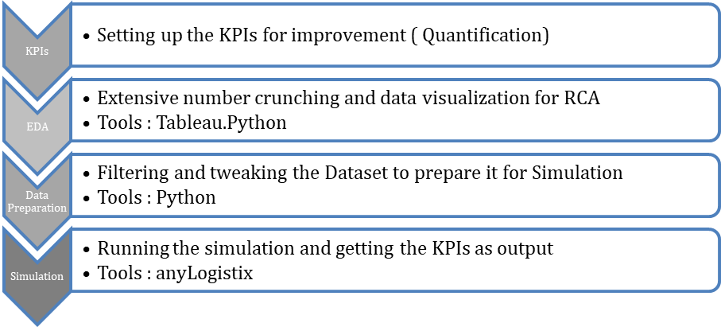
Based on the problem statement first we set our KPIs for improvement (Performance Metrics) because what gets measured gets solved.

SETTING UP KEY PERFORMANCE INDICATORS
- Service Level: The ultimate KPI of a Responsive Supply Chain
- Shipping Delay Variance: It should measure the difference between the actual number of shipping days and the scheduled shipping days. Formula: Actual Shipping Day – Scheduled Days
- Timely Delivery Rate: It should track the percentage of shipments that meet the agreed delivery timeframe (SLA). Formula: (No of orders delivered on time / Total no of orders) * 100
- Average Fulfilment Time: It should represent the typical time taken for a shipment to reach the customer. Formula: Average (Actual Shipping Days)

PICKING THE CITIES TO FIX WAREHOUSES
The top two order regions are identified from the dataset based on the quantity ordered. They are Central America, and Western Europe. In these regions, we found the top 2 countries based on the quantity ordered. For each country, we took the top 10 cities to analyse further. Thus, a total of 2 regions, 4 countries and 40 cities are considered.

SETTING UP WAREHOUSE
AnyLogistix Implementation:
- Green Field Analysis: We placed the 40 cities across countries in the map.
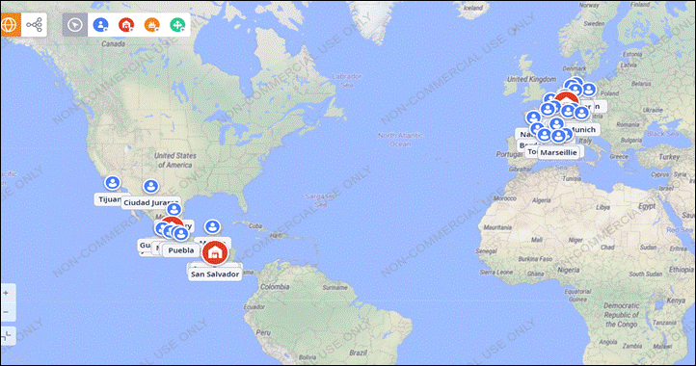
We chose the top products and grouped them. Added their cost price and selling price and unit of measurement.
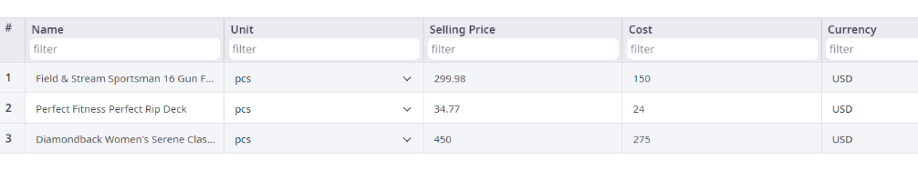
We added the demand (order quantity and order demand) for each of the 40 cities (From forecasting). For some products we added Poisson distribution (since people don’t order it regularly). Using Python, we checked what kind of distribution they are following and found their mean, standard deviation and added those in AnyLogistix.
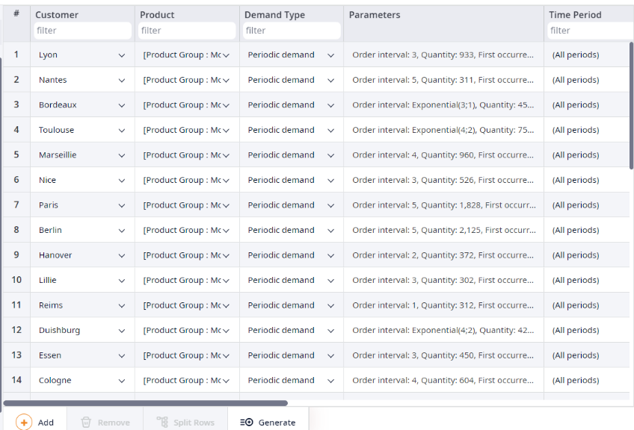
We ran the Green Field Analysis and found 3 Warehouses. The locations for these are Juventino Rosas, San Salvador, and Morbach. The products which have to be stored in larger quantities are estimated using Pareto analysis. The three warehouses are meant to cater to the top cities in terms of order.

WAREHOUSE DETAILS
Warehouse 1: Juventino Rosas
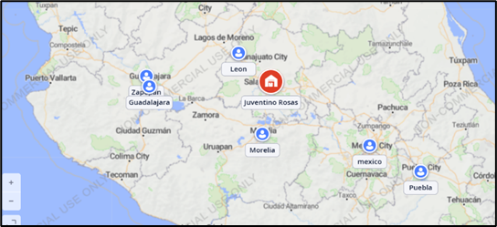
- Order Region: Central America
- Order Country: México
- Order cities: León, Morelia, Mexico City, Puebla, Juárez, Guadalajara, Zapopan, Tijuana, Monterrey, Mérida.

Warehouse 2: San Salvador
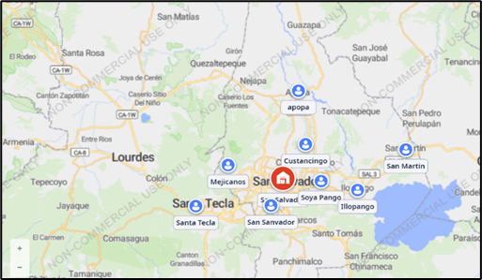
- Order Region: Central America
- Order Country: El Salvador
- Order cities: San Salvador, Mejicanos, Santa Ana, Ilopango, Sonsonate, San Martín, Antiguo Cuscatlán, Soyapango, Apopa, Cuscatancingo

Warehouse 3: Morbach
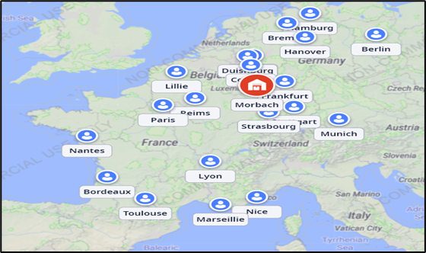
- Order Region: Western Europe
- Order Country: Francia, Alemania
- Order cities: Paris, Marseille, Nice, Lyon, Bordeaux, Reims, Nantes, Lille, Berlín, Munich, Cologne, Bremen, Essen, Duisburg, Hanover, Stuttgart, Hamburgo, Toulouse, Strasbourg, Frankfurt

WAREHOUSE WISE CHOOSING PRODUCTS FOR INVENTORY MANAGEMENT
Each warehouse requires forecasting of products which are highly selling in that particular region to manage inventory. The approach for this is to pick top products which contribute to 80% sales or 80% quantity sold in the cities catered by the warehouse. Time series forecasting is performed on those products to hold inventory. It is based on the idea that those are the products which will be sold/ordered most, hence stocking those will help in on-time delivery without stocking out, thus helping to solve the late delivery issue. `
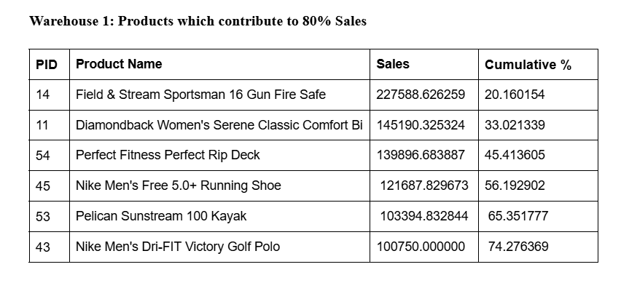
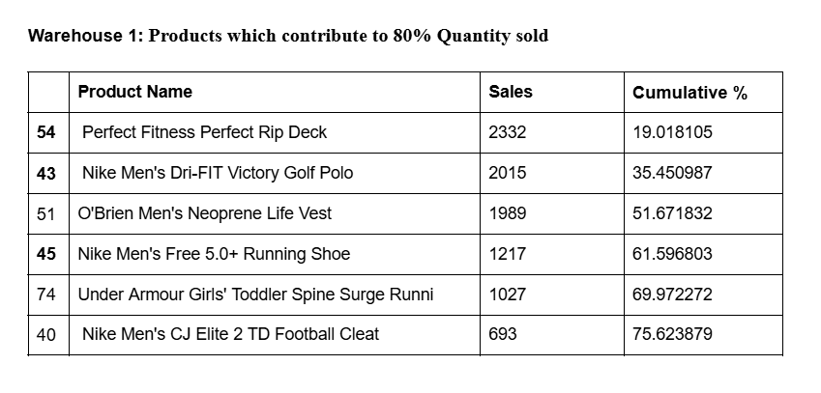
Unique products from the above analysis for Warehouse 1
- Perfect Fitness Perfect Rip Deck
- Nike Men's Dri-FIT Victory Golf Polo
- O'Brien Men's Neoprene Life Vest
- Nike Men's Free 5.0+ Running Shoe
- Under Armour Girls' Toddler Spine Surge Running
- Nike Men's CJ Elite 2 TD Football Cleat
- Field & Stream Sportsman 16 Gun Fire Safe
- Diamondback Women's Serene Classic Comfort Bi
- Pelican Sunstream 100 Kayak
Similarly, for each of the warehouses, products which contribute to 80% sales and quantity are used to analyze unique products to consider for forecasting and these are added in the appendix.

INVENTORY FORECASTING FOR EACH PRODUCT IN THE WAREHOUSE
The top products contributing to 80% sales or quantity is found. With this, it is required to perform time series forecasting based on the past historic data to get the forecasted inventory levels for each of these products. All the products show a seasonality. So, SARIMA seems to be an ideal. Also, standard deviation for each of these products is calculated. The forecast values are as follows for each of the warehouse.
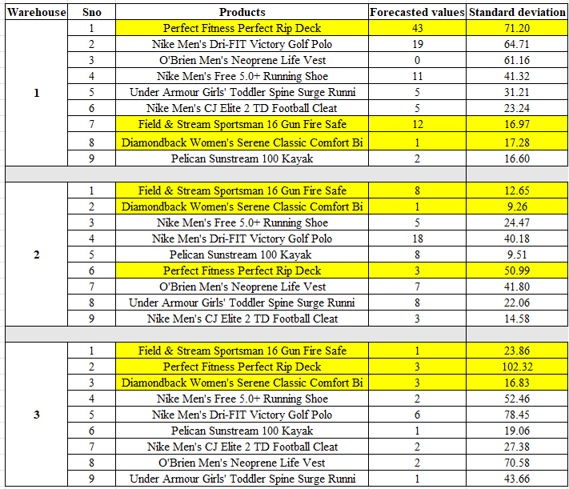

MARKET BASKET ANALYSIS USING APRIORI ALGORITHM
Today's data-driven business environment understanding customer purchasing behavior is crucial for efficient supply chain operations. Apriori based Market Basket Analysis helps identify frequently bought-together products. Apriori can improve inventory management, product bundling, warehouse optimization, and logistics efficiency.
- Confidence: Measures how often the consequent appears when the antecedent is present. Higher confidence means a stronger association between products.
- Lift: Measures how much more likely the consequent is to appear given the antecedent compared to its independent occurrence. Lift > 1 means the rule is stronger than random chance
- Support: Measures how often the rule appears in transactions. Higher support means the rule is common and widely applicable.
For Product Bundling, it is good to find strongly associated products that frequently appear together in transactions. Lift ensures strong product association (good for cross-selling). Support ensures popularity (bundles should be common to sell well). Confidence ensures reliability (higher chance customers will buy the suggested bundle). Hence the order of sorting is sort descending by lift, support, confidence.
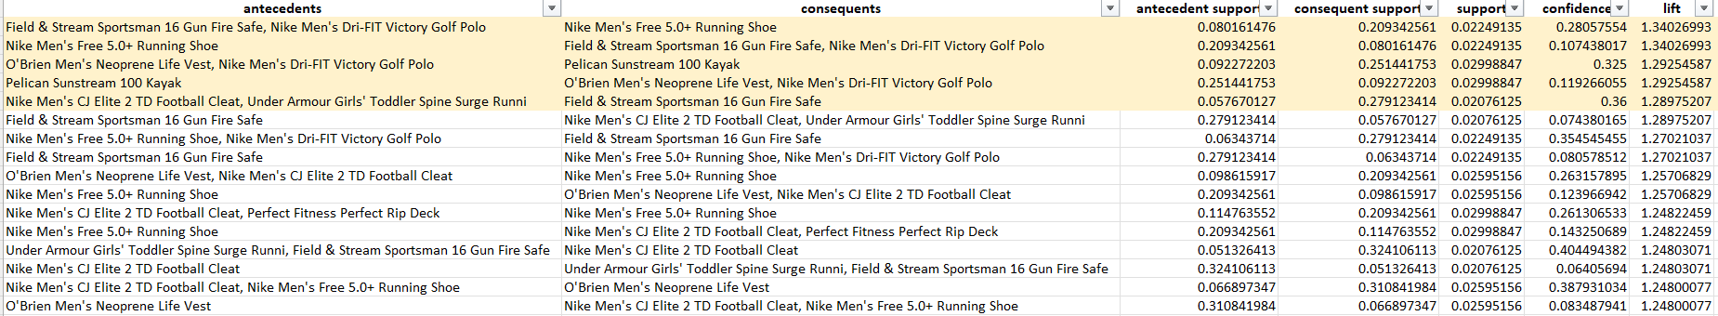
For warehouse 1, from the output of the Apriori algorithm, it is inferred that customers who buy Nike Men’s Free 5.0+ Running Shoes often purchase Nike Dri-FIT Victory Golf Polo and Field & Stream Gun Fire Safe. This suggests that warehouses can store these items closer together, reducing picking and fulfillment time. The combination of Life Vests, Golf Polo and Kayaks suggests an opportunity for bundling and promotions. Providing discounts on kayaks when a customer buys life vests and polo helps increase overall sales volume. The Nike CJ Elite 2 TD Football Cleat and Field & Stream Gun Fire Safe appear together frequently. This suggests optimized warehouse slotting by grouping related items together, reducing retrieval time in large distribution centers. Similarly, Apriori market basket analysis is used for each warehouse to curate strategies specific for each warehouse. The output of each of the warehouses is attached in the appendix. Hence this e-commerce business should integrate Apriori analysis into inventory management software to leverage it for better understanding the purchase behavior of consumers which helps in enhancing supply chain efficiency by:
- Reducing stock out situations through demand forecasting.
- Improving warehouse operations with strategic product placement.
- Boosting sales via personalized promotions, discounts & bundling strategies.
- Improvising customer experience by offering the right products at the right time through recommendations.
Apriori algorithm helps businesses to enhance their operational efficiency, reduce costs, and increase customer satisfaction in an increasingly competitive marketplace.

RECENCY-FREQUENCY-MONETARY ANALYSIS
For the customer segmentation part, there are a lot of clustering algorithms and its variations available. But, RFM is easier to perform, unlike the ML algorithms which require proper selection of parameters. RFM provides clear recommendations for the clusters. RFM is about how recently they purchased, how frequently and how much money they spend. The segments obtained from RFM are big spenders, new customers, loyal customers, etc. One can define this based on the RFM values. In clustering, the clusters are labelled after studying their characteristics.
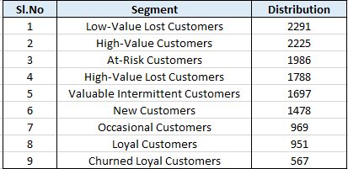
A significant portion of customers from low-value and high-value lost customers have been left out. There is a need for win-back campaigns with personalized offers. There is a need for proactive engagement strategies to prevent churn. Exclusive perks and loyalty programs are needed to maintain profits. New customers are also present in good numbers. The company can enhance customer lifetime value, and strengthen its market position.

GREEN SUPPLY CHAIN
Converted the GFA into simulation in AnyLogistix to add more parameters. As we are putting stress on Sustainability, we tried different combinations of transportation and inventory policies to optimize our Net CO2 emissions. At the same time our service level needed to be checked. So, there is a trade-off between Service Level and Net CO2 emission. We found that EOQ Policy is best suited for this and chose our vehicle accordingly. We used the below mentioned formula to get reorder points and quantity for each of the products using Python.
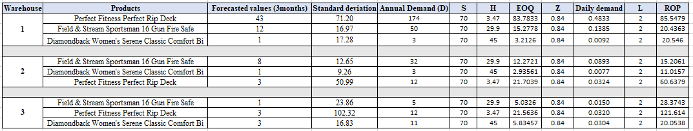
We had the forecasted value and standard deviation of every product. We took the ordering cost based on the Industrial standards in retail segments. Holding cost is 10% of the selling price. We assumed 85% service level and found the values of EOQ and ROP.
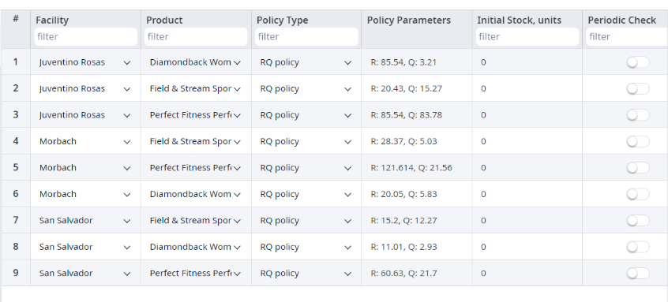
We added other parameters accordingly. For CO2 emission we added calculation in Path parameter of AnyLogistix. We ran the simulation to get the final KPIs.
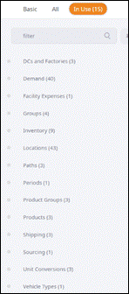
OUTPUT
AVAILABLE INVENTORY

SERVICE LEVEL: 96.5%
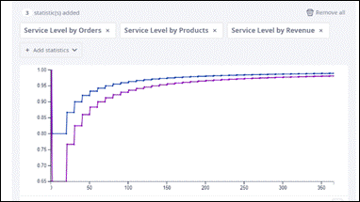
NET CO2 EMISSION:
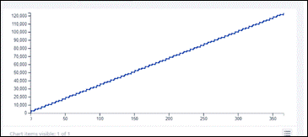
The objective was to have a tradeoff between service level and sustainability. For this AnyLogistix software was used to evaluate different inventory policies like Min-Max, EOQ, and Fixed Time Period. After analysis EOQ emerged as the most effective in optimizing inventory while maintaining high service levels. Along with this various vehicle types and inventory strategies were explored to reduce carbon emissions. With the analysis of transportation and inventory decisions, we were able to minimize net CO₂ emissions to 110,225 while maintaining a 96.5% service level. This approach allowed us to enhance sustainability without compromising operational efficiency.

CHAPTER 5: DISCUSSION & INFERENCES
- Profitability & Cost Management: A strong profitability with efficient cost control is required and maintained. Transportation costs are a major expense. It always indicates a room for further optimization.
- Service Level Performance: A high service level of 96.5% is achieved. It ensures strong order fulfillment and customer satisfaction. Service levels improved steadily over time, reflecting the effectiveness of the supply chain strategy.
- Inventory Management: The inventory developed follows a cyclical replenishment pattern, which demonstrates stable demand and supply planning. The chosen inventory policy effectively balanced stock levels while minimizing holding costs.
- Sustainability Considerations: Strategies are successfully implemented to reduce CO₂ emissions while maintaining operational efficiency. A trade-off between service level and sustainability was effectively achieved.
- Overall Supply Chain Performance: Profitability, service reliability, and sustainability are all integrated at the end. Improvements further in transportation and inventory fine-tuning will be able to enhance overall performance.

CHAPTER 6: CONCLUSION & RECOMMENDATIONS
The scope of the study was to optimize the supply chain of a retail business by leveraging data analytics and some simulation techniques. Using AnyLogistix, we conducted Green Field Analysis to identify optimal warehouse locations and streamline the logistics setup. Additionally, time series forecasting models were used to predict demand patterns, allowing for improved inventory management and route optimization. The simulation also tried to achieve maximum service levels and sustainable supply chain. This is expected to deliver the following benefits:
- Decreased delivery delays
- Reduced operational costs through efficient logistics.
- Higher customer satisfaction due to faster and more reliable service.
- Enhanced sustainability with optimized transport routes and lower emissions.
The company can use the market basket analysis to have better bundling and offers. AI powered logistics planning can be deployed for better delivery routes which ultimately reduces fuel costs. In a retail segment, reverse logistics systems should be designed efficiently. Planning and forecasting can be done collaboratively with the suppliers to have a better procurement strategy.

REFERENCES
[1] Chin, T. A., Tat, H. H., & Sulaiman, Z. (2015). Green supply chain management, environmental collaboration and sustainability performance. Procedia CIRP, 26, 695–699. https://doi.org/10.1016/j.procir.2014.07.035

[2] Masoumik, S. M., Abdul-Rashid, S. H., Olugu, E. U., & Ghazilla, R. a. R. (2015). A strategic approach to develop green supply chains. Procedia CIRP, 26, 670–676. https://doi.org/10.1016/j.procir.2014.07.091

[3] Seyedan, M., & Mafakheri, F. (2020). Predictive big data analytics for supply chain demand forecasting: methods, applications, and research opportunities. Journal of Big Data, 7(1). https://doi.org/10.1186/s40537-020-00329-2

[4] Szczepański, E., Jachimowski, R., Izdebski, M., & Jacyna-Gołda, I. (2019). Warehouse location problem in supply chain designing: a simulation analysis. Archives of Transport, 50(2), 101–110. https://doi.org/10.5604/01.3001.0013.5752

[5] Longo, F., Manfredi, K. A., Solina, V., Conte, R., & Cosma, A. (2024). Improving supply chain sustainability and resilience via AnyLogistix: Research Trends and Future Challenges. Procedia Computer Science, 232, 1721–1728. https://doi.org/10.1016/j.procs.2024.01.170

[6] Hermogenes, L. R. D. S., De Almeida, I. D. P., Moreira, M. Â. L., De Araújo Costa, I. P., Gomes, C. F. S., Santos, M. D., De Oliveira Costa, D., & De Moura Pereira, D. A. (2022). E-commerce Supply Chain analysis using the ANYLOGISTIX computational tool. Procedia Computer Science, 214, 487–494. https://doi.org/10.1016/j.procs.2022.11.203

APPENDICES

EDA Files
- Customer Segments https://public.tableau.com/app/profile/nithesh.v.k/viz/CustomerSegment_17421315038070/CustomerSegment?publish=yes
- https://drive.google.com/file/d/1SbOSlVNKvMme72WWkXeMks0v9xFFAL2U/view?usp=sharing

Picking products for warehouse
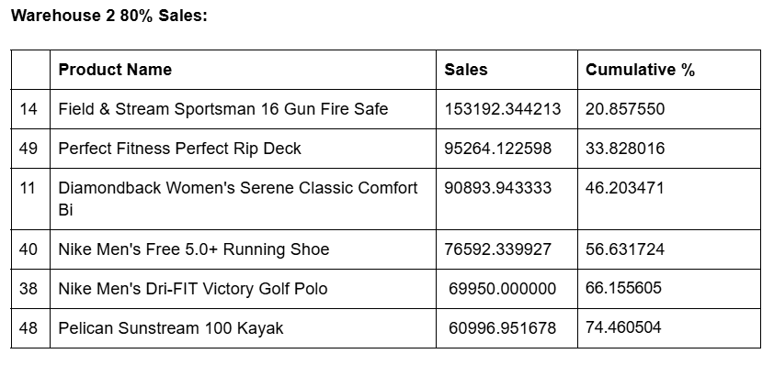

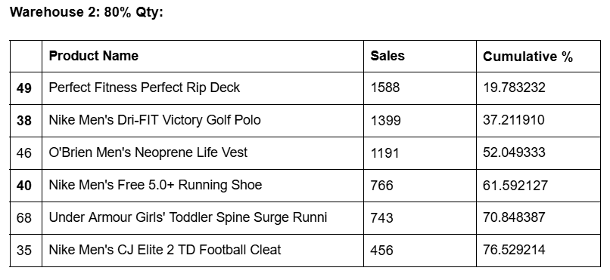

9 Unique products of warehouse 2
- Field & Stream Sportsman 16 Gun Fire Safe
- Diamondback Women's Serene Classic Comfort Bi
- Nike Men's Free 5.0+ Running Shoe
- Nike Men's Dri-FIT Victory Golf Polo
- Pelican Sunstream 100 Kayak
- Perfect Fitness Perfect Rip Deck
- O'Brien Men's Neoprene Life Vest
- Under Armour Girls' Toddler Spine Surge Running
- Nike Men's CJ Elite 2 TD Football Cleat

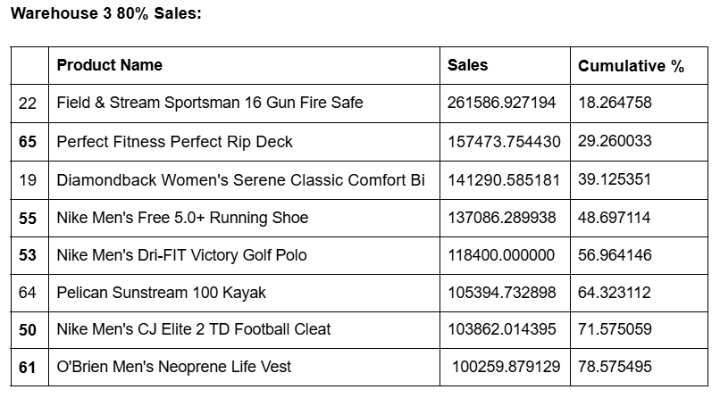

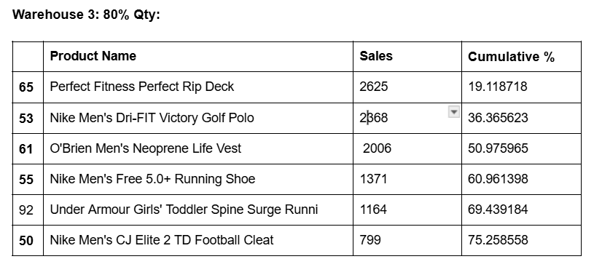
Unique products of warehouse 3
- Field & Stream Sportsman 16 Gun Fire Safe
- Perfect Fitness Perfect Rip Deck
- Diamondback Women's Serene Classic Comfort Bi
- Nike Men's Free 5.0+ Running Shoe
- Nike Men's Dri-FIT Victory Golf Polo
- Pelican Sunstream 100 Kayak
- Nike Men's CJ Elite 2 TD Football Cleat
- O'Brien Men's Neoprene Life Vest
- Under Armour Girls' Toddler Spine Surge Running

Codes and files
https://drive.google.com/drive/folders/1FgzOgvG18Exytt7XnNZ-TgiqWhLcKaCi?usp=sharing

