CS 260 / CS 371 — Image Processing
Project 1 Report: Rows of Armenian Text in Stone Inscriptions
American University of Armenia — College of Science and Engineering
[Your Full Name]
Individual submission

1. Introduction
This project implements and analyzes the assigned ImageJ pipeline for detecting / enhancing Armenian inscriptions on stone monuments (tapanakars and khachkars). Armenian letterforms rely heavily on vertical strokes; therefore the pipeline emphasizes directional vertical-edge extraction, morphological cleaning, spectral bandpass filtering, skeletonization, and Hough-based estimation of text-row positions.
The report uses the official assignment numbering (Steps 0–16). Tasks 2–4 study Steps 2, 5, and 10 via with/without comparisons. Task 5 studies Bandpass parameters in Step 11. Task 6 proposes an algorithm for Step 16.
Different monument photographs were used across Tasks 2, 3, and 4 (as encouraged by the assignment’s multi-image design). Within each task, the with/without runs are intended as the same pipeline on that task’s chosen photograph. A complete default-parameter pipeline for one monument (Image 1) is also included from original through Hough.
Source links (fill in): Image 1 original: [URL]. Task 2 original: [URL]. Task 3 original: [URL]. Task 4 original: [URL].

2. Task 1 — Purpose of Each Official Step (0–16)
Step 0 — Selection. Select a tombstone/khachkar/monument image with Armenian inscriptions. Deliverable: original file + source link.
Step 1 — Scale & grayscale (S00). Scale width to 400 px; convert to 8-bit. Standardizes size and reduces computation.
Step 2 — Mean filter. Mean filter, radius 1.0 on S00. Suppresses high-frequency stone grain before derivatives; may slightly blur fine strokes.
Step 3 — Vertical kernel → S01. Convolve with [1 0 −1; 2 0 −2; 1 0 −1]. Emphasizes vertical boundaries (horizontal gradients).
Step 4 — Opposite-polarity kernel → S02. Convolve with [−1 0 1; −2 0 2; −1 0 1]. Complementary vertical-edge polarity (not a horizontal Sobel-y kernel).
Step 5 — Translate S01/S02. S01 +1 px right, S02 −1 px left. Compensates asymmetric-kernel spatial offset before combining.
Step 6 — Add, invert, equalize, unsharp (Result of S01). Image Calculator Add; Invert; Enhance Contrast (Equalize, saturated 0.00%); Unsharp Mask (σ=10, weight=0.60). Merges gradients, dark-on-light contrast, sharpening.
Step 7 — Threshold (Result of S02). Bottom = top = 0 (as assigned). Binarizes candidate strokes.
Step 8 — Horizontal dilation (Result of S03). Translate + OR. Bridges small horizontal gaps in characters.
Step 9 — Vertical erosion (Result of S04). Translate down + AND. Trims spurious vertical thickness/noise.
Step 10 — Median filter. Median radius 1.0. Removes salt-and-pepper binary noise while preserving major edges.
Step 11 — Bandpass (S05). FFT Bandpass: large=40 px, small=10 px (defaults). Removes broad shading and fine speckles; keeps mid-scale letters.
Step 12 — Unsharp + equalize (S06). Unsharp (10, 0.60) + equalize; Log histogram of S06. Restores edge contrast after FFT filtering.
Step 13 — Histogram threshold (S07). Threshold using darkest intensity and darkest gap in S06 histogram.
Step 14 — Skeletonize (S08). Reduce binary regions to 1-pixel centerlines for Hough voting.
Step 15 — Hough transform. Hough_Transform.java on S08 → Hough of S08. Points vote as sinusoids in (ρ,θ); intersections mark lines.
Step 16 — Centroids. y-coordinates of centroids of prominent dark regions near the vertical middle axis of Hough of S08 → text-row positions.

3. Full default pipeline example (Image 1)
Image 1 is a reddish khachkar processed with the full default pipeline (no step omitted; Bandpass at 40/10). Selected stages:
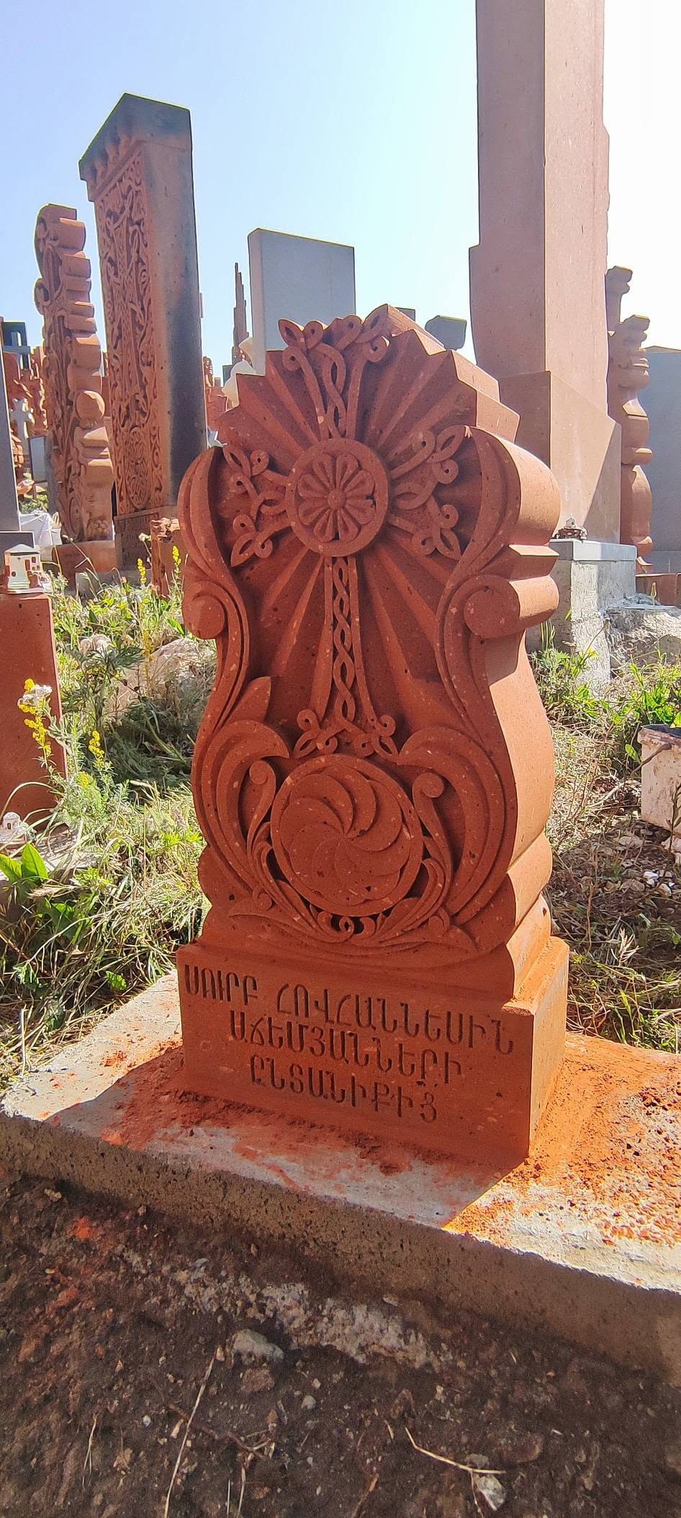 | 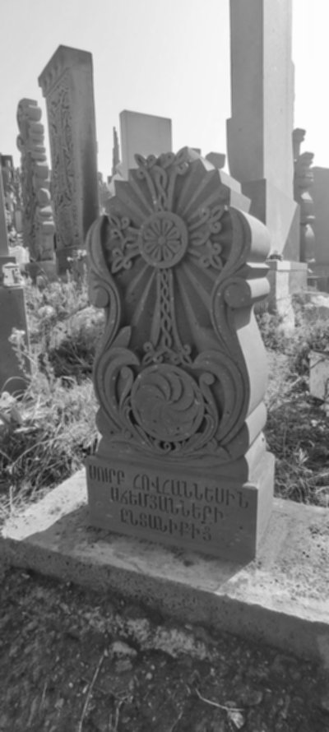
Figure 1. Original photograph (Image 1). | Figure 2. S00 — scaled width 400, 8-bit grayscale.

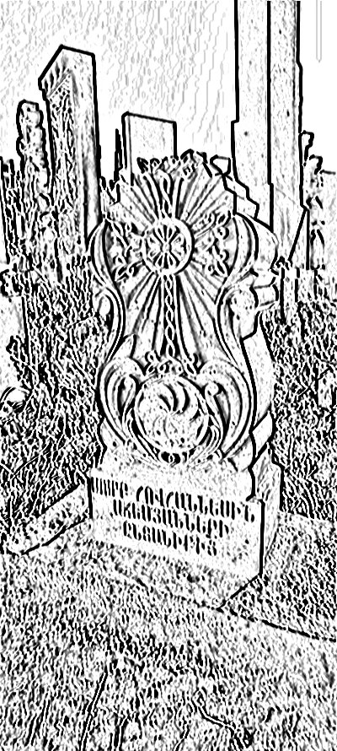 | 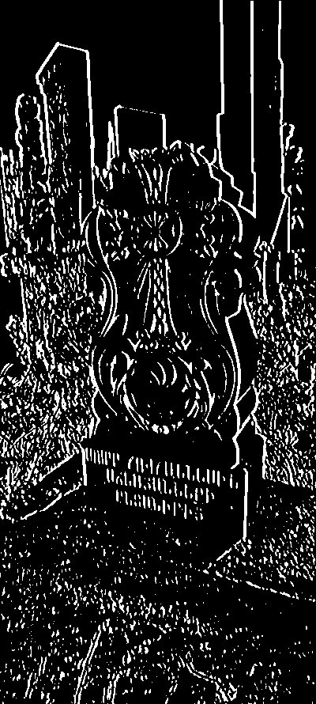
Figure 3. Result of S01 after combine / invert / equalize / unsharp (Step 6). | Figure 4. Result of S02 — binary threshold (Step 7).

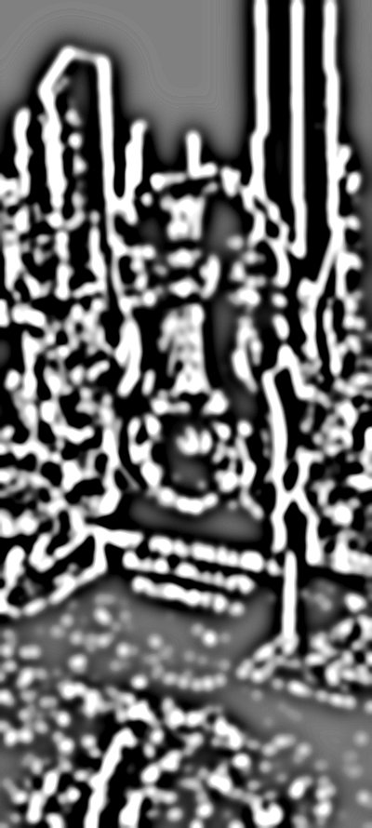 | 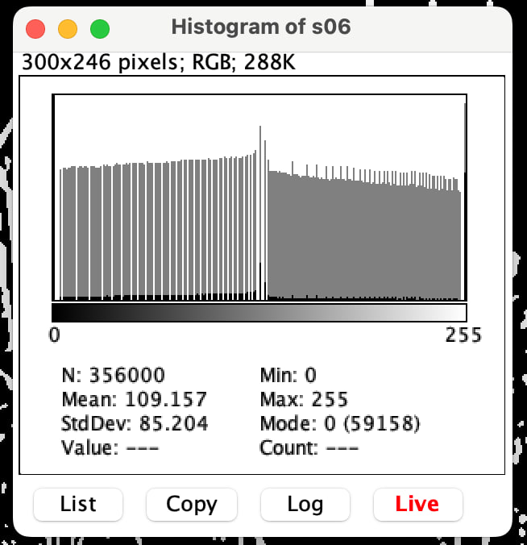
Figure 5. S06 after Bandpass + sharpen/equalize. | Figure 6. Log-scale histogram of S06 (assignment deliverable).

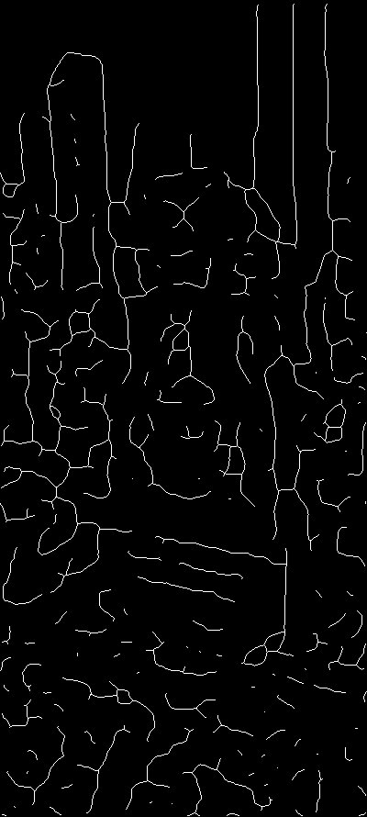 | 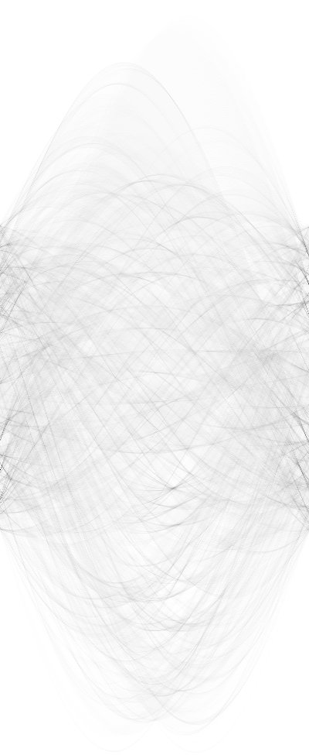
Figure 7. S08 — skeletonized centerlines (Step 14). | Figure 8. Hough of S08 (Step 15).

4. Task 2 — Importance of Step 2 (Mean Filter)
Assignment: run the algorithm twice on the same photograph (WITH / WITHOUT Step 2). Then find one image where inclusion helps and another where omission helps. Different photographs may be used for those two cases, but each case must itself be a same-photo pair.
Original used for this Task 2 comparison set:
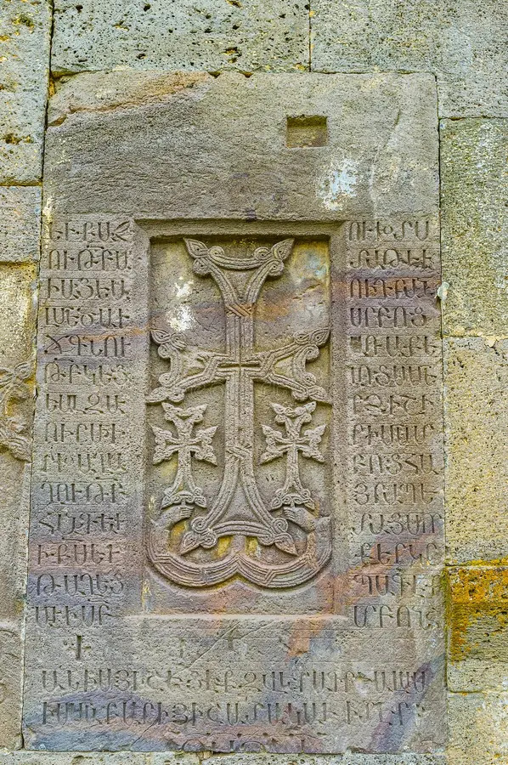
Figure 9. Original photograph used for the Step 2 study (khachkar with dense side inscriptions).
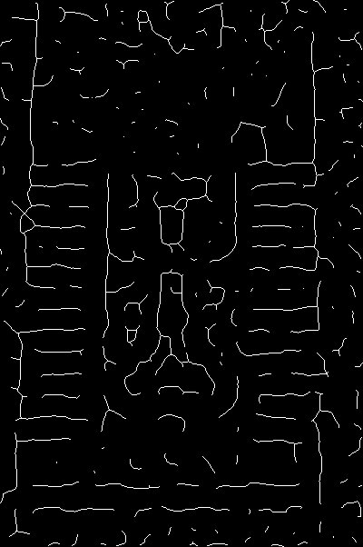 | 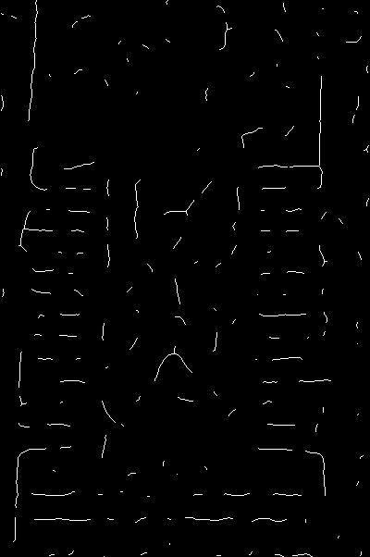
Figure 10. S08 WITH Step 2 (Mean). Denser skeleton; more short branches remain. | Figure 11. S08 WITHOUT Step 2. Sparser / cleaner but less complete centerlines.

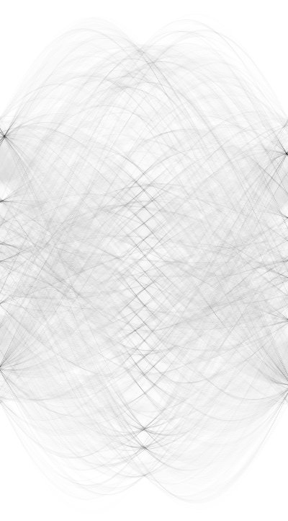 | 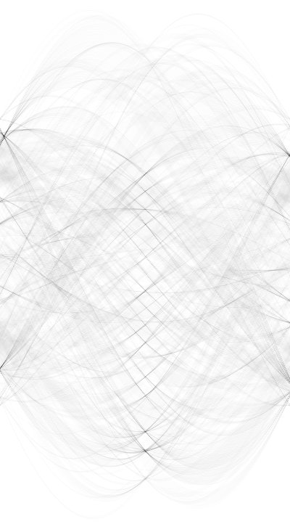
Figure 12. Hough WITH Step 2 — denser voting patterns. | Figure 13. Hough WITHOUT Step 2 — less densely filled accumulator.

Observation: WITH Mean yields roughly 2.4× more S08 foreground pixels than WITHOUT on this pair. Including Step 2 preserves more structural strokes on weathered stone grain; omitting it reduces clutter but also loses connecting strokes.
When inclusion helps: highly weathered / coarse stone where micro-texture creates false edges — mild Mean (r=1) stabilizes later derivatives.
When omission helps: already clean high-contrast engravings — Mean can blur thin strokes; omitting it keeps sharper corners.
Note: if a second opposite-case monument pair is available, insert it here labeled Image B to fully match the “one better with / one better without” wording.

5. Task 3 — Importance of Step 5 (Translation)
Step 5 translates S01 +1 px and S02 −1 px to align asymmetric kernel responses before addition. A different source photo was used for this task than for Task 2 (allowed).
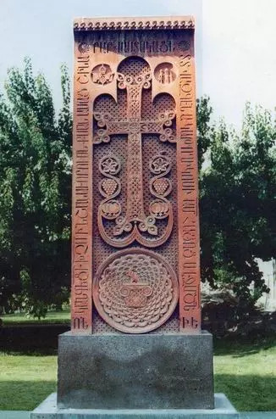
Figure 14. Original photograph used for the Step 5 study.
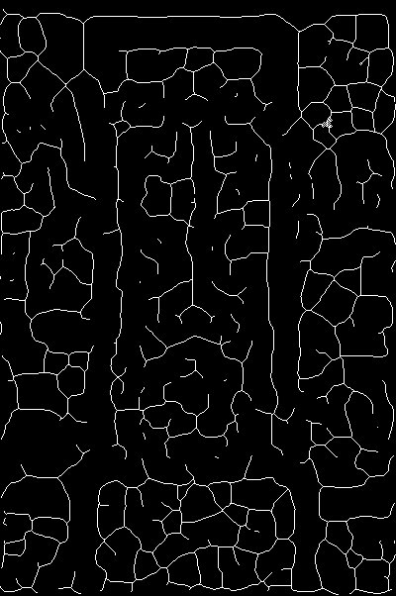 | 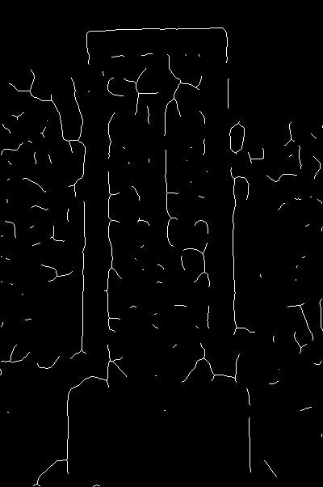
Figure 15. S08 WITH Step 5. Dense coherent skeletal structure. | Figure 16. S08 WITHOUT Step 5. Much sparser / fragmented centerlines.

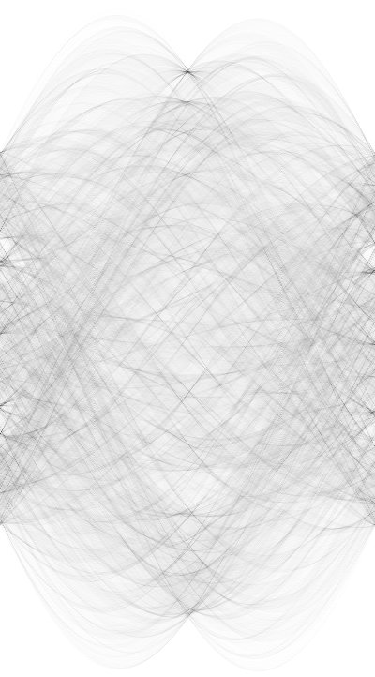 | 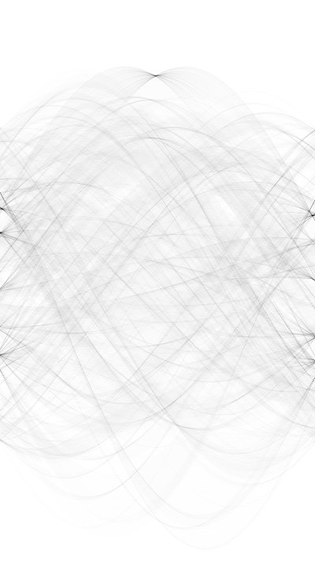
Figure 17. Hough WITH Step 5 — stronger organized accumulator. | Figure 18. Hough WITHOUT Step 5 — weaker structure.

Conclusion: omitting translation misaligns opposite-polarity gradients, causing cancellation/doubling after Add and poorer binaries. On this experiment, WITH Step 5 produced about 2.7× more S08 foreground pixels and a clearly stronger Hough map. Step 5 is critical for edge localization.

6. Task 4 — Importance of Step 10 (Median Filter)
Official Step 10 is the Median filter (radius 1.0) on Result of S04 — not Bandpass (Bandpass is Step 11). A third source photograph was used for this task.
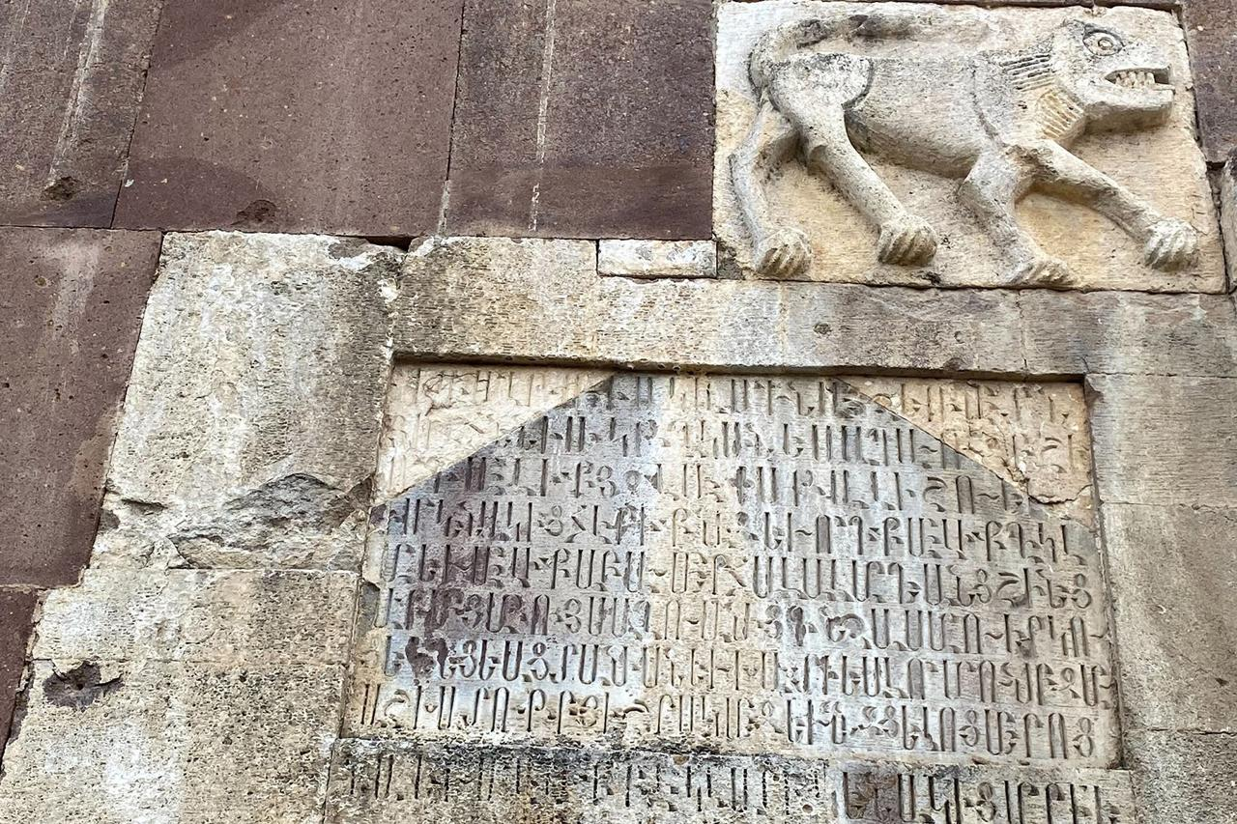
Figure 19. Original photograph used for the Step 10 (Median) study.
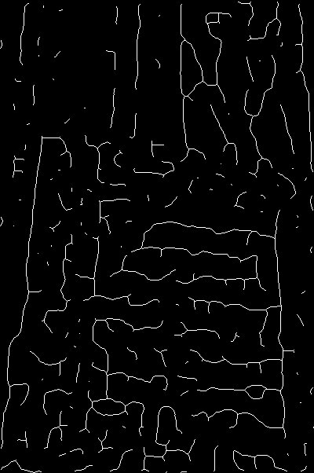 | 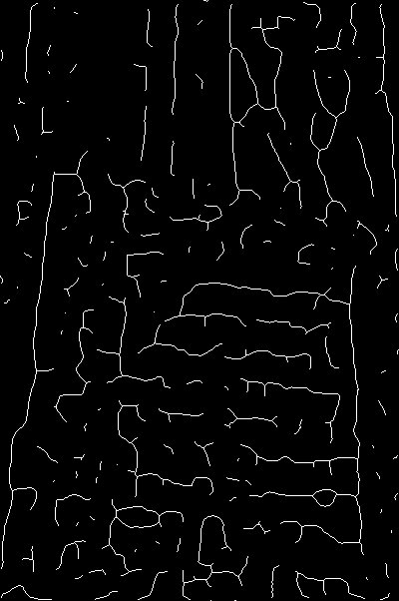
Figure 20. S08 WITH Step 10 (Median included). | Figure 21. S08 WITHOUT Step 10 — nearly the same primary layout.

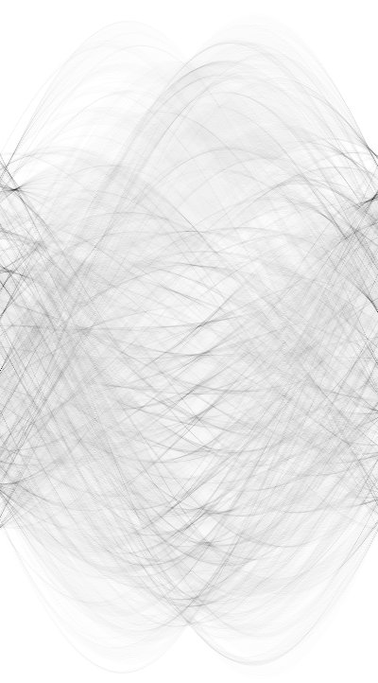 | 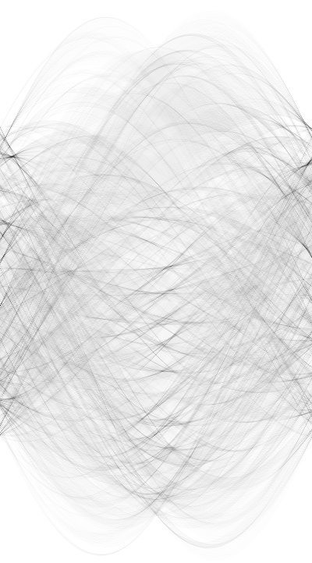
Figure 22. Hough WITH Step 10. | Figure 23. Hough WITHOUT Step 10 — highly similar.

Conclusion: WITH vs WITHOUT Median differ by only ~2% in S08 foreground count and produce nearly identical Hough accumulators. Prior morphology and later Bandpass/thresholding already remove much isolated noise. Practical impact of Step 10 is minor on this image, though Median remains a justified cheap cleanup before FFT filtering when salt-and-pepper spikes remain after Step 9.

7. Task 5 — Bandpass parameters (Step 11)
Step 11: Process → FFT → Bandpass Filter. Defaults are large structures = 40 px and small structures = 10 px. Large controls suppression of broad illumination/relief; small (emphasized by the assignment) controls removal of fine grain/speckle. Trials below change one parameter family at a time and compare S08 (and selected Hough) outputs.

7.1 Changing small structures (large fixed at 40)
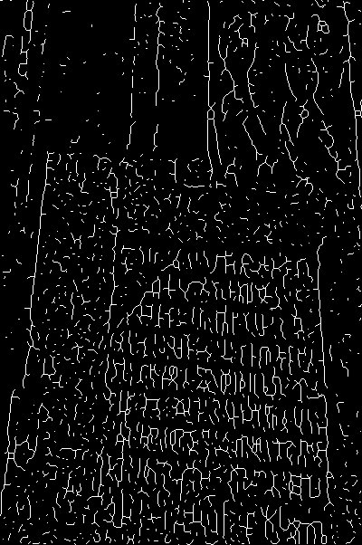 | 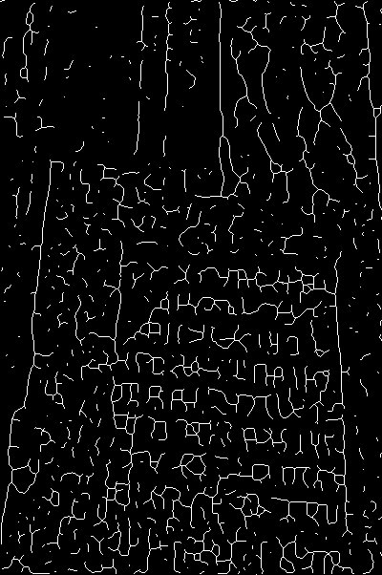 | 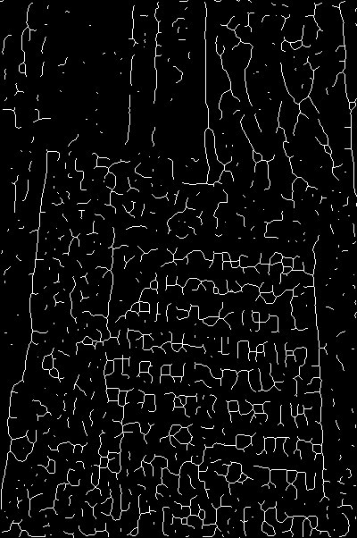
Fig. 24. S08, large=40, small=3 (most fine detail/noise kept; densest skeleton). | Fig. 25. S08, large=40, small=5. | Fig. 26. S08, large=40, small=15 (more fine texture attenuated).

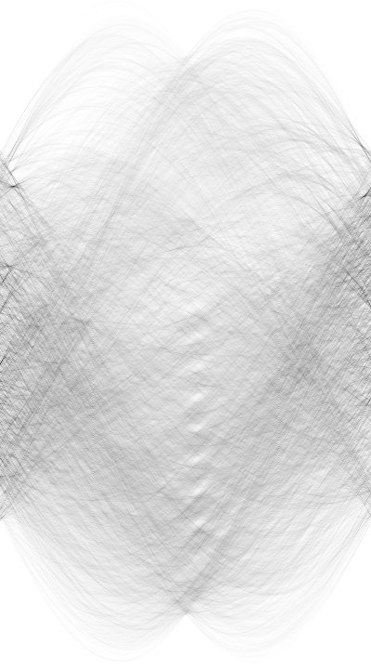 | 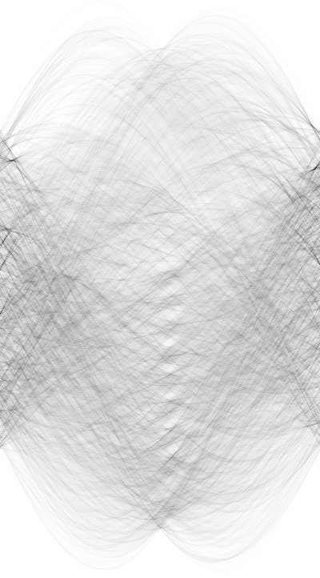 | 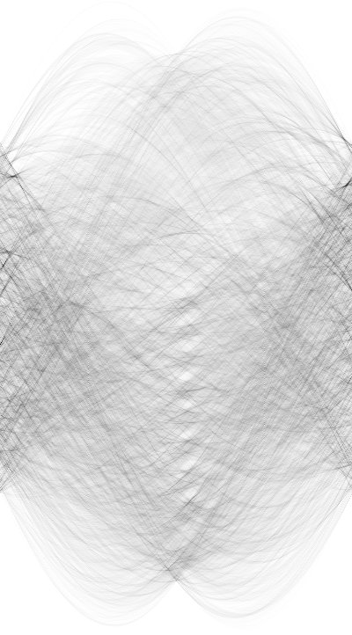
Fig. 27. Hough, 40/3. | Fig. 28. Hough, 40/5. | Fig. 29. Hough, 40/15.

As small decreases (3→5), more high-frequency stone grain survives into S08, producing denser, noisier skeletons and busier Hough voting. Raising small toward 15 removes more micro-structure; letter strokes can also thin or break if the cutoff becomes too aggressive. This confirms the assignment focus on small-structure size as a sensitive control for noise vs. stroke preservation.

7.2 Changing large structures (small fixed at 10)
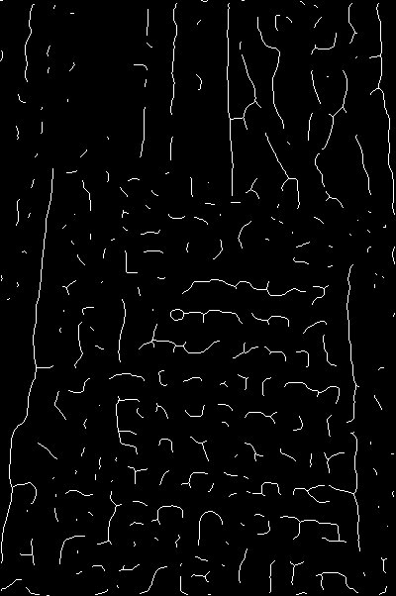 | 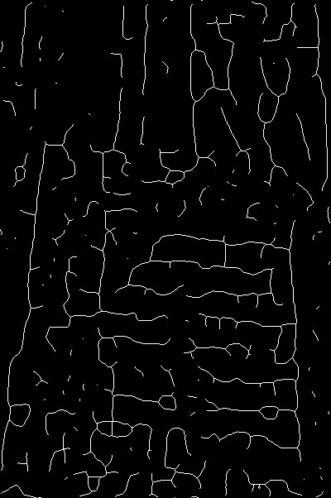
Figure 30. S08, large=20, small=10 (stronger rejection of larger trends; sparser skeleton). | Figure 31. S08, large=80, small=10 (more large-scale shading/relief retained).

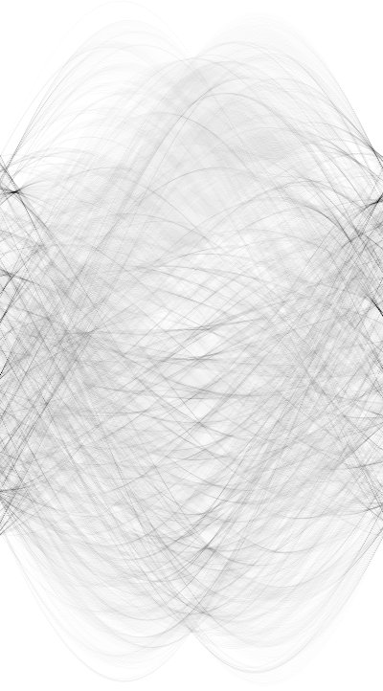 | 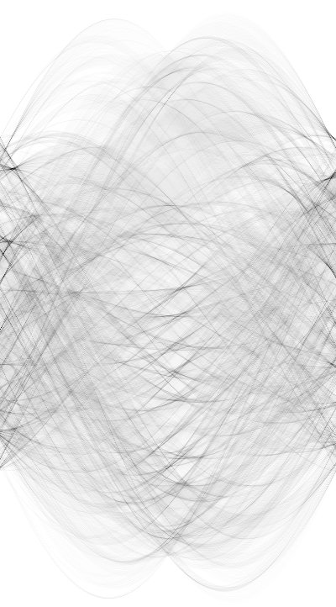
Figure 32. Hough, 20/10. | Figure 33. Hough, 80/10.

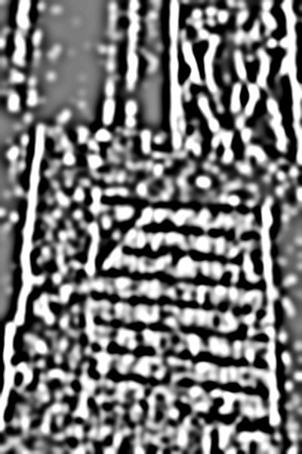 | 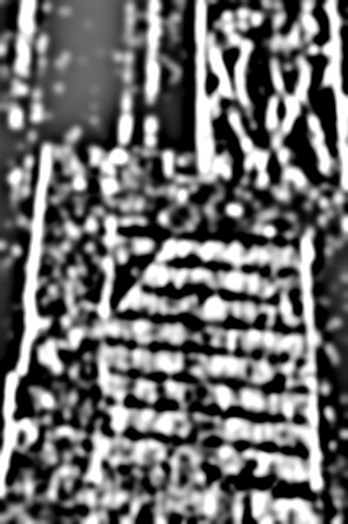
Figure 34. S05 (Bandpass output) for 20/10. | Figure 35. S05 for 80/10 — more low-frequency content remains.

Lowering large (20) removes more broad intensity variation and yields a cleaner but sparser S08. Raising large (80) keeps uneven illumination/large relief, which later thresholding can turn into extra false structure. The default large=40 is a compromise between suppressing background trends and not erasing real mid-scale letter energy.
Overall recommendation for width-400 inscription images in this study: settings near the assignment default (large ≈ 40, small ≈ 10) balance grain suppression and stroke retention; small-structure changes have a particularly visible effect on S08 clutter.

8. Task 6 — Algorithm for Step 16 (centroid extraction)
Goal: y-coordinates of centroids of prominent dark regions in Hough of S08 near the vertical middle axis.
- Input: Hough of S08.
- Crop a vertical ROI around the horizontal center (~10–25% of width).
- Threshold for dark peaks (assignment polarity), or invert then Otsu if brighter peaks are easier to code.
- Connected-component labeling; keep components with area ≥ Amin.
- Intensity-weighted centroid y_c = Σ y·I / Σ I for each kept component.
- Discard blobs far from middle axis; sort y_c → text-row positions.
function extractRowYs(hough):
w, h = hough.width, hough.height
roi = crop(hough, w/2 - w/8, 0, w/2 + w/8, h)
bin = thresholdDark(roi)
ys = []
for C in connectedComponents(bin):
if area(C) >= Amin:
ys.append(weightedCentroidY(C, roi))
return sort(ys)
Assumptions: rows are approximately straight and dominate middle-axis peaks. Limitations: curved/broken rows, strong ornaments, and weak inscriptions create false/missing centroids; Amin and strip width need per-image tuning.

9. Difficulties, assumptions, simplifications
Weathering and uneven lighting complicate thresholding. Directional kernels assume dominant vertical strokes. Skeletonization creates spurs on textured stone. Hough assumes near-straight rows. Assignment defaults were used except when a task required omitting a step or changing Bandpass sizes.

10. Conclusion
The pipeline converts inscription photographs into skeletons and Hough accumulators for row-position estimation. Experimentally: Step 5 (translation) strongly affects coherence of S08/Hough; Step 2 (Mean) trades density vs. clutter on weathered stone; Step 10 (Median) has only a minor final-stage effect here; Bandpass small/large sizes (Task 5) visibly change retained grain versus letter structure, with small-structure size especially sensitive. Completing shared-drive macros/plugins and filling source URLs finishes the submission package.

11. References
- W. Burger, M. J. Burge. Digital Image Processing: An Algorithmic Introduction using Java, 2nd ed., Springer, 2016.
- American University of Armenia, CS 260 / CS 371 Image Processing, Project 1 Assignment (2026).

Appendix — Clarification on same vs different photos
Correct reading of the assignment:
- WITH vs WITHOUT inside Task 2 (or 3 or 4): must be the SAME photograph run twice.
- Across Task 2 vs Task 3 vs Task 4: DIFFERENT photographs are fine (and useful). This report uses distinct originals for Steps 2, 5, and 10 studies.
- Task 2 additionally asks for two images with opposite Mean conclusions; each of those is its own same-photo pair.

