Sorensen Assignment Part 3

Isolde Lane Shaw

April 5, 2018

Here the populations of two contrasting caribou (*Rangifer tarandus caribou*) populations in two ecodistricts are simulated and their extinction rates are predicted based on the percentage of land that has been disturbed by fire within the last 50 years and the percentage of land that is within 250 metres of anthropogenic disturbance (such as roads or industrial activities).

Initial population sizes have been scaled according to the ecoregion size as compared with the population range size.

# A Declining Population: Red Wine Mountain Range (NL2)

This is one of the several populations that is listed by Environment Canada as declining (in Table F-1). Appendix J: Critical Habitat Factsheets states that it has relatively low levels of anthropogenic disturbance however (IND is 3%).

library(igraph)

##   
## Attaching package: 'igraph'

## The following objects are masked from 'package:stats':  
##   
## decompose, spectrum

## The following object is masked from 'package:base':  
##   
## union

library(SpaDES.core)

## Loading required package: quickPlot

## Loading required package: reproducible

##   
## Attaching package: 'reproducible'

## The following object is masked from 'package:igraph':  
##   
## %>%

library(SpaDES)

## using reproducible 0.1.4  
## using quickPlot 0.1.3  
## using SpaDES.core 0.1.1  
## loading SpaDES.tools 0.1.1  
## loading SpaDES.addins 0.1.1

## Default paths for SpaDES directories set to:  
## cachePath: C:\Users\RALAS6\AppData\Local\Temp\RtmpKcfP9X/SpaDES/cache  
## inputPath: C:\Users\RALAS6\AppData\Local\Temp\RtmpKcfP9X/SpaDES/inputs  
## modulePath: C:\Users\RALAS6\AppData\Local\Temp\RtmpKcfP9X/SpaDES/modules  
## outputPath: C:\Users\RALAS6\AppData\Local\Temp\RtmpKcfP9X/SpaDES/outputs  
## These can be changed using 'setPaths()'. See '?setPaths'.

library(magrittr)

##   
## Attaching package: 'magrittr'

## The following object is masked from 'package:reproducible':  
##   
## %>%

library(raster)

## Loading required package: sp

##   
## Attaching package: 'raster'

## The following object is masked from 'package:magrittr':  
##   
## extract

library(spatial.tools)

## Loading required package: parallel

## Loading required package: iterators

## Loading required package: foreach

##   
## Attaching package: 'foreach'

## The following object is masked from 'package:SpaDES.core':  
##   
## times

## Loading required package: rgdal

## rgdal: version: 1.2-16, (SVN revision 701)  
## Geospatial Data Abstraction Library extensions to R successfully loaded  
## Loaded GDAL runtime: GDAL 2.2.0, released 2017/04/28  
## Path to GDAL shared files: C:/Users/RALAS6/Documents/R/win-library/3.3/rgdal/gdal  
## GDAL binary built with GEOS: TRUE   
## Loaded PROJ.4 runtime: Rel. 4.9.3, 15 August 2016, [PJ_VERSION: 493]  
## Path to PROJ.4 shared files: C:/Users/RALAS6/Documents/R/win-library/3.3/rgdal/proj  
## Linking to sp version: 1.2-7

library(rgdal)  
library(ggplot2)  
  
moduleDir <- file.path("C:/Users/RALAS6/Documents/Modelling Forest Landscapes Class/Labs/scfmmodules/")  
  
inputDir <- file.path("inputs") %>% reproducible::checkPath(create = TRUE)  
outputDir <- file.path(moduleDir, "outputs")  
cacheDir <- file.path(outputDir, "cache")  
times <- list(start = 0, end = 75)   
  
dsn <- file.path(inputDir, "Ecodistricts")  
 shape <- readOGR(dsn = dsn, layer = "ecodistricts")  
 studyArea<-shape[shape$ECODISTRIC== 325,] #decide what ecodistrict to look at   
   
parameters <- list(  
 Sorensen = list( N0 = 7, #decide initial herd size  
 IND = 3, #decide % of landscape has been disturbed by anthropogenic factors  
 minHabitatAge = 50), #decide the age a forest must be to provide caribou habitat  
 scfmLandcoverInit = list(nonFlammClasses = c(38)),  
 ageModule = list(initialAge=50),  
 scfmSpread = list(pOverRide=0.18  
 ))  
  
modules <- list("scfmCrop", "scfmLandcoverInit", "scfmIgnition", "scfmEscape", "scfmSpread", "ageModule", "mapBurns", "Sorensen")  
  
objects <- list(studyArea=studyArea,  
 nNbrs=8)  
paths <- list(  
 cachePath = cacheDir,  
 modulePath = moduleDir,  
 inputPath = inputDir,  
 outputPath = outputDir  
)  
  
mySim <- simInit(times = times,   
 params = parameters,   
 modules = modules,  
 objects = objects,   
 paths = paths  
 )

## Loading required package: rgeos

## rgeos version: 0.3-26, (SVN revision 560)  
## GEOS runtime version: 3.6.1-CAPI-1.10.1 r0   
## Linking to sp version: 1.2-7   
## Polygon checking: TRUE

## Loading required package: data.table

##   
## Attaching package: 'data.table'

## The following object is masked from 'package:raster':  
##   
## shift

## Loading required package: RColorBrewer

## Using or creating cached copy of .inputObjects for scfmCrop

## Using or creating cached copy of .inputObjects for scfmLandcoverInit

## Running .inputObjects for scfmEscape

## Running .inputObjects for scfmSpread

## Running .inputObjects for ageModule

## Running .inputObjects for Sorensen

mySim<-spades(mySim,debug=TRUE)

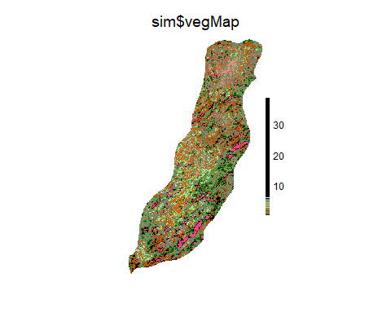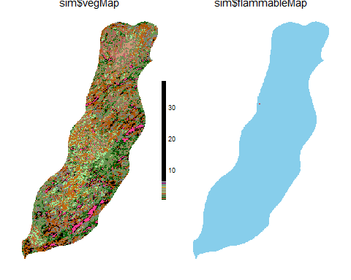

### NL2 Herd Projectory

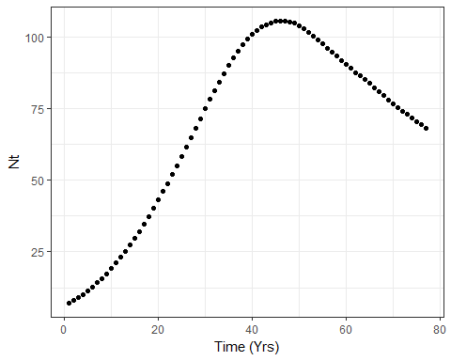

# An Increasing Population: Manicougan Population (QC5)

This is the only population in Canada that is listed by Environment Canada as increasing (in Table F-1), however Appendix J: Critical Habitat Factsheets states that it has much higher anthropogenic disturbance (IND is 32%) than population NL2.

todelete <- dir("C:/Users/RALAS6/Documents/Modelling Forest Landscapes Class/Labs/scfmModules/outputs/cache/gallery", full.names = TRUE)  
todelete2 <- dir("C:/Users/RALAS6/Documents/Modelling Forest Landscapes Class/Labs/scfmModules/outputs/cache/", full.names = TRUE)  
unlink(todelete)  
unlink(todelete2)  
  
rm(list=ls())  
  
library(igraph)  
library(SpaDES.core)  
library(SpaDES)  
library(magrittr)  
library(raster)  
library(spatial.tools)  
library(rgdal)  
library(ggplot2)  
  
  
moduleDir <- file.path("C:/Users/RALAS6/Documents/Modelling Forest Landscapes Class/Labs/scfmmodules/")  
  
inputDir <- file.path("inputs") %>% reproducible::checkPath(create = TRUE)  
outputDir <- file.path(moduleDir, "outputs")  
cacheDir <- file.path(outputDir, "cache")  
times <- list(start = 0, end = 75)   
  
dsn <- file.path(inputDir, "Ecodistricts")  
 shape <- readOGR(dsn = dsn, layer = "ecodistricts")  
 studyArea<-shape[shape$ECODISTRIC== 436,] #decide what ecodistrict to look at   
   
parameters <- list(  
 Sorensen = list( N0 = 270, #decide initial herd size  
 IND = 32, #decide % of landscape has been disturbed by anthropogenic factors  
 minHabitatAge = 50), #decide the age a forest must be to provide caribou habitat  
 scfmLandcoverInit = list(nonFlammClasses = c(38)),  
 ageModule = list(initialAge=50),  
 scfmSpread = list(pOverRide=0.14))  
  
modules <- list("scfmCrop", "scfmLandcoverInit", "scfmIgnition", "scfmEscape", "scfmSpread", "ageModule", "mapBurns", "Sorensen")  
  
objects <- list(studyArea=studyArea,  
 nNbrs=8)  
paths <- list(  
 cachePath = cacheDir,  
 modulePath = moduleDir,  
 inputPath = inputDir,  
 outputPath = outputDir  
)  
  
mySim <- simInit(times = times,   
 params = parameters,   
 modules = modules,  
 objects = objects,   
 paths = paths  
 )

## Using or creating cached copy of .inputObjects for scfmCrop

## Using or creating cached copy of .inputObjects for scfmLandcoverInit

## Running .inputObjects for scfmEscape

## Running .inputObjects for scfmSpread

## Running .inputObjects for ageModule

## Running .inputObjects for Sorensen

mySim<-spades(mySim,debug=TRUE)

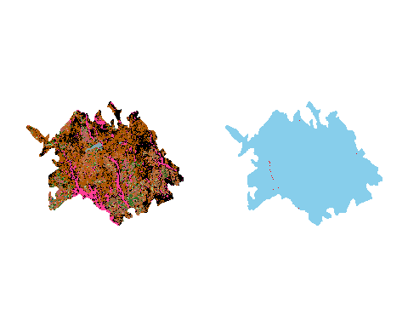

### QC5 Herd Projectory

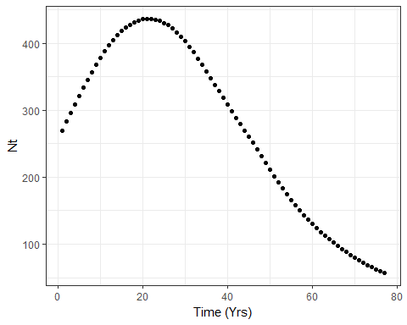

# Discussion

Both populations initially increase under the parameters given, and both populations reach a point where the fire regimes prescribed to them disturb so much habitat that their populations go into decline. The QC5 population, despite having a much larger initial population, and a less intense fire regime (with 4% less chance of a fire spreading), reaches the point of population decline (where Lambda becomes less than 1) after only 20 years. The NL2 population on the other hand does not experience population decreases until 45 years, and although the maximum population reached is not as large as in QC5, the rate of decline is much slower (Lambda is larger).

Given that the largest difference between parameters affecting the two populations is the level of disturbance, where NL2 has only 3% IND and QC5 has 32%, it suggests that despite other more favourable conditions for the QC5 population, this large degree of human disturbance ultimately makes the population more sensitive to other forms of distrubance, such as increases in the incidence of fire.

# References

Environment Canada. 2012. Recovery Strategy for the Woodland Caribou (*Rangifer tarandus caribou*), Boreal population, in Canada. Species at Risk Act Recovery Strategy Series. Environment Canada, Ottawa. xi + 138pp.

Sorensen, T., McLoughlin, P., Hervieux, D., Dzus, E., Nolan, J., Wynes, B., Boutin, S. 2007. Determining Sustainable Levels of Cumulative Effects of Boreal Caribou. Journal of Wildlife Management 72(4):900-905.