https://mystery.knightlab.com

Schemadiagram.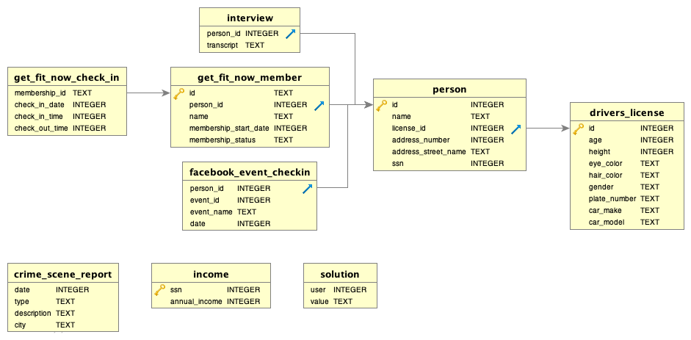

CREATE TABLE crime_scene_report ( "20180118", type "murder", description "the crime was a murder that occurred sometime on Jan.15, 2018 and that it took place in SQL City.", city "SQL City") )

SELECT *

FROM crime_scene_report

where type = "murder"

AND date = 20180115

AND city = "SQL City";

| **date** | **type** | **description** | **city** |
| --- | --- | --- | --- |
| 20180115 | murder | Security footage shows that there were 2 witnesses. The first witness lives at the last house on "Northwestern Dr". The second witness, named Annabel, lives somewhere on "Franklin Ave". | SQL City |

SELECT *

FROM person

where address_street_name LIKE ‘%Franklin Ave%"

AND

name LIKE ‘%Annabel Miller%"

| **id** | **name** | **license_id** | **address_number** | **address_street_name** | **ssn** |
| --- | --- | --- | --- | --- | --- |
| 16371 | Annabel Miller | 490173 | 103 | Franklin Ave | 318771143 |

SELECT *

FROM interview

where person_id ="16371"

| **person_id** | **transcript** |
| --- | --- |
| 16371 | I saw the murder happen, and I recognized the killer from my gym when I was working out last week on January the 9th. |

SELECT *

FROM get_fit_now_check_in gfnci

inner join get_fit_now_member gfnm on gfnci.membership_id = gfnm.id

where check_in_date = "20180109"

Haut du formulaire

| **membership_id** | **check_in_date** | **check_in_time** | **check_out_time** | **id** | **person_id** | **name** | **membership_start_date** | **membership_status** |
| --- | --- | --- | --- | --- | --- | --- | --- | --- |
| X0643 | 20180109 | 957 | 1164 | X0643 | 15247 | Shondra Ledlow | 20170521 | silver |
| UK1F2 | 20180109 | 344 | 518 | UK1F2 | 28073 | Zackary Cabotage | 20170818 | silver |
| XTE42 | 20180109 | 486 | 1124 | XTE42 | 55662 | Sarita Bartosh | 20170524 | gold |
| 1AE2H | 20180109 | 461 | 944 | 1AE2H | 10815 | Adriane Pelligra | 20170816 | silver |
| 6LSTG | 20180109 | 399 | 515 | 6LSTG | 83186 | Burton Grippe | 20170214 | gold |
| 7MWHJ | 20180109 | 273 | 885 | 7MWHJ | 31523 | Blossom Crescenzo | 20180309 | regular |
| GE5Q8 | 20180109 | 367 | 959 | GE5Q8 | 92736 | Carmen Dimick | 20170618 | gold |
| 48Z7A | 20180109 | 1600 | 1730 | 48Z7A | 28819 | Joe Germuska | 20160305 | gold |
| 48Z55 | 20180109 | 1530 | 1700 | 48Z55 | 67318 | Jeremy Bowers | 20160101 | gold |
| 90081 | 20180109 | 1600 | 1700 | 90081 | 16371 | Annabel Miller | 20160208 | gold |

Bas du formulaire

### Check your solution

**Did you find the killer?** Jeremy Bowers

Haut du formulaire

Bas du formulaire