CSE 581

**Lab 1: Database Account Setup**

**Steps:**

1. Follow the steps described in class to create your database environment.
   1. Use the web application to create your database environment.
   2. Make sure the creation was successful by connecting to the server, making sure you can login (***screenshot***) as well as access your database (***screenshot***).

A. Created the environment properly.

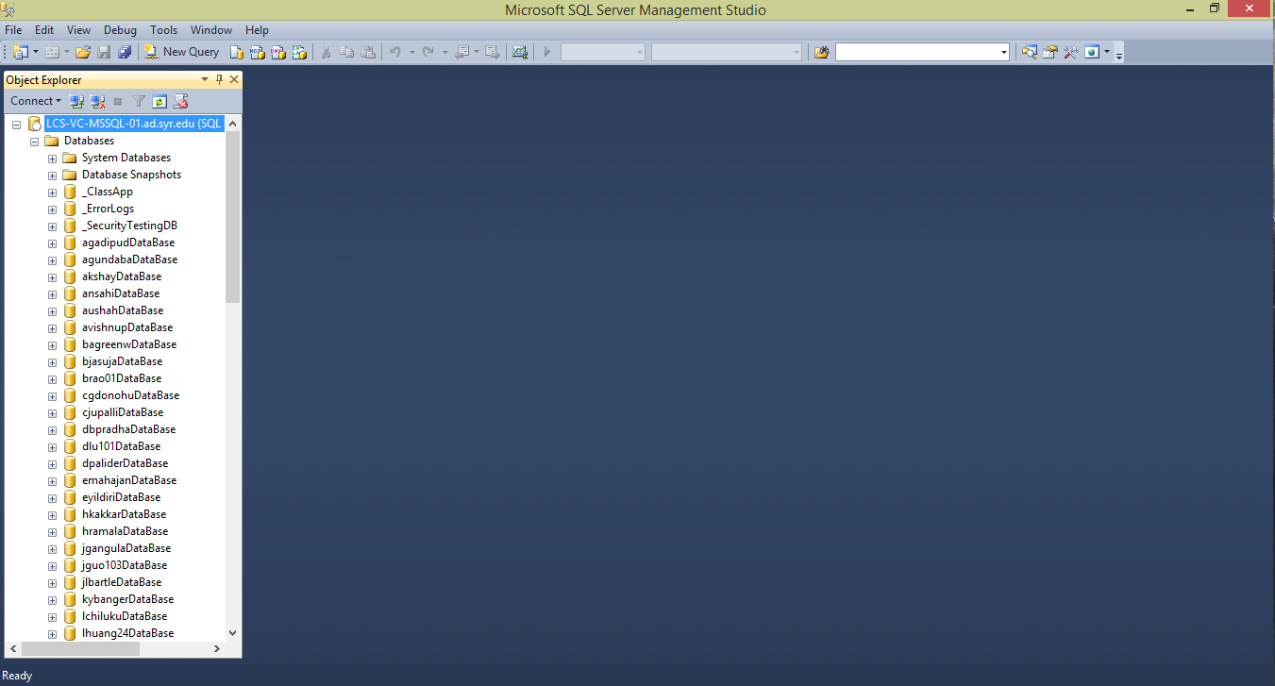B. Post login:

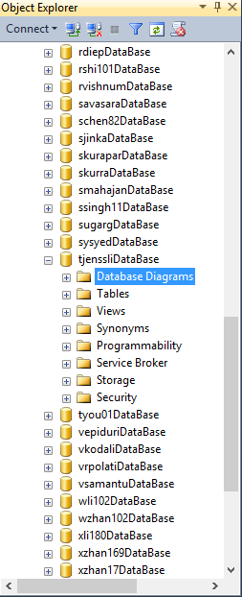Accessing my database: