Tatiana Ensslin

CSE 581

**Lab 3: Selects with Joins**

*Do this lab against the Northwind database.*

***For the entire lab, provide all of your SQL as text, inserted at the beginning of the document.***

***For each step also provide a screenshot of execution, showing the SQL and the results.***

***Please make sure both the SQL and the screenshots are marked w/ the question number that they are answering.***

**Steps:**

**1.**

SELECT *

FROM Orders, [Order Details];

**2.**

SELECT OrderID, CompanyName

FROM Orders, Customers;

**3.**

SELECT OrderID, CompanyName

FROM Orders

INNER JOIN Customers

ON Orders.CustomerID = Customers.CustomerID

**4.**

SELECT Orders.OrderID, Customers.CompanyName

FROM Orders

FULL OUTER JOIN Customers

ON Customers.CustomerID=Orders.CustomerID ;

**5.**

SELECT Orders.OrderID, Customers.CompanyName

FROM Orders

RIGHT OUTER JOIN Customers

ON Customers.CustomerID=Orders.CustomerID ;

1. List all orders and their corresponding order details

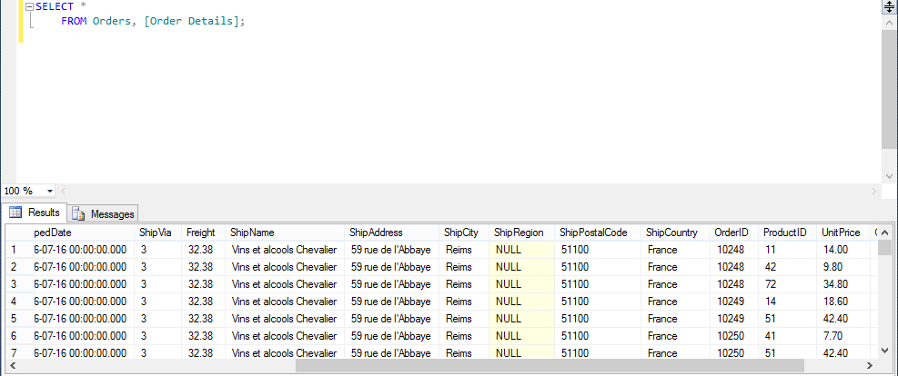

1. List all orders (OrderID) and matching customers (Company Name).

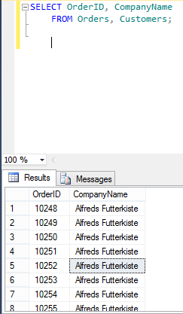

1. List orders (OrderID) and corresponding customers (Company Name), only where the records match up.

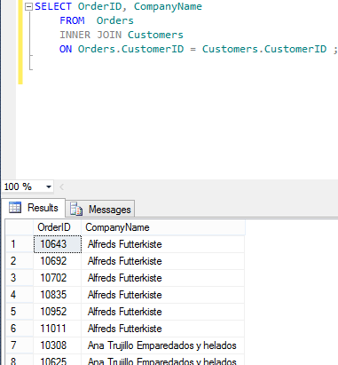

1. List all orders (OrderID) and all customers (Company Name), matching records appropriately.

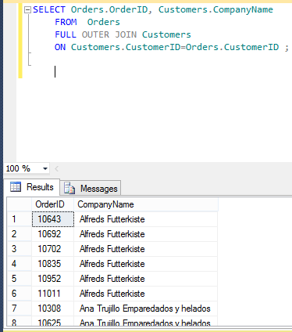

1. List matching orders (OrderID) and all customers (Company Name).

