Tatiana Ensslin

CSE 581

**Lab 8: Selects with Data Types**

**Steps:**

1. Select all data from the Orders table, ordered by OrderDate, newest date on top, for orders shipped between January 1997 and August 1997.

SELECT *

FROM Orders

WHERE (YEAR(OrderDate) = 1997

AND MONTH(OrderDate) > 12)

OR (YEAR(OrderDate) = 1997

AND MONTH(OrderDate) < 7)

ORDER BY OrderDate DESC;

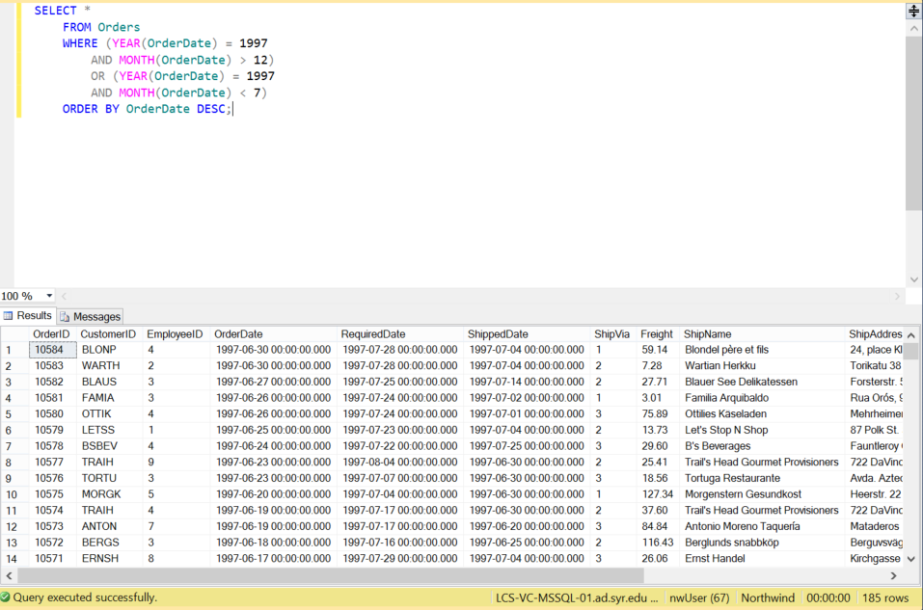

1. Select all data from the Orders table, ordered by OrderDate, newest date on top, for orders placed between July 1996 and January 1997.

SELECT *

FROM Orders

WHERE (YEAR(OrderDate) = 1996

AND MONTH(OrderDate) > 6)

OR (YEAR(OrderDate) = 1997

AND MONTH(OrderDate) < 12)

ORDER BY OrderDate DESC;

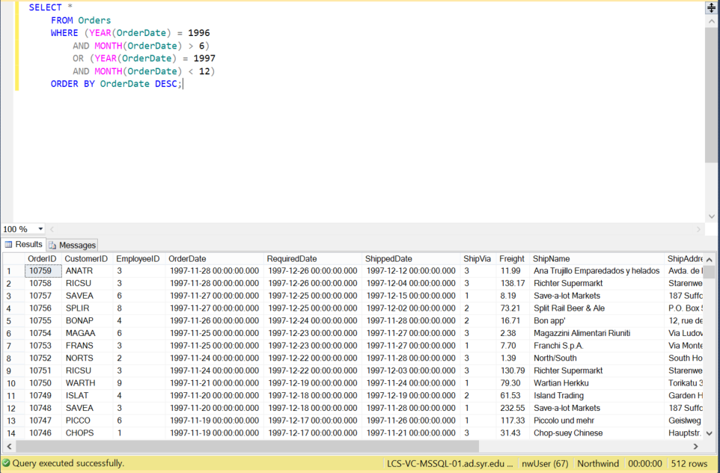

1. Select all data from the Orders table, for orders placed in January 1998.

SELECT *

FROM Orders

WHERE (YEAR(OrderDate) = 1998

AND MONTH(OrderDate) = 1);

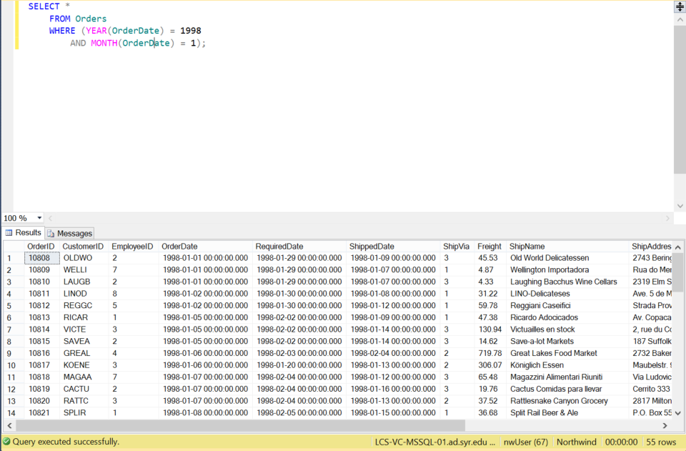

1. Select count of Orders shipped in 1996, 1997 and 1998. (one query containing all values) -> 2 columns (count and year), 3 rows (1 row per year)

SAMPLE (and hence WRONG) result for Q4:

|  |  |
| --- | --- |
| **Year** | **Number Of Orders Shipped** |
| 1996 | 55 |
| 1997 | 101 |
| 1998 | 104 |

SELECT YEAR(ShippedDate), COUNT(OrderID)

FROM Orders

WHERE (YEAR(ShippedDate) = 1996

OR YEAR(ShippedDate) = 1997

OR YEAR(ShippedDate) = 1998)

GROUP BY YEAR(ShippedDate)

ORDER BY YEAR(ShippedDate) ASC;

