Tatiana Ensslin

CSE 581

**Lab 11: Views**

**Steps:**

1. Create a view that will display all of the following columns, joining tables as appropriate:
2. Student First Name
3. Student Last Name
4. Course Title

Create View [Student Courses] AS

SELECT Users.FirstName AS [Student FirstName], Users.LastName as [Student LastName],

Courses.CourseTitle

FROM Users

INNER JOIN CourseEnrollment ce ON Users.NTID = ce.StudentId

INNER JOIN Courses ON Courses.CourseId = ce.CourseId;

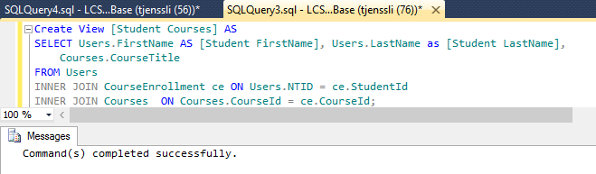

1. Create a view that will display all of the following columns, joining tables as appropriate:
   1. Student First Name
   2. Student Last Name
   3. Course Title
   4. Course Faculty First Name
   5. Course Faculty Last Name
   6. Final Grade (number)

Create View [Course Data] AS

SELECT Users.FirstName AS [Student FirstName], Users.LastName as [Student LastName],

Courses.CourseTitle,

F.FirstName AS [Faculty FirstName],

F.LastName AS [Faculty LastName],

ce.FinalGrade

FROM Users

INNER JOIN CourseEnrollment ce ON Users.NTID = ce.StudentId

INNER JOIN Courses ON Courses.CourseId = ce.CourseId

INNER JOIN Users F ON Courses.Faculty = F.NTID

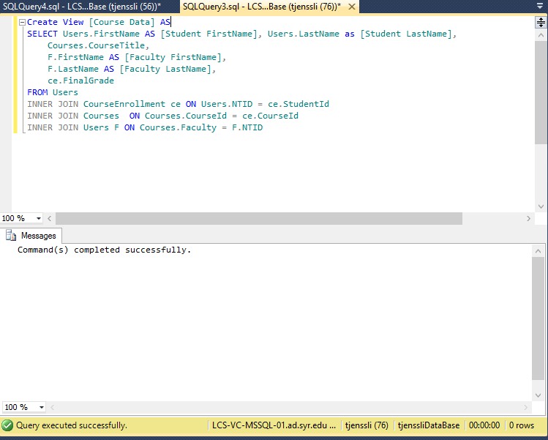

1. Select data from the 2nd view, *for Harry’s classes only*.

SELECT CourseTitle

FROM [Course Data]

WHERE [Student FirstName] = 'Harry';

