Tatiana Ensslin

CSE 581

**Lab 13: Functions**

**Steps:**

1. Create a function that will accept CourseId and Numerical Grade and will calculate the letter grade. The function will return the appropriate *Letter Grade Description* based on the input and the ***Course Grading*** table[1][2].

CREATE FUNCTION GradeInformation (@CourseId AS INT,

@NumericalGrade as INT)

Returns VARCHAR(40) as BEGIN

DECLARE @CurrentGradeInfo VARCHAR(40)

SELECT @CurrentGradeInfo = (SELECT TOP 1 DESCRIPTION FROM LetterGrades L

FULL OUTER JOIN CourseGrade C

ON L.LetterGradeId = C.LetterGradeId

WHERE CourseID = @CourseId AND GradeValue BETWEEN 0 AND @NumericalGrade)

Return @CurrentGradeInfo

END;

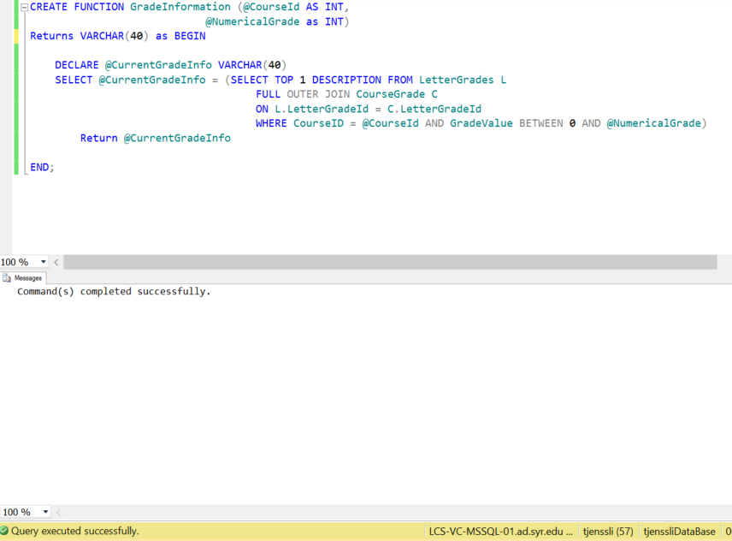

1. Verify that the function works as expected:
   1. 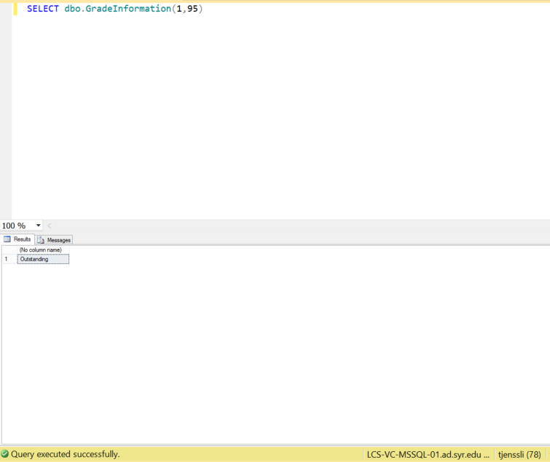Run the function for the CourseId = 1, NumericalGrade = 95.

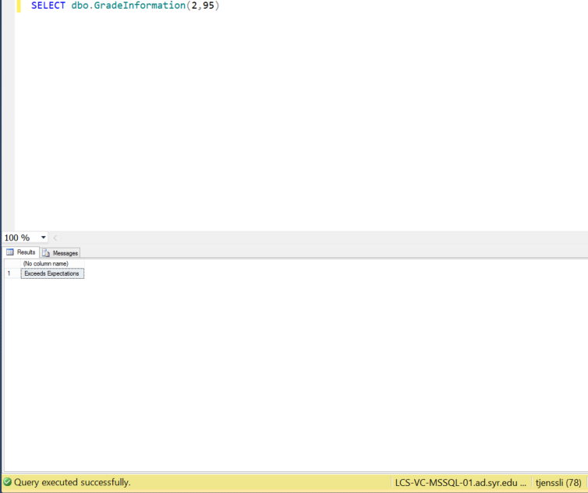

* 1. Run the function for the CourseId = 2, NumericalGrade = 95.
  2. Run the function for the CourseId = 2, NumericalGrade = 85. 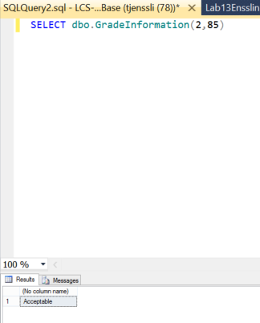

1. Please consider how grades are calculated. For example, if 90-92.9 is an A-, and you get a 92, then you get an A-.
2. Please do not hardcode values into your function. Use the table to make the decisions. **If you hardcode the values, you will lose 60% of your grade.**