Tatiana Ensslin

UBTCSE 581

**Lab 14: Error Handling**

**Steps:**

1. Create a stored procedure: The SP should accept (for input) 2 parameters (let’s say A and B) and returns the result of A divided by B (in some way). The SP should do error handling[1], and if an error occurs, it should print out *“An error has occurred”* and ***return*** -1 as a result.

CREATE PROCEDURE dbo.DivideErrorHandler (@A as INT,

@B as INT)

as

DECLARE @Answer INT

BEGIN TRY

SELECT @Answer = @A/@B

END TRY

BEGIN CATCH

RAISERROR ('An error has occured',16,-1)

SELECT @Answer = -1

END CATCH

PRINT @Answer

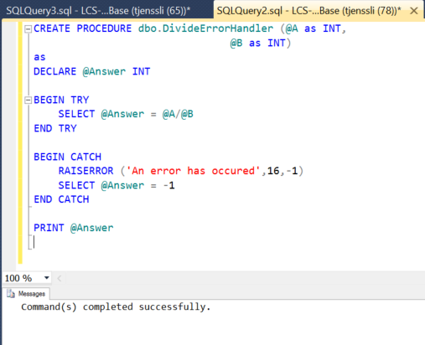

1. Execute the SP with input A = 10, B = 2. Verify that the result and error message are as expected.

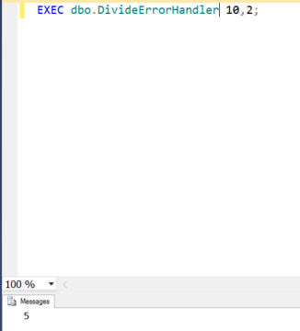

1. 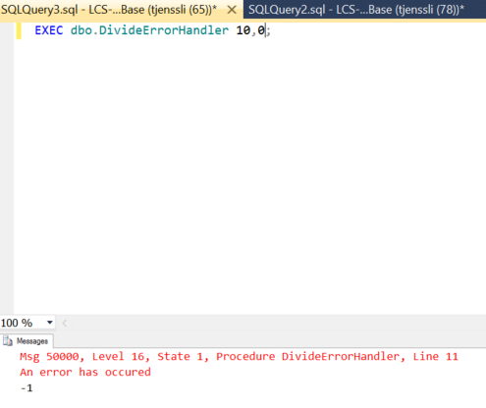Execute the SP with input A = 10, B = 0. Verify that the result and error message are as expected.

1. I would recommend using the TRY/CATCH block