Tatiana Ensslin

CSE 581

**Lab 16: Cursors**

**Steps:**

1. Create a function that will take in a student id as a parameter and then calculate that student’s average grade[1]*.*
2. Create Function FindAverage (@StudentID as VARCHAR(25))
3. Returns DECIMAL(5,2) AS
4. BEGIN
5. DECLARE @Answer DECIMAL(5,2)
6. DECLARE @Sum DECIMAL(10,2)
7. DECLARE @Average DECIMAL(5,2)
8. DECLARE @Grade DECIMAL(5,2)
9. DECLARE @Total INT --total grades added up
10. SELECT @Sum = 0
11. SELECT @Total = 0
12. DECLARE AverageCursor CURSOR FOR
13. SELECT FinalGrade
14. FROM CourseEnrollment
15. WHERE @StudentID = StudentID
16. OPEN AverageCursor --lock table
17. FETCH NEXT FROM AverageCursor INTO @Grade --fetch grades
18. WHILE (@@FETCH_STATUS = 0)
19. BEGIN
20. If @Grade is NULL --if no grade add 0 to sum
21. BEGIN
22. SELECT @Grade = 0
23. SELECT @Sum = @Grade + @Sum
24. END
25. ELSE --if there is a grade tally how many grades total and ammend sum with grade
26. BEGIN
27. SELECT @Total= @Total + 1
28. SELECT @Sum = @Grade + @Sum
29. END
30. FETCH NEXT FROM AverageCursor INTO @Grade
31. END
32. SELECT @Average = @Sum/@Total
33. CLOSE AverageCursor --release lock on table
34. DEALLOCATE AverageCursor
35. SELECT @Answer = @Average
36. Return @Answer
37. END;

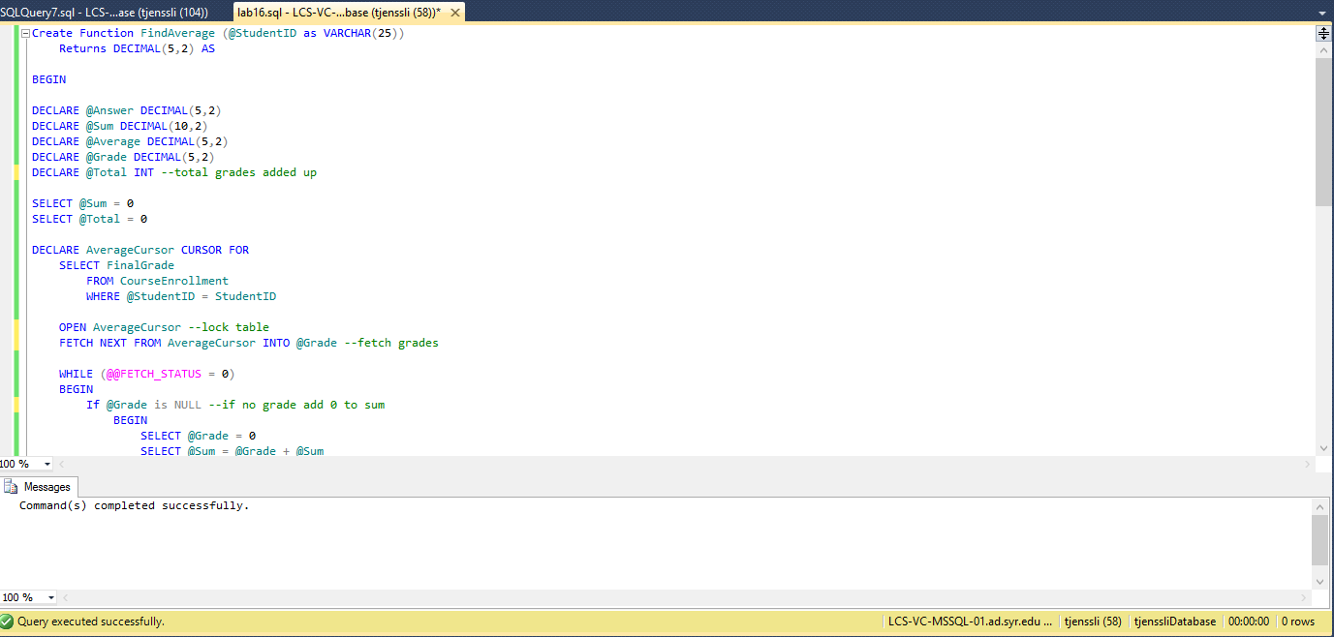

1. Verify that the function with the cursor/function works as expected.

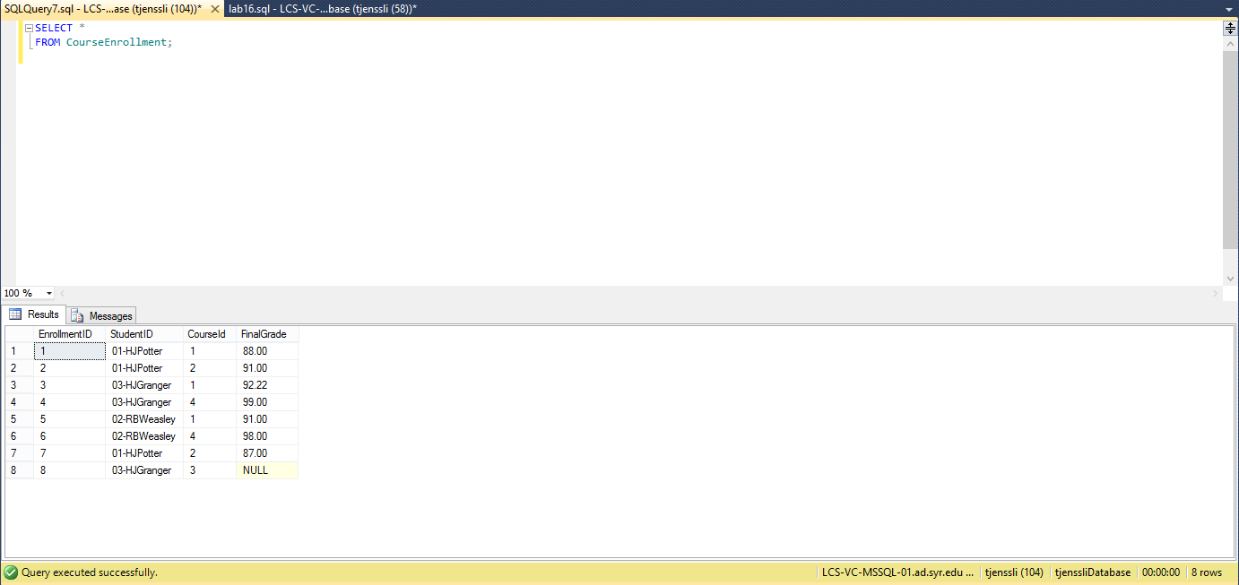

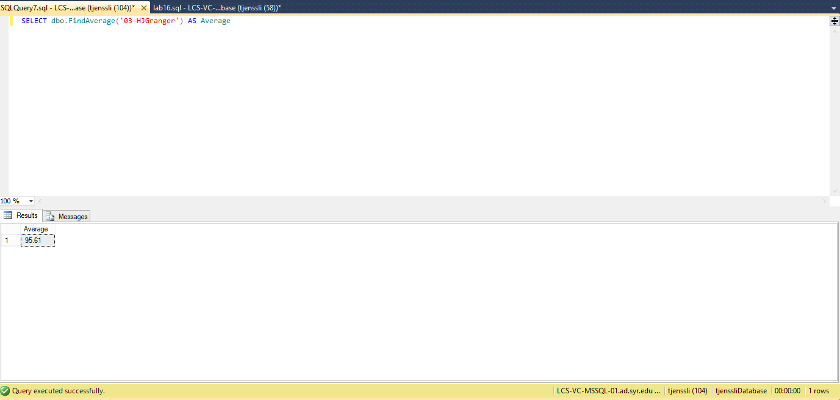

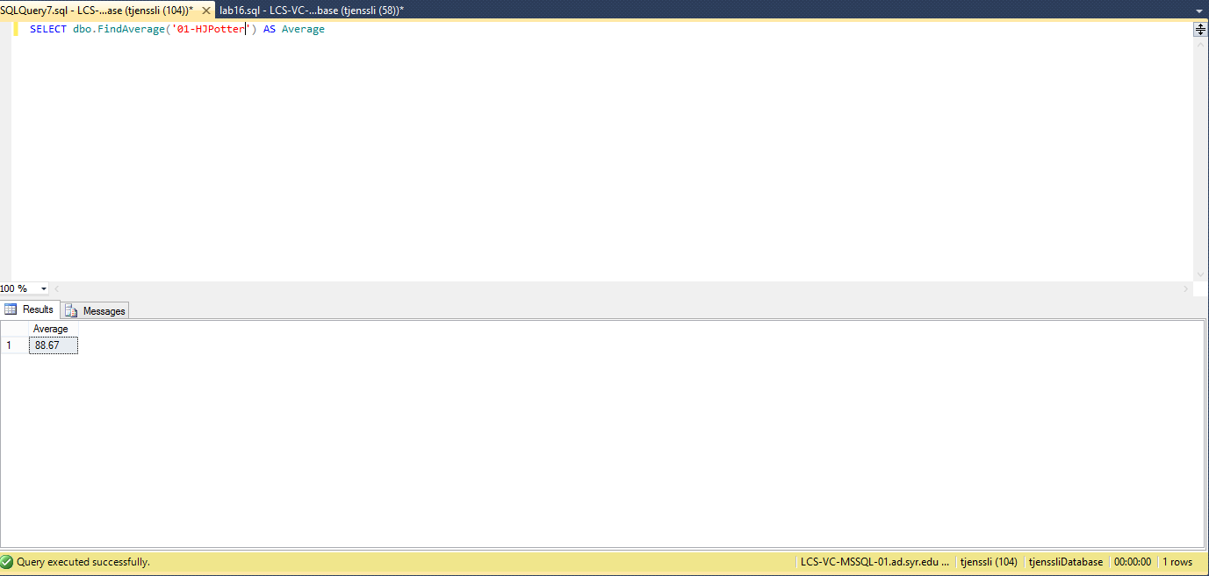

1. Please note that this can be done in easier ways, but the point here is to create a cursor and make sure it works.