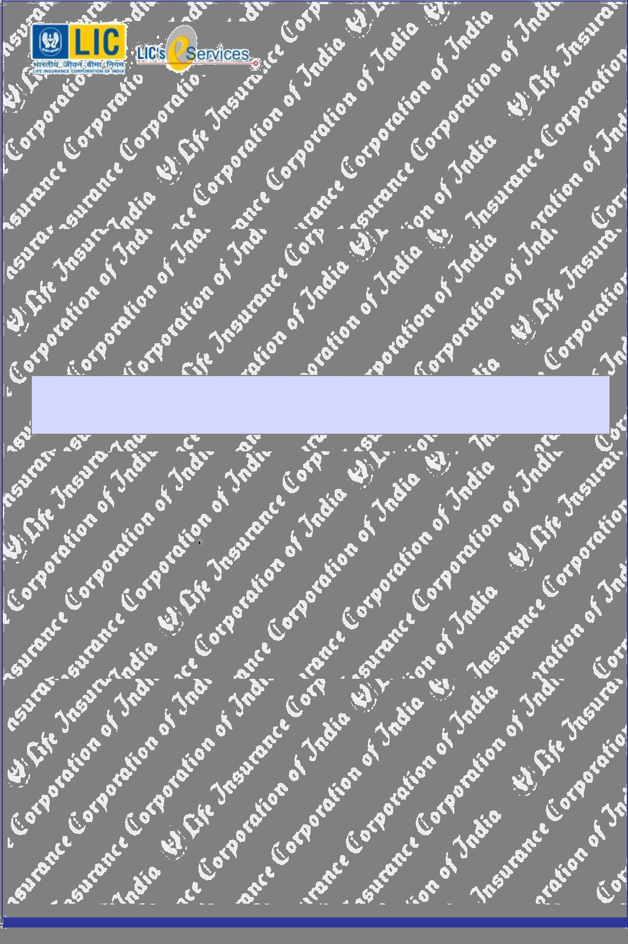
Collecting Branch : EPS1 |  | Servicing Branch : LIC of India, Mumbai B O
Transaction No : 15452584 |  | Laxmi Commercial Centre
 |  | Tulsi Pipe Road.,Dadar (W) Mumbai
Date ( Time ): | 07/12/2018 ( 11:21:47 ) | Dadar(W),400028
Receipt No : | PR1545259000011811 | bo_eps1@licindia.com
Receipt No : | PR1545259000011811 | HelpDesk: +91-022-1251

RENEWAL PREMIUM RECEIPT

Received with thanks ₹97,131.00 through Payment Gateway over the Internet from:

Smt./Ms./Shri : | Tatireddy
towards the following :
Policy No | Plan | Inst. Premium | No Of Inst | Total Premium |  |  | CGST | Branch
Name | Term | Mode | Due From |  | Late Fee |  | SGST/UTGST | Next Due
Agency Code | D.O.C. | Sum Assured | Due To | CD Charges |  |  | Total Amt | Reg. No.
 |  | (₹) |  | (₹) |  |  | (₹)
904816039 | 814 | 95,239.00 | 1 | 95,239.00 |  |  | 1892.00 | 897
Thulasiram | 15 | YLY | 10/18 | 0.00 |  |  | 0.00 | 10/19
02166892 | 05/01/2016 | 16,00,000 | 10/18 | 0.00 |  |  | 97,131.00
Page Total (₹) |  | 95,239.00 |  | 95,239.00 |  |  | 946.00
 |  |  |  | 0.00 |  |  | 946.00
 |  |  |  | 0.00 |  |  | 97,131.00
Grand Total(₹) |  | 95,239.00 |  |  | 95,239.00 |  | 946.00
 |  |  |  | 0.00 |  |  | 946.00
 |  |  |  | 0.00 |  |  | 97,131.00

NINTY SEVEN THOUSAND ONE HUNDREDEN THIRTY ONE RUPEES ONLY

Thulasiram

Mobile: 8454015525

Consolidated Stamp Duty Paid

CSD/64/2018/2366/18 dtd. 26/06/2018

Payment Acknowledgement generated through
Online Portal on 07-Dec-18 Time: 11:25:29.

Email: ttr6677@gmail.com.com

This receipt is electronically generated and no signature is required.

Har Pal Aapke Saath!

