1. 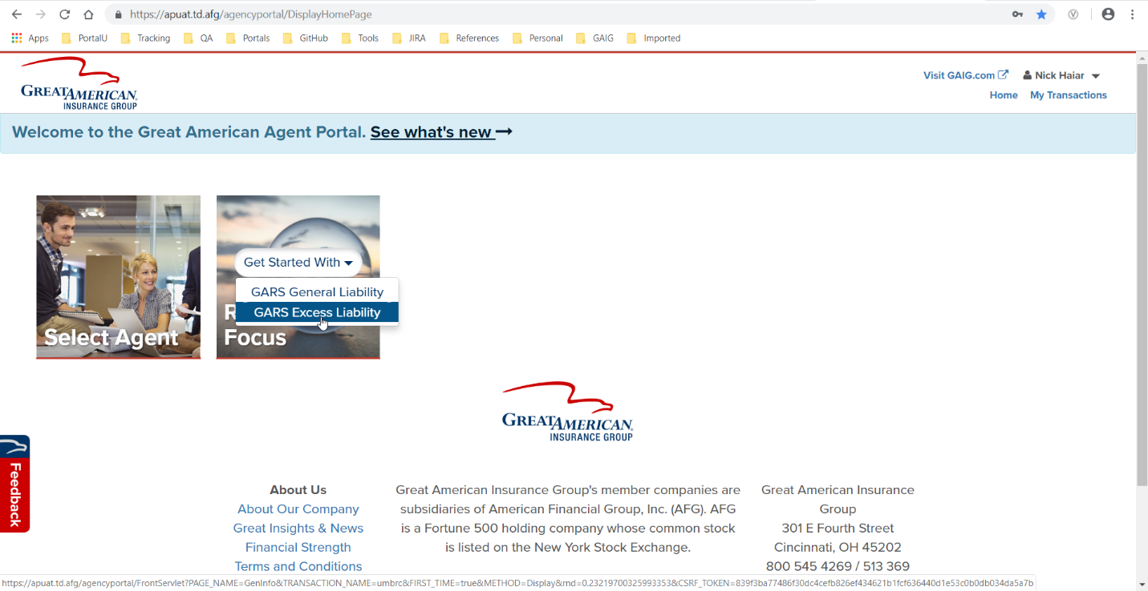From Home, click Get Started With GARS Excess Liability.
2. Complete the General Information page using only the required fields. Click Continue.

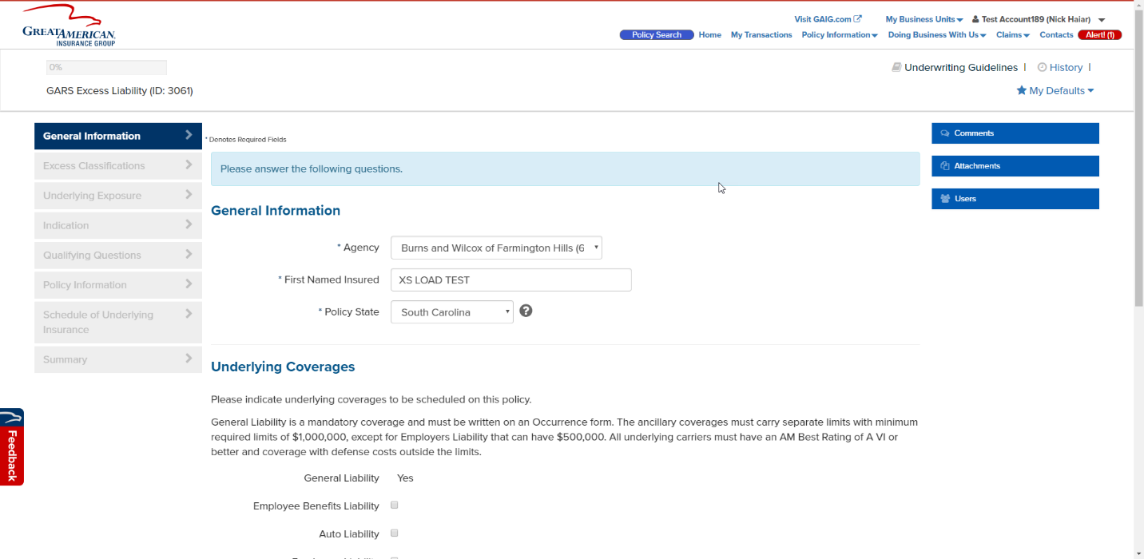

1. Add a Zip Code that matches the selected Policy State from the General Information page. For example, if South Carolina is the policy state, use Zip Code 29020. The City and State will be filled out automatically (reaches out to a third party).

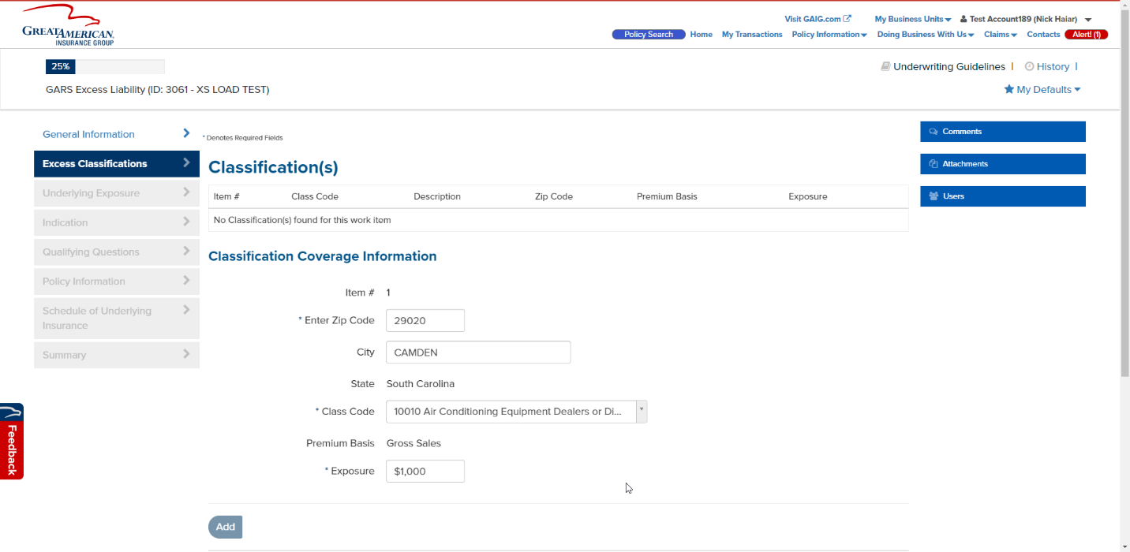

1. 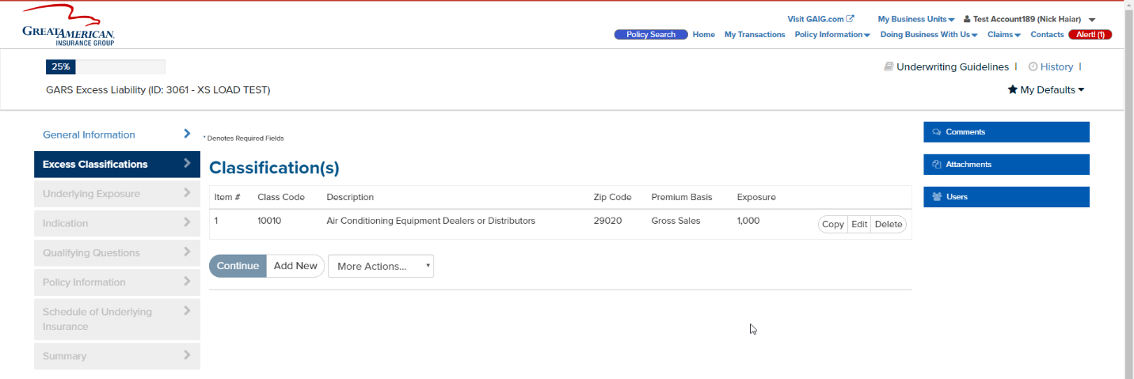Add a class code of 10010 and an exposure of 1,000. Click Add then click Continue.
2. Fill out the Underlying Exposure page. Click Continue.

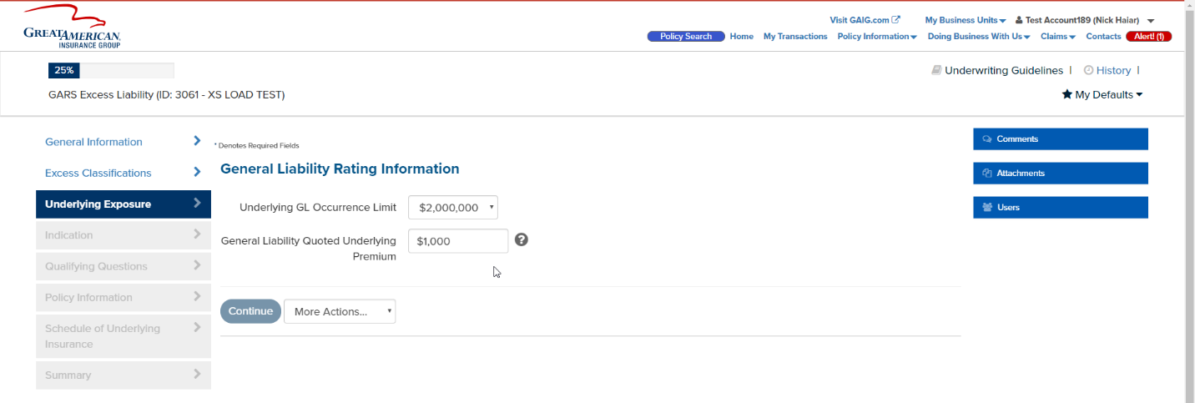

1. 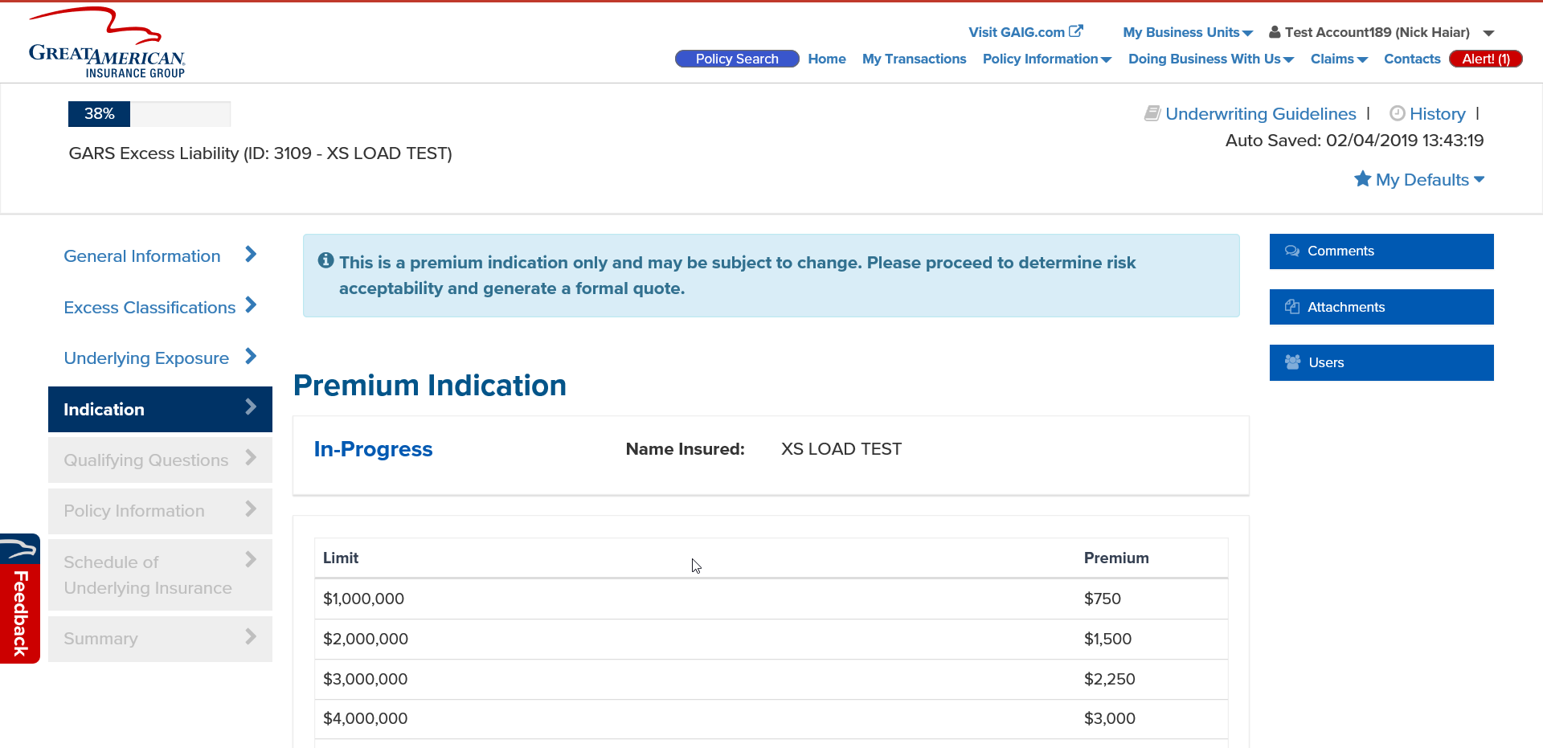Stop at the Indication page.