1. 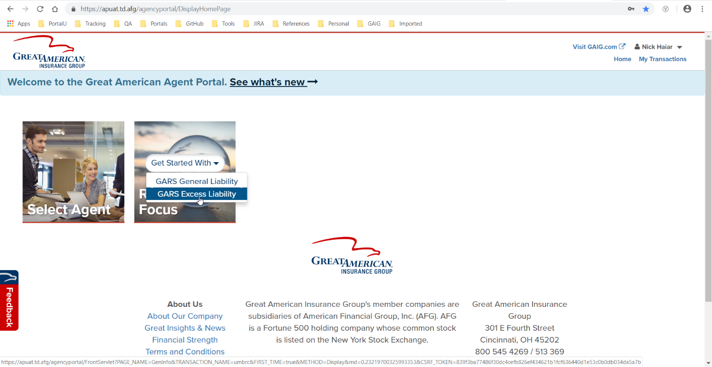From Home, click Get Started With GARS Excess Liability.
2. Complete the General Information page using only the required fields. Click Continue.

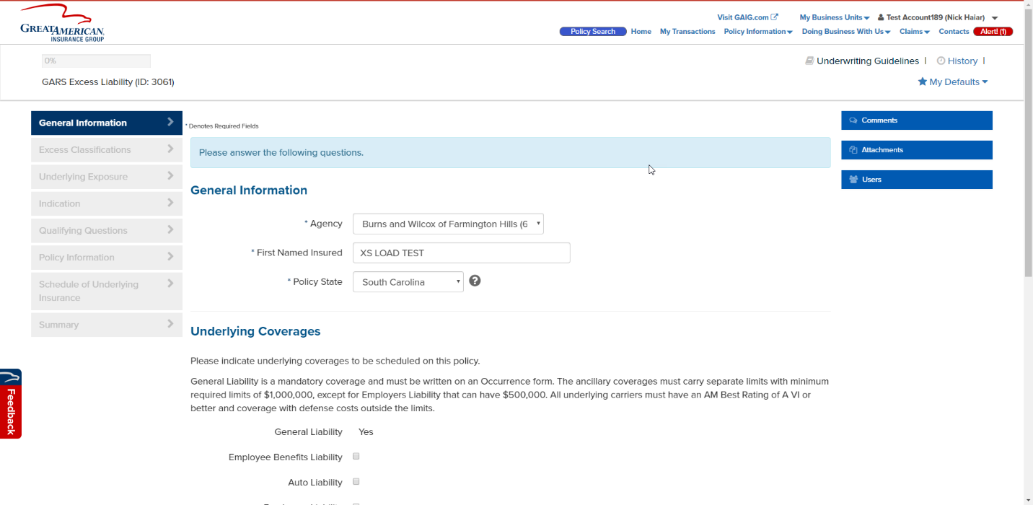

1. 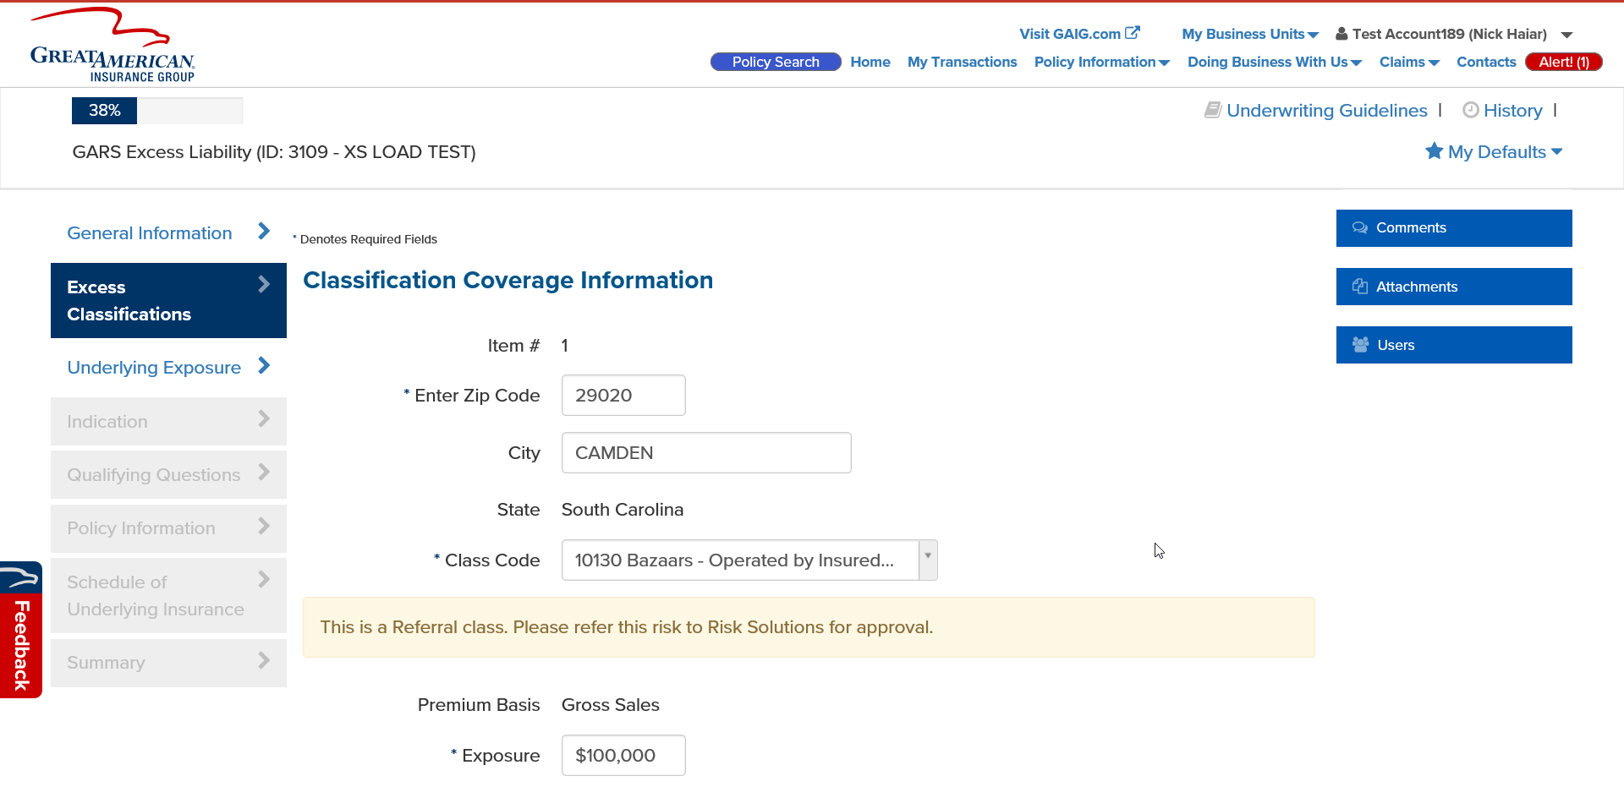Add a Zip Code that matches the selected Policy State from the General Information page. For example, if South Carolina is the policy state, use Zip Code 29020. The City and State will be filled out automatically (reaches out to a third party).
2. 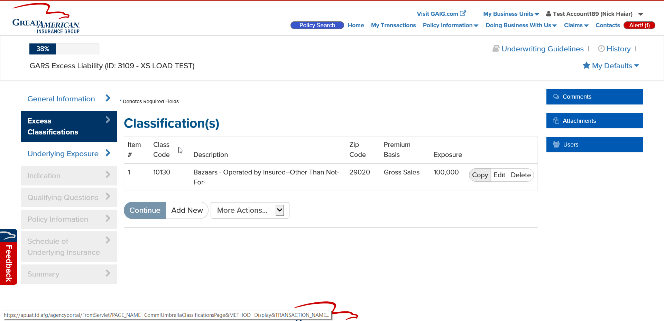Add a class code of 10130 and an exposure of 100,000. Click Add then click Continue.
3. Fill out the Underlying Exposure page. Click Continue.

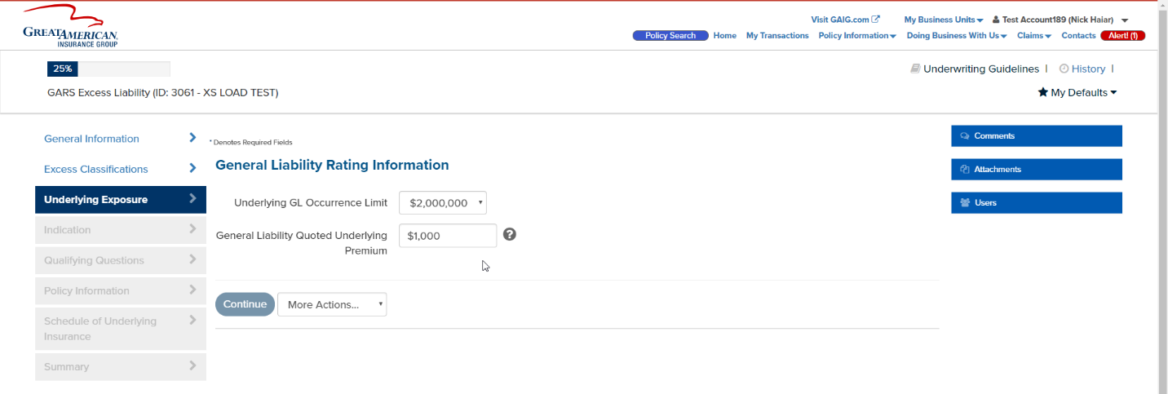

1. The Indication Page will show for new work items. Click Continue.
2. Select yes for General section of the Qualifying Questions.

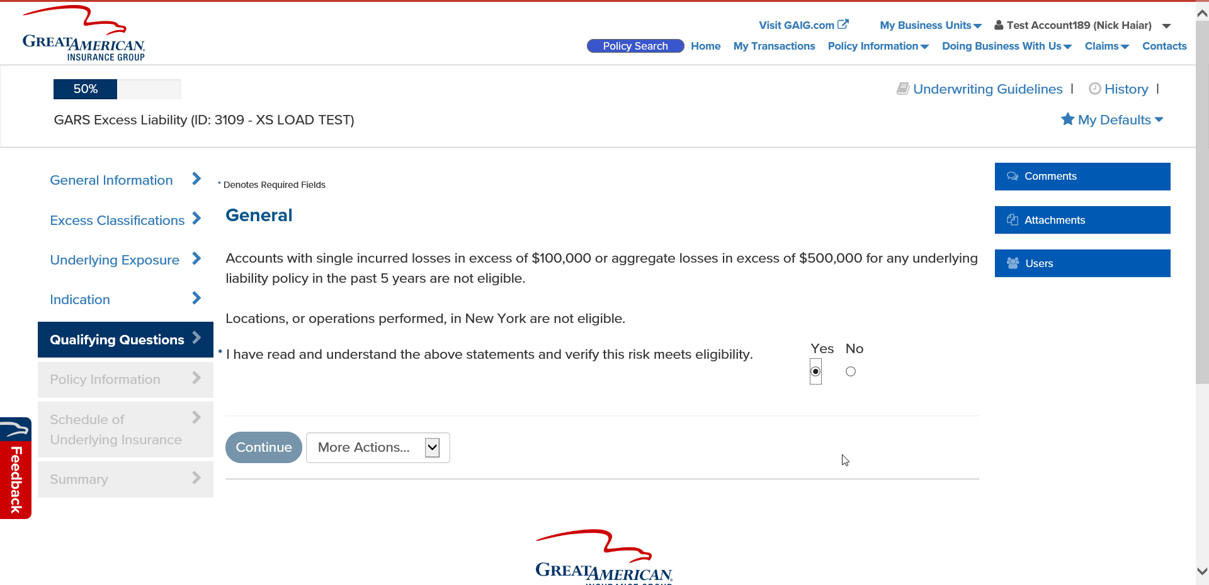

1. 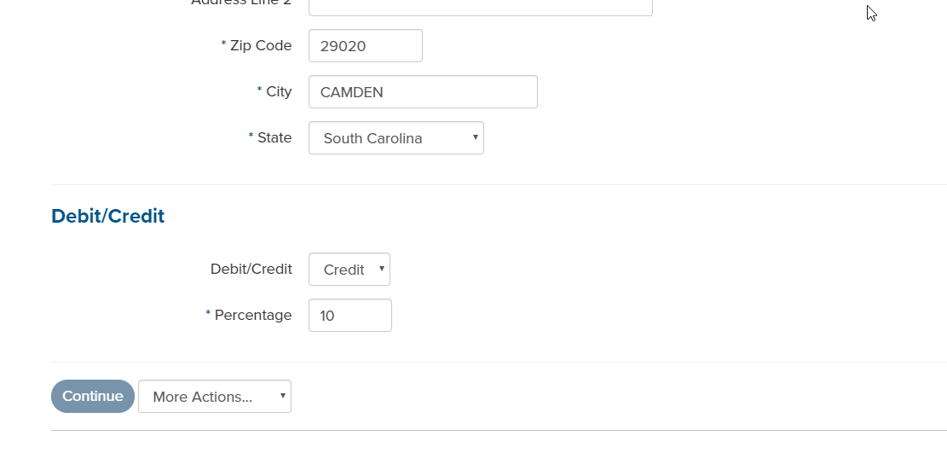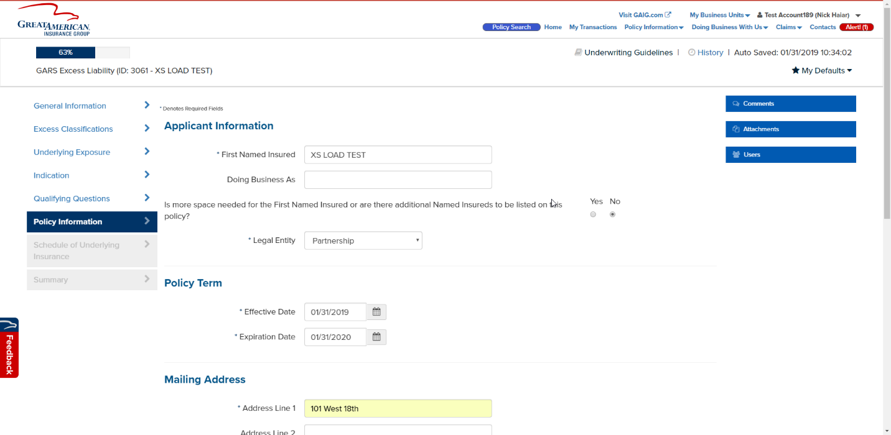Complete the Policy Information page required fields. Also select Credit from the dropdown and enter in 10. Then click Continue.
2. 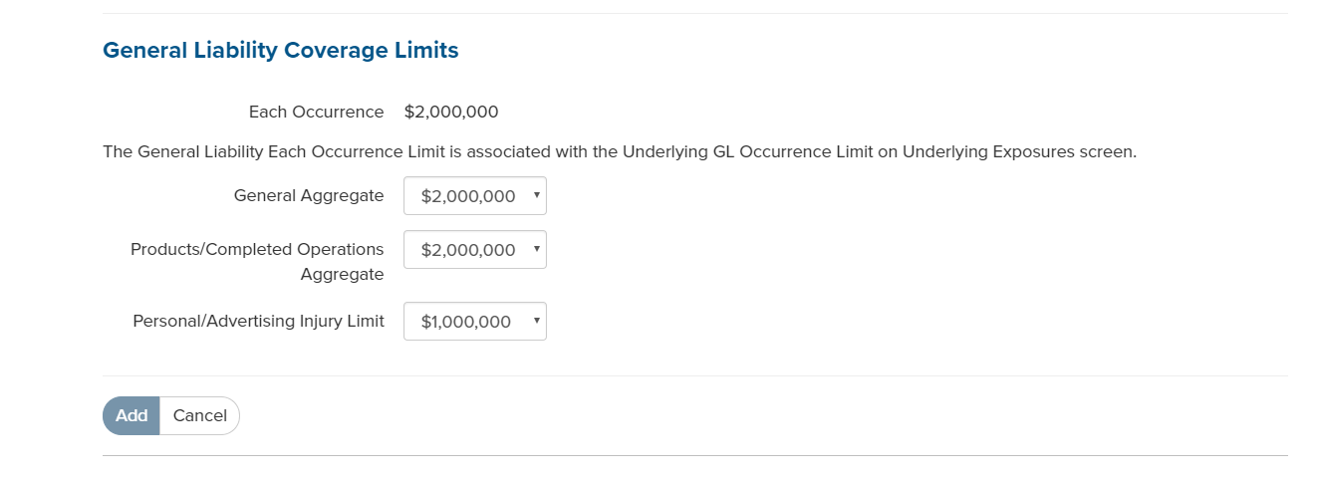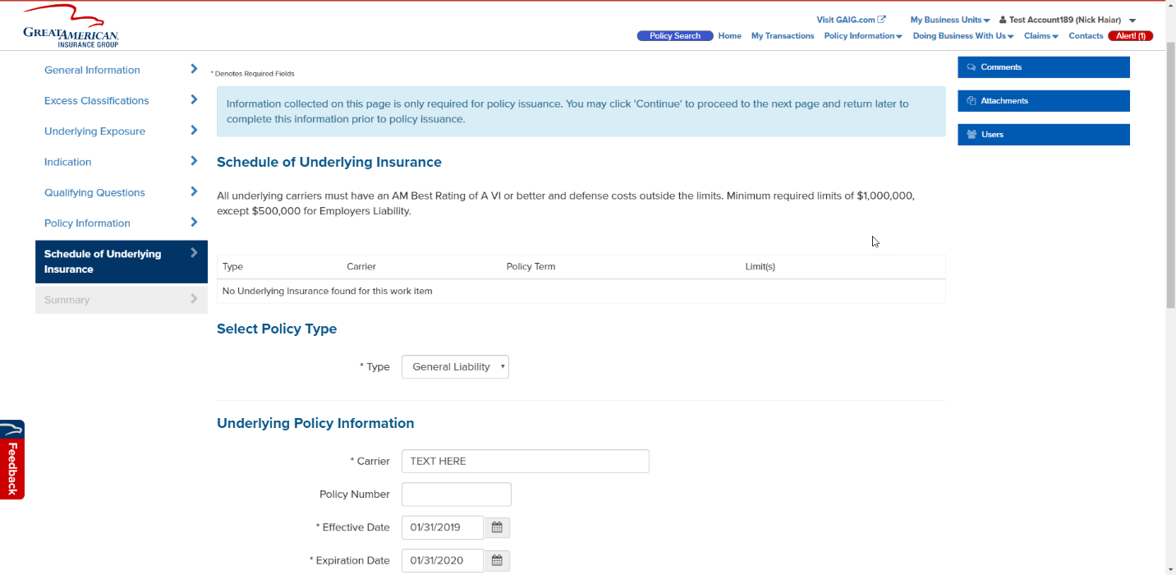Click Add New, select Policy Type of General Liability. Fill out the Carrier (any text is fine). Click Add then click Continue.
3. On the Summary page, select Accept on the Terrorism section. Then click Refer.

