1. Open a previously created work item from My Transactions. It might be best to use one we created for the load test.

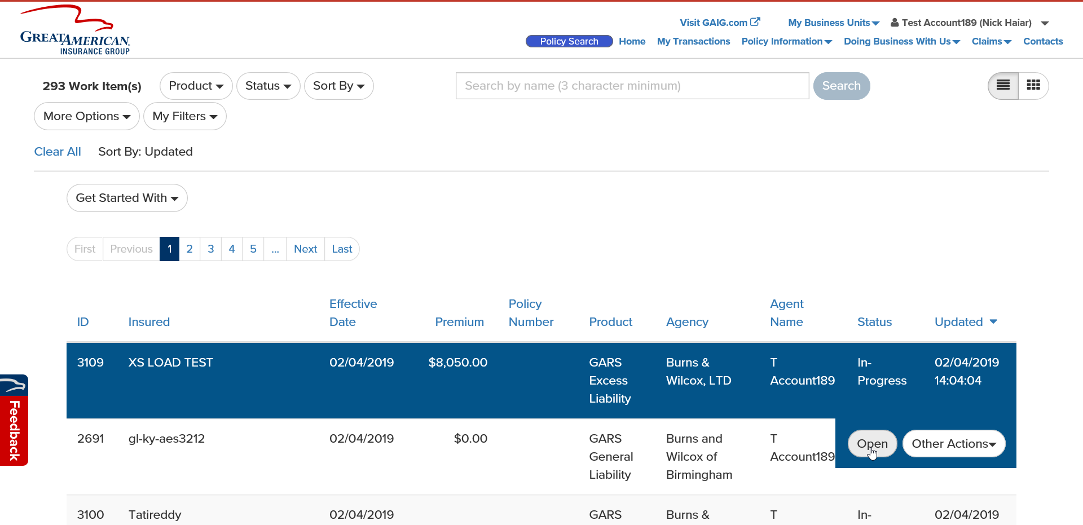

1. 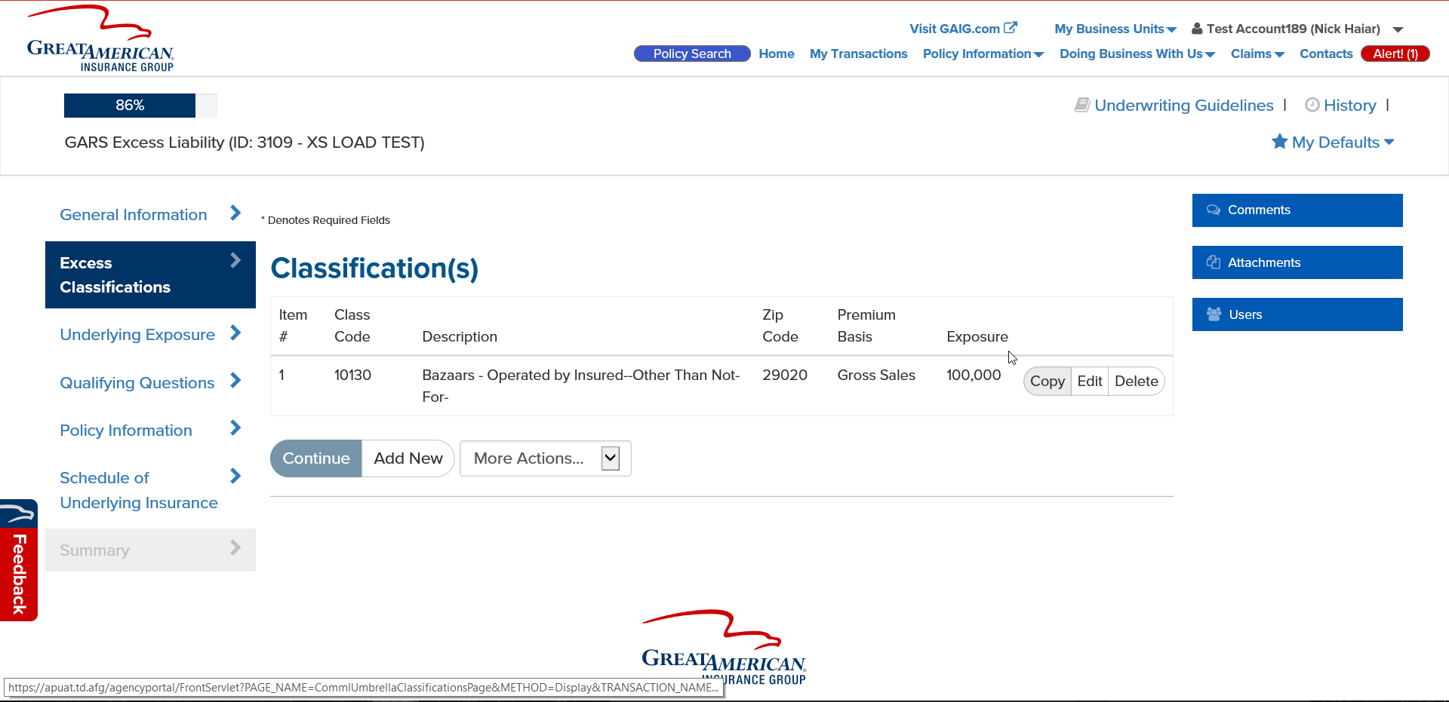Click on the Excess Classications page. Click Edit on any of the Class Codes.
2. 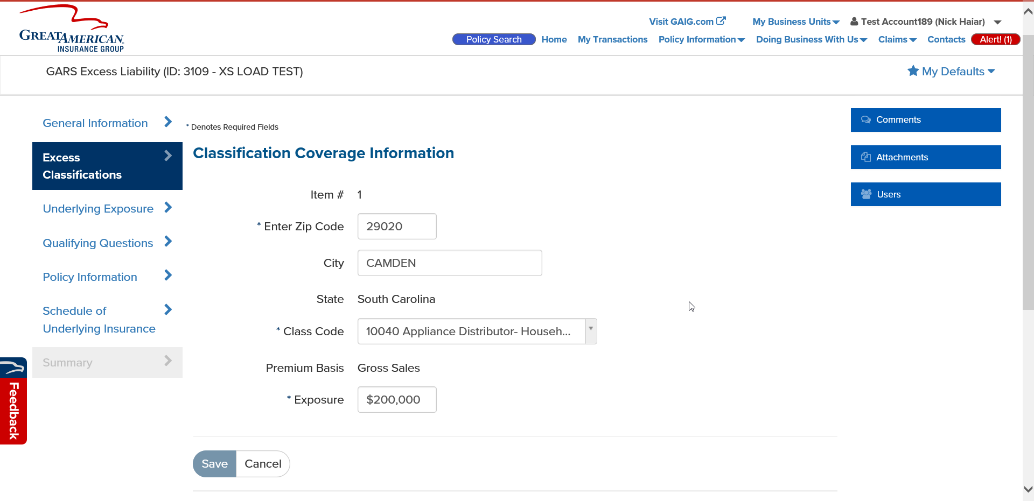Change the Class Code to an accepted class code (10040 or 10042) and complete any remaining required fields. Click Save.
3. Click to go to the Summary page. Then click Exit.

