1. 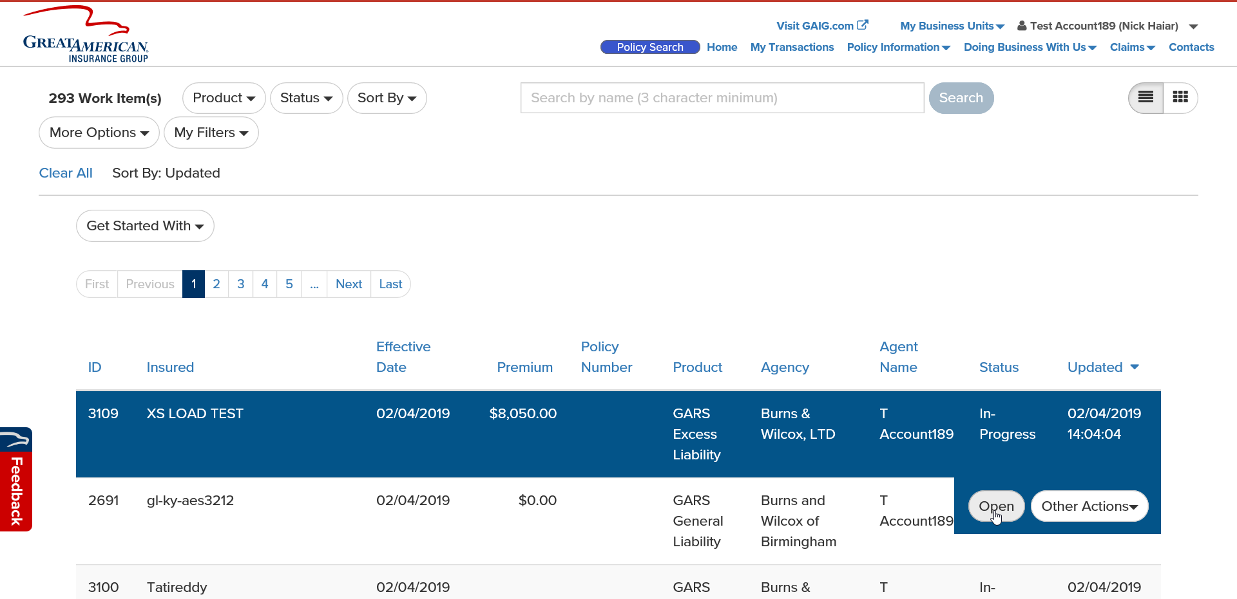Open a previously created work item from My Transactions. It might be best to use one we created for the load test.
2. Click on the Policy Information page. Change all the fields in the Mailing Address section and click Continue.

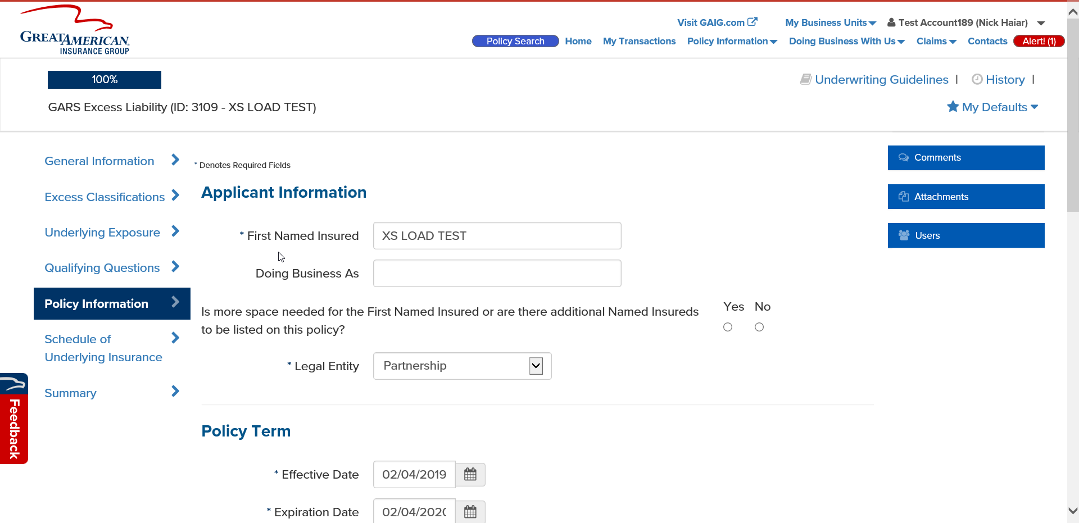

1. 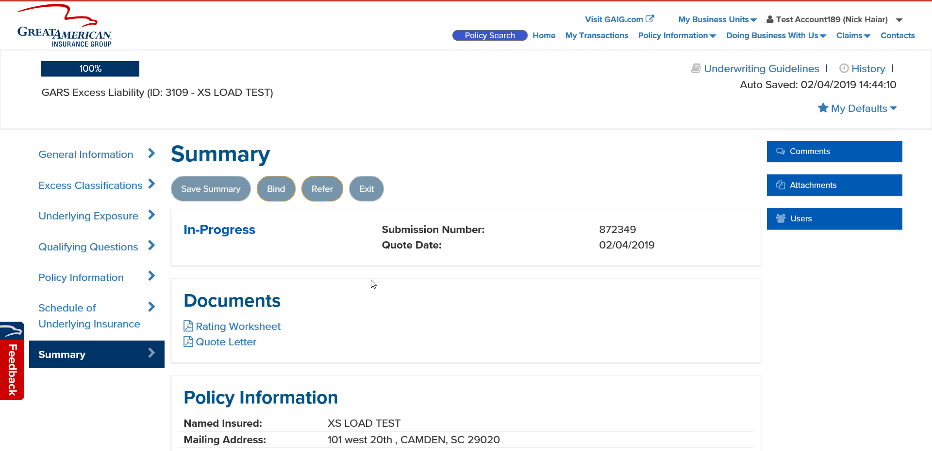Click the Summary Page. Click Exit.