1. Open a previously created work item from My Transactions. It might be best to use one we created for the load test.

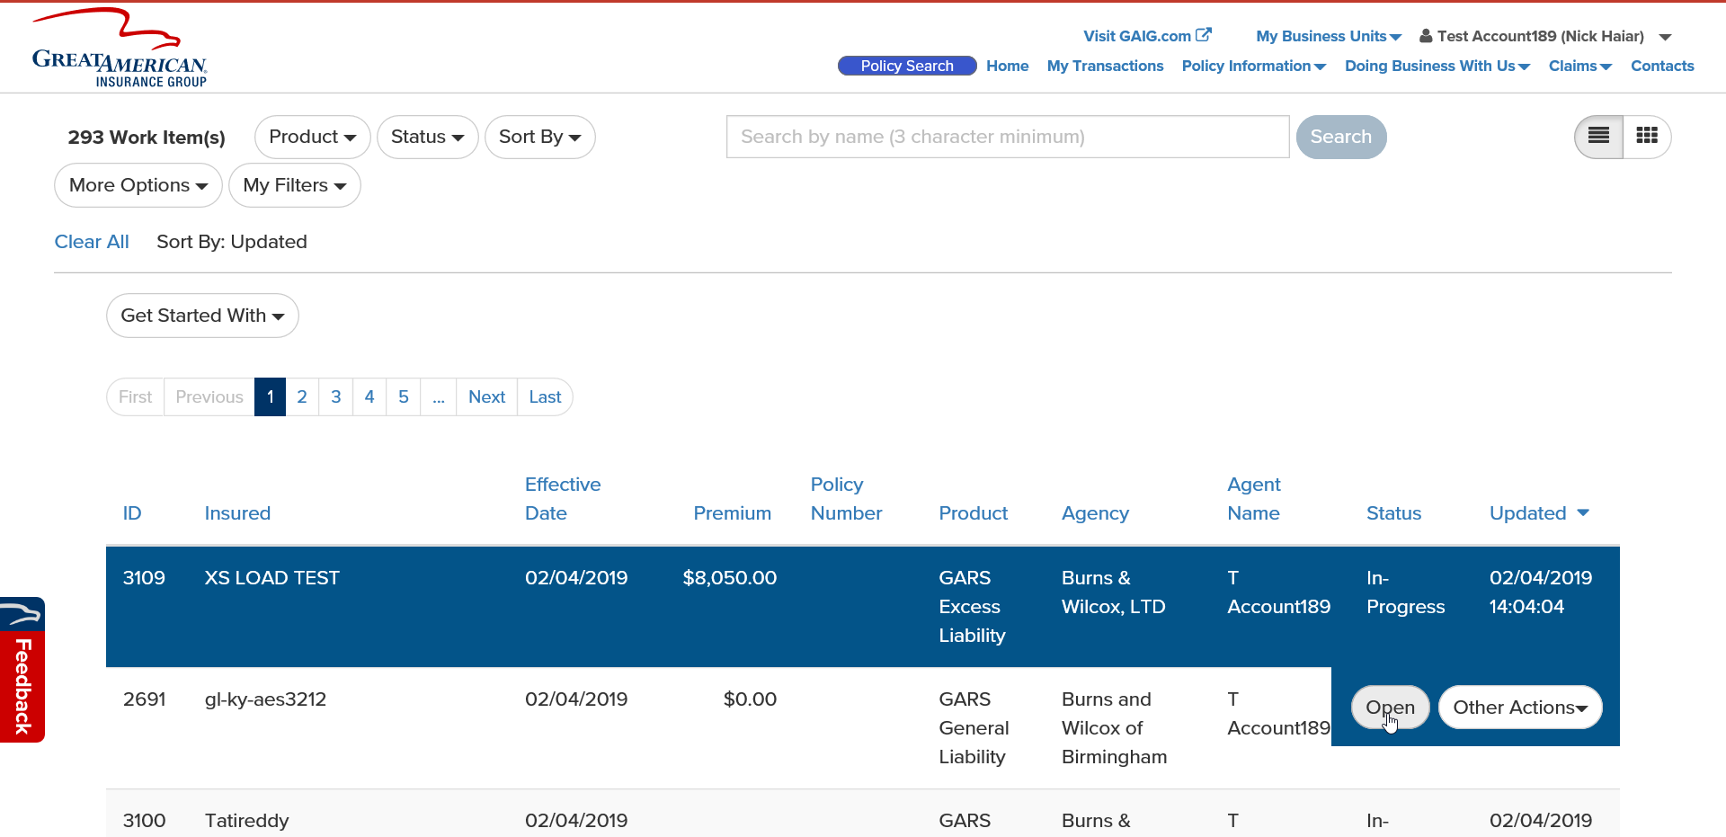

1. Go to the Underlying Exposure page. Change both fields in some way. Click Continue.

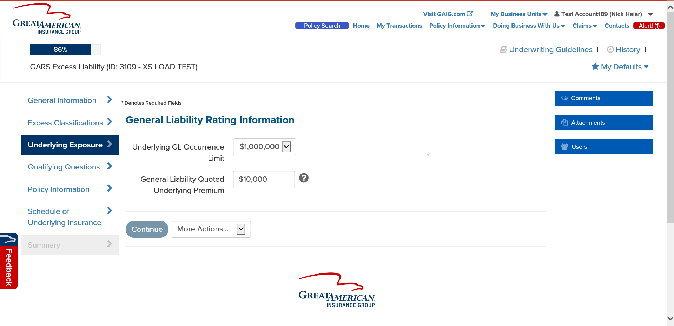

1. 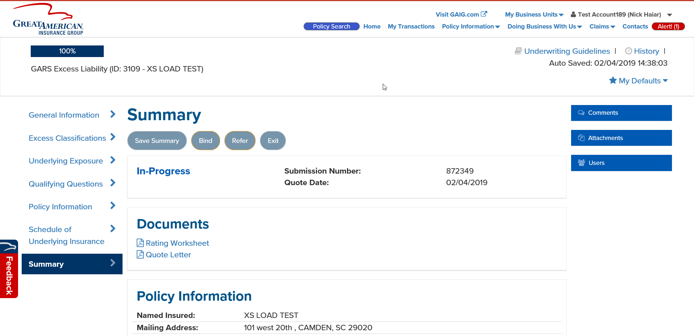Go to the Summary Page. Click Save Summary, then click Exit.