**The science breaker**

**Visualizing the cellular mechanisms of sleep**

David Zada and Lior Appelbaum

The Faculty of Life Sciences and The Multidisciplinary Brain Research Center, Bar Ilan University, Israel

Why do we spend a third time of our lives sleeping? Why do all animals with a nervous system sleep? and how can we define sleep across phylogeny? From jellyfish to mice to humans, all animals sleep despite the risk for predation and survival. Remarkably, the evolutionarily conserved role of sleep remains a mystery and is considered among the biggest unanswered questions in life sciences.

Much theoretical and experimental research was conducted in the attempt to explain the function of sleep. Indeed, sleep has been shown to be important for brain performance, and aids in vital processes, such as metabolic clearance, energy conservation, macromolecule synthesis, synaptic plasticity, learning and memory consolidation. However, even animals with a very simple nerve net require sleep, and sleep in local brain regions was observed in animals such as marine mammals. These observations suggest that sleep could be vital for the function of single neurons.

In a recent work that was published in Nature Communication, we used the zebrafish model to study the cellular mechanism of sleep in live animals. Zebrafish is a vertebrate with conserved, yet relatively, simple brain compared to mammals, which sleeps during the night, as is the case in humans. Zebrafish are highly amenable for genetic manipulations, and their transparent brain gives a unique opportunity to image live neurons within the brain in the context of physiological behaviors such as arousal and sleep. We developed 3D imaging techniques in order to image and quantify the movements of basic DNA structures, i.e., chromosomes, within single neurons during day, night and sleep manipulations. Surprisingly, sleep increases chromosome movements compared to wakefulness. These sleep-dependent increased movements appear to be unique to neurons and were not detected in two other cell types.

Why do DNA structures increase their movements during sleep? How do the single neurons, the whole brain and the entire animal benefit from sleep-dependent increased DNA movements? Using quantification of DNA damage in single neurons, we showed that during wakefulness, when chromosome movements are low, DNA damage increases. This accumulation in DNA damage can be the result of chemical species containing oxygen, natural nuclear processes to expedite gene expression, and even neuronal activity. The accumulation of DNA damage eventually triggers sleep that increases the movements of the DNA, which is essential for efficient repair of the DNA damage. If sleep-dependent DNA movements are inhibited in single neurons, DNA damage keeps accumulating, which may lead to malfunctioning neuronal networks and possibly cell death. This could explain how sleep disturbances affect brain performance, aging, and various brain disorders.

Altogether, this work on zebrafish suggests that the role of sleep is to enable efficient nuclear maintenance in neurons. An intriguing allegory could be a city center. During the daytime rush hours, the roads accumulate potholes, wear and tear. Although we can fix this damage during the day, the most convenient and efficient time to maintain and fix the roads is during low traffic nighttime hours.

These findings open new research capabilities and fields in neuroscience and sleep research. It shifts cell biology experiments, which traditionally were performed in a plate, into a live transparent and behaving animal. Furthermore, this work links sleep behavior with processes at the levels of single cells and molecules. It suggests that quantification of chromosome movements can be used to define sleep in single cells and that one of the functions of sleep is nuclear maintenance. However, further experiments should be performed in additional organisms, ranging from cnidarian to mammals, in order to test whether these findings are conserved across all animal kingdom. Regardless, this work provides a possible explanation for why sleep is not a luxury; it is mandatory.

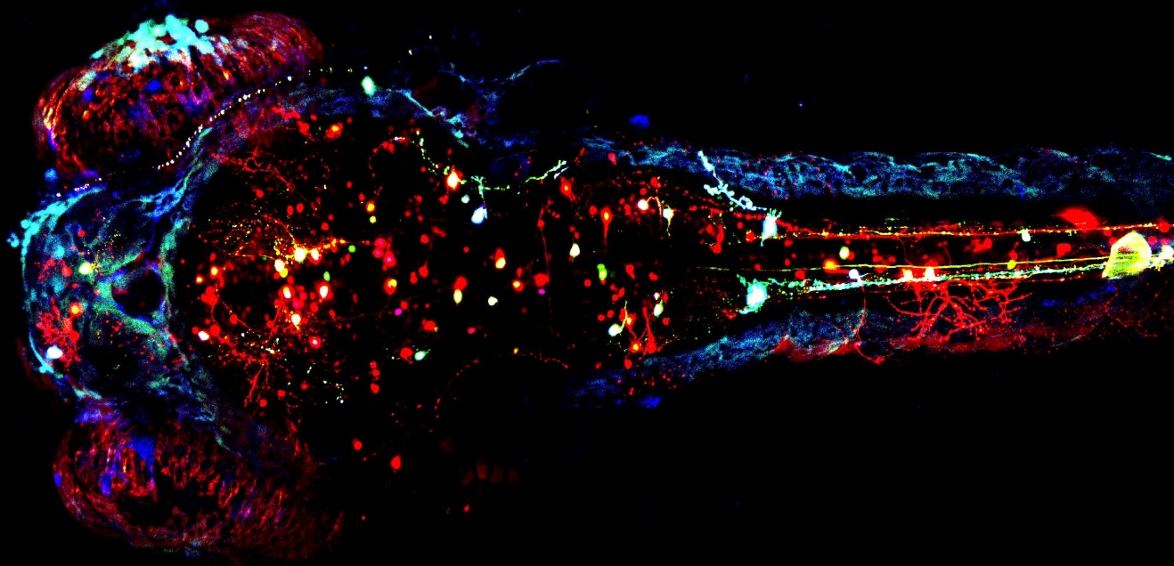

Figure legend:

The transparent zebrafish enables time-lapse imaging of single neurons and chromosomes in live animal. Using multicolor fluorescent proteins (Brainbow), each neuron can be labeled independently in the zebrafish brain.