**AntBot is able to go home like desert ants.**

*Julien Dupeyroux, Stéphane Viollet, and Julien R. Serres*

*Aix Marseille Univ, CNRS, ISM, Marseille, France.*

Autonomous navigation is one of the leading technological challenges of the 21st century in the fields of automotive industry, air and maritime transport, and mobile robotics. To be functional, such systems must perform multi-sensor data fusion provided by the GPS and other devices like radars and embedded cameras. Although performant, the accuracy of the civilian GPS is hampered by both the urban infrastructures surrounding the vehicle and the meteorological conditions. Camera-based strategies are also able to precisely estimate the vehicle’s position in its environment, but the data processing requires important computational resources, and the performances depend on the stability of the lightening conditions. However, when put together, all these techniques are capable of compensating for their own disadvantages with interesting results.

The challenge is to develop brand new navigation systems reliable enough to increase the robustness and the accuracy of the localization of vehicles, aircrafts, ships and robots in a wide range of environmental and meteorological conditions. Researchers from the Biorobotics Dpt. of the Institute of Movement Sciences E. J. Marey (AMU/CNRS) developed a hexapod walking robot, called AntBot (Fig. 1), inspired by desert ants Cataglyphis fortis, to experiment a parsimonious navigational toolkit based on the one existing in desert ants. This work was recently published in Science Robotics1.

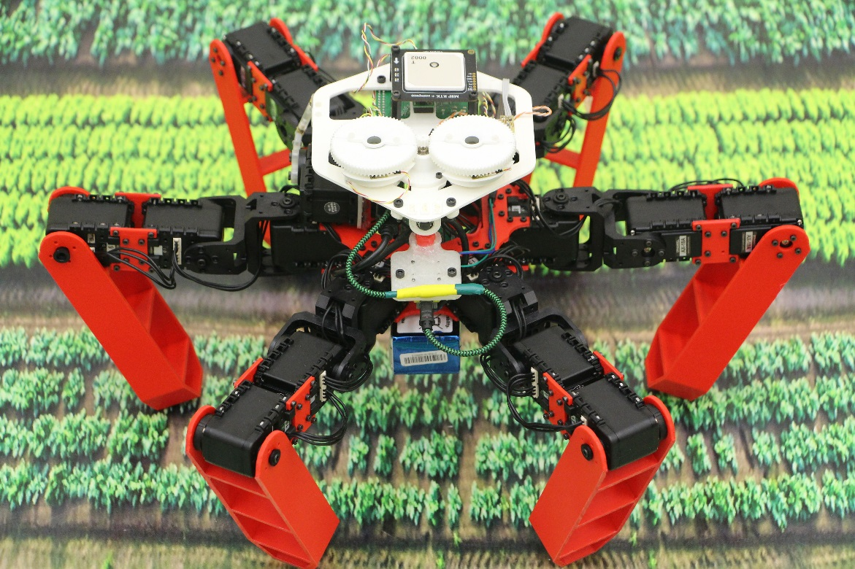

Figure 1: The AntBot robot. Credits: Julien Dupeyroux, ISM (AMU/CNRS).

Unlike their European cousins, desert ants cannot refer to pheromone trails to home after roaming in the desert. This is explained by the extreme heat (higher than 50°C) that would instantly destroy the pheromones dropped on the ground. Instead, they use their vision and they count their strides to find their way back to the nest entrance. This is a famous strategy that biologists call path integration and explain how such small insects can successfully go back to the nest after a 1km-long trajectory in the desert! To achieve this outstanding behavior, desert ants determine their heading based on the ultraviolet polarized skylight coming from the zenith. Human beings are not sensitive neither to ultraviolet light nor to polarization – a particular property of light propagation. In addition, desert ants estimate the distance traveled by counting their strides and integrating the scrolling speed of the ground: this is referred to as optic flow.

To mimic this outstanding behavior, the AntBot robot is equipped with two tiny, unconventional visual sensors. The first one is a sky compass: it is composed of two ultraviolet-sensitive pixels topped with linear polarizers looking toward the zenith par of the sky dome. Basically, this compass works in the same way as the traditional magnetic compass; the difference is that the reference is no longer the magnetic North but the sunlight scattering interacting the atmosphere of the sky dome and drawing a pattern of polarization. This sky compass was inspired by the dorsal part of the compound eye in desert ants, the photoreceptors of which are sensitive to ultraviolet polarized skylight. It provided strong results in a wide range of meteorological conditions, thus suggesting it would fit for outdoor autonomous navigation applications2. The purpose of the sky compass is to make the robot able to determine its heading with respect to the sky dome.

The second visual sensor aims at reproducing the ventral part of the insects’ compound eye where photoreceptors are sensitive to optic flow. Therefore, this scrolling speed sensor is made of 12 pixels that have the property to auto-adjust as function of unpredictable variations in the lightening conditions. This is a key parameter to make a visual-based navigation system functional in real world where ambient light can change randomly. The AntBot robot uses this 12-pixel sensor combined with the stride counter to estimate the distance traveled.

AntBot took its first steps in the heart of the French Calanques National Park. The robot, endowed with the desert ant-inspired navigation system, was able to precisely locate without GPS nor map, and find its way back home with an accuracy 100 times better than the GPS (Fig. 2). It also showed that such bio-inspired approach to navigation can help improving our traditional tools without increasing the development cost or the computational needs. Future autonomous cars could benefit this ant-based navigation systems as a spare in case of GPS failure, for example.

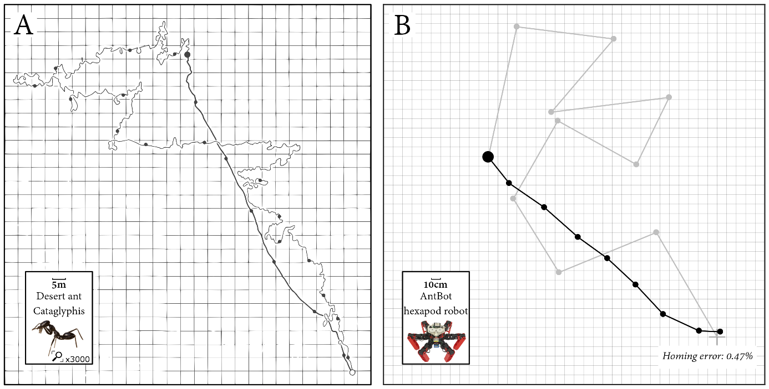

Figure 2: (A) The homing behavior observed in desert ants Cataglyphis fortis3. (B) Corresponding experiments performed with the AntBot robot equipped with a pair of ant-like visual sensors. Gray lines show the outbound trajectories, and black lines depict the inbound trajectories.

**References**

1 Dupeyroux, J., Serres, J. R., & Viollet, S. (2019). AntBot: A six-legged walking robot able to home like desert ants in outdoor environments. Science Robotics, 4(27), eaau0307.

2 Dupeyroux, J., Viollet, S., & Serres, J. R. (2019). Polarized skylight-based heading measurements: a bio-inspired approach. Journal of the Royal Society Interface, 16(150), 20180878.

3 Wehner, R., & Wehner, S. (1990). Insect navigation: use of maps or Ariadne's thread? Ethology Ecology & Evolution, 2(1), 27-48.