**Original Article (DOI)**: 10.1126/sciadv.aav6699

**Author(s):** Carine Emer

**Position:** Post-doctoral researcher

**Affiliations:** São Paulo State University

**Corresponding Author:** Carine Emer

**Word count (700-750 max):** -- 750

**Field:** Ecology

**Twitter handle:** carineemer; Labic-unesp; Unesp_Oficial; AgencyFapesp

**Keywords**: species interactions, defaunation, evolutionary history, Atlantic Forest, Anthropocene

**Title:** Humans are affecting the evolution of animals and plants

**Abstract:**

Species on Earth are interconnected to each other through ecological interactions. Human activities can erode those connections, leading to the loss of millions of years of evolutionary history, with unknown consequences for ecosystems’ functioning.

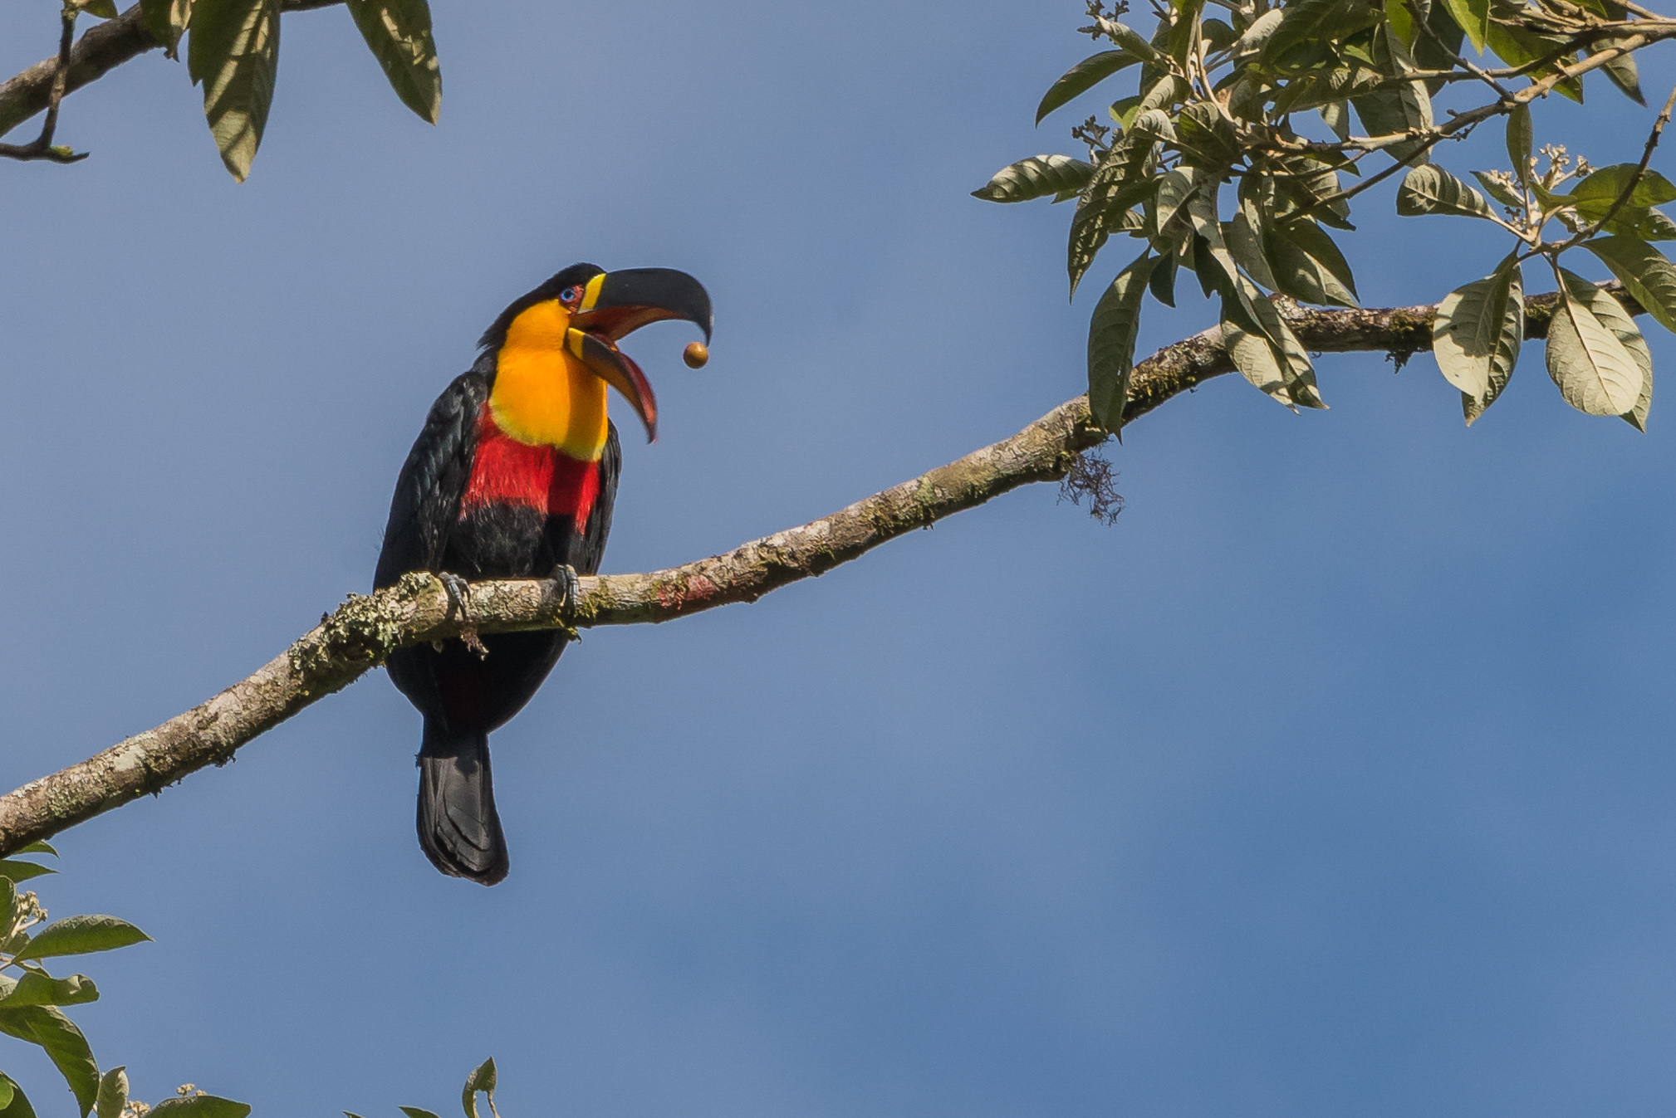

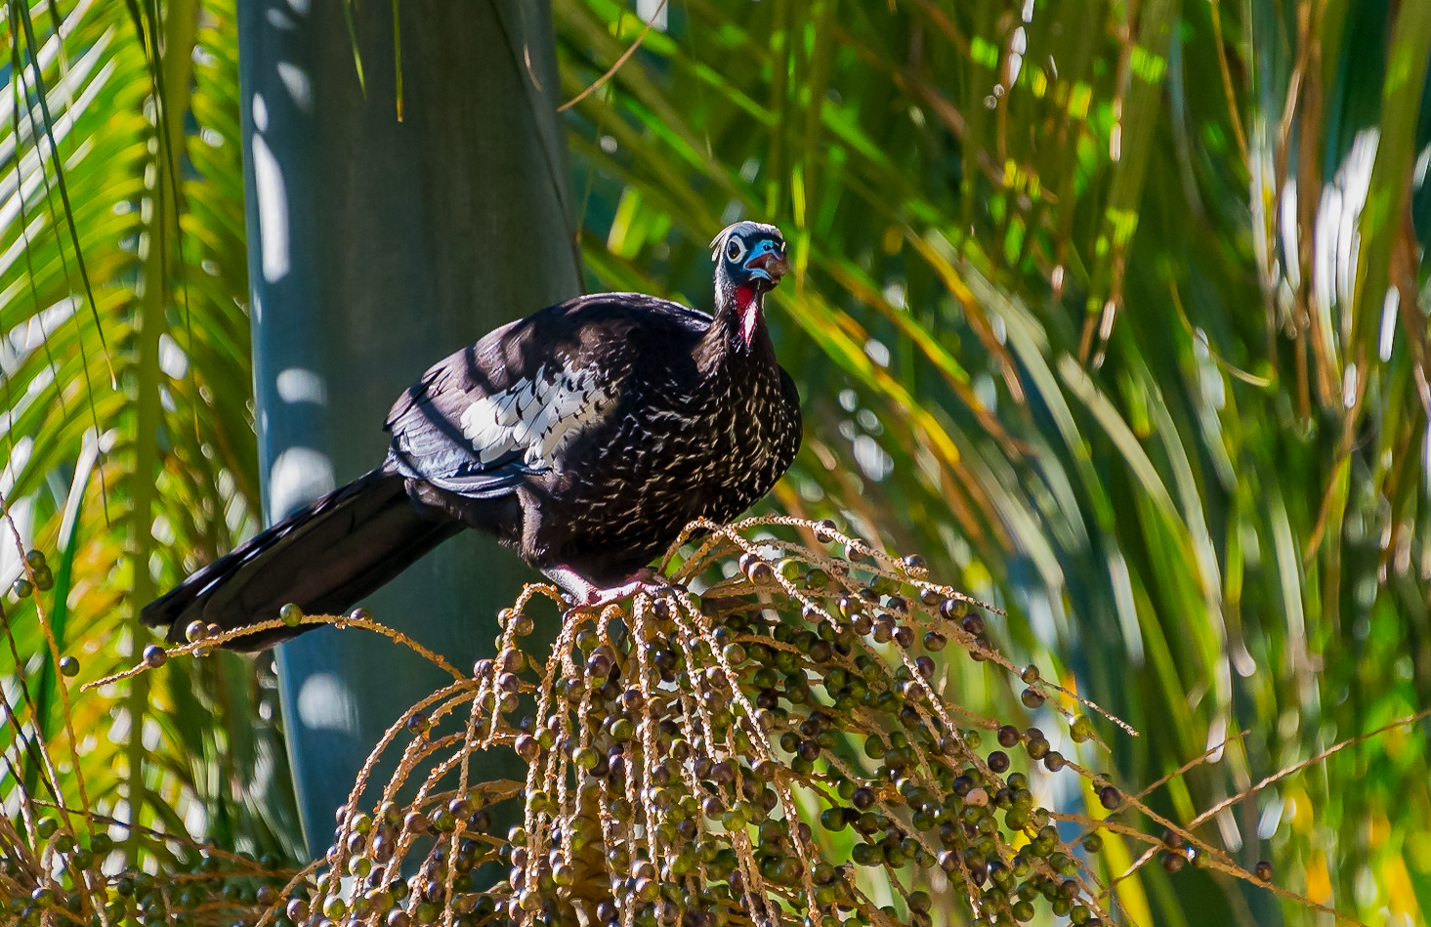

*Credits: Pedro Jordano*

Like in a theatre where actors interact to perform the script of a given play, species on Earth interact to each other in an ecological arena interpreting millions of years of evolution. The famous ecologist G.E. Hutchinson made that analogy back in 1965 calling attention for the environment influence on evolutionary processes. As evolution determines which species can interact, likewise ecology must influence the evolutionary trajectory of the interacting partners. As such, some species establish beneficial relationships with their partners, performing mutualistic interactions as the product of millions of years of evolution. Pollination and seed-dispersal are good examples of this play, in which plant and animal species are the actors interacting according to a given ecological scenario, and according to their evolutionary history that favored some traits over the others, allowing their interaction to occur. When we observe a bee pollinating a flower, or a bird eating a fruit and afterwards dispersing its seeds, we are actually watching a play in which millions of years of combined evolutionary trajectories are interacting in the contemporaneous ecological arena. That’s an Oscar!

Humans are a novel character in this play though. Humans are so influential on Earth that we are currently living in the Anthropocene – a new geological epoch determined by anthropogenic impacts on the planet, including climate change and irreversible biodiversity loss. Defaunation stands as one of the main causes of species loss - defined as the global, local or functional extinction of species due to human activities, such as hunting and deforestation. Although species go extinct with a certain pace over the evolutionary time, humans are definitely speeding-up that process, acting as the meteor that killed the dinosaurs.

In tropical forests, up to 94% of the plant species depend on mutualistic interactions with animals to complete their life cycle. One important step is seed-dispersal, in which birds are very efficient by moving seeds to safety sites where plants can germinate and grow. Here, defaunation plays an important role by primarily affecting large-bodied seed-dispersers, and consequently, the interactions they perform. Large-sized plant and bird species tend to be older and more distinct in their phylogenetic tree, carrying an irreplaceable set of genetic, evolutionary and ecological information that may not survive the challenges imposed by human-driven disturbances. Contrarily, small-sized species able to survive in anthropogenic landscapes tend to be more recent and less distinct in their phylogenetic tree, performing redundant ecological functions potentially replaced by their sister species. Thus, the evolutionary history of an interaction can be quantified as the combination of the evolutionary distinctness of both interacting partners. Therefore, when an interaction is removed from the scene, it takes with it millions of years of evolutionary history as well.

In the Atlantic Forest of Brazil, a highly threatened hotspot of biodiversity, defaunation is removing the most evolutionarily distinct interactions from the stage. Millions of years of evolution are vanishing as the highly evolutionarily distinct bird species that disperse highly evolutionarily distinct plant species are disappearing. An example is the interaction between the highly hunted Black-fronted Piping-guan (*Pipile jacutinga*, 29 Ma), and the ‘juçara’ palm (*Euterpe edulis,* 99 Ma) a keystone species also threatened by illegal harvesting. Combined, the *Pipile-Euterpe* interaction, nowadays only found in pristine, large forest tracts, carries 130 Ma of unique evolutionary history that has been extirpated from the landscape. In this novel human-made fragmented scenario, the persisting interactions are performed by small-sized, generalist bird species dispersing small-seeded plant species therefore corresponding to lower values of evolutionary distinctness, lacking the adaptive information of ancient species. Yet, sometimes, unexpected associations arise. For instance, the asymmetric association between low-evolutionarily distinct bird species dispersing ancient, highly evolutionarily distinct plant species. These relatively recent birds on the Tree of Life are playing a phylogenetic rescuing-effect of ancient plants, by dispersing seeds of species that have lost their primary mutualistic partner, and that would have been out of the scene otherwise.

Given the increasing defaunation in most tropical forests, a marked reshaping of the Tree of Life may occur in the Anthropocene as bird-driven losses of unique evolutionary history of ecological interactions persists, and cannot be replaced by contemporaneous species. Furthermore, medium-to-long term changes on Earth biogeochemical cycles may arise, such as on CO2 storage by large-seeded plants going extinct with their large-bodied seed-dispersers. In a more positive setting, active restoration of evolutionary history of threatened interactions by reintroducing one or both partners could potentially minimize the losses. Concomitantly small-generalist bird species may be rescuing highly evolutionarily distinct plant species from the verge of extinction.