Nikolaos Tsopoulidis and Oliver T. Fackler

Department of Infectious Diseases, Integrative Virology, CIID, University Hospital Heidelberg, Heidelberg, Germany

A nuclear spider web to control immune cell function

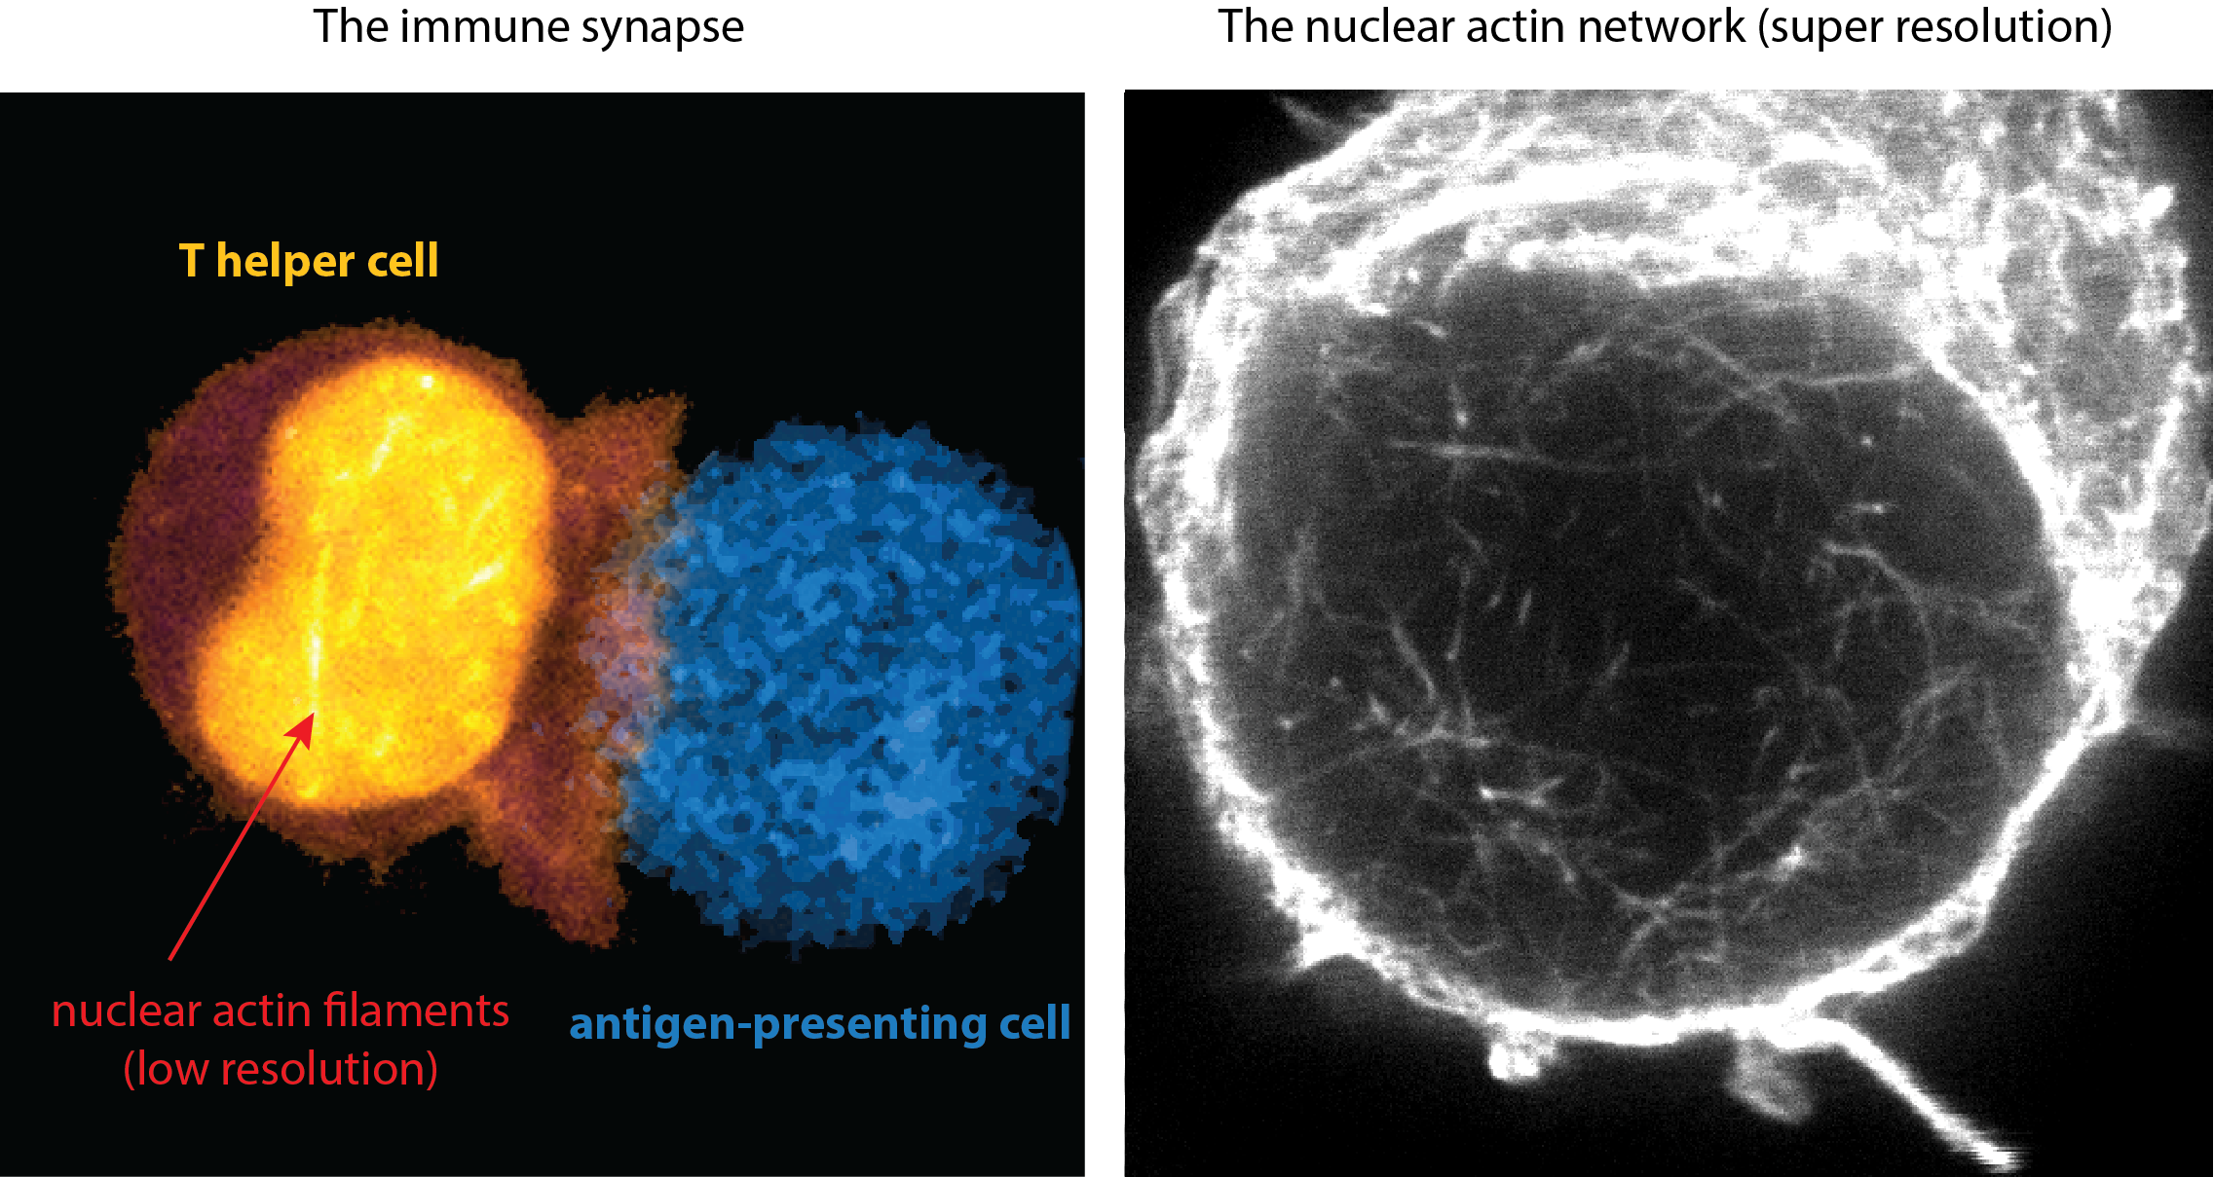

Every day cancer, viruses, bacteria, and parasites are threatening our health. The weapon to fight these threats is our immune system. Our immune system is armed with several types of immune cells, with each of them pursuing a distinct task. Scavenger cells are the first line of defense and eat anything they consider foreign to the body. Then they present fragments of the ingested material (called antigens) on their surface so other immune cells can recognize them. T helper cells (also called CD4 T lymphocytes) scan the surface of these antigen-presenting cells, and as soon as they recognize a dangerous antigen, they become activated. Activated T helper cells are very efficient in influencing the behavior of other immune cells as they rapidly send messenger molecules called cytokines to activate antibody-producing B cells. These antibodies bind to e.g. bacteria or infected body cells and mark them for destruction by other immune cells.  
  
Because of their outstanding importance scientists are interested in understanding how T helper cells work. One of their interesting characteristics is that they form stable contacts with antigen presenting cells when attracted by the specific antigen presented. This cell-cell contact (also called immunological synapse) resembles the neurological synapses in the brain in that it is vital for the communication between involved immune cells. The discussion between the two cells decides in which direction the immune response needs to be shaped: do we need more scavenger cells or should we activate B cells to make antibodies?  
  
To engage in an immunological synapse, T helper cells need to rapidly restructure their architecture. The shape of any cell is mainly determined by a network of filaments formed out of the scaffolding protein actin. Upon T helper cell stimulation, single units of actin rapidly aggregate to form actin filaments that change the shape of the T helper cell to a configuration reminiscent of a grabbing hand catching the round antigen-presenting cell. Although actin filament formation in the cytoplasm of T helper cells is well understood, nothing is known about actin filaments in the nucleus, which is the cellular compartment that contains the DNA.  
  
In our study, we found that actin filaments in the nucleus form rapidly upon T helper cell activation and disassemble shortly after they have formed. Nuclear actin quickly assembled within 30 sec of activation to a complex meshwork spanning the whole nucleus and this complex network dismantled again within 10 min. The speed of nuclear actin filament formation was, therefore, faster than that observed in the cytoplasm. Also, we could show that nuclear actin rearrangements are coupled to one of the fastest signals in biology, the calcium signal. Calcium is stored inside cells in dedicated storage places and is released upon T helper cell stimulation, rapidly flushing the whole cell. This explains why nuclear actin filament assembly can be so fast!  
  
So what are these filaments good for? To study this, we had to find a way to interrupt actin filament formation in the nucleus and see if T helper cells can still do their job. For this, we had first to find out how these actin filaments are made. To assemble individual actin building blocks into filaments, complex protein machines are required.  We discovered the responsible machinery (the Arp2/3 complex) and engineered a way to selectively disrupt its function in the nucleus. This strongly reduced nuclear actin filament formation, which went hand-in-hand with reduced cytokine production following T helper cell activation. When we examined the cytokine profile closely, we found that many of these cytokines are necessary for helping B cells to become antibody-secreting cells. To test whether nuclear actin filament formation in T helper cells is essential to initiate antibody production, we designed an animal vaccination experiment. For this, we injected T helper cells that were unable to form nuclear actin filaments into mice and vaccinated these mice with an engineered antigen. Compared to mice that had received normal T cells, these mice only produced much lower amounts of antibodies. This means that the short pulse of nuclear actin filaments in the very beginning of the immune response (immune synapse formation) had long-lasting effects on the immune system. Thus, nuclear actin filament formation is a prerequisite for proper T helper cell function.

How exactly nuclear actin filaments drive the production of a selective set of cytokines and which other physiological processes may be regulated by this novel mechanism remain intriguing open questions we are currently addressing. Since life is an arms race, it is probable that some pathogens or cancer have developed means to interfere with nuclear actin filaments and to paralyze our immune system. Only now that we are aware of existence and importance of this nuclear actin filament system, we can start to search for such interference and hopefully find ways to prevent it.