‘Peeling back the onion’, a multi-layered approach to the problem of sleep

Maxime Jan & Paul Franken

*Center for Integrative Genomics, University of Lausanne, Lausanne, Switzerland*

We now know that a good night’s sleep is essential for maintaining optimal brain functioning and health. Many will have experienced the acute detrimental effects of ‘pulling an all-nighter’ on attention and performance, which are usually quickly remedied by sleep. Chronically curtailed or disrupted sleep can, however, have severe long-lasting negative health consequences as both epidemiological and experimental studies have found it to predispose for e.g. metabolic disorders such as type-2 diabetes and obesity. The biological substrates through which sleep protects us from the harmful effects of excess wakefulness remain largely unknown.

To gain insight into the problem of sleep, researchers have taken advantage of the genetic variability in how individuals cope with sleep loss. Although cataloging the DNA-variants that explain part of the variance in sleep traits may point to candidate molecular-signaling pathways important in sleep regulation, this approach does not inform on how the information encoded in the DNA reaches the traits of interest. Researchers have therefore begun complementing the genetics approach with a systems approach, the latter referring to collecting multi-layered data such as gene expression and metabolites, to track the flow of information connecting DNA to trait. This combined approach is referred to as systems genetics, and is now considered critical for predicting disease susceptibility.

We took a systems genetics look at sleep to peel back the many layers regulating sleep [***PMID: 30091978***]. We based our research on a widely-used and well-characterized genetically diverse panel of mice, the BXD; a large collection of inbred lines all originating from a cross of two parental strains: C57BL6/J and DBA2/J (represented by the ‘*B*’ and ‘*D*’ in BXD, respectively). Each BXD line is unique in the way the DNA of the two parental lines is distributed over the genome making this panel extremely useful to identify genes differing between *B* and *D* and causally affecting sleep. We established a map of 11’000 such genomic variants, which served as the *genome* core of our systems genetics analyses. As the outermost layer we assembled a ‘*sleep phenome*’ comprising an in-depth analysis of many aspects of sleep and related phenotypes such as brain activity and locomotion. As intermediate layers, bridging core and outermost layer, we quantified expression levels of all genes in brain and liver. These two ‘*transcriptomes*’ each comprised close to 15’000 different RNA molecules. Finally, 124 metabolites measured in blood made up the ‘*metabolome*’ layer. Importantly, all data were collected both under undisturbed conditions during mice could sleep as they pleased, and after a 6-hour period during which we kept mice awake. In this multi-layered system we then determined *i*) the wiring of the many connections within and between layers, and *ii*) the influence of DNA variants and sleep loss this complex, multi-layered wiring.

***Sleep as a multi-layered -omics onion***

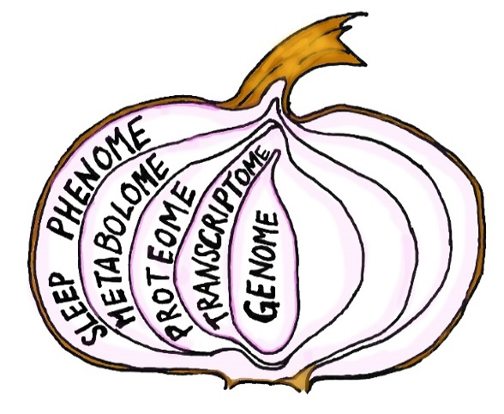

With this resource in hand we could address the question which molecular pathways are required to mount an adequate response to sleep loss. Analyzing this big data set proofed to be a challenge and new analytical tools needed to be developed first. We made a number of unexpected observations. A first surprise was the sheer magnitude of the effect of eliminating sleep during the first half of the rest phase on the system; levels of 78% of all genes expressed in the brain, 60% of liver genes, and 60% of blood metabolites significantly changed. Even more surprising was that for a number of sleep phenotypes and molecules, levels increased with sleep deprivation in one BXD line but decreased in another, attesting to the pervasive effects of genetic factors in shaping how we cope with an external challenge.

For several of these remarkable changes we could connect DNA to trait and track the layer-to-layer information flow. For example, a DNA variant affecting the number of RNA molecules transcribed from a gene called *Acot11*, encoding an enzyme important in the regulation of free fatty acids, also determined levels of several blood metabolites, and, importantly, how much extra sleep mice accrued during recovery from the sleep deprivation. A very surprising aspect of these findings is that this DNA variant affects *Acot11* RNA levels in the liver and not in the brain, suggesting that a complex behavior, such as sleep, is regulated by peripheral processes and thus not primarily under the control of the central nervous system. The relevance of *Acot11* is further demonstrated by its role in obesity and type-2 diabetes, conditions that in humans are known to be associated with insufficient sleep, likely through a dysregulation of free fatty acids.

The power of our systems genetics approach clearly lies in generating novel hypotheses on sleep regulation. Peeling back the –omics onion of sleep already revealed a number of new insights that we are now following up on such as the role of *Acot11* in sleep homeostasis. Thus far, we only managed to uncover a fraction of the novel information still hidden in the resource. Because we made our data publically accessible (https://bxd.vital-it.ch/), we invite all to further mine this resource. In the meantime, we continue to add extra layers to the onion.