**When gut bacteria spoil drug treatment**

Patients often respond differently to the same drug. In many cases doctors do not know why one patient responds well to a drug, while another experiences significant side effects. We found that bacteria living in the gut can be partially responsible for such differences, because they can break down certain drugs to small molecules that cause serious complications during drug therapy.

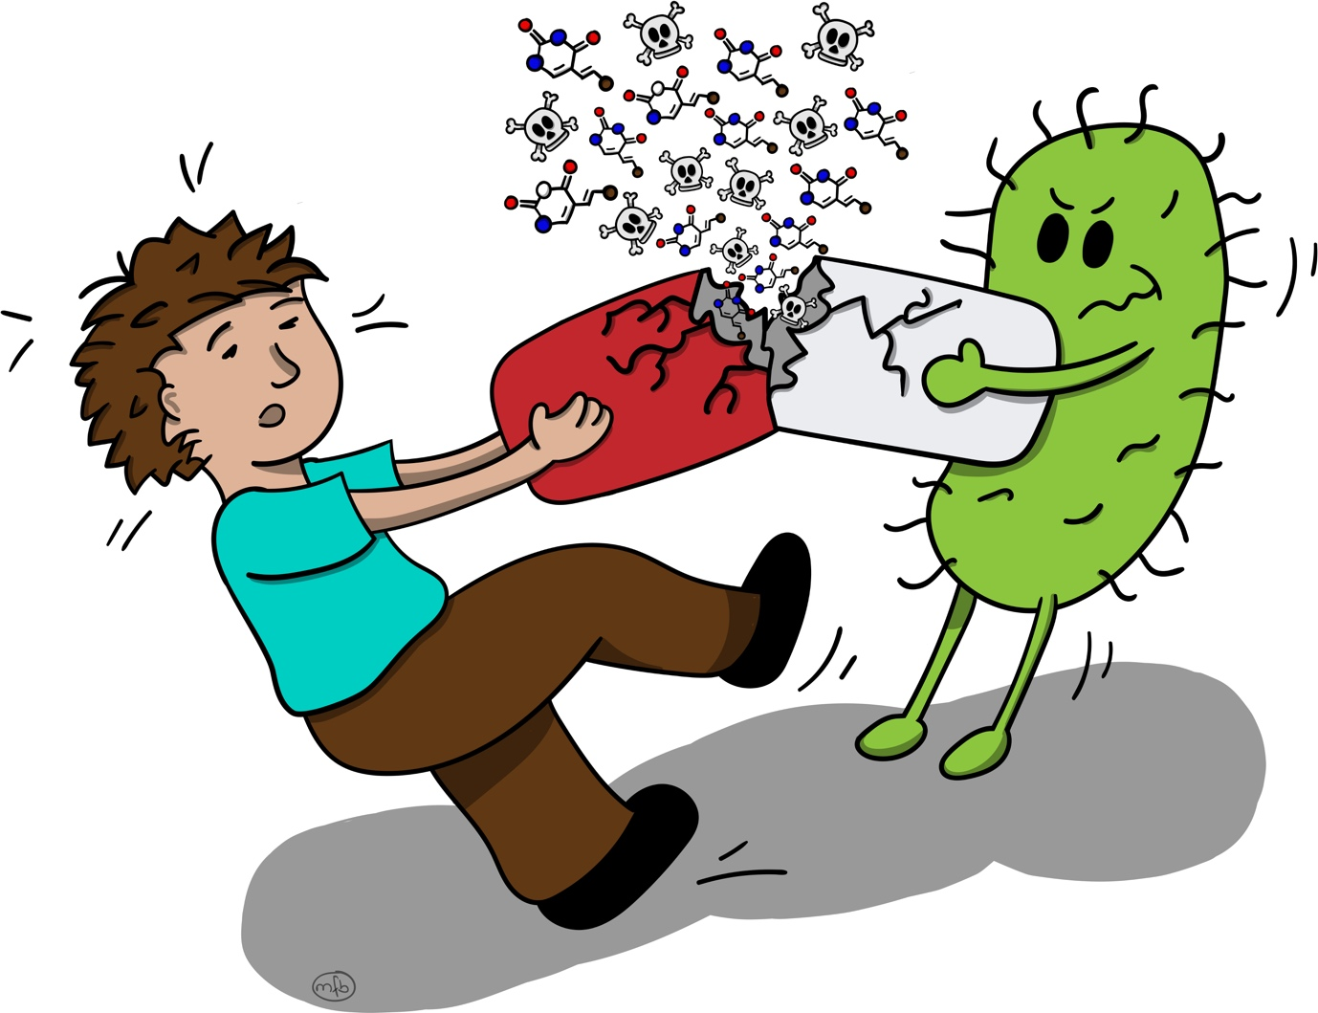

**ARTICLE**

Therapeutic drugs are an important pillar of modern health care and often crucial for the treatment of patients. Besides their desired effects to cure diseases, drugs can also cause unwanted side effects, which often occur only in some patients. The causes of these side effects often remain unknown due to their complex nature involving many chemical processes breaking down the drug inside the body. This makes it difficult to predict which patients will experience drug side effects and challenging to find the right drug and dose for the right patient.

Human physiology is not determined solely by human genes: our body also harbors communities of bacteria at different sites, such as the skin, mouth, and intestine, collectively called the microbiome. These bacteria play essential roles in human health and disease, including production of vitamins, digestion of nutrients that we cannot digest ourselves, and protection from intruder bacteria that could make us sick. Remarkably, there are hundreds of different types of bacteria living in the human body, and their composition varies greatly between individuals, which influences interpersonal differences in body physiology. We wondered if microbiome differences could also impact drug response.

To study whether the microbiome can influence drug metabolism, we focused on the antiviral drug brivudine, which is known to be broken down into a metabolite that is harmful to the liver. Previously, human liver cells have been reported to be able to perform this breakdown reaction. Using test tubes mimicking the intestinal environment, we tested different bacterial types isolated from the human gut for their ability to transform the drug into the harmful metabolite. In this experiment, we identified a common gut bacterium that is capable of breaking down the drug, and the bacterial gene responsible for this reaction. Next, we were interested in quantifying the contribution of the gut bacteria and its mammalian host to the levels of this breakdown product measured in the blood. We administered an oral dose of the drug to two groups of mice that differed only by the ability of their gut bacteria to transform the drug. We measured drug and drug metabolite levels in the intestine and the blood of these animals and found much lower levels of the harmful drug products in mice with the drug-metabolism deficient gut bacteria. Using these data, we developed a mathematical model to describe drug metabolism processes in the body and to quantify host and microbiome contributions to the formation of the harmful metabolite.

With the help of the developed computational model, we found that the microbiome contributes more than 70% of the harmful drug metabolite circulating in the body, which substantially increased its toxic effect in the liver. In addition, we performed independent experiments with two other drugs, the antiviral drug sorivudine and an anti-anxiety drug clonazepam, and used the mathematical model to quantify bacterial contribution to their break-down products. Remarkably, in both cases microbial contribution to circulating drug metabolites in the blood was >60%, even though host cells were also capable of breaking down the drugs. These results clearly demonstrate that the bacteria in our gut can influence drug response, in particular the formation of drug metabolites that can cause unwanted side effects. We simulated hundreds of different drug-microbiome-host scenarios to find out how different types of gut bacteria, the oral formulation of the medication and uptake of the bacteria-produced breakdown products in the gut would shape the bacterial impact on drug processing.

Together, this study provides an experimental and computational strategy to identify and quantify microbial contributions to drug response. A better understanding of these processes will help to explain how differences in gut microbiome composition between patients may impact drug therapy. This could help doctors to choose better-suited medications for patients, or even design a combination therapy to alter an individual’s microbiome to improve the benefits of specific drugs. This knowledge about microbiome-drug interactions may also influence future efforts to develop new drugs or functional foods in order to avoid or purposefully exploit interactions with intestinal bacteria.