**Scutoid, the novel cellular block that puzzles out how to build your body.**

**Pedro Gómez-Gálvez1, Luis M. Escudero1 and Javier Buceta2,3.**

1: Departamento de Biología Celular, Universidad de Sevilla and Instituto de Biomedicina de Sevilla (IBiS), Hospital Universitario Virgen del Rocío/CSIC/Universidad de Sevilla. 41013 Seville, Spain.

2: Bioengineering Department, Lehigh University. Bethlehem, PA 18018, USA.

3: Chemical and Biomolecular Engineering Department, Lehigh University. Bethlehem, PA 18018, USA.

Breaking news! Believe or not, we are formed by cells! Well, to be honest, we know this since 1665 when Robert Hooke discovered and named the fundamental constituents of all animals. Hooke performed pioneering microscopy and biological studies but, in addition, he was also professor of geometry and a renowned physicist… wow! He coined the term “cell” because he found a resemblance in the way they pack together with the cells of a honeycomb. Curiously enough we have also used tools from microscopy, biology, geometry, and physics to dig deeper into the cell packing problem.

Understanding how cells are shaped and packed is indeed a key question because those properties are directly related with their functionality. In this context, epithelial cells are 'the building blocks' of all animals. They move and pack in a finely controlled way during embryonic development to carry out the transition from an early embryo (a simple structure formed by a few cells) to a complete individual with complex organs such as a liver or a pancreas. You can actually see epithelial cells right now: take a look to the dorsum of your hand. A close look will reveal a sort of polygonal organization (a sort of honeycomb as Hooke described). The way in which these cells are arranged in that 2D representation has been widely studied. However, less is (was!) known about the way cells organize and pack in 3D (e.g. as you go deeper your skin surface).

A group of us, formed by biologists, mathematicians, engineers, and physicist, joined efforts to understand this. In particular, we were puzzled about what happens to those cells when tissues are subjected to curvature (because, to some degree, all tissues are!). We first developed a 3D computational tubular model (similar to a toilet paper roll) in which cells tesselate the space without leaving empty spaces. This model followed the principles of Voronoi Diagrams (a common tool used to understand geometrical organization). When we checked the predictions of this model, we observed a strange thing: cells had peculiar properties in regards of their topology (how they were connected to their neighbours). After carefully examining this from a mathematical perspective, we concluded that the existence of curvature in a tissue forces the cells to adopt shapes that were previously undescribed: the scutoid.

Ok… but wait a second… what is a scutoid? Until now, it was accepted that epithelial cells had shapes similar to prisms (in flat tissues) or to truncated pyramids (in curved tissues). In both cases, the top and the bottom polygons present the same number of sides. Scutoids are a little more complicated since not only top and bottom surfaces can be different in size, but they can present a different number of sides (see the figure of this “break”). What about the name? Well, there is an official, but also an un-official, reason:

1. Official: Its resemblance with the scutellum—the dorsal part of an insect thorax.
2. Un-official: the phonetic similarity with the surname of one of the corresponding authors, Luisma Escudero.

Now we need to go back to the biology. Thus, following our computational predictions, we took the lab gloves, the pipettes… and we worked hard to interrogate some of our favourite pets (the *Drosophila* fly and the zebrafish). We used microscopy techniques combined with computer-aided processing tools and found that, after lot of hours of processing and analysis, scutoids were indeed a building block in the epithelial structures of these organisms when tissues have curvature. We were so happy!

This adventure did not finish here though, because we wanted also to answer the following question: why did nature decide to pack cells using scutoids? Thus, we put on our physicist hats and analysed the problem trying to find the advantage that scutoids mean to tissues. Again, after blackboards full of equations (and some headaches) we found the answer: scutoids allow tissues to optimize energy expenditure. This actually makes sense since, after aeons of evolution, nature is wise and does not want to waste energy in vain: scutoids are (energetically) cheap!

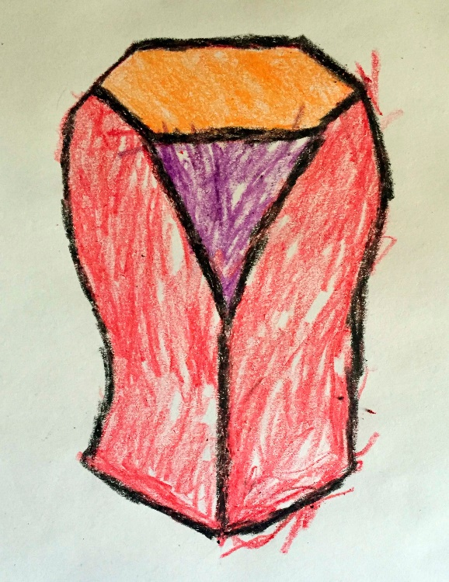In summary, if a tissue is curved surely scutoids will be there; and nature loves curvy things: all animals are formed from tissues that bend into complex shapes! Moreover, our discovery opens new avenues of research. For example, in tissue engineering to make artificial organs copying nature’s solution. We like to think that Robert Hooke would have enjoyed our findings... and you too!