**Original Article (DOI)**: **0.1038/s41586-019-1345-6**

**Author(s) (3 authors max):** Nicholas B. Holowka, Bert Wynands, Daniel E. Lieberman

**Position:** Postdoctoral Fellow and Lecturer

**Affiliation:** Harvard University

**Corresponding Author (undisclosed to readership):** Nicholas B. Holowka

**Word count (700-750 max):** 743

**Field:** Biological Anthropology

**Twitter handle:** -- @HarvardHEB

**Keywords**: -- Human Evolution, Skin, Biomechanics, Anthropology, Sensory Biology

**IMPORTANT: read carefully the guidelines (**[**https://www.thesciencebreaker.org/information**](https://www.thesciencebreaker.org/information)**) before drafting your manuscript - manuscripts which will not address the suggested guidelines, will not be considered for publication.**

**SUBMIT your manuscript through the online form:** [**https://www.thesciencebreaker.org/contact/submit-your-break**](https://www.thesciencebreaker.org/contact/submit-your-break)

**Calluses Provide Protection Without Sensory Loss in Barefoot Walking**

Abstract -- Prior to footwear, calluses served as the primary protection for our feet. To understand how our species walks safely without shoes, we investigated foot skin biology in regularly barefoot and shod people in Western Kenya. Unlike shoes, calluses provide protection without trading off sensitivity or changing impact forces in walking, making them a remarkable example of evolutionary engineering.

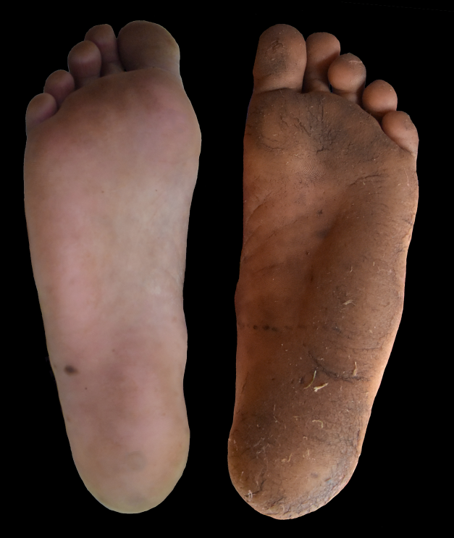

Image by Daniel E. Lieberman

For most of our species existence, we humans wandered the earth barefoot, walking over a vast diversity of daunting and often dangerous terrains with no shoes to protect our feet. Instead, we relied in part on a natural line of defense: calluses that form in the epidermis, the outer most layer of the skin on the soles of our feet. Only relatively recently have we replaced this evolutionary solution to foot protection with comfy, cushioned footwear, and now calluses are widely viewed as unsightly and painful by-products of shoes that don’t fit properly. However, shoes, sandals and other types of footwear come with other potential costs, including losing sensory feedback from the ground below us through our sense of touch. In this study, we set out to determine whether the protection afforded by calluses also comes with similar costs.

To tackle this question, we traveled to a remote but beautiful region of eastern Kenya called the Nandi Hills, where people engage in non-industrialized farming and many rarely, if ever where shoes. Our team included local researchers from Moi University led by Drs. Paul Okutoyi and Robert Ojiambo Mang’eni, and skin sensitivity experts led by Dr. Thomas Milani from the Technical University of Chemnitz in Germany. We used portable ultrasound equipment to image the soles of people’s feet and measure callus thickness, industrial devices to measure skin mechanical properties, and a specially-engineered vibrating probe that stimulates nerves in the foot called mechanoreceptors associated with the sense of touch, allowing us to measure their sensitivity. Lastly, we recorded our study participants walking over a platform that measures the amount of force the body imparts on the ground during foot contact. Subsequently, we traveled to the nearby city of Eldoret and took the same measurements in people belonging to the same ethnolinguistic heritage as those in the Nandi Hills, but who had regularly worn footwear for most of their lives.

As we anticipated, habitually barefoot individuals had thicker, stiffer calluses than habitually shoe-wearing individuals, and across all study participants there was a strong correlation between callus thickness and skin hardness. This means that regularly walking barefoot results in calluses that protect against dangerous objects and surfaces that could pierce and otherwise damage the skin of the foot. However, we found that participants did not lose mechanoreceptor sensitivity as callus thickness increased, meaning that calluses, unlike shoes, still enable people to receive sensory feedback from the ground below their feet, which could come in handy when walking or running on treacherous terrains. Correspondingly, from our ground force data we found no effect of how thick one’s calluses were with how hard they hit the ground with their foot at the beginning of a step, which would be expected if calluses do not reduce tactile sensory feedback.

This last result made us curious about how thick calluses compare to modern shoes in affecting the way we walk. So, back at our lab in Harvard, we conducted a follow-up study with a sample of local participants, including individuals with thick calluses who professed to being frequently barefoot. We had them walk on a treadmill that measures ground forces barefoot, and in two types of shoes: a minimal shoe meant to simulate walking barefoot, and a heavily cushioned modern running shoe. We found that while once again callus thickness had no effect on walking, shoes changed the forces at ground contact, slowing the rate of force rise but ultimately increasing the magnitude of shock experienced by the leg. These effects were much more substantial in the cushioned athletic shoe.

Altogether, these findings demonstrated clear differences in how calluses versus shoes affect the way we interact with the ground underfoot while walking. We humans evolved as barefoot animals, and thus took advantage of a remarkable example of evolutionary engineering – the ability to develop thick calluses in response to the specific surfaces we encountered that not only protected the soles of our feet, but allowed us to maintain a keen sense of touch to detect dangerous objects or unstable footing. Furthermore, our research highlights the fact that shoes have fundamentally altered the way we walk, diminishing our sense of the world below us and changing the forces we experience with each step. While the implications of these changes for modern human health and safety are currently unclear, we advocate for future research on footwear that better mimics barefoot walking, and thereby brings us closer to how we evolved to walk and run.