**Loss of chimpanzee behavioural and cultural diversity amid increasing human disturbance**

Ammie K. Kalan

Safeguarding earth’s biodiversity has been become an urgent priority in the current era of unprecedented environmental and ecosystem degradation. Although scientists have been monitoring the loss of species, populations and their genetic diversity, comparatively little attention has been given to the influence of human growth and development on the behaviour of animals. As such, we investigated whether the maintenance of behavioral traits and cultural traditions in one of our closest living relatives, chimpanzees, might suffer due to increasing human disturbance.

Chimpanzees, *Pan troglodytes*, have a diverse repertoire of behaviors they naturally use in the wild, including various forms of tool-use to access insects, meat, algae and water. In addition, many chimpanzee behaviors are cultural, meaning they are socially learned traits that are found in some populations but not all. Overall, chimpanzees, along with other non-human primates, cetaceans, and birds show some of the best studied examples of culture in animals.

For this study we collected a large dataset on wild chimpanzee behaviors, focusing on 31 behaviours, of which more than half show cultural or population-specific variation in the wild. We combined data collected in the field via the Pan African Programme: the Cultured Chimpanzee (http://panafrican.eva.mpg.de/) with data on these behaviours mined from the published literature. In total, we compiled data on the presence (direct observation or indirect evidence such as tool artefacts, feeding remains, fecal samples) of these 31 behaviours for 144 unique chimpanzee groups. We then used an open access, published GIS layer, the human footprint (https://sedac.ciesin.columbia.edu/data/set/wildareas-v2-human-footprint-geographic), created by a collaborative network of independent scientists, to test if chimpanzee groups living in areas with a high human footprint have a lower diversity in the numbers of behaviours they exhibit. Here we controlled for observation effort for each chimpanzee group, the subspecies of chimpanzee, and geographic similarity between groups.

We found that chimpanzees living in high human impact environments showed far fewer of the 31 behaviours investigated. On average, this was an 88% reduction in the probability of these behaviours being present. We also did not find any evidence for a particular behaviour to be driving this pattern. We further verified that our results were not dependent upon the inclusion of long-term research sites (i.e., more than 5 years of observation) and found that the observed pattern was still robust. More recently, we further examined that our results were not dependent on the inclusion of short term survey sites (i.e., 1 month effort or less) and again the result holds: high human impact areas are associated with lower chimpanzee behavioural diversity than low impact areas. As mentioned above, many of the behaviours we investigated are also cultural; therefore, we inferred that our results also reflect a reduction in chimpanzee cultural diversity in high human impact environments.

These results were not altogether surprising, and confirmed many of our own personal observations in the field where we witness first-hand the devastating effects of human activities such as deforestation, mining and the bushmeat trade. However, this study marks the first time we were able to empirically demonstrate that our growing human footprint across the globe has repercussions not only for the loss of animal lives but also for the loss of the behavioural and cultural traits animals use in their day to day survival.

Although chimpanzees may adapt to living in close association with humans, for example becoming more active at night or feeding on human crops, these behaviours are dangerous and risky. Therefore, if we wish to protect wild chimpanzee populations then we must also consider conservation actions that safeguard their behavioral and cultural diversity. Our results therefore support the use of ‘culturally significant units’ to be used more generally in wildlife conservation, which has been previously designated and applied for whales. Even more pertinent, we advocate identifying chimpanzee ‘cultural heritage sites’ where particular locations, resources or populations are protected to safeguard the behavioural and cultural diversity of the species’ for future generations. This will aid the conservation not only of wild chimpanzees but also of the rainforest and savanna woodland habitats they live in, as well as the accompanying biodiversity found in these environments. Such a concept could prove valuable for other wildlife, to encourage and support the protection of cultural traditions and social knowledge in species such as elephants, orangutans, macaques, capuchins, whales and dolphins.

{POTENTIAL IMAGES TO ACCOMPANY ARTICLE}

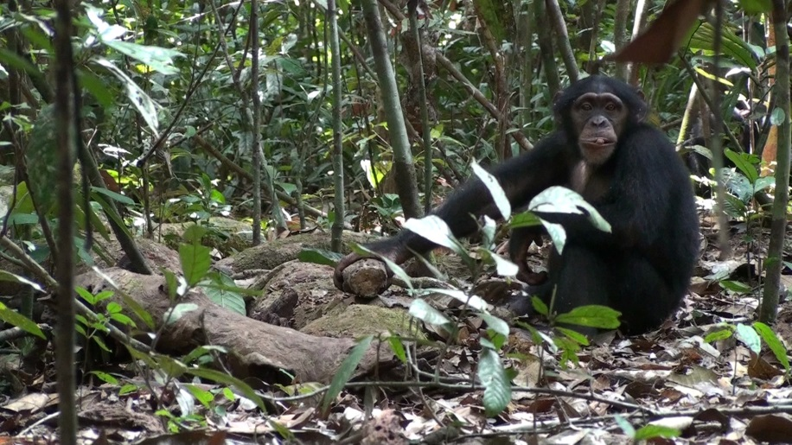

Copyright: Tobias Deschner/Taï Chimpanzee Project

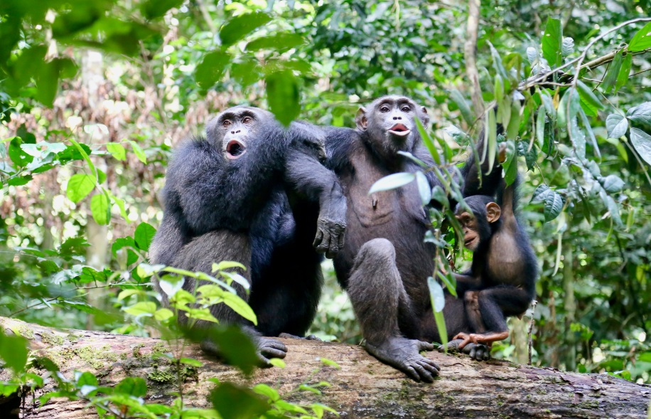

Copyright: Liran Samuni/ Taï Chimpanzee Project