# Taxing our food: The global burden of pathogens and pests on food crops

Serge Savary 1, Laetitia Willocquet 1, Sarah Jane Pethybridge 2, Paul Esker 3, Neil McRoberts 4 and Andy Nelson 5

## Why is this important?

We take food for granted: for two generations at least, most of the developed world has not been faced with famine. For two generations at least, too, the majority of those who live in the developed world have no farmers among their immediate kin. We have become disconnected from agriculture. Things are very different in the developing world, where food is often scarce, and sometimes lacking, and where agriculture still is a major activity. Yet, in both worlds, the developed and the developing, plants are sick because of pathogens and pests. When considering food crops, one could say that pathogens and pests (P&Ps) are levying taxes. It has become seldom realised that these taxes are withdrawn by P&Ps on all crops, everywhere.

And so, crop pathogens and pests constitute a burden to food production worldwide: P&Ps are frequent causes for crop losses – losses in both quantity or quality of harvests – irrespective of the agrosystems, whether in small-scale, diverse, single-cycle, "traditional" agriculture, or in large-scale, genetically uniform, monoculture-based, "intensive" systems.

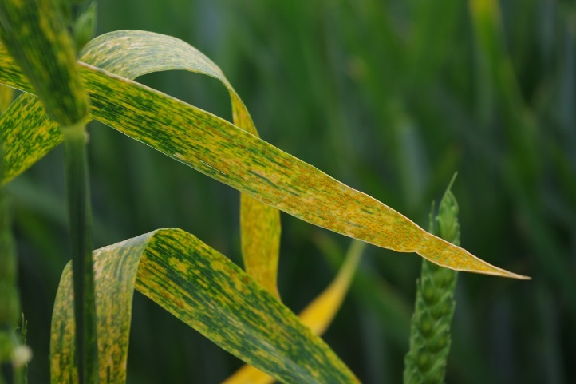

Stripe rust (yellow rust) in wheat, France (Photo: L. Willocquet)

Yet, while scientists agree that pathogens and pests are an important cause of crop losses, and sometimes a threat to food security, precise figures on these crop losses are very hard to produce.

Estimating losses to P&Ps is difficult for two reasons. One is rooted in the sheer biological diversity of P&Ps: these can be viruses, bacteria, fungi, nematodes, arthropods, molluscs, vertebrates, or parasitic plants. This diversity means that quantifying losses on an individual P&P basis, for each of the many cultivated crops, is a daunting task. The other reason is ecological: P&Ps are integral parts of the human-made agrosystems – in fact, P&Ps have been domesticated at the same time as crop plants, over millennia. As a result, the effects of P&Ps in agriculture are very hard to disentangle from the complex web of interactions among factors at play within agrosystems.

## How the problem was addressed

The International Society for Plant Pathology (ISPP) decided that a survey on P&P losses should be conducted. This worldwide online survey was conducted between Nov 1, 2016 and Jan 31, 2017, reaching over 2,500 members of the ISPP, along with nearly 100 specific crop health experts of many scientific organisations worldwide.

Using a very simple online questionnaire, we collected almost 1,000 responses from 219 crop health experts on five major food crops (wheat, rice, maize, soybean, and potato) in 67 countries. We chose these five crops since together they provide about 50% of the global human calorie intake. The 67 countries represent a substantial fraction (84%) of the global production of these five crops.

## Losses are substantial and they vary across food security hotspots

The "global burden of pathogens and pests" study documents losses associated with 137 P&Ps in wheat, rice, maize, potato and soybean worldwide. At a global scale, we estimate that the range of losses are 10.1–28.1% in wheat, 24.6–40.9% in rice, 19.5–41.1% in maize, 8.1–21.0% in potato, and 11.0–32.4% in soybean.

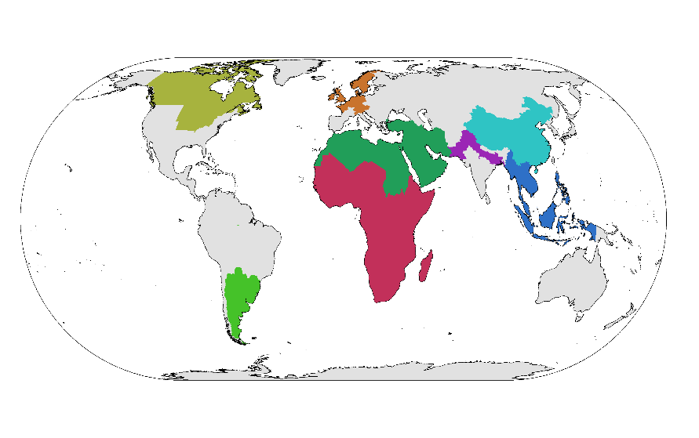The study also provides loss estimates to individual P&Ps for these crops globally, as well as in several global food security “hotspots”. These hotspots are critical sources and/or sinks in the global food system: North-West Europe, the plains of the US Midwest and Southern Canada, Southern Brazil and Argentina, the Indo-Gangetic Plains of South Asia, the plains of China, South-East Asia, and Sub-Saharan Africa.

Global food security hotspots considered in the study

Our results highlight differences in impacts among crop pathogens and pests and among food security hotspots. Importantly, we also show that the highest losses appear associated with food-deficit regions with fast-growing populations, and frequently with emerging or re-emerging pests and diseases.

## Information to enable progress and address chronic and emerging crop pathogens and pests

Quantification of crop losses provides a measure of past advances and a benchmark for future progress in crop health management. Our results provide a basis for research and policy prioritisation of crop health management. Some P&Ps occur chronically – meaning they occur regularly and over large areas. For chronic P&Ps, efforts to deliver more efficient and sustainable management tools, such as resistant varieties, are needed. Some P&Ps are emerging or re-emerging and are associated with recent large increases in losses in specific food security hotspots. For emerging or re-emerging P&Ps, urgent action is needed to contain them and efforts to generate long term solutions, such as varietal resistance, need to be undertaken rapidly.

Sheath blight on rice, Myanmar (Photo : S. Savary)

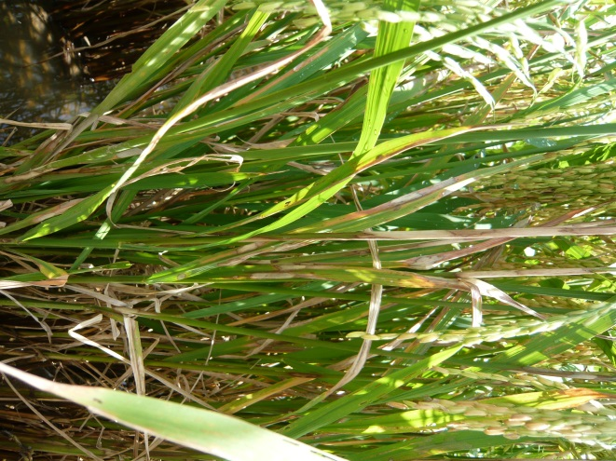

## Links

**1** S. Savary, L. Willocquet, S. J. Pethybridge, P. Esker, N. McRoberts and A. Nelson, (2019) “The global burden of pathogens and pests on major food crops”, Nature Ecology & Evolution. doi:10.1038/s41559-018-0793-y [link to the paper: [https://rdcu.be/bj4tC](http://em.rdcu.be/wf/click?upn=lMZy1lernSJ7apc5DgYM8c4inf7aC71g3c69JkrYvrc-3D_uQKHpzd-2FPfFzCiVWXV8Et-2Fu3fH28znIl0Lbm445GrDOvoFpFERpvz0rUo7EmsWmovZelMIrirWbnifzTwPWaTja74SR9JjW2XA1gBmDR-2FLU7FhQ5y5wOe2n6Wc8Fjg-2BJe72S8U1tBBYM-2FA60ifvykahP8tzZ4bbCU9VmqryN4pawdNfxSU9Rh6Wvk4X6g8S8cEStxmhXd4IBchgvKC35hUe7eIWVp9y-2F02TnnBudAMLs9FayI9QA15pJQ1rPNqxq0sUI2uYHcvTABA7PBoCdFA-3D-3D)]